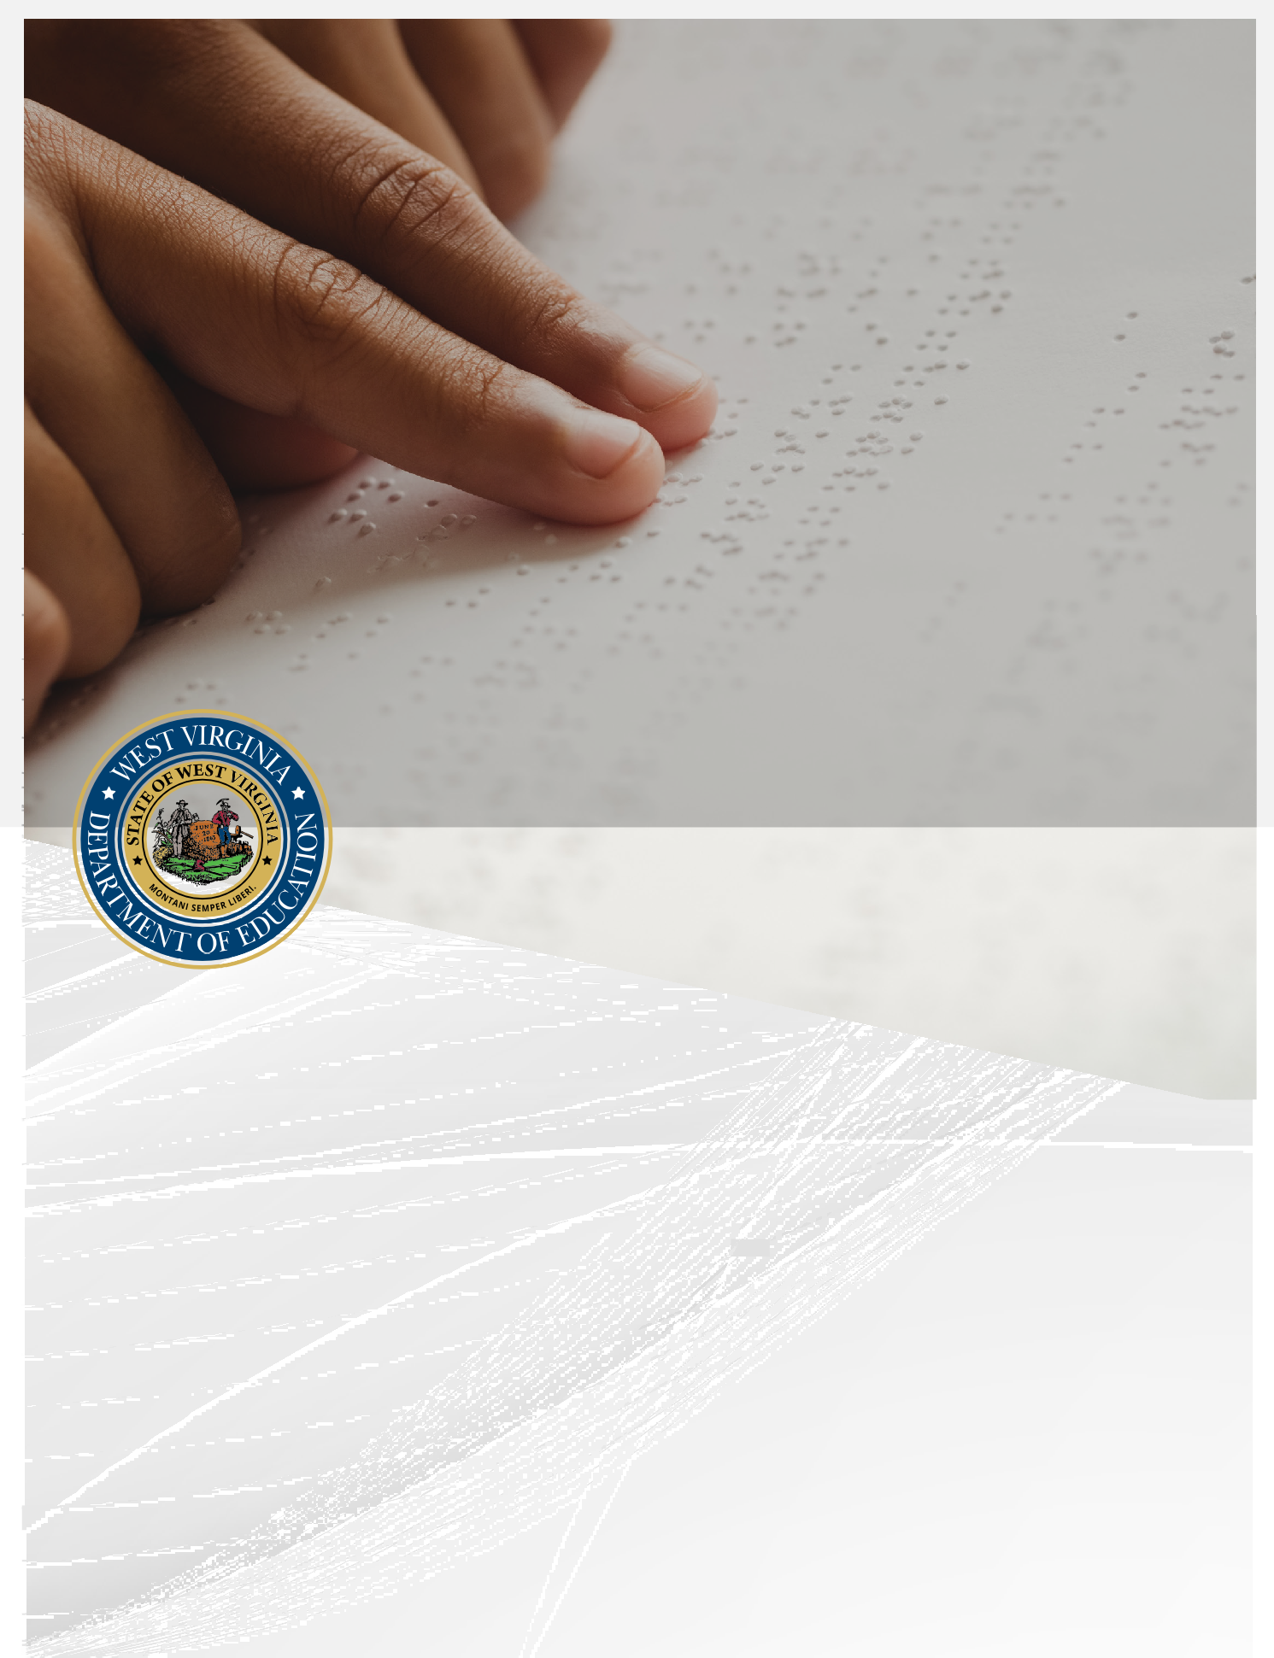

PARTICIPATION GUIDELINES FOR WEST VIRGINIA STATE ASSESSMENTS
2026-2027
Guidance for Accommodations for State Testing v.2

https://wvde.us/academics/assessment/participation-guidelines

West Virginia Board of Education
2026-2027
L. Paul Hardesty, President
Victor L. Gabriel, Vice President
F. Scott Rotruck, Secretary
Nancy J. White, Financial Officer

Robert W. Dunlevy, Member
Cathy L. Justice, Member
James Paul, Ph.D., Member
Christopher A. Stansbury, O.D., Member
Gregory F. Wooten, Member

Sarah Armstrong Tucker, Ph.D., Ex Officio
Chancellor
West Virginia Higher Education Policy Commission
West Virginia Council for Community and Technical College Education

Michele L. Blatt, Ex Officio
State Superintendent of Schools
West Virginia Department of Education

West Virginia Department of Education
Office of Assessment
Building 6
1900 Kanawha Boulevard East
Charleston, West Virginia 25305-0330
August 2026
Michele L. Blatt
State Superintendent of Schools

Jeffrey Kelley
Associate Superintendent, Division of External Operations

Vaughn Rhudy, Ed.D.
Director
Office of Assessment

© 2026 by the West Virginia Department of Education

Content Contact
Sonja Phillips, M.A. Coordinator
Office of Assessment sonja.phillips@k12.wv.us

Suggested Citation

West Virginia Department of Education (2026). Participation guidelines for West Virginia state assessments, 2026-2027: Guidance on accommodations for students with disabilities and/or English learners in state and county-wide testing. https://wvde.us/assessment/participation- guidelines/



Contents
Contents 4
What’s New in this Version? 5
Section I. Introduction 13
Section II. Guidelines for Supporting and Accommodating Students with Disabilities 27
Section III. Guide to Accommodations 39
Section IV. West Virginia Alternate Summative Assessment (WVASA) 81
Section V. Guidelines for Supporting and Accommodating English Learner (EL) Students 95
Section VI. West Virginia General Summative Assessment 113
Section VII. SAT School Day 133
Section VIII. Accommodations Guidelines for the National Assessment of Educational Progress (NAEP) 145
Section IX. References and Additional Readings 169
Section X. Appendix 175

What’s New in this Version?
Information about these topics has been added or enhanced in this version.

Topic
Updated NAEP information
Updated NOCTI information
Retired Accommodations codes:
P49 – Amplification System
Added new Accommodation Codes:
P51 – Math section only, read aloud (TTS) – SAT School Day only
P52 – Math section only, Human Read aloud – SAT School Day only
Clarified expanded accommodation code use across all state assessments
Added P13/P14 Eligibility Matrix & FAQ
Updated P19A-D sizing for SAT & ELPA21

List of Abbreviations and Terms
AAAS Alternate Academic Achievement Standards – Including Policies 2520.16, 2520.161, and 2520.162, which define the alternate academic achievement standards in reading/language arts (Policy 2520.161), mathematics (Policy 2520.162), and science (Policy 2520.16) for students with the most significant cognitive disabilities.
Accommodations
Changes in how a student learns or is evaluated on the standards
ACC.OMS
Accommodations application developed within WVEIS
ADA Americans with Disabilities Act
AEM Accessible Educational Materials
Alt-ELPA Alternate summative assessment for demonstrating English proficiency for English learners who have the most significant cognitive disabilities.
ASL American Sign Language
ATC Assistive Technology Compatible
Bluebook Student test platform for the SAT School Day
CAI Cambium Assessment, Inc.
CCSSO Council of Chief State School Officers
CSR Confidential Summary Report – Assessment report
CTC County Test Coordinator
County Assessments
Assessment given to students of an entire grade without exclusion (e.g., students who take the alternate assessment or are on an IEP, EL plan, or Section 504 plan)
DLM Dynamic Learning Maps
EL English Learner – Student identified as acquiring English for their education; students who speak a language other than English in their home
ELPA21 English Language Proficiency Assessment
ESEA Elementary and Secondary Education Act
ESL English as a second language
ESSA Every Student Succeeds Act
IASA Improving America's Schools Act – Reauthorization of the Elementary and Secondary Education Act (ESEA) in 1994 (predecessor to the No Child Left Behind Act of 2001)
IDEA 2004
Individuals with Disabilities Education Improvement Act of 2004
IEP Individualized Education Program
JAWS Job Access with Speech – screen reader program
Kite Kansas Interactive Testing Evolved – platform used to deliver testlets for students with the most significant cognitive disabilities
LEA Local Education Agency
MAE.4SA Monitoring Accommodations Electronically.4 State Assessments
Modifications Changes what a student is taught or expected to learn of state standards
NAEP National Assessment of Educational Progress – Sometimes known as the Nation's Report Card, conducted by the National Center for Education Statistics at the U.S. Department of Education
NAGB National Assessment Governing Board
NCEO National Center on Educational Outcomes
NCES National Center for Education Statistics
NCLB No Child Left Behind Act – Elementary and Secondary Education Act reauthorization for 2001.
NOCTI National Occupational Competency Testing Institute
OSE Office of Special Education, West Virginia Department of Education
Participation Guidelines (PG)
Participation Guidelines for West Virginia State Assessments, 2026-2027
PLP Personal Learning Profile
PNP Personal Needs Profile
Policy 2340
West Virginia Measures of Academic Progress – West Virginia Board of Education policy establishing rules governing the administration and operation of the West Virginia Measures of Academic Progress (WV-MAP)
Policy 2417
Regulations and English Language Proficiency Standards for English Learners – West Virginia Board of Education legislative rule defining the expectations for programs of study for improving the English language proficiency of students with limited English proficiency
Policy 2419
Regulations for the Education of Students with Exceptionalities – West Virginia policies that apply to preschool, early childhood, middle childhood, adolescent, and adult students whose educational programs require special education and related services
Policy 2510
Assuring the Quality of Education: Regulations for Education Programs – West Virginia Board of Education policy that establishes the regulations for all education programs that are designed to prepare students for the 21st century
SAT School Day
SAT School Day is the annual summative assessment for all 11th grade West Virginia students, except for those students who are eligible to participate in the West Virginia Alternate Summative Assessment.
SC School Coordinator
SEA State Education Agency
Section 504 Plan
An amendment to the Rehabilitation Act of 1973 prohibiting exclusion from participation in, denial of benefits to, or discrimination against individuals with disabilities based on their disability, in federally assisted programs or activities.
SEE Signed Exact English
SSD College Board’s Services for Students with Disabilities (SAT School Day)
Standard Conditions
General testing conditions, described in test administration materials, are followed for all students. An IEP team, Section 504 committee, or EL committee may require specific assessment accommodation(s) for individual students, which augment the standard conditions.
TAM Test Administration Manual
TIDE Test Information Distribution Engine
TIPS Test Information Page
USED United States Department of Education
WVASA West Virginia Alternate Summative Assessment
WVBE West Virginia Board of Education
WVCCRS
West Virginia College- and Career-Readiness Standards, defined in Policy 2520
WVDE West Virginia Department of Education
WVEIS West Virginia Education Information System
WVGSA West Virginia General Summative Assessment
WVTAC West Virginia Technical Assistance Committee
WV-MAP
West Virginia Measures of Academic Progress—multiple assessments conducted by the WVDE, including the West Virginia General Summative Assessment Grades 3-8; SAT School Day; West Virginia Alternate Summative Assessment; ELPA 21; and NAEP

Preface
The West Virginia Department of Education (WVDE) has put in place an ongoing process to review and improve how assessment accommodations are provided to students with Individualized Education Programs (IEPs), Section 504 plans, and English Learner (EL) plans. This process is designed to make sure accommodations are effective, appropriate, and consistently implemented across the state.
This work is supported in several ways. First, national experts on the West Virginia Technical Advisory Committee (WVTAC) review the technical quality of the state’s assessment system. In addition, a group of stakeholders reviews this document to ensure it is clear, accurate, and complete. Finally, the WVDE Office of Assessment conducts a yearly review to evaluate how accommodations are being used during statewide testing and to identify areas for improvement.

Governance and Review

West Virginia Technical Advisory Committee (WVTAC)
The West Virginia Technical Advisory Committee (WVTAC) provides guidance and recommendations to the West Virginia Department of Education (WVDE) to help ensure the state meets federal accountability requirements. Members are chosen for their expertise in areas such as assessments, academic standards, system alignment, and supporting students with disabilities and English learners.
The committee supports important work related to how assessments are designed, used, and reviewed. This includes helping with reporting and sampling, setting performance standards, improving accommodations and accessibility, and ensuring assessments follow universal design principles. The group also plays a role in preparing for federal ESEA peer reviews and advising on assessment research and design.

Membership includes:
- Dr. Vaughn Rhudy, WVDE Office of Assessment
- Dr. Paul Williams, American Institutes for Research (ret.)
- Dr. William Auty, Education Measurement Consulting
- Dr. Damian Betebenner, National Center for the Improvement of Educational Assessment
- Dr. Annie Davidson, CrescendoED LLC
- Robyn Lopez, Berkeley County Schools
- Dr. Richard Patz, University of California, Berkeley
- Dr. Martha Thurlow, NCEO/University of Minnesota

Participation Guidelines Stakeholder Group
The Stakeholder Group reviews the Participation Guidelines to make sure they are clear, accurate, and easy for educators and families to use. This review process is coordinated by the WVDE Office of Assessment.

The group brings together a wide range of perspectives, including staff from WVDE offices such as Assessment, Legal, Special Education, and Federal Compliance, as well as county leaders like special education directors, Title III directors, and test coordinators. School administrators, teachers, parent advocates, and partner agencies also play an important role.

Together, these members identify areas that need improvement and share their recommendations with WVDE staff, who lead updates and revisions to the guidelines.

WVDE Revision Leadership
The following WVDE staff coordinate content updates and revisions:
- Deborah Adams – Low Incidence
- Veronica Barron – NOCTI
- Timothy Butcher – WVGSA (Science)
- Mami Itamochi – EL Accommodations / ELPA21
- Sheila Paitsel – Policy 2419 / Special Education Monitoring
- Jason Perdue – WVGSA / Data Specialist
- Sonja Phillips – WVASA / Accessibility / Document Editor
- Dr. Vaughn Rhudy – Policy 2340 / Federal Requirements
- Terry Riley – Section 504
- Christy Schwartz – NAEP
- Jonathan Shank – Research
- Heather Waselchalk – Communication Disorders

Research and Continuous Improvement
For more than two decades, the West Virginia Department of Education (WVDE) has led a comprehensive research effort focused on how assessment accommodations are used and how effective they are for students with disabilities and English learners. This work examines key questions such as how often accommodations are used, how students perform with and without them, and whether assessment results remain comparable across different testing conditions.
WVDE’s research has evolved over time through several important milestones. An external study in 2006 reviewed accommodation use from the 2003–2004 school year, followed by an internal study in 2009 that analyzed data from WESTEST 2. In 2011, this work expanded to include accommodations for English learners, and in 2012–2013, WVDE partnered with George Washington University’s Center for Equity and Excellence in Education to further study the appropriateness of accommodations for these students.
This ongoing research has provided valuable tools and insights for counties. Schools are better equipped to analyze trends in accommodation use, make stronger IEP decisions, and identify when students may be over- or under-accommodated. It also helps educators ensure that instruction and assessment are aligned, supporting more effective and equitable outcomes for all students.

Data Systems and Monitoring
WVDE has developed several systems to support statewide monitoring and reporting:

WVS.326
A statewide accommodations data collection tool that allows tracking of assignment, provision, and usage.

ACC.OMS
An application within WVEIS that retrieves accommodations from IEP, 504, and EL plans, enabling verification and reporting.

ZoomWV / ZoomWV-e
State data dashboards providing access to accommodations data for educators.

MAE.4SA (Monitoring Accommodations Electronically)
Launched in 2022, this system:
- Captures real-time accommodation verification
- Records user activity and timestamps
- Provides reporting at school, district, and state levels
- Eliminates delays and data loss associated with paper processes

National Partnerships and Innovation
West Virginia continues to collaborate with national organizations to strengthen accessibility and assessment practices:
- NCEO DIAMOND Project – data-informed accessibility decisions
- OELA Partnership – professional development modules for EL accommodations
- CCSSO Collaboration – research and standards development
- CEDS Initiative (2024) – standardizing accommodation definitions

Major Initiatives
- Development of Alternate English Language Proficiency (Alt-ELP) assessment
- Participation in MIDAS project (multi-measure decision-making)
- Pilot and operational implementation of Alt-ELP (2023–2024)
These initiatives support improved decision-making, consistency, and equity in assessment access.

Section I.
Introduction



Section I. Introduction

Purpose of Assessment
Assessment is a critical component of a high-quality educational program and plays an essential role in improving classroom instruction. It provides meaningful information about what students know and can do, as well as how effectively they are progressing toward college and career readiness. These assessments measure student performance against clearly defined academic standards aligned with classroom instruction.
Assessment results provide valuable feedback to students, educators, parents, policymakers, and the public. They help identify student strengths and areas for improvement while also offering insight into the effectiveness of the state’s educational system. In addition, state summative assessments ensure that West Virginia meets federal accountability requirements.
Assessments also support instructional decision-making by helping educators identify learning gaps and adjust instruction accordingly. They inform opportunities such as scholarships and recognition programs, provide data for school and district accountability, and offer objective results that support consistent interpretation. Through rigorous development processes—including content, bias, and sensitivity reviews—assessments are designed to ensure validity and reliability for all students, including those with disabilities and English learners.
Standardized testing is also a common requirement beyond K–12 education. Students encounter similar assessments when entering higher education, the military, and many professions. Participation in statewide assessments helps build the skills and resilience needed for these future opportunities.
West Virginia is committed to ensuring that all students have a positive, productive, and accessible assessment experience.

Purpose of the Participation Guidelines
The Participation Guidelines for West Virginia State Assessments provide direction for educators and teams responsible for assessment decisions. These guidelines support IEP teams, Section 504 committees, and EL committees in identifying and implementing appropriate accommodations. They also help ensure that assessment practices align with federal laws and state policies, including ESSA and IDEA, and support accurate documentation and compliance.

Assessments Covered in These Guidelines
These guidelines align with West Virginia Board of Education Policy 2340, West Virginia Measures of Academic Progress (WV-MAP), and apply to the following assessments:

West Virginia General Summative Assessment (WVGSA)
The West Virginia General Summative Assessment (WVGSA) serves students in Grades 3–8 and measures achievement of the West Virginia College- and Career-Readiness Standards. It assesses English language arts and mathematics in all tested grades, along with science in Grades 5 and 8, using a computer-adaptive format for accountability purposes.

SAT School Day
The SAT School Day serves as the statewide assessment for Grade 11 students, except those participating in the alternate assessment. It is administered during the school day and is widely recognized for college admissions and placement. Students may also use SAT scores to qualify for programs such as the Promise Scholarship. Free preparation resources are available through Khan Academy.

West Virginia Alternate Summative Assessment (WVASA)
The West Virginia Alternate Summative Assessment (WVASA) is designed for students with the most significant cognitive disabilities. Delivered through the Dynamic Learning Maps system, it assesses English language arts, mathematics, and science using alternate achievement standards.

English Language Proficiency Assessments

ELPA21 & Alt-ELPA
English learners participate in one of two assessments: ELPA21, which measures English language proficiency for general EL populations, or the Alt-ELPA, which is designed for English learners with the most significant cognitive disabilities. Both assessments evaluate speaking, listening, reading, and writing skills.

National Assessment of Educational Progress (NAEP)
West Virginia also participates in the National Assessment of Educational Progress (NAEP), a national assessment administered to a representative sample of students. Although NAEP is not used for accountability, participation is required under state law. Accommodations for NAEP are determined at the federal level.

National Occupational Competency Testing Institute (NOCTI)
NOCTI assessments are used in Career and Technical Education programs and are aligned with industry standards.

Legislative and Policy Foundations
The Participation Guidelines are grounded in federal and state law governing student participation in assessment and the provision of accommodations. Policy 2340 requires all students—including those with IEPs, Section 504 plans, and English learners—to participate in statewide assessments.

Federal laws, including IDEA and Section 504 of the Rehabilitation Act, require that assessments measure academic standards rather than the effects of a disability and ensure that students are not excluded from participation. ESSA reinforces these expectations by requiring accountability for all student groups.

Decisions about assessment participation and accommodations must be made by IEP teams, Section 504 committees, and EL committees. Standard testing conditions must be followed unless accommodations are documented in a student’s plan. All personnel involved in assessment administration are required to follow procedures and maintain documentation in accordance with Policy 2340.

All students are expected to be assessed on grade-level standards. Students with the most significant cognitive disabilities may participate in alternate assessments, and English learners must participate annually in assessment programs, with limited exceptions in specific cases such as NAEP.

WVDE is responsible for monitoring implementation to ensure accommodations documented in student plans are provided during testing. These requirements support compliance with federal reporting expectations and ensure consistency across the state.

In summary, accommodations identified in a student’s IEP, Section 504 plan, or EL plan must be implemented as written. Any changes must be made through the appropriate team process.

Research Base
West Virginia’s assessment and accommodation practices are grounded in a nationally recognized research base, including work from NCEO and other leading researchers. This research informs decisions about accessibility and ensures that accommodations support valid assessment results.

The state participates in major assessment consortia, including Dynamic Learning Maps (DLM) and ELPA21, which provide research-based tools and accommodations aligned to specific assessments. All WV-MAP assessments are developed using principles of universal design and technology-enhanced accessibility to ensure equitable access for all students.

Research consistently shows that when accommodations are aligned with individual student needs—particularly for English learners—students are better able to demonstrate their knowledge and skills.

Modifications
Modifications change what is intended to be measured by the assessment or the meaning of the resulting scores and are not allowed. One example of unallowable modifications is off-grade-level testing for assessments. The WVDE distinguishes among assessment options, accommodations, and modifications as shown in Table 1 which may be useful when a special accommodations request is being considered.
Table 1. Characteristics of Options and Accommodations versus Modifications

Options and Accommodations versus Modifications
Options and Accommodations (allowed) | Modifications (not allowed)
Provide equitable access during assessments by mitigating the effects of a student’s disability or limited English proficiency. | Provide unfair advantage by reducing the difficulty of a test or altering the nature of the test.
Do not reduce learning or achievement expectations for a student. | Reduce the learning or achievement expectations for a student.
Do not change the construct being assessed. | Change the construct being assessed.
Do not compromise the integrity or validity of the test. | Compromise the integrity of the test, resulting in invalid scores that are not meaningful.

Ensuring Accommodations

Federal and state laws require that accommodations specified in a student’s Individualized Education Program (IEP), Section 504 plan, or English Learner (EL) plan be provided during testing. Any changes to these accommodations must be reviewed and determined by the appropriate team, including the IEP team, Section 504 committee, or EL committee.

To ensure compliance, the West Virginia Department of Education (WVDE) has established the Monitoring Accommodations Electronically for State Assessments (MAE.4SA) process. This system ensures that all eligible students receive the accommodations documented in their plans and that appropriate documentation is maintained for monitoring and accountability purposes. These procedures have met federal review requirements and are required for both state and county assessments.

Required state assessments include the West Virginia General Summative Assessment (WVGSA), West Virginia Alternate Summative Assessment (WVASA), SAT School Day, ELPA21 or Alt-ELPA, NOCTI, and the National Assessment of Educational Progress (NAEP).

County assessments include any assessments administered to an entire grade level without excluding students who have an IEP, Section 504 plan, or EL plan, as well as students participating in the WVASA.

Provision of Accommodations

West Virginia requires documentation and monitoring of all accommodations identified in a student’s Individualized Education Program (IEP), Section 504 plan, or English Learner (EL) plan to ensure they are implemented as intended.

For the West Virginia General Summative Assessment (WVGSA) Grades 3–8, SAT School Day, and ELPA21, embedded accommodations are electronically uploaded to testing platforms such as TIDE and Bluebook from finalized IEPs.

West Virginia public schools are required to use the IEP program within the West Virginia Education Information System (WVEIS) to document accommodations for students with disabilities, while accommodations for students with Section 504 or EL plans must be entered according to state and county procedures.

Additional guidance on these processes is available through county Special Education offices.

Prior to assessment
- Six weeks prior to any state assessment window, the principal/SC should use the WVEIS Accommodations Application (ACC.OMS) (see Appendix A: Assessment Accommodations Verification - ACC.OMS) to identify students who receive accommodations. The ACC.OMS report displays data from current plans. Any changes must be addressed through the plan (IEP, 504, or EL) process. The ACC.OMS report should be used by principals/SCs to periodically review accommodations provided both instructionally and with assessments.

Please note:
  - For ELPA21, the Title III director or the EL specialist designee will fulfill the role of the principal/SC throughout the process.
  - For SAT School Day, the Test Supervisor will coordinate with IEP/504/EL case managers and the principal/SC throughout the process to verify accommodations are correctly entered into WVEIS.

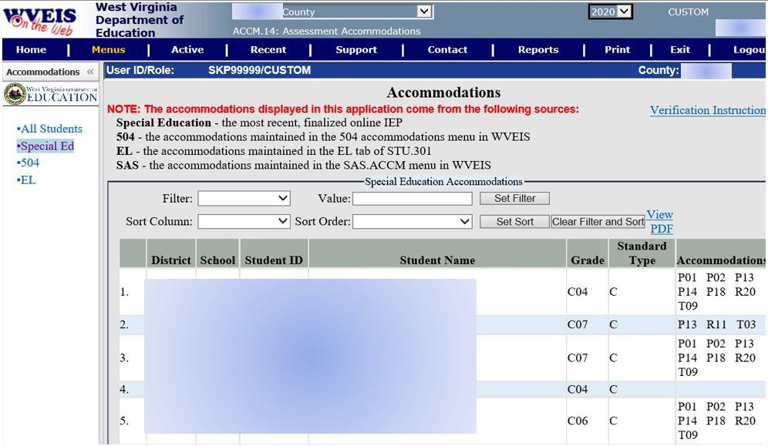

Screenshot of ACC.OMS app student accommodation information.

Note: The principal/SC should work with the student’s case manager to ensure all IEP plans are finalized in the WVEIS IEP program at the end of each IEP meeting. This process is to ensure the most recent IEP’s accommodations are automatically uploaded into testing platforms and general education teachers have access to updated IEPs.

This provision requiring the finalization of IEPs in no way limits the fact IEPs/504s/El plans can continue to be reviewed and updated throughout the testing window. However, adjusting assessment accommodations while the student is testing could put them at a disadvantage of unfamiliarity with the new tools thus increasing frustration and potentially decreasing the student’s ability to demonstrate mastery of what they have learned during the school year.

- A few weeks prior the assessment window:
  - SAT School Day - the SSD coordinator, School Test Coordinator, case manager, and test administrator(s) review the Student Roster and plan for accommodated testing of students.
      - If the Student Roster is missing students or has inaccurate accommodation information, the accommodation information for students with IEPs is changed by entering and finalizing data in the WVEIS IEP program.
        - If the accommodations are from a 504 or EL plan, those supports are hand-entered directly into WVEIS and must be updated via the county-determined process.
      - If difficulty arises, reach out to the county’s Special Education director or CTC for assistance.
    - ELPA21, Alt-ELPA, and WVGSA – the School Test Coordinator, case manager, and test administrator(s) should review the ACC.OMS report and compare the reported accommodations to what has been uploaded into the TIDE platform for each student with a qualifying plan.
      - If TIDE is missing students or has inaccurate accommodation information, the accommodation information for students with IEPs is changed by entering and finalizing data in the WVEIS IEP program.
      - If difficulty arises, reach out to the county’s Special Education director or CTC for assistance.
    - DLM – the School Test Coordinator, case manager, and test administrator(s) should review the ACC.OMS report and compare the reported accommodations to the First Contact Survey and Personal Needs Profile extracts found in Educator Portal.
      - If the ACC.OMS report does not match the extracts, the team should meet to determine which document needs to be updated and who will be responsible for completing these changes in a timely manner.
- Verify student data in ACC.OMS.
      - The accommodation information for students with IEPs is changed by entering and finalizing data in the WVEIS IEP program.
      - The accommodation information for students with a 504 plan is entered directly into WVEIS.
      - The accommodation information for students with an EL plan is entered directly into WVEIS.
It is the test examiner’s responsibility to ensure all embedded and non-embedded accommodations are provided and functional prior to the student being given access to the test materials.
If the assigned examiner has any questions on the provision of an accommodation, the principal/examiner will clarify any concerns. If the principal/SC is not sure, they will contact the CTC. The provision of accommodations is a requirement under Policy 2340.

During the administration of the assessment

Before a student is admitted to a testing platform (TDS, Bluebook, or Kite Student Portal) or provided access to any printed testing materials, the examiner must verify that all required accommodations are in place and fully functional.

During the assessment, the examiner is responsible for ensuring that the student appropriately uses both embedded and non-embedded supports and tools. The examiner must also maintain a record of the students being tested and the specific accommodations provided during each testing session. The ACC.OMS report provided by the school should be used as the primary reference for this information.

The principal or school coordinator (SC) is responsible for monitoring the administration of the assessment to ensure that accommodations are provided in accordance with each student’s plan. This oversight includes promptly addressing and following up on any accommodation administration errors.

After the assessment
Immediately following each day’s testing session*, the examiner must verify, using the MAE.4SA program in WVEIS, that all required accommodations were available to the student throughout the testing session (see Appendix B: Accommodations Monitoring Process).

At the conclusion of the assessment window, the principal or school coordinator should review accommodation data using the MAE.4SA report builder. If it is determined that a student did not receive a required accommodation, the administrator must take immediate action. This includes notifying the county test coordinator (CTC) when a potential misadministration has occurred.

*The accommodation verification process for students participating in the DLM may be completed at the end of each subject area rather than daily or at the end of each separate testlet.

Reviewing an accommodations administration error

If an accommodation is not provided as documented—or if an unapproved accommodation is given (excluding Codes 1 or 2) - the situation is considered an accommodation administration error and must be addressed promptly.

The principal or school coordinator must immediately notify the county test coordinator of the error. These incidents, including both under-accommodation and over-accommodation, represent a breach in testing integrity and require formal documentation according to county procedures.

The parent or guardian must then be informed of the error and provided with the following options:

Option 1: Reset the test and retest the student using a different form, if the testing window remains open.

Option 2: Accept the test as administered (only available if the student was under-accommodated).

Option 3: Invalidate the test. This option is available but not recommended for under-accommodated students. For over-accommodated students, only Options 1 or 3 may be selected.

If the parent or guardian selects Option 2 or 3, a signed written agreement must be obtained. Copies of this agreement must be maintained at the school, with the county test coordinator or appropriate program director, and in the student’s record.

Following the parents’ decision, an appeal must be submitted to the WVDE Office of Assessment. The appeal must include signed, written statements from all individuals involved, explaining the circumstances of the error. The WVDE will review the documentation and issue a determination.

The county test coordinator will use the MAE.4SA report builder to review missing verifications and reported errors with school staff and will communicate findings to the county superintendent and appropriate program directors. The county test coordinator may also consult with the WVDE Office of Assessment for further guidance.

In some cases, additional investigation may be required. The county must submit a written report of any corrective actions taken within 30 days to the WVDE Office of Assessment. Documentation related to the incident must be maintained by the county for a minimum of three years for compliance review.

Notice

In accordance with both special education monitoring and state special education compliance procedures, county noncompliance with federal statutory requirements results in corrective actions and technical assistance, if appropriate. Continued and/or persistent noncompliance at the county or school can result in state-imposed enforcement which may include a variety of sanctions, including the withholding or redirection of federal and/or state funds.

Special Assessment Circumstances

Catastrophic Medical Emergency/Medically Fragile Exemptions
Policy 2340 and federal law require that all students, including students with disabilities and English learners, participate in statewide assessments. However, in rare circumstances, a student experiencing an acute medical emergency may be unable to participate. In such cases, a request for a participation rate exemption may be submitted to the West Virginia Department of Education (WVDE) for review.
Each request is evaluated by the WVDE Office of Assessment to determine whether the documented circumstances justify an exemption. Additional information may be requested as needed to support the review. Any approved exemption applies only to the accountability year in which the request is submitted.
Information that will need to be submitted for review should include:
- Brief description of the emergency
- Date(s) of the emergency
- Date(s) the assessment is scheduled to be administered at the school
  - Student attendance with attendance codes for the year
- Confirmation of a doctor’s note is on file
Examples of circumstances that may qualify for an exemption include hospitalization or severe, debilitating illness. Situations such as minor illnesses or typical pregnancies do not qualify. Students receiving homebound instruction must still be provided the opportunity to participate in assessments if their health permits, and homebound instructors may be trained to administer assessments when appropriate.
Questions regarding this process may be directed to the WVDE Office of Assessment. The application form for requesting an exemption is provided in Appendix J: Request for Exclusion from Participation Rate due to Catastrophic Medical Emergency. Requests are reviewed after the close of the state testing window.

Virtual learning students
Students enrolled in a county virtual learning program remain public school students and are assigned to their school of record in WVEIS. Although instruction is delivered outside of the physical school setting, these students are expected to participate in all applicable components of the West Virginia Measures of Academic Progress (WV-MAP).

Homebound students
Homebound students are those enrolled in public school who, due to injury or other health-related conditions, are temporarily confined to a home or hospital setting for a period lasting, or expected to last, more than three consecutive weeks during the assessment window. Eligibility for homebound instruction must be certified in writing by a licensed physician or other qualified healthcare provider and must meet the requirements outlined in WVBE Policy 2510.
Homebound students are required to participate in all applicable state assessments, including the WVGSA, SAT School Day, WVASA, ELPA21, or Alt-ELPA. Whenever possible, students should be assessed at their school of enrollment. If this is not feasible, testing may occur at an alternate location approved by the county test coordinator.
All test administration must adhere to WVBE Policy 2340, including test security and administration procedures. The examiner must meet the qualifications defined in policy, and all required agreements must be maintained at the student’s home school. Testing must be conducted in a secure environment, and family members are not permitted to be present during testing or to access any testing materials.
If a student is able to attend school for testing, they should follow the school's established schedule. If not, the county will determine the appropriate method for administering the assessment.
Students with an IEP, Section 504 plan, or EL plan must receive and have documented all accommodations in the same manner as students tested within the traditional school setting.

Alternative schools
Students enrolled in public alternative education programs are required to participate in state assessments at the school where they receive instruction. These programs provide temporary placement for students whose needs are not met within a traditional school setting, as defined in WVBE Policy 4373.
All assessment administration and security procedures outlined in WVBE Policy 2340 must be followed. Students with IEPs, Section 504 plans, or EL plans must receive accommodations as documented, consistent with standard testing practices.

Charter schools
These guidelines apply to West Virginia public charter schools as described in West Virginia Board of Education (WVBE) Policy 3300: Public Charter Schools, pursuant to compliance with (WVBE) Policy 2340: West Virginia Measures of Academic Progress.

Homeschooled students
County test coordinators (CTCs) are responsible for requesting student identification numbers for homeschooled students who will participate in West Virginia Measures of Academic Progress (WV-MAP) assessments. Instructions for requesting these numbers are provided in advance of each testing window.
Homeschooled students may participate in WV-MAP assessments administered in the public schools of the county in which they reside. Each year, the home instructor must notify the county test coordinator of the student’s intent to participate prior to the testing window and in accordance with county-established deadlines. Eligible students may participate in the WVGSA Grades 3–8 or the SAT School Day.
The county test coordinator will assign participating students a testing location and schedule within the testing window. Testing must be conducted by an approved educator who has completed all required training and signed the WVBE Examiner’s/Scribe’s Secure Materials and Test Procedures Agreement. All testing must follow WVBE Policy 2340 procedures and security requirements. Failure to comply with these requirements may result in the loss of testing privileges.
Testing must occur in a secure environment, and family members are not permitted in the testing area or to access any testing materials.
Homeschooled students are not eligible to receive accommodations on the WVGSA Grades 3–8 and may not participate in the West Virginia Alternate Summative Assessment (WVASA).
However, if a homeschooled student seeks accommodations for the SAT School Day, appropriate documentation must be submitted to the county test coordinator for review. Requests are submitted to the WVDE, and the College Board makes final determinations regarding SAT accommodations.

Nonpublic schools – Private Schools
Students enrolled in nonpublic schools may participate in WV-MAP assessments. Each year, the nonpublic school administrator must submit a Participation Form and a Verification of Certification Form to both the WVDE Office of Assessment and the county test coordinator by the established deadline.
The county test coordinator is responsible for receiving and distributing all testing materials. Materials will only be released to the nonpublic school principal or designated school coordinator after required training has been completed and all secure materials agreements have been signed.
All educators administering assessments must be trained annually, and all testing must follow WVBE Policy 2340 procedures and security requirements. Training schedules are coordinated by the county test coordinator in collaboration with the nonpublic school. As with all testing programs, violations of policy may result in the loss of testing privileges.
If a nonpublic school student has a current public school-developed IEP, Section 504 plan, or EL plan that includes assessment accommodations, those accommodations must be provided if the parent or guardian submits the plan to the county. The plan may be subject to verification, and the WVDE Office of Assessment is responsible for entering approved accommodations into the testing platform.
For SAT School Day participation, nonpublic school students requesting accommodations must submit appropriate documentation to the county test coordinator. These requests are forwarded to the WVDE, and final approval is determined by the College Board.

Non-Standard Accommodation(s) Requests
IEP teams, Section 504 committees, and EL committees may request permission to use accommodations other than those included in this manual.
The request must come from the county test coordinator, county special education director, Section 504 coordinator or Title III coordinator. The following information must be included in the request:
- Student’s name, West Virginia Education Information System (WVEIS) number, school, and county
- Specific requested accommodation(s) – please include as much information as possible including descriptions of any devices (make and model numbers, names and version of apps required, etc.)
- Rationale for the request provided by the IEP team, Section 504 committee, or EL committee
- Verification the student receives the accommodation(s) on a regular basis during classroom instruction and classroom assessment, and is familiar with the accommodation(s)
- Impact on student’s assessment results if the student is not permitted to use the requested accommodation(s)

Please see Appendix Q: Non-Standard Accommodation(s) Requests for the appropriate form and signatures to submit.

These requests must be submitted to your county test coordinator.
Upon completion of the review of the request, the county test coordinator, county special education director, Section 504 coordinator, or Title III coordinator (EL students only) will be notified of the review committee’s decision.

WV-MAP Online Resources
  - The WVDE Office of Assessment: https://wvde.us/assessment/
  - WVGSA Portal: https://wv.portal.cambiumast.com/
  - SAT School Day: https://satsuite.collegeboard.org/sat/sat-school-day
  - Official SAT Practice on Khan Academy: https://www.khanacademy.org/digital-sat
  - WVASA: http://dynamiclearningmaps.org/westvirginia
  - West Virginia State Board Policies: http://wvde.state.wv.us/policies/

References

IDEA https://sites.ed.gov/idea/regs/b/b/300.160/c

Section II.

Guidelines for Supporting and Accommodating
Students with Disabilities

Section II. Guidelines for Supporting and Accommodating Students with Disabilities

Federal requirements governing student participation in assessments are established under the Every Student Succeeds Act (ESSA) of 2015, the Individuals with Disabilities Education Improvement Act (IDEA) of 2004, and Section 504 of the Rehabilitation Act of 1973. These laws require that all students, including students with disabilities and English learners, be included in statewide assessment systems.

To meet these requirements, the West Virginia Department of Education (WVDE) must ensure that assessments are valid, reliable, and aligned with national standards. Assessment administration and content must remain consistent to allow for accurate comparisons of student and school performance over time. At the same time, assessments must be administered in a way that ensures equitable access and avoids discrimination.

This section provides guidance to support schools and counties in making informed decisions regarding assessment participation and accommodations for students with disabilities. It applies to students who are eligible under IDEA and WVBE Policy 2419, students with disabilities served under Section 504, and English learners with disabilities who receive services under both frameworks.

Students with disabilities include those with an Individualized Education Program (IEP) or a Section 504 plan. These students may receive appropriate accommodations as determined by their IEP team or Section 504 committee. Decisions regarding accessibility supports should consider the student’s individual characteristics, instructional experiences, and the demands of assessment tasks.

Purpose of These Guidelines
The guidelines for IEP teams and Section 504 committees are intended to:
- Define appropriate, research-based accommodations and their proper implementation for WV-MAP assessments (excluding NAEP, which has separate requirements);
- Clarify that modifications that alter what a test measures are not permitted;
- Ensure that prohibited modifications are not documented in IEPs or Section 504 plans;
- Establish criteria for participation in general and alternate assessments; and
- Describe how assessment decisions must be documented in student plans.

Role of Academic Teams
IEP Teams
An Individualized Education Program (IEP) is a written plan developed by a team in accordance with WVBE Policy 2419. The IEP outlines specially designed instruction and identifies accommodations needed for a student to access grade-level content and prepare for postsecondary opportunities.

The IEP also specifies the student’s participation in statewide assessments, including whether the student will participate in the general assessment with or without accommodations or in an alternate assessment. If accommodations are required, they must be documented in the current IEP and provided during assessment administration.

Federal law requires that these decisions be made with a full understanding of their impact on reporting and accountability. Tools to support teams in making these decisions are provided in Appendix H: Accessibility Tools.

Section 504 Committees
For students identified under Section 504, the Section 504 committee determines the need for accommodations during WV-MAP assessments. These plans are developed by a team of qualified individuals who evaluate the student’s needs and determine appropriate supports.

Local education agencies (LEAs) are responsible for maintaining procedures for developing Section 504 plans. When accommodations are required, they must be documented and entered into WVEIS according to established procedures.

English Learners with Disabilities
When determining appropriate accommodations for students who are English learners (ELs) with disabilities, the decision-making team must include an individual with expertise in language development. This ensures that both the student’s disability-related and language-related needs are addressed.

Students in this group typically have both an IEP or Section 504 plan and an EL plan. Each plan must be maintained and implemented, and team membership should reflect the expertise needed to support all aspects of the student’s needs.

Guidelines for Instructional Practice
Students with disabilities may receive both supports and accommodations as part of their instructional program. English learners with disabilities should have access to the language supports they use regularly during instruction. These supports should reflect the student’s day-to-day learning experience.

Instructional supports may be provided based on student need and are not limited to students with formal plans. However, accommodations used during assessment must be documented in the student’s IEP or Section 504 plan.

The supports and accommodations a student uses routinely in instruction should guide decisions regarding assessment supports. Consistency between instruction and assessment is essential to ensure valid results.

Guidance for Needs-Specific Accessibility Options
Accessibility is achieved when barriers are removed so that all students, regardless of ability, can access instructional and assessment materials. Incorporating principles of universal design into instruction and assessment ensures that environments are inclusive and responsive to diverse learner needs.

The WVDE emphasizes the importance of designing learning and assessment systems that allow all students to meaningfully demonstrate their knowledge and skills while maintaining the integrity of the assessment.

Table A provides some suggestions for addressing common accessibility needs. This table should not be considered inclusive, but rather a resource to encourage decision-making committees to consider potential solutions to student needs.

Table A: Guidance for Needs-Specific Accessibility Options
Area of Support | Guidance for Accessibility
Visual Impairments | - Reading Materials: All materials that are required to be read by a student may be read aloud to the student.  - Pictures, Figures, Drawings, and Photographs: Descriptions may be read to students. In addition, teachers can provide students with further explanation of the descriptions. These explanations may clarify the description without adding additional content.  - Graphs: Further descriptions or repetition of descriptions may be necessary for a student. These explanations may clarify the description without adding additional content.  - Venn Diagrams: Venn diagrams may be described to the student. In addition, a teacher may use a different chart, diagram format, or  graphic organizer.
Reading Impairments | - Reading Materials: All materials that are required to be read by students may be read aloud to the student.  - Writing Activities: All activities that require the student to write may allow for an oral response or the use of technology usually used by the student in a classroom environment.
Physical Impairments | - Kinesthetic Activities: If a student cannot participate in a kinesthetic activity, the student may be asked to describe the activity orally.  - Activities Requiring Movement: Tasks such as moving around the room or coming up to the board can be modified to allow the teacher or other students to interact with the student or allow for the student to respond orally.  - Writing Activities: If helpful to a student, all activities that require the student to write may allow for an oral response or the use of technology usually used by the student in a classroom environment.
Hearing Loss | - Activities Requiring Listening: Listening activities may be presented in American Sign Language (ASL) or Signed Exact English (SEE). For activities that require students to describe sounds, such as those from a thunderstorm, a sound may be described by the student as how it feels and looks.  - Activities Requiring Oral Responses: Oral responses may be provided via sign language or in writing.  - Word-to-Sign glossaries are permitted on SAT School Day (see approved list) and WVGSA.
Expressive Language Impairments | - Activities Requiring Oral Responses: Oral responses may be provided in writing, using a communication device, or any other means the  student uses to communicate.
English Learners | - Reading Materials: All materials that are required to be read by students may be read aloud to the student.  - For an EL student without disabilities, ELA reading passages for WVGSA Grades 3-8 assessment cannot be read aloud.  - Writing Activities: All activities that require the student to write may allow for an oral response.  - Visual Supports: If helpful to a student, vocabulary and key contextual topics may be supplemented with visual supports.  - Flexible Grouping: Teachers may administer the Classroom Activity in flexible groups based on English language proficiency.  - Activities Requiring Oral Responses: Oral responses may be provided in writing.  - Students may use an English, non-English, and bilingual dictionary and thesaurus as needed.
Separate Setting | - Group activities may be tailored to occur between a single student and their educator where the educator and student share discussion and work.  - Activities between student(s) and an educator may be conducted online or via a telephone connection.  - All student-facing information included in a classroom activity should be presented to students working in a separate setting.

Selecting WVGSA and SAT School Day Accommodations: Three Steps
When participation in the WVGSA or SAT School Day is determined to be the appropriate assessment choice, the student will participate in all appropriate components of WV-MAP (except for students on WVASA). IEP teams, Section 504 and EL committees must actively engage in a planning process that addresses the provision of accommodations if needed, to facilitate student access to grade-level instruction and state assessments. That is, IEP teams, Section 504 committees and EL committees must determine if the student will participate under (a) standard conditions for all students, (b) standard conditions with options available to all students (see Options to Standard Conditions and/or universal tools), or (c) standard conditions with accommodations. If the latter is chosen, the following three-step process should be followed for deciding which accommodations are needed, for which tests and subtests.
EL students without disabilities may be eligible to receive language supports (see subsequent sections for more information). Students with disabilities, including students with IEPs or Section 504 plans, may be eligible for further accommodations based on demonstrated and documented need. Many accommodations for the WVGSA and other tests in the WV-MAP are considered options to standard conditions for the WVASA; therefore, they are not considered accommodations but universal tools.

Step One — Select appropriate accommodations
Decisions about appropriate assessment accommodations must be reviewed annually. The parent(s) and student, if appropriate, must be involved in and informed of decisions regarding assessment participation. The implications of the decisions must be carefully explained to the parent(s) and student.
When making decisions about which assessment accommodations to allow, IEP teams, EL, and Section 504 committees should consider the following:
- What classroom and assessment supports are needed for a student with an educational plan (e.g., Section 504, IEP, or EL plan)?
- Would using this accommodation in the various assessments in the WV-MAP result in getting the best measure of what the student knows and can do on the skill being tested?
  - Not every accommodation used during instruction is appropriate or helpful in assessment. Consider whether an accommodation used to assist a student in learning is also needed to show what they have learned. Accommodations should address the barriers to accessing the test resulting from the student’s disability; therefore, ensuring the skill, rather than the disability, is being measured.
  - Other factors to consider in making accessibility decisions may include the effectiveness of the support/accommodation according to available research and difficulties encountered when using the accommodation.
- Will the student use the accommodation when testing occurs? When possible, the student should be involved in the decision. An accommodation is more likely to be effective if the student understands how to use it and is willing to do so.
- Which specific assessment accommodations, if any, should be required when assessing for the WVGSA and other components of the WV-MAP—and to which tests and subtests do these accommodations apply?

The CCSSO Accessibility Manual is a reference for teams to use in decision-making processes for administering accessibility supports. This manual is available in a pdf document on the following link: http://ccsso.org/resource-library/how-select-administer-and-evaluate-use-accessibility-supports- instruction-and.

Step Two — Document the reasons for accommodations selected
All accommodations must be specified on the IEP, EL plan, or Section 504 plan. In the documentation, the committee must articulate the reasons for differentiating supports/accommodations for the student.
- What does this individual student need to show us what they really know?
- If provided, will the accommodation change what the test is trying to measure?
- If supports/accommodations are deemed appropriate has the student had prior experience using them?

Step Three — Verification of information in WVEIS
Testing conditions and accommodations identified, if any, must also be documented in the student’s IEP, Section 504 plan, and/or EL plan. The same information should be verified in the WVEIS student information, as applicable. The ACC.OMS Application should reflect any codes that are currently on a plan.

Expansion Accommodation Codes
The College Board’s and Cambium’s digital testing platforms in combination with WVDE’s electronic uploading of accommodation settings, provide additional options for student supports. Some of the accommodation codes have been expanded to permit committees additional options to refine support selections. Please examine the full description of each code to review those requirements.

P17 Braille computer test – refreshable braille device

P17A – Braillant 40 cell

P17B – Qbraille XL

P17C – Active Braille

P17D – Braille note touch 32 cell

P17E – Other __________________(indicate name/brand of device used for refreshable braille display)

P19 Large print paper test book
For students whom the zoom universal tool is insufficient to provide an appropriate size for test items, committees may choose from the following expanded codes for P19:

P19A – 14-point font

P19B – 20-point font

P19C –22-point font (WVGSA Grades 3-8 only)

P19D -- 24-point font (SAT School Day only)

P23 Magnifying device to enlarge assessment material

P23A – Other ____________ (indicate name/brand of device used to enlarge materials/computer screen)

P42 Noise buffers

P42A – Other ____________ (indicate name of device/app/program used to provide noise buffering/white noise)

R03 Braille writer

R03A - Perkins Embosser

R03B - ViewPlus Embosser

R03C - PixBlaster Embosser

R03D - Other _____________ (indicate name/brand of device used for embossing)

R11 Assistive technology – alternate response options

R11A - Other ___________ (indicate name/brand of electronic device(s) used for alternate response input)

R21 Permissive mode

R21A – Dragon NaturallySpeaking series for speech-to-text

R21B - Other ___________ (indicate name/brand of program(s) needing permissive mode for Bluebook)

R32 Personal health management monitoring devices

If the student has an electronic health monitoring device that pairs with a smart device that must be in contact with or close proximity to the student, the student’s academic plan needs to reflect the device that will be in the testing environment. Additional requirements exist for this accommodation – please review the full description of the accommodation for additional information.

R32A – Blood Glucose Monitoring device and cell phone app (i.e., Omnipod or Freestyle Libre with paired smart devices)

R32B – Seizure monitoring and alert device/cell phone app (i.e., Embrace or Bay Alert Medical SOS Smartwatch)

R32C – Migraine monitoring and alert device/cell phone app (i.e., Nerivio with paired smart devices)

R32D – Other ____________ (If the student has an electronic health monitoring device not otherwise specified with an expanded code option, select R32D and indicate the name of the device and app used for monitoring.)

T13 Outside of traditional school setting

T13A – Home or hospital setting

T13B - _____________ (enter location)

Universal Tools (available for all students)
Universal tools are accessibility tools that allow any student access to the assessment and are available under standard conditions. They are access features of the assessment that are either provided as digitally delivered components of the test administration system or separate from it. Universal tools are available to all students based on student preference and selection. Embedded universal tools are available to all students as part of the technology platform. Some universal tools are non-embedded, may need to be provided outside of the computer test administration system, and must be provided locally for students. Although these tools are generally available to all students, educators may determine one or more might be distracting for a student and might indicate the tool should be turned off for the administration of the assessment to the student. It is recommended all students practice with the tools prior to the assessment.
Tables B (embedded Universal Tools) and D (non-embedded Universal Tools) specifically list universal tools for the WVGSA that may support any student and will not need to be identified on the assessment page of an IEP or Section 504 plan. Consider using these tools if these are provided to students instructionally.
Table C (embedded Universal Tools) and E (non-embedded Universal Tools) lists universal tools for SAT School Day assessment. These are supports available to any student. Consider using these tools if these are provided to students instructionally.
Additional details for each tool can be found in the appropriate section.
Tools will be referred to as either “embedded” or “non-embedded.” An embedded tool is one that is provided by the test vendor within the testing system. A non-embedded tool is one that is provided to the student locally – by the county or school.

Table B: Embedded Universal Tools available for the WVGSA Grades 3-8
Universal Tool  WVGSA Grades 3-8 | Description
Breaks | The number of items per session can be flexibly defined based on the student’s need. Breaks of more than 20 minutes (on Reading, math, and science sections) will prevent the student from returning to items already attempted by the student.  There is no limit on the number of breaks a student might be given. The use of this universal tool may result in the student needing additional overall time to complete the assessment.
Calculator  (For calculator-allowed items only, Grades 6-8)  (See Non-embedded Accommodations for students who cannot use the embedded calculator) | An embedded on-screen digital calculator can be accessed for calculator-allowed items when students click on the calculator button. This tool is available only for the specific items for which it would be appropriate.  When the embedded calculator, as presented for all students, is not appropriate for a student (e.g., for a student with visual impairments), the student may use the calculator offered with assistive technology devices (such as a talking calculator or a braille calculator).
Global Notes and Digital Notepad | These tools are used for making notes, computations, or responses about an assessment item. These strategies allow students to create notes or work on computations. Students may create notes to record main ideas and to make connections with previous knowledge or ask questions. Students can organize ideas by listing all ideas for each topic and then prioritize them.  Global Notes: Notes will continue to be saved and moved from item to item across the assessment segment or if the test is paused.  Digital Notepad: This tool is item-specific and is available through the end of the test segment. However, when the student moves to the next item, the notes created do not follow the next item. Notes are not saved when the student moves on to the next segment or after a break of more than 20 minutes. To enter notes for a question, select Notepad from the context menu. After entering a note, a pencil icon appears next to the question number on the test page.
English Dictionary  (for ELA) | An online English dictionary is available for the ELA assessment. The use of this universal tool may result in the student needing additional overall time to complete the assessment.
Expandable Passages | Each passage or stimulus can be expanded so it takes up a larger portion of the screen. Typically, the screen is split between the passage on the left and the questions on the right. This tool is accessed via a small arrow at the top left of the passage half of the screen the student may select to have the passage be expanded for it to be viewed on the whole screen.
Highlighter | A digital tool for marking desired text, item questions, item answers, or parts of these with a color. Highlighted text remains available throughout each test segment.
Keyboard Navigation | Navigation throughout text can be accomplished by using a keyboard.
Mark for Review | Allow students to flag items for future review during the assessment. Markings are not saved when the student moves on to the next segment or after a break of more than 20 minutes.
Math Tools | These digital tools (i.e., embedded ruler, embedded protractor) are used for measurements related to mathematics items. They are available only with the specific items for which they would be appropriate.
Spell Check  (for ELA Writing) | Writing tool for checking the spelling of words in student-generated responses. Spell check gives an indication a word is misspelled and offers a correct spelling. Spell check is bundled with other embedded writing tools for all full writes (planning, drafting, revising, and editing).
Strikethrough | Allow users to cross out answer options. If the answer option is an image, a strikethrough line will not appear, but the image will be grayed out.
Thesaurus  (for ELA) | A thesaurus contains synonyms of terms while a student interacts with text included in the assessment. The use of this universal tool may result in the  student needing additional overall time to complete the assessment.
Writing Tools | Students use publishing software to format text when completing the ELA Writing session. Examples include bold, italic, bullets, and undo/redo.
Zoom | A tool for making text or other graphics in a window or frame appear larger on the screen. The default font size for all tests is 14 pt. The student can make text and graphics larger by clicking the Zoom In button. The student can click the Zoom Out button to return to the default or smaller print size. When using the zoom tool, the student only changes the size of text and graphics on the current screen. To increase the default print size of the entire test (from 1.5X to 3.0X default size), the print size must be set for the student in the Test Information Distribution Engine (TIDE) or set by the test administrator in the TA Interface prior to the start of the test. This is the only tool test administrators can set. The use of this universal tool may result in the student needing additional overall time to complete the assessment.

Table C: Embedded Universal Tools for Online Assessments – SAT School Day
Embedded Universal Tools  SAT School Day | Description
Annotator | After clicking and dragging the cursor over a section of text, click the “Annotate” icon for a notepad pop up.
Answer eliminator | Answer options can be eliminated as a test taking strategy. Eliminated responses can be toggled to being available for selection again.
Color contrast | The device’s color settings are available for students to select their required displays. Students can also use colored plastic overlays on the device’s screen.
Calculator | A calculator is built into the platform and is available to all students. Bluebook uses the Desmos calculator. There isn’t a “math with no calculator” section of the assessment.
Clock display | A countdown of remaining time left for each section and gives a 5-minute warning is provided at the top of the screen. This clock display can be toggled on/off. If toggled off, when the timer reaches 5 minutes left in the test sessions – it will reappear and not be able to be hidden.
Expand passage or item | Depending on the screen size and resolution settings, the test taker may have the option to expand the right and left sides of a passage or item for improved readability.
Math reference sheet | A reference sheet displaying common math formulas is displayed for each math question.
Mark for review | Questions can be flagged by clicking the icon in the upper right corner for later review.
Question navigator | Specific questions can be quickly reviewed and navigated to.
Zoom | Use the device’s native controls (Control +/- on a PC; Command +/- on a Mac; pinch and zoom on an iPad) to zoom in and out for all items. The default font size is 12 points.

Non-embedded Universal Tools for WVGSA Grades 3-8

Some universal tools may need to be provided outside of the computer test administration system. These tools, shown in Table C, are to be provided locally for those students. They can be made available to any student.

Table D: Non-Embedded Universal Tools for WVGSA Grades 3-8
Non-embedded Universal Tools  WVGSA Grades 3-8 | Description
Breaks | Breaks may be given as predetermined intervals or after completion of sections of the for students taking a paper-based test. Sometimes students are allowed to take breaks when individually needed to reduce cognitive fatigue when they experience heavy assessment demands. The use of this universal tool may result in the student needing additional overall time to complete the assessment.
English Dictionary  (for ELA) | An English dictionary can be provided for the ELA assessment. The use of this universal tool may result in the student needing additional overall time to complete the assessment. The student may use only specific test approved  dictionaries.
Scratch (lined or unlined paper) Paper | Scratch paper (lined or unlined) to make notes, write computations, or record responses should be made available (refer to the assessments’ specific Test Administration Manuals for a description of what constitutes scratch paper).  Graph paper is required beginning in sixth grade and can be used on all mathematics assessments.  All scratch paper (lined or unlined) must be collected and securely destroyed at the end of each assessment session to maintain test security. All notes on assistive technology devices must be erased at the end of each session.

Non-embedded Universal Tools for SAT School Day

Table E: Non-Embedded Universal Tools for SAT School Day
Non-Embedded Universal Tools  SAT School Day | Description
Breaks | All students are provided with breaks between modules which do not count against the “testing clock.”
Scratch (lined or unlined paper) Paper | Scratch paper (lined or unlined) to make notes, write computations, or record responses should be made available (refer to the assessments’ specific Test Administration Manuals for a description of what constitutes scratch paper).

Section III.

Guidelines for Supporting and Accommodating
Students with Disabilities

Section III. Guide to Accommodations

Acceptable accommodations for summative assessments with specific guidance on each of the WV- MAP components in subsequent sections (WVGSA, SAT School Day, WVASA, ELPA21 and Alt-ELPA) are detailed below. Allowable NAEP accommodations are determined at the federal level and are described in the NAEP section (Section VIII) of this document.
Standard accommodations fall into three categories:
- Presentation—affecting how test items are presented to students;
- Response—affecting how students can convey their responses to items; and
- Setting and Time—affecting where, when, and on what schedule testing takes place.

All allowable accommodations for students with disabilities fall into these categories and are described in detail by category of presentation, response, and timing. The codes to the left of each accommodation/option heading are the WVEIS codes associated with the allowed accommodation.

Presentation
Presentation accommodations allow students to access instruction and assessments through alternate modes. These alternate modes of access include auditory, tactile, visual, and a combination of auditory and visual accommodations. Students who benefit most from presentation accommodations are those with print disabilities, defined as difficulty or inability to read standard print visually because of a physical, sensory, or cognitive disability.
The following is a list of all WVEIS presentation codes for accommodations for state assessments listed in WV-MAP.

P01 Text-to-speech (TTS), excluding ELA reading passages
Allowed for: WVGSA
Description: Text is read aloud to the student via embedded text-to-speech technology. The student can control the speed as well as raise or lower the volume of the voice via volume control. This accommodation excludes reading passages. Blue tooth connected headphones are not permitted on any state assessment. Cochlear implants and blue tooth hearing aids are exempt from this policy.
Instructional practices: Text is read aloud to the student via embedded text-to-speech technology. When to select: For students who are struggling readers and who may need assistance accessing the assessment by having the assessment read aloud, excluding ELA reading passages. This accommodation may be needed by students with reading-related or visional impairment disabilities. This option may also be appropriate for EL students.
Notes for implementation:
- Educational teams are instructed to not select both P01 with P13. The team should select the
accommodation with which the student is most familiar, and documentation supports the use of during an assessment. If not used regularly during instruction, this accommodation is likely to be confusing and may impede the performance on assessments.
- Students who use text-to-speech will need headphones unless tested individually in a separate setting.

P02 Human read aloud, excluding ELA reading passages
Allowed for: WVGSA, ELPA21, and Alt-ELPA
Required Accommodation Pairing: This accommodation must be paired with:
T10 Separate setting (one to one)
Description: Text is read aloud to the student by a trained and qualified human reader. The trained examiner reads aloud the directions, stimulus material, questions, and answer choices. This accommodation excludes passages.
Instructional practices: Text is read aloud to the student via a human. A teacher or assistant reads aloud instructions.
When to select: For students who are struggling readers and may need assistance accessing the assessment by having the assessment read aloud, excluding ELA reading passages. This accommodation may be needed by students with reading-related disabilities. This option may also be appropriate for EL students.
Notes for implementation:
- Educational teams are instructed to not select both P02 with P14. The team should select the
accommodation with which the student is most familiar and include documentation on the academic plan supporting the use of it during an assessment.
- If not used regularly during instruction, this accommodation is likely to be confusing and may impede the performance on assessments.
- As the WVGSA is a computer-adaptive test, human read aloud should be provided to students on an individual basis (see T10) – not to a group of students. A student should also have the option of asking a reader to slow down or repeat text.
- Test readers must be familiar with the terminology and symbols specific to the content (see Appendix C: Read Aloud Guidelines, Test Reader).
- Readers ensure all students understand what is expected of them when reading test directions.
- Readers must allow students an opportunity to ask questions about how to mark their answers before they begin taking the test.
- Readers must be prepared to answer questions about item format and timing.
- Readers must NOT clarify, elaborate, or answer questions about test items; or give clues while reading items that indicate the correct answer or help eliminate answer choices.

P03 Paper Braille test booklet
Allowed for: WVGSA, SAT School Day, WVASA, and ELPA21
Required Accommodation Pairing: This accommodation must be paired with:
R04 Scribe
Description: Braille is a raised-dot code individuals read with the fingertips. Graphic material (e.g., maps, charts, graphs, diagrams, and illustrations) is presented in a raised format (paper, thermoform or refreshable braille display when available). The student uses contracted braille (a system that reduces the number of cells by abbreviating words or parts of words), and Nemeth code braille (a system used to convey technical expressions that occur in mathematics and science).
Instructional practices: Instructional materials and assignments are completed in braille.
Educational teams are instructed to not pair this with P17 or P35.

….See more next page
When to select: For students who are blind or have low vision and read braille fluently or choose braille as their primary mode of reading. Students with visual impairments may read text via braille. Tactile overlays and graphics also may be used to assist the student in accessing content through touch. The use of this accommodation may result in the student needing additional overall time to complete the assessment.
Notes for implementation:
WVASA notes
- Uncontracted braille – All testlets are delivered as .brf files and will need to be embossed by the test administrator.
WVGSA notes:
- Paper braille test editions are ordered prior to the assessment by the county. This must be ordered in TIDE by the county test coordinator for the WVGSA.
- This is a contracted braille paper form of the test. Uncontracted braille is not provided unless the WVDE Assessment Office receives a special accommodations request.
- This accommodation cannot be paired with P17 – Braille computer test – computer adaptive test format.
- This accommodation cannot be paired with P35 - Braille computer-based, fixed form, with paper booklet for tactile graphics.
- See Appendix R: Braille Accommodations Selections and WVGSA for additional guidance on selecting braille-based accommodations.
SAT School Day notes:
- Students needing extended time should also utilize one of the following codes: T17 through T22.
- Braille test editions are ordered through the accommodation file upload from WVDE to College Board and will arrive prior to the assessment window.
- Student will receive UEB with Nemeth Math test book.
- Student will receive a Braille Figure Supplement with raised line drawings.
- Typically approved with another accommodation such as scribe (R04) or braille writer (R03) to record answers.

P06 Test presented through sign language, locally provided, excluding ELA passages
Allowed for: WVGSA, WVASA, and ELPA21
Required Accommodation Pairing: This accommodation must be paired with:
T10 Separate setting (one-to-one)
Description: A trained examiner may present directions in ASL or Signed Exact English (SEE). This accommodation excludes reading passages.
Instructional practices: For students who have a hearing loss and use sign language as the primary mode of communication.
When to select: For students who have a hearing loss and use sign language as the primary mode of communication.
Notes for implementation:
- Locally provided interpreters, certified (in accordance with Policy 5202), are allowed – in lieu of the ASL videos when IEP documentation indicates ASL is not the student’s primary language or for EL students.
- Educational sign language interpreters must not clarify, elaborate, paraphrase, or provide assistance with the meaning of words, intent of test questions, or responses to test items.
- A student’s teacher should not serve as the interpreter/translator in a testing situation unless a second person is present to monitor for quality and fairness.
- Student must be in a one-to-one setting with an adult (T10).

P13 Text-to-speech (TTS), including ELA reading passages
Allowed for: WVGSA, SAT School Day, and WVASA
Required Accommodation Pairing: This accommodation must be paired with:
T03 Extra breaks for the SAT School Day and, either:
T17 Extended time +50% Whole Test for the SAT School Day or
T20 Extended time +100% Whole Test for the SAT School Day
Description: Text is read aloud to the student via embedded text-to-speech technology or using assistive technology. The student can control the speed as well as raise or lower the volume of the voice via volume control. Blue tooth connected headphones are not permitted on any state assessment. Cochlear implants and blue tooth hearing aids are exempt from this policy.
Instructional practices:
- Nearly all text is read aloud to the student via embedded text-to-speech technology or a human on a daily basis.
- Teacher or assistant reads aloud instructions.
- Listening skills are taught using read-aloud material, and then students are checked for understanding.
- The student receives accessible educational materials (AEM) for instructional purposes.
When to select:
- The student is blind or has low vision.
- The student is a beginning braille reader who has not yet developed braille fluency.
- The student whose disability severely affects their ability to read passages independently and who utilize classroom accommodations such as text-to-speech, audio recordings, and/or a human reader during classroom instruction and during classroom assessments.
Notes for implementation:
- Please review Appendix S – P13/P14 Eligibility matrix.
- Educational teams are instructed to not select both P01 and P13. The team should select the
accommodation with which the student is most familiar, and documentation supports the use of during an assessment.
- Students who use text-to-speech will need headphones unless tested individually in a separate setting.
- NAEP computer-based assessments have text-to-speech capability built into the universal design, excluding passages.
- For information on students who use screen readers, such as JAWS, Win-eyes or voiceover, see code P21 (Use screen-reading software to access computer).
- For WVASA information concerning this accommodation, see Alternate Summative Assessment Section IV.
WVGSA notes:
- The student whose disability severely affects their ability to read passages independently and who utilizes classroom accommodations such as text-to-speech, audio recordings, and/or a human reader during classroom instruction and during classroom assessments on a near daily basis. This accommodation is not appropriate for those students who merely read at a slower rate.
SAT School Day notes:
- This accommodation is not appropriate for those students who merely read at a slower rate – for those students, consider the Extended Time codes T17-T22.
- Students who use text-to-speech will need headphones unless tested individually in a separate setting.
- Students will be provided with the entire amount of standard time for the mathematics and the ELA sections plus 50% extended time or 100% extended time (dependent on which was selected). Once the standard time has elapsed for each section and the timer has entered the extended time, the student may end that test session at any point and proceed to the next section or break.

P14 Human read aloud, including ELA reading passages
Allowed for: WVGSA, WVASA, SAT School Day
Required Accommodation Pairing: This accommodation must be paired with:
T03 Extra breaks for the SAT School Day and,
T10 Separate setting (one-to-one) for the SAT School Day and WVGSA and, either:
T17 Extended time +50% Whole Test for the SAT School Day or
T20 Extended time +100% Whole Test for the SAT School Day
Description: Text is read aloud to the student by a trained and qualified human reader. The trained examiner must follow administration guidelines. All or portions of the test may be read aloud including ELA reading passages, for any grade.
Instructional practices:
- Teacher or assistant reads aloud classroom materials, activities, passages, and instructions on a near daily basis.
- Listening skills are taught using read-aloud material, and then students are checked for understanding.
- Students listen to human recorded audio files (book-on-tape) of text or a book.
- The student receives accessible educational materials (AEM) for instructional purposes.
When to select:
- The student is blind or has low vision.
- The student is a beginning braille reader who has not yet developed braille fluency.
- The student whose disability severely affects their ability to read passages independently and who utilizes classroom accommodations such as text-to-speech, audio recordings, and/or a human reader during classroom instruction and during classroom assessments.
Notes for implementation:
- Please review Appendix S – P13/P14 Eligibility matrix.
- Educational teams are instructed to not select both P02 and P14. The team should select the
accommodation with which the student is most familiar, and documentation supports the use of during an assessment.
- NAEP computer-based assessments have text-to-speech capability built into the universal design, excluding passages.
- For information on students who use screen readers, such as JAWS, Win-eyes or voiceover, see code P21 (Use screen-reading software to access computer).
- Readers are provided to students on an individual basis – not to a group of students. A student should have the option of asking a reader to slow down or repeat text.
- The use of this accommodation may result in the student needing additional overall time to complete the assessment.
SAT School Day notes:
- Student will be read the SAT School Day aloud by an adult.
- Student must be in a one-to-one setting with an adult (pair this accommodation with T10).
- Readers must meet testing staff requirements.
- This accommodation is not appropriate for those students who merely read at a slower rate – for those students, consider the Extended Time codes T17-T22.
- Students will be provided the entire amount of standard time for the both mathematics and the ELA sections plus 50% extended time or 100% extended time (dependent on which was selected).

Once the standard time has elapsed for each section and the timer has entered the extended time, the student may end that test session at any point and proceed to the next section or break.

P15 Item specific directions read aloud by human reader
Allowed for: WVGSA
Required Accommodation Pairing: This accommodation must be paired with:
T10 Separate setting (one-to-one)
Description: A trained examiner reads aloud, verbatim, the item directions contained within the test. Instructional practices: Teacher or assistant reads aloud directions for classroom materials, activities, passages, and instructions on a near daily basis.
When to select: Students who are struggling readers may need assistance accessing the assessment. Having a human reader for item specific test directions may assist students in accessing the assessment.
Notes for implementation:
- This accommodation does not apply to general test directions read to all students prior to the test.
- This specific accommodation applies to items within the test with directions specific to the item.

P16 Directions presented through sign language, locally provided
Allowed for: WVGSA, SAT School Day, and ELPA21
Description: A qualified examiner presents test directions in sign language. Certified (in accordance with Policy 5202) locally provided interpreters are allowed in lieu of the American Sign Language videos when IEP documentation indicates ASL is not the student’s primary language.
Instructional practices: Students who have a hearing loss and use an interpreter for instructional presentation of materials and directions.
When to select: For students who have hearing loss who receive this accommodation from an interpreter.
Notes for implementation:
- Educational sign language interpreters must not clarify, elaborate, paraphrase, or help with the meaning of words, intent of test questions, or responses to test items.
- A student’s teacher should not serve as the interpreter/translator in a testing situation unless a second person is present to monitor for quality and fairness. This accommodation can be provided in the regular session in the back of the room (or wherever it is typically provided to the student for classes).
SAT School Day notes:
- Student will receive test directions (only listening portion of the SAT School Day) in ASL or SEE by a trained examiner.
- Test examiners must meet testing staff requirements.
- Educational sign language interpreters must not clarify, elaborate, paraphrase, or help with the meaning of words, intent of test questions, or responses to test items.
- A student’s teacher should not serve as the interpreter/translator in a testing situation unless a second person is present to monitor for quality and fairness. This accommodation can be provided in the regular session wherever it is typically provided to the student for classes.

P17 Braille computer test – computer adaptive test format
Allowed for: WVGSA and SAT School Day
Description: Use braille for computer-presented testing. This is for students who will use the computer for braille testing including options for refreshable braille displays for ELA and/or use of embossers to print the test items.
Instructional practices: Students whose instructional materials and assignments are provided using refreshable braille or an embosser.
When to select: For students who are blind or have low vision and when it is the typical learning medium is braille.
Notes for implementation:
- Required expansion code (IEP team must select which code matches the device the student will complete their state assessment with. If the device is not listed, select “other” and enter the name of the device.):
- P17A – Braillant 40 cell
- P17B – Qbraille XL
- P17C – Active Braille
- P17D – Braille note touch 32 cell
    - P17E – Other _____
WVGSA notes:
- This accommodation cannot be paired with P03 – Paper Braille Test Booklet.
- The default setting is contracted braille. Uncontracted braille is available and can be locally set.
- For ELA and science, braille will be presented via embosser or refreshable braille display.
- For mathematics, this accommodation requires an embosser which provides access to the tactile graphics.
- The use of this accommodation may result in the student needing additional overall time to complete the assessment.
- The files for the embosser will need to be downloaded and may take additional time to print.
- Only if the student needs to access math problems via a pre-printed-embossed paper booklet for mathematics, additionally select P35 - Braille computer-based fixed form with paper booklet for tactile graphics (available for Math only).
- See Appendix R: Braille Accommodations Selections and WVGSA for additional guidance on selecting braille-based accommodations.

P18 Simplified test directions
Allowed for: WVGSA
Required Accommodation Pairing: This accommodation must be paired with:
T10 Separate setting (one-to-one)
Description: The test administrator simplifies or paraphrases the test directions found in the test administration manual according to the Guidelines for Simplified Test Directions (see Appendix F: Guidelines for Simplified Test Directions).
Instructional practices: For students who need directions broken into steps and/or into more simple language. Simplifying test directions should be consistent with classroom instruction and includes repeating or rephrasing.
When to select: Students who need additional support understanding the test directions may benefit from this resource. Students with difficulties in auditory processing, short-term memory, attention, or decoding may benefit from having test directions simplified for them. EL students may also find this process beneficial.

….See more next page
Notes for implementation:
    - This accommodation may include breaking the Test Administration Manual (TAM) directions into parts or segments or using similar words or phrases, but it should exclude defining words or concepts.
    - Test administrators must be familiar with the vocabulary used in the TAM directions and be able to speak clearly and at a normal pace with clear pronunciation.
    - Test administrators must be patient and willing to repeat test directions.
    - It is recommended that the same test administrator be assigned to students for each day of testing.
    - May not be used for the SAT School Day.

P19 Large print paper test
Allowed for: WVGSA, SAT School Day, and ELPA21
Required Accommodation Pairing: This accommodation must be paired with:
R04 Scribe
Description: The student uses a large print paper version of the assessment.
Instructional practices: Students who need a large print paper version for access.
When to select: For a student who needs a large print paper version of the assessment due to a vision or physical impairment.
Notes for implementation:
- Required expansion codes: For students whom the zoom universal tool is insufficient to provide an appropriate size for test items, committees must choose from the following expanded codes for P19 when ordering a large print test book:
  - P19A – 14-point font – WVGSA Grades 3-8 and SAT School Day (See ELPA21 notes below for more information)
  - P19B – 20-point font - WVGSA Grades 3-8 and SAT School Day
  - P19C– 22-point font – WVGSA Grades 3-8 assessment only
  - P19D - 24-point font – SAT School Day assessment only
WVGSA notes:
- For the WVGSA, any paper-based books must be ordered by the CTC.
    - All text and graphic materials, including labels and captions on pictures, diagrams, maps, charts, exponential numbers, notes, and footnotes, are presented in at least 18-point type for students who need large print.
    - The large print version does not contain contrast and is useful for students who have vision impairment or have difficulty in discriminating shades of contrast in graphs and charts.
    - Student responses must be transcribed into the Response Entry system by the trained scribe upon completion of testing session.
    - If this accommodation is selected, the student must complete the entire test as a paper-tester. There are no “hybrid” options available such as completing the ELA online and the Math via paper testing.
ELPA21 notes:
    - The Large Print books are 128% larger than the regular 8.5 x 11 test books.
    - Grades K -3: Large print books are 18pt.
    - Grades 4+: Large print books are 15.5pt.
    - For ELPA21, IEP/504/EL teams are directed to use P19A for all grades. The books will be printed in the above point sizes as indicated by the student’s grade level. If larger sizes are needed, the team should contact the County Test Coordinator for guidance.
SAT School Day notes:
- Orders will be automatically processed via the WVEIS upload for the SAT School Day assessment based on the selection of the expanded accommodation code.

P21 Screen-reading software used with computer
Allowed for: WVGSA and SAT School Day
Required Accommodation Pairing: This accommodation must be paired with:
R21 Permissive mode for secure browser
Description: Screen-reading software provides text-to-speech translation for students who are blind or have low vision. Job Access with Speech (JAWS) is a screen reader program that allows blind and visually impaired users to read the screen either with text to speech output or by a refreshable braille display. JAWS provides speech and braille output for most computer applications.
Instructional practices: For students who routinely use JAWS or other screen reader for navigation and access to screen information.
When to select: For students with visual impairments and for whom the use of screen-reading software is the typical mode of navigation of computer and accessing written material.
Notes for implementation:
- Screen readers are allowed only when they are typically accessed during instruction.
- On NAEP the text-to-speech function is a built-in universal design element. This is not the same accommodation as a text-to-speech (see P01 or P13).
- See test administration manuals for more information and select other accommodations that could provide access when the student uses older versions of JAWS, or another screen-reading software is used to provide access.
SAT School Day notes:
- For use with screen readers
- When this accommodation is selected for SAT School Day, the student is not automatically provided with additional time on the College Board’s platform. If additional time is required, the appropriate accommodation codes should be reviewed and added to the students’ supports (see Extended time codes T17-T22).

P22 Enlarge text on computer screen
Allowed for: WVGSA, WVASA, and ELPA21/Alt-ELPA
Required Accommodation Pairing: This accommodation must be paired with:
P43 Streamline mode for computer-based assessments for the WVGSA
Description: The size of font and or specific areas of the screen (e.g., text, formulas, tables, graphics, and navigation buttons) may be adjusted by the teacher prior to admitting the student into the test session. Screen-enlarging software may involve the use of enlarged computer monitors or computers with screen-enlargement programs. Some students use closed-circuit television to enlarge print and display printed material with various image enhancements on a screen.
Instructional practices: Students receive large-print texts or use of magnifying devices during instruction large-print versions of state textbooks, or other text, to enable access to curriculum. Students have access to enlarged mathematics problems to make sure all steps are completed.
When to select: For students with vision impairment and for whom computer screen adjustment is the typical mode of navigating and accessing onscreen written material.
Notes for implementation:
- The WVGSA platform has a default of 14-point font size. The universal tool allows the screen to be increased from 1.5X to 3.0X default size. This can be set in TIDE locally by the test coordinator prior to the test. If the universal tool option is utilized instead of the accommodation code of P22, P43 is not needed and would not be automatically activated in TIDE.
- NAEP Writing has the universal design element of text enlargement up to a 48-point font for prompts, stimuli, and responses, not tool icons, menus, etc.
- Use the text size typically used by the student to gain access to materials.
….See more next page

SAT School Day notes:
- This accommodation is supported via the Universal Tool of “Zoom” and is not necessary as a separate accommodation code.

P23 Magnifying device to enlarge assessment material
Allowed for: WVGSA, SAT School Day, WVASA, and ELPA21/Alt-ELPA
Description: Magnification devices include eyeglass-mounted magnifiers, free-standing or hand-held magnifiers, or a lens placed over the paper test or computer monitor and may include the use of video magnifiers. The size of specific areas of the screen (e.g., text, formulas, tables, graphics, and navigation buttons) may be adjusted by the student with an assistive technology device.
Instructional practices: Students receive large-print texts or use of magnifying devices during instruction to enable access to curriculum. Some students with specific learning disabilities may use this tool to enlarge mathematics problems to make sure all steps are completed.
When to select: This is for students with visual impairments and for whom the use of magnifying equipment is the typical mode of accessing written material. Students accustomed to viewing enlarged text or graphics, or navigation buttons may need magnification to comfortably view content. This accommodation also may meet the needs of students with visual impairments and other print disabilities.
Notes for implementation:
- Use whatever magnifier the student uses during instruction.
- Use visual magnifying equipment (standard option).
- The size of specific areas of the screen (e.g., text, formulas, tables, graphics, and navigation buttons) may be adjusted by the student with an assistive technology device.
- Magnification allows increasing the size to a level not provided for by the Zoom universal tool.
- Required Expansion Codes:
- P23A – Other ______ (Indicate device being used to magnify assessment material.)
SAT School Day notes:
- Use the magnifier the student uses during instruction. Use visual magnifying equipment (standard option). The size of specific areas of the screen (e.g., text, formulas, tables, graphics, and navigation buttons) may be adjusted by the student with an assistive technology device.
- The magnifying device must not be connected to the internet or can record images.
- The use of this accommodation may result in the student needing additional overall time to complete the assessment.
- Use of visual aids (e.g., closed circuit television, magnification devices)
- Magnifiers and magnifying machines are referred to as “non-electronic magnifying devices” and “electronic magnifying devices”.

P24 Translator (Human)
Allowed for: WVASA only
Description: Test administrators may translate the text for the students who are English learners. Language translations are not provided via the computer. This accommodation also includes using translators or bilingual word-to-word dictionaries. Translations may be used to present directions, stimulus material, questions, and answer choices. Translators are limited to word-to-word.
Instructional Practices: For students who are English learners (ELs) or respond best to a language other than English and who are using a human translator or electronic language translator as a language support.
When to select: For students who are ELs, when it is typically accessed, refer to Section V for English learners for further support.

P27 Approved bilingual/dual language word-to-word dictionary for directions only Allowed for: WVGSA (For SAT School Day, a word-to-word/word-to-sign dictionary is allowed for the complete test including directions; see accommodation code P41)
Description: A bilingual/dual-language/sign language paper word-to-word/word-to-sign dictionary is a language accommodation.
Instructional practices: For students who are ELs who are using approved bilingual word-to-word dictionary as a language support. Students use electronic or paper bilingual/dual language/sign language dictionaries to look up word meanings during instruction.
When to select: For students who are ELs or who have hearing loss who use this instructionally as a language support. For students whose primary language is not English and who use dual language supports in the classroom, use of a bilingual/dual language word-to-word dictionary may be appropriate. Students participate in the assessment regardless of the language. Refer to English Learners Section (Section V) of this document.
Notes for implementation:
- For the WVGSA bilingual/dual-language word-to-word dictionaries are allowed for directions only on all sections.
- Review accommodation R15 Bilingual Word-to-Word Glossary if the student requires a glossary for the entire assessment.
- For the WVGSA students may use the glossary they are accustomed to using in their classroom.
- The use of this accommodation may result in the student needing additional overall time to complete the assessment.
- For more information, refer to the English Learners Section (Section V) of this document.
- This accommodation is not permitted for ELPA21.

P28 High contrast for computer-based assessments
Allowed for: WVGSA, WVASA, and ELPA21/Alt-ELPA
Description: Enable students to adjust screen background or font color, based on student needs or preferences. This may include reversing the colors for the entire interface or choosing the color of font and background. Reverse contrast turns the screen from white to black and creates text in white. The selection of color is locally set by the test administrator (See the TA User Guide for screenshots for the WVGSA Grades 3-8 assessment/ELPA21/Alt-ELPA).
Instructional practices: Students have instructional materials that have different font or background paper color(s). Students use one color for a main idea and another color for details when outlining or taking notes. Students need varying contrast to see visually presented material.
When to select: For students who have visual impairments or perception difficulties and use this accommodation for instructional purposes. Students with attention difficulties may need this accommodation for viewing test content. It also may be needed by some students with visual impairments or other print disabilities (including learning disabilities).
Notes for implementation:
- Choice of colors should be informed by evidence that color selection meets the student’s needs. See test administration manual for color options.
SAT School Day notes:
- This support can be controlled with Universal Tool settings in the test platform – Bluebook and is not necessary as an accommodation.

P30 Translated test directions
Allowed for: WVGSA, SAT School Day, ELPA21/Alt-ELPA
Required Accommodation Pairing: If using a human translator or if the student has a device read the translation out loud, this accommodation must be paired with:
T10 Separate setting (one-to-one)
Description: Translation of test directions is a language accommodation. If sign language support is needed, see accommodations P06 and P50.
Instructional practices: Written translated test directions are provided on the page, on the board, or on a classroom visual media device. Students are provided both English and native language
directions to build skill and understanding in classroom directions. Students have their assignment directions translated into their native language.
When to select: Students who have limited English language skills can use the translated directions accommodation. This accommodation should only be used for students who are proficient readers in the other language and not proficient in English. Refer to English Learners Section V of this document. Notes for implementation:
WVGSA notes:
- An approved and trained bilingual human translator may read the test directions and translate “on the fly.”
- If a human translator is not available, a translator app is permitted if used by a trained examiner.
SAT School Day notes:
- Printed test directions in Albanian, Arabic, Bengali, Chinese/Mandarin, Gujarti, Haitian-Creole, Hindi, Polish, Portuguese, Russian, Spanish, Urdu, and Vietnamese. (PDF available for download)
- Translated test directions may be offered via a biliterate adult trained in the test administration manual.

P32 Embedded Spanish Translations for computer-based assessments
Allowed for: WVGSA – for mathematics and science items only, Spanish Only
Description: Translations are a language accommodation. Toggle translations are available in Spanish only.
Instructional practices: Students utilize bilingual glossaries in the rear of textbooks to find unknown word meanings. Students use bilingual word list(s) appropriate to the subject area and language acquisition. Students use bilingual translations during their instruction (homework, worksheets, etc.). When to select:
- For students whose primary language is not English and who use dual language supports in the classroom, use of the (dual language) translation may be appropriate.
- Students participate in the assessment regardless of the language.
- This accommodation will increase reading load and cognitive load.
- The use of this accommodation may result in the student needing additional overall time to complete the assessment.
- Refer to English Learners Section V of this document.
- Embedded Spanish translations are available only on the “B” forms of the non-summative modules.

P34 Embedded American Sign Language
Allowed for: WVGSA – excluding writing
Description: Listening test content is interpreted into American Sign Language (ASL) video. ASL human signer and the signed test content are viewed on the same screen. Students may view portions of the ASL video as often as needed.
Instructional practices: An ASL interpreter or ASL-certified instructor signs during instruction.
When to select: Some students who have hearing loss and who typically use ASL may need this accommodation when accessing text-based content in the assessment. The use of this accommodation may result in the student needing additional overall time to complete the assessment. For many students who have hearing loss, viewing signs is the only way to access information presented orally. It is important to note, however, some students who have hearing loss will be able to listen to information presented orally if provided with appropriate amplification and a setting in which extraneous sounds do not interfere with clear presentation of the audio presentation in a listening test.
Notes for implementation:
- This accommodation must be carefully monitored to ensure signing is working for the items which is allowed.
- Closed captioning is available for use by those who are not fluent in ASL – see accommodation code P36 Closed Captioning.

P35 Braille computer-based, fixed form, with paper booklet for tactile graphics for math only
Allowed for: WVGSA (mathematics section only) and SAT School Day
Required Accommodation Pairing:
P17 Braille computer test – computer adaptive test format
Description: Students who use braille. The mathematics braille booklet provides the tactile graphics necessary for the mathematics portion of the assessment. This will allow the student the opportunity to interact with the assessment via the computer and may decrease the amount of time required for online braille testing. Embossing of the tactile graphics is not required.

The braille math section is an online fixed-form. It is expected that this is a very time efficient way to access information. The tactile graphics are provided (e.g., maps, charts, graphs, diagrams, and illustrations) in the braille paper booklet. This eliminates the need for embossing numerous mathematics items that are displayed in Nemeth code. Nemeth code is a familiar braille code for mathematics. The use of tactile graphics makes visual content available to a student who is blind or has low vision.
Instructional practices: Students whose instructional materials and assignments are provided in braille and tactile graphics.
When to select: Students with visual impairments who read braille and use tactile graphics.
For mathematics, tactile graphics typically presented via embosser will be provided prior to the test. The use of this accommodation may result in the student needing additional overall time to complete the assessment.
Notes for implementation:
- This accommodation is for students using braille.
- No changes may be made to the provided tactile graphics.
- This option may decrease the time lost printing embossed graphics associated with mathematics test.

….See more next page
WVGSA notes: This must be ordered in TIDE by the county test coordinator.
- See Appendix R: Braille Accommodations Selections and WVGSA for additional guidance on selecting braille-based accommodations.
SAT School Day notes:
- This accommodation is for students taking the SAT School Day assessment via a refreshable braille device but needs graphic figures in an embossed format.

P36 Closed captioning
Allowed for: WVGSA
Description: Printed text that appears on the computer screen as audio materials are presented. Instructional Practices: Students who have hearing loss and who typically access information presented via audio by reading words that appear in synchrony with the audio presentation may need this accommodation to access audio content. For many students who have hearing loss, viewing words (sometimes in combination with reading lips and ASL) is how they access information presented orally. It is important to note, however, some students who have hearing loss will be able to listen to information presented orally if provided with appropriate amplification and a setting in which extraneous sounds do not interfere with clear presentation of the audio presentation in a listening test.
When to select: Students with hearing difficulties who need to access material presented in audio/video formats.

P37 Masking
Allowed for: WVGSA, SAT School Day, and ELPA21/Alt-ELPA
Description: Masking involves blocking off content that is distracting to the student. Students can focus their attention on a specific part of a test item by masking.
Instructional practices: During instruction, students use a masking device that covers up sections of text before/after they read it, to maintain visual attention. Teachers create a clean document for students to work on that is not too busy or crowded with distracting information. Students use paper to block test questions to decrease distractions. Teachers block off text on classroom boards or overhead projectors to focus students on topics during whole-group discussions. The embedded version typically has the student click-and-dragging the mouse in a square or rectangular shape which then blocks the parts of the screen the student wishes to temporarily cover.
When to select: Students with attention difficulties may need to mask content not of immediate need or that may be distracting during the assessment. This accommodation also may be needed by students with print disabilities (including learning disabilities) or visual impairments. Masking allows students to hide and reveal individual answer options, as well as all navigational buttons and menus.
Notes for implementation:
- This accommodation is not available for the WVASA/DLM.

P38 Color contrast
Allowed for: WVGSA and ELPA21/Alt-ELPA
Optional Accommodation Pairing: If the embedded Color Contrast options are not sufficient for the student’s needs, this accommodation must be paired with:
P40 Print on Demand for the WVGSA and ELPA21/Alt-ELPA
Description: Test content of online items may be printed with different colors.
Instructional practices: Students have instructional materials that have different font or background paper color(s). Color coding using a variety of print colors on paper is used for students. Students can use one color for a main idea and another color for details when outlining or taking notes.
When to select: Students with attention difficulties may need this accommodation for viewing the test when digitally provided color contrasts do not meet their needs. Some students with visual impairments or other print disabilities (including learning disabilities) also may need this accommodation. Choice of colors should be informed by evidence of those colors that meet the student’s needs.
Notes for implementation:
- For the WVGSA if this accommodation is paired with Print on demand (P40), a color printer must be available. Any printed items must follow security procedures. Any printed items must be treated as a secure material and shredded after testing. Steps to follow security procedures should be monitored at all testing sites.
- The student may need additional test time.
WVGSA Grades 3-8 notes:
- The WVGSA TA User Guide provides screenshots and directions for the teacher to locally set the best color combination for the student prior to the student being admitted into the test session.
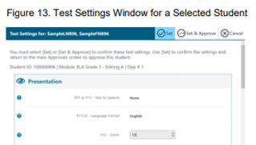

P39 Color overlays
Allowed for: WVGSA, SAT School Day, and ELPA21/Alt-ELPA
Description: Color transparencies (acetate sheets) are placed over assessment items.
Instructional practices: Color transparencies are placed over instructional materials and computer screen(s).
When to select: Students with attention difficulties may need this accommodation to view test content. This accommodation also may be needed by some students with visual impairments or other print disabilities (including learning disabilities). Choice of color should be informed by evidence of those colors that meet the student’s needs.
Notes for implementation:
- The student may need additional time for testing.

P40 Print-on-demand
Allowed for: WVGSA and ELPA/Alt-ELPA
Description: Paper copies of either passages/stimuli and/or items are printed for students. For those students needing a paper copy of a passage or stimulus, permission for the students to request printing must first be set in the WVEIS data system.
Instructional practices: Teacher-provided print materials are used to facilitate learning activities. Photocopies of passages are used instead of textbooks so students can write and/or highlight. Student does not access materials solely using the computer.
When to select: Some students with disabilities may need paper copies of either passages/stimuli and/or items. A very small percentage of students need this accommodation.
The use of this accommodation may result in the student needing additional time to complete the assessment.
Notes for implementation:
- Any printed items must be treated as secure material and shredded after testing.
- Steps to follow security procedures should be monitored at all testing sites.
- This may add to the time needed for testing.

P41 Provide translation glossary
Allowed for: SAT School Day
Description: Translated glossaries are a language support. Translation glossaries must be word-to- word/word-to-sign translations. See SAT School Day (Section VII) of this document and the “notes” section below for approved list.
Instructional practices: Students use a translation glossary at the rear of their text to facilitate transferring knowledge/skills from their primary language to English. Students use bilingual/sign language glossaries to find the meanings of content-specific words (e.g., mathematics, science, history). Glossaries may be in the appendices of their textbooks or instructional materials.
When to select: Students who have limited English language skills can use the translation glossary for specific items. The use of this support may result in the student needing additional overall time to complete the assessment. Refer to English Learners (Section V) of this document.
Notes for implementation:
SAT School Day notes:
- See the list of approved glossaries on the College Board website: https://collegereadiness.collegeboard.org/pdf/sat-sd-college-board-approved-glossaries.pdf.

P42 Noise buffers
Allowed for: WVGSA, SAT School Day, WVASA, and ELPA21/Alt-ELPA
Description: Ear mufflers, white noise, and/or other equipment used to block external sounds.
Instructional practices: Student wears devices to block out auditory stimuli.
When to select: Student (not groups of students) wears equipment to reduce environmental noises. Students may have these testing variations if regularly used in the classroom. Students who use noise buffers will need headphones unless tested individually in a separate setting.
Notes for implementation:
Required Expansion Codes:
  - P42A – Other ______ (Indicate device being used as a noise buffer.)

P43 Streamlined mode for computer-based assessments
Allowed for: WVGSA and Alt-ELPA
Description: Provides a streamlined interface of the test in an alternate, simplified format. The items are presented below the stimuli/passage (rather than side-by-side on the screen); this may entail the student having to scroll up and down the screen to refer to the stimuli/passage.
Instructional practices: Students use altered text that is structured in a more sequential format.
When to select: This accommodation may benefit a small number of students who have specific learning and/or reading disabilities need in which the text must be presented in a more sequential format.
Notes for implementation:
- This accommodation increases scrolling which may be detrimental for students with fine motor difficulties and students struggling with short term mental memory deficits.

P44 Line tracker
Allowed for: WVGSA and ELPA21/Alt-ELPA
Description: Provides a line tracker for students who need assistance in visual tracking and reading.
Instructional practices: Students receive support services for reading support.
When to select: This accommodation may benefit English learners or students with disabilities who have specific learning or reading difficulties

.P46 Human read aloud in a language other than English or ASL
Allowed for: WVGSA (mathematics and science sections only)
Required Accommodation Pairing: This accommodation must be paired with:
T10 Separate setting (one-to-one)
Description: Text is read aloud to the student by a trained and qualified human reader who follows the administration guidelines provided in the Test Administration Manual and the read aloud guidelines. All or portions of the content may be read aloud.
Instructional practices: Students routinely need access to translated materials.
When to select: Students receiving the translations (i.e., embedded translations for Spanish) accommodation and who are struggling readers may need assistance accessing the assessment by having all or portions of the assessment read aloud. This accommodation also may be needed by students with reading-related disabilities.
Notes for implementation:
- If not used regularly during instruction, this accommodation is likely to be confusing and may impede the performance on assessments.
- A student should have the option of asking a reader to slow down or repeat text.
- The use of this accommodation may result in the student needing additional overall time to complete the assessment and/or the use of a separate setting.

P47 Alternate form – visual impairment
Allowed for: WVASA only
Description: This option is used for some specific items and alternate forms are not provided at every essential element and linkage level.
Notes for implementation:
- This is not the accommodation to order a paper-form of the DLM.
- This accommodation allows for some flexibility on the teacher’s part when having to “Say” or “Show” something to a student who has hearing loss and/or blind/low vision.
- The DLM Test Administration Manual provides the questions and options for the students’ First Contact Survey under the vision tab.
- The Test Administration Manual also mentions how to address sensory modality modes and accessing the testlets.

P49 Amplification system (retired 2026)

P50 Test presented through sign language, locally provided, including ELA reading passages
Allowed for: WVGSA, SAT School Day, WVASA, and ELPA21/Alt-ELPA
Required Accommodation Pairing: This accommodation must be paired with:
T03 Extra breaks for the SAT School Day and
T10 Separate Setting (One-to-one) for the SAT School Day and
T17 50% Extended time – Whole Test for the SAT School Day
Description: For WVGSA a trained examiner will present directions, stimulus material, questions, and answer choices in ASL or Signed Exact English (SEE). For SAT School Day, test passages, questions, and response choice presentations must be only in SEE.
Instructional practices: For students who have a hearing loss and use sign language as the primary mode of communication.
When to select: For students who have a hearing loss and use sign language as the primary mode of communication.
Notes for implementation:
- Locally provided interpreters, certified in accordance with Policy 5202 are allowed – in lieu of the ASL videos (WVGSA has ASL videos) when IEP documentation indicates ASL is not the student’s primary language or for EL students.
- Educational sign language interpreters must not clarify, elaborate, paraphrase, or aid with the meaning of words, intent of test questions, or responses to test items.
- A student’s teacher should not serve as the interpreter/translator in a testing situation unless a second person is present to monitor for quality and fairness.
SAT School Day notes:
- Presentation must be in Signed Exact English.
- For SAT School Day, if only test directions (the only listening section of SAT School Day) need to be signed, see accommodation code P16.
- Interpreters must meet testing staff requirements.
- Educational sign language interpreters must not clarify, elaborate, paraphrase, or help with the meaning of words, intent of test questions, or responses to test items.

P51 Math-only, Text-to-speech
Allowed for: SAT School Day only
Description: Text is read aloud to the student via embedded text-to-speech technology or using assistive technology. The student can control the speed as well as raise or lower the volume of the voice via volume control. Blue tooth connected headphones are not permitted on any state assessment. Cochlear implants and blue tooth hearing aids are exempt from this policy.
Instructional practices: Text is read aloud to the student via embedded text-to-speech technology. When to select: For students who may need assistance accessing the assessment by having the assessment read aloud, excluding ELA reading passages. This accommodation may be needed by students with reading-related or visional impairment disabilities. This option may also be appropriate for EL students.
Notes for implementation:
- Educational teams are instructed to not select both P13 and P51. The team should select the accommodation with which the student is most familiar, and documentation supports the use of during an assessment. If not used regularly during instruction, this accommodation is likely to be confusing and may impede the performance on assessments.
  - Students who use text-to-speech will need headphones unless tested individually in a separate setting.

P52 Math only, Human Read-Aloud
Allowed for: SAT School Day only
Required Accommodation Pairing: This accommodation must be paired with:
T10 Separate setting (one-to-one) for the SAT School Day and
T19 Extended Time +50% Math Section Only for the SAT School Day, Or
T22 Extended Time +100% Math Section only
Description: Text is read aloud to the student by a trained and qualified human reader. The trained examiner reads aloud directions, mathematics stimulus material, questions, and answer choices. This accommodation is limited to the mathematics section of the assessment.
Instructional practices: Text is read aloud to the student via a human reader. A teacher or assistant reads aloud mathematics materials and instructions on a regular basis.
When to select: For students who may need assistance accessing the mathematics section of the assessment by having mathematics content read aloud. This accommodation may be needed by students with reading-related or visual impairment disabilities. This option may also be appropriate for EL students.
Notes for implementation:
- Educational teams are instructed to not select both P14 and P52. The team should select the accommodation with which the student is most familiar, and documentation supports the use of during an assessment.
- If not used regularly during instruction, this accommodation is likely to be confusing and may impede performance on assessments.
- As this accommodation involves a human reader, the student must be tested individually in a one-to-one setting (T10).
- A student should have the option of asking the reader to slow down or repeat text.
- Test readers must be familiar with the terminology, notation, and symbols used in mathematics.
- Readers must NOT clarify, elaborate, or answer questions about test items or provide clues that could influence student responses.

Response

Response accommodations allow students to complete assignments, tests, and activities in different ways or to solve or organize problems using some type of assistive device or organizer. Response accommodations can benefit students with physical, sensory, or learning disabilities, including difficulties with memory, sequencing, directionality, alignment, and organization.

R03 Braille writer or tactile to respond
Allowed for: WVGSA and SAT School Day
Required Accommodation Pairing: This accommodation must be paired with:
R04 Scribe for the SAT School Day and WVGSA
R11 Assistive Technology – alternate response options for the SAT School Day
Description: For this response mode, a student uses a brailler, which is a braille keyboard used for typing braille that can then be printed in standard print or braille (embosser). The brailler is similar to a typewriter or computer keyboard. Paper is inserted into the brailler, and multiple keys are pressed at once, creating braille dots with each press.
Instructional practices: Student uses a braille note taker to record notes and create documents.
When to select: This accommodation is for students who are blind or have low vision who respond in braille.
Notes for implementation:
- See detailed instructions for scribing and transcribing student responses in Appendix E: Guidelines for Scribing and Transcribing Student Responses.
- Required Expansion Codes:
  - R03A – Perkins Embosser
  - R03B – ViewPlus Embosser
  - R03C – PixBlaster Embosser
  - R03D – Other ______
WVGSA notes:
- A trained examiner transcribes the student’s responses directly into the testing website using the student’s username, and password; or
- A trained examiner acts as a scribe to transcribe student responses from a paper-based book to the Response Entry system.
SAT School Day notes:
- A manual braille writer may be used for all sections.
- Use of braille writer or electronic braille writer for reading and writing with the following tools disabled: spell check, thesaurus, grammar check.
- Electronic braille writers must be connected to a monitor, so the proctor can observe what student is entering.
- Student responses must be transcribed to the student’s answer sheet. Return the braille pages with the transcribed answer sheet.

R04 Scribe – including WVGSA ELA essay
Allowed for: WVGSA, SAT School Day, WVASA, and ELPA21
Required Accommodation Pairing: This accommodation must be paired with:
T03 Extra breaks for the SAT School Day
T10 Separate setting, 1:1 for WVGSA, SAT School Day, and ELPA21 assessments
T17 50% Extended time – Whole Test for the SAT School Day or
T20 100% Extended time – Whole Test for the SAT School Day
Description: Students dictate their responses to a human who records verbatim what they dictate. The scribe must be trained, qualified, and must follow the administration guidelines provided in the administration manual.
Instructional practices: Students use a tape recorder or scribe as an alternative to writing when a processing or physical challenge is present. Student’s word-for-word response for tests and/or assignments are recorded.
When to select: Students who have documented significant motor or processing difficulties, or who have had a recent injury (such as a broken hand or arm) that makes it difficult to produce responses may need to dictate their responses to a human, who then records the students’ responses verbatim. For many students dictating to a human scribe is the only way to demonstrate their composition skills. It is important for these students to be able to develop planning notes via the human scribe, and to view what they produce while composing via dictation to the scribe.

Scribes may be provided for any student (with or without an IEP or Section 504 plan) who has a short-term medical condition (e.g., a fractured arm in a cast) that precludes the student from word processing a response. Approval needs to be obtained from the WVDE through the county test coordinator and/or the county special education director prior to testing using the Temporary Medical Condition Form. (Appendix K: Request for Accommodations for Temporary Medical Conditions)

Scribes may be provided for students who are blind or have low vision that may need additional supports such as navigational and transcribing supports.
Notes for implementation:
- See guidelines for scribing in Appendix E: Guidelines for Scribing and Transcribing Student Responses
- The use of this accommodation may result in the student needing additional time overall to complete the assessment.
- Scribes should be monitored to ensure students’ verbatim responses are recorded.
- On the day of testing, before testing begins, the principal/school coordinator should give the scribe no more than 2 hours to become familiar with the directions and format of the test. Scribes should be familiar with the test, so they can easily record student answers (Thompson, Thurlow, & Walz, 2000).
- To the extent possible, the same scribe should have responsibility for transcribing information given by students during educational instruction and assessments.
- Scratch (lined or unlined paper) paper, rough drafts, and login information must be collected immediately at the end of the testing session. These items are considered secure material and must be collected and shredded according to procedures established by the principal/school level coordinator (SC) at the end of the testing session.
- At the completion of the assessment, the scribe must complete and submit Appendix L: West Virginia Assessment Scribe/Interpreter/Translator Verification form.
WVGSA notes:
- Following administration of the assessment, if the student’s responses were recorded in a paper answer book, the scribe must enter the responses into the Response Entry system immediately.
- Failure to complete this process will result in the student not receiving scores and not counting in the school’s participation rate.
….See more next page
SAT School Day notes:
- Student responds orally and the trained examiner captures the student responses.
- In the SAT School Day test platform, Bluebook, the student automatically receives “time and one-half” (T17) and Extra Breaks (T03). If student needs “double time” +100% time, use code T20.
- Students MUST use the entire time for which they are approved. They cannot move to the next section or end the assessment when they are finished, even if they are the only student testing.
- Appendix E: Guidelines for Scribing and Transcribing Student Responses should be read carefully to gain an understanding of how scribing can and cannot be used. The WVDE scribing protocol applies.
- A student using this accommodation must be tested in a separate setting (T10) to avoid interruption while testing and to avoid examinees being able to hear or see other students’ responses.
- Scribes should be monitored to ensure students’ verbatim responses are recorded.
- To the extent possible, the same scribe should have responsibility for transcribing information given by students during educational instruction and assessments.
- At the completion of the assessment, the scribe must complete and submit Appendix L: West Virginia Assessment Scribe/Interpreter/Translator Verification form.
- For students using a paper-based assessment, the scribe will enter Bluebook as the student, select “linear version” and then transcribe the student responses into the platform. Failure to complete this process will result in the student not receiving scores and not counting in the school’s participation rate.
WVASA notes
- If a teacher typically scribes/transcribes for a student, this accommodation needs to be selected in the IEP plus entered in the Personal Needs Profile/First contact Survey in Educator Portal so that the appropriate features will be available when completing the testlets.

R05 Abacus
Allowed for: WVGSA, SAT School Day, and WVASA
Description: This tool may be used in place of scratch (lined or unlined paper) paper for students who typically use an abacus.
Instructional practices: Students use items to count during their instruction. Counting devices (blocks, tiles, chips, etc.) or scratch (lined or unlined paper) paper are utilized to assist the student with mathematical concepts.
When to select: Some students with visual impairments who typically use an abacus may use an abacus in place of using scratch (lined or unlined paper) paper.
Notes for implementation:
- The abacus should be one the student uses during instruction on a regular basis.

R11 Assistive technology - alternate response options
Allowed for: WVGSA, SAT School Day, WVASA, and ELPA21
Description: Alternate response options include but are not limited to computer-connected braille writers, keyboards, adapted large keyboards, Sticky Keys, Mouse Keys, Filter Keys, adapted mouse, touch screen, head wand, and switches. Students may use a computer, typewriter, or other assistive technology device to respond.
Instructional practices: Students dictate responses to a teacher or an instructional assistant who records them. Students use communication boards, picture representations, or other individual expressive communication devices and assistive technologies.
When to select: Students with some physical disabilities (including both fine motor and gross motor skills) may need to use the alternate response options accommodation. Some alternate response options are external devices that must be plugged in and be compatible with the assessment delivery platform. Students who have physical limitations sometimes use alternate response options, assistive technologies, or devices during routine instruction.
….See more next page

Notes for implementation:
- Required Expansion Codes:
  - R11A – Other ______ (Indicate response device being used.)
WVGSA notes:
- Do not select this code just because the student has a read aloud (i.e., P01 or P13…etc.) accommodation code without other ALTERNATE RESPONSE DEVICE needs. This code is for the response supports only and read aloud supports are a presentation support.
- Refer to test administration and the assistive technology manuals for additional guidance.
- Administration via tablet – Students can take the assessment via a tablet. Consider the fine motor skills of student prior to using tablet.
- Adaptive equipment used by student – While educators can test devices beforehand, it is not guaranteed all devices are compatible for all testing platforms (e.g., keyboard, mouse, touchpads, switches).
WVASA notes
- Do not select this code just because the student has a read aloud (i.e., P01 or P13…etc.) accommodation code without other ALTERNATE RESPONSE DEVICE needs. This code is for the response supports only and read aloud supports are a presentation support.
- Single-switch system – Single switch scanning is activated using a switch set up to emulate the “Enter” key on the keyboard. In PNP, educators can set scan speed, indicate whether scanning should begin automatically when the page appears, and select the number of times the scan cycle repeats before stopping.
- Two-switch system – Two-switch scanning does not require any activation in PNP. The system automatically supports two-switch step scanning, with one-switch set up to emulate the “Tab” key to move between choices, and the other switch set up to emulate the “Enter” key to select the choice when highlighted.
SAT School Day notes:
- Do not select this code just because the student has a read aloud (i.e., P01 or P13…etc.) accommodation code without other ALTERNATE RESPONSE DEVICE needs. This code is for the response supports only and read aloud supports are a presentation support.
- Use of augmentative/alternate communication devices (e.g., Pocket Go-Talk 5-Level Communication Device, Roloquo2Go…)
- Use of computers with alternative access for an alternative response mode (e.g., braille writers – i.e. Orbit Writer, switches, alternative keyboards, eye-gaze motion sensors, voice recognition software, head or mouth pointed, specialized trackballs, or mice)
- For use of a speech-to-text word processor for responses to reading and writing, see accommodation code R21 Permissive mode for secure browsers which permit third party software (e.g. Dragon suite software) STT access to the test.

R15 Bilingual word-to word glossary
Allowed for: WVGSA and SAT School Day. (For SAT School Day, translation glossaries must be word-to-word/word-to-sign translations, not dictionaries. See College Board-Approved Word-to-Word Glossaries for approved list of glossaries.)
Description: A bilingual/dual language word-to-word glossary is a language support.
Instructional practices: Students use electronic or paper bilingual/dual-language dictionaries to look up word meanings during instruction.
When to select: For students whose primary language is not English and who use dual language supports in the classroom, use of a bilingual/dual language word-to-word dictionary may be appropriate. Students participate in the assessment regardless of the language. The use of this accommodation may result in the student needing additional overall time to complete the assessment.
Notes for implementation:
- For SAT School Day, translation glossaries must be word-to-word/word-to-sign translations. See SAT School Day Section VII of this document. See also the list of approved glossaries on the College Board website: https://collegereadiness.collegeboard.org/pdf/sat-sd-college-board-approved- glossaries.pdf
- For WVGSA, students may use the glossaries they utilize in their classroom. A bilingual/dual language word-to-word glossary can be provided for the full-write portion of an ELA assessment for the WVGSA.

R19 Calculator – tactile/talking calculator
Allowed for: WVGSA (Grades 6-8 only, mathematics and science) and SAT School Day (See SAT School Day notes below)
- WVGSA this accommodation is for students needing a special calculator in Grades 6-8
only, e.g., tactile or talking.
Description:
- For WVGSA (Grades 6-8 only), for use during the calculator-allowed portion of the mathematics test, a non-embedded calculator for students requiring a special calculator (tactile or talking) currently unavailable within the assessment platform.
- For SAT School Day, this may be a special calculator (tactile or talking) for use during the mathematics test.
Instructional practices: Grades 6 and above students use a calculator offered with assistive technology devices (such as a talking calculator or a tactile calculator). Calculators can be used to do basic calculation in multi-step mathematics processes where the construct does not assess mathematical fluency.
When to select: Students with visual impairments who are unable to use the embedded calculator for calculator-allowed items will be able to use the calculator they typically use, such as a braille calculator or a talking calculator. Test administrators should ensure the calculator is available only for designated calculator items.
Notes for implementation:
- This accommodation is not allowed for Grades 3-5. For WVGSA additional information on calculators, refer to the General Summative Assessment Section of this document.
- Required expansion codes:
- R19A – Orion TI-84 Plus Talking Graphing Calculator
- R19B – Other _______ (Indicate model of calculator)
SAT School Day notes:
- For students with visual impairments who require a special calculator (tactile or talking) for calculator-allowed items will be able to use the calculator they typically use, such as a braille calculator or a talking calculator.

R20 Multiplication table
Allowed for: WVGSA (mathematics Grades 4-8 only) and SAT School Day
Description: A single digit (1-9) multiplication table available for reference. This accommodation is allowed for Grade 4 and above mathematics items.
Instructional practices: Students use a multiplication table (often it is stickers on their desks) during regular instruction and assessments.
When to select: For students with a documented and persistent calculation disability (i.e., dyscalculia).
Notes for implementation:
- This accommodation is not permitted for third grade.
WVGSA notes:
  - Cambium’s secure browser provides an embedded multiplication table for those students in grades 4-8 who have this accommodation.
  - A paper copy can be located in the Cambium portal for the WVGSA.
SAT School Day notes:
    - College Board has a paper copy in their resources.

R21 Permissive mode for secure browser
Allowed for: WVGSA, SAT School Day, and ELPA21/Alt-ELPA
Description: Permissive mode is an accessibility support option that allows students to use accessibility software while using the secure browser.
Instructional practices: This support permits a student’s specific accessibility software through the secure browser environment. Examples may include third-party speech-to-text programs such as the Dragon suite.
When to select: This is an accommodation for students who have motor or processing disabilities which make traditional methods of accessing instructional and assessment materials difficult.
Notes for implementation:
Students need to be proficient in using the software instructionally.
- Required expansion codes:
    - R21A –– Dragon series for speech-to-text
  - R21B – Other ______
WVGSA notes:
- The Embedded Speech-to-text (R31) accommodation has been created for this support. If the student was using R21 to access the embedded speech-to-text support only for the WVGSA, please remove R21 and add R31 to their accommodation plan.
- For non-embedded speech-to-text, the only speech-to-text third party software Cambium supports is the Dragon series for Windows OS. R21 Permissive mode for secure browser is still the appropriate accommodation for students needing the Secure Browser to permit access to the Dragon software.

R23 100s number table
Allowed for: WVGSA (mathematics Grades 4-8 only) and SAT School Day
Description: A table listing numbers from 1–100 available for reference. This accommodation is allowed for Grade 4 and above mathematics items.
Instructional practices: Students who need graphic organizers or manipulatives for visual processing to complete mathematics tasks.
When to select: Students with visual processing or spatial perception needs may find this beneficial, as documented in their IEP or 504 plan.
Notes for implementation:
- The table can be printed from the Cambium portal for students requiring this accommodation. Use of any other 100s number tables is prohibited.
- This accommodation is not permitted for third grade.
WVGSA notes:
  - Cambium’s secure browser offers an embedded 100s number table for those students in grades 4-8 who have this accommodation.
  - A paper copy can be located in the Cambium portal for the WVGSA.

R24 Calculator – 4 function calculator
Allowed for: WVASA and NAEP
Description: A four-function calculator (square root and percentage keys are acceptable) for the non- calculator portion of the mathematics test.
Notes for implementation:
- For students needing a calculator on the non-calculator portion of the mathematics test.
- The only calculator approved for use during the non-calculator portion of the mathematics test is a four-function calculator (percentage key and square root key are acceptable).
WVASA notes:
- Follow instructions on testlet TIPs pages for when a calculator is permitted for each portion of the math assessment.

R25 Word processor use
Allowed for: (see Notes for implementation)
Description: Use of a word processing program to create responses for essay questions and prompts.
Instructional practices: Students needing accommodations for answering writing prompts due to physical constraints or dysgraphia.
Notes for implementation:
SAT School Day notes:
- Test administrators should ensure the word processing program and computer have disabled any special word processing features, applications, or software (spell checker, dictionary, etc.).
- Must be paired with either T17 (“time and one-half” +50% time reading) or T20 (“double time” +100% time reading)
- Computer must: 1) be connected to a working printer and 2) not be connected to the internet.
- The SAT School Day administered in West Virginia does not have a separate essay section – however, this accommodation is still available for AP tests.

R26 Listening domain exemption
Allowed for: ELPA21 and Alt-ELPA
Description: ELPA21 allows for domain exemptions for student situations that preclude engagement with any of the four language domains.
Instructional practices: A domain exemption is only appropriate when the student cannot access part of the assessment, which is different than the potential to not score well on it. A Listening Domain exemption may be necessary when the student has a hearing loss and cannot access the listening test even with appropriate accommodations or devices.
Notes for implementation:
- Students must have a documented disability or impairment in an IEP or 504 plan applicable to the domain.
- Students are recommended to use the practice tests, if appropriate, to determine if an exemption is appropriate.
- Students are expected to take the remaining sections of the test.
- Exemptions from all domains (the entire assessment) are not allowed.

R27 Reading domain exemption
Allowed for: ELPA21 and Alt-ELPA
Description: ELPA21 allows for domain exemptions for student situations that preclude engagement with any of the four language domains.
Instructional practices: A domain exemption is only appropriate when the student cannot access part of the assessment, which is different than the potential to not score well on it. A Reading Domain exemption may be necessary when the student is unable to access the reading portions of the assessment even with appropriate accommodations.
Notes for implementation:
- Students must have a documented disability or impairment in an IEP or 504 plan applicable to the domain.
- Students are recommended to use the practice tests, if appropriate, to determine if an exemption is appropriate.
- Students are expected to take the remaining sections of the test.
- Exemptions from all domains (the entire assessment) are not allowed.

R28 Speaking domain exemption
Allowed for: ELPA21 and Alt-ELPA
Description: ELPA21 allows for domain exemptions for student situations that preclude engagement with any of the four language domains.
Instructional practices: A domain exemption is only appropriate when the student cannot access part of the assessment, which is different than the potential to not score well on it. A Speaking Domain exemption may be necessary when the non-verbal student who, because of the identified disability and the absence of appropriate accommodations, cannot engage with the speaking portion of the assessment.
Notes for implementation:
- Students must have a documented disability or impairment in an IEP or 504 plan applicable to the domain.
- Students are recommended to use the practice tests, if appropriate, to determine if an exemption is appropriate.
- This domain exemption is only for students with zero communication systems. AAC devices are acceptable and if the student utilizes one during class, is expected to be used during the assessment.
- Students are expected to take the remaining sections of the test.
- Exemptions from all domains (the entire assessment) are not allowed.

R29 Writing domain exemption
Allowed for: ELPA21 and Alt-ELPA
Description: ELPA21 allows for domain exemptions for student situations that preclude engagement with any of the four language domains.
Instructional practices: A domain exemption is only appropriate when the student cannot access part of the assessment, which is different than the potential to not score well on it. A Writing Domain exemption may be necessary when the student is unable to access this portion of the assessment even with appropriate accommodations.
Notes for implementation:
- Students must have a documented disability or impairment in an IEP or 504 plan applicable to the domain.
- Students are recommended to use the practice tests, if appropriate, to determine if an exemption is appropriate.
- Students are expected to take the remaining sections of the test.
- Exemptions from all domains (the entire assessment) are not allowed.

R30 Familiar listener
Allowed for: ELPA21
Description: A very small percentage of students have disabilities such that their recorded speech for the Speaking Domain may be scored down or not scorable due to their impediment. For this very small percentage of students, ELPA21 allows an accommodation for a person who will act as a scribe only for those speaking items. The student’s speech is transcribed by the familiar listener with their speaking and sent to the scoring vendor to be re-scored.
Notes for implementation:
- There will only be a very small percentage of students who will need accommodation when participating in the Speaking domain test using normal testing conditions.
- Those students may require the R30 accommodation of a paraprofessional scribe who is a "familiar listener." A "familiar listener" is someone who knows the student and their speech patterns. That familiarity can make it easier for them to understand the students’ speech. "Familiar listeners" would include the current or past classroom teachers or paraprofessionals, speech-language pathologists or the EL teachers.
- The student's current EL teacher and speech-language pathologist should collaborate regarding who needs the R30 Familiar Listener accommodation.
- There are several subjective rating scales available for rating speech intelligibility; however, there are no known norms available for determining a cutoff score for intelligible versus unintelligible speech (American Speech and Hearing Association (ASHA) Practice Portal). Children above the age of four with intelligibility percentages below 66 percent may be considered "at-risk" (Gordon-Brannon & Hodson, 2000).
- For English learning students whose speech may be too unintelligible for the computer to score their Speaking domain test, the EL teacher and the speech-language pathologist should collaborate on determining students who may be candidates for the R30 Familiar Listener Accommodation.

R31 Embedded speech-to-text
Allowed for: WVGSA (essay section only) and SAT School Day
Required Accommodation Pairing: This accommodation must be paired with:
R11 Assistive Technology – alternate response options for SAT School Day and WVGSA and
T10 Separate setting, one-to-one for SAT School Day and WVGSA and
T17 50% Extended time, Whole test for SAT School Day only
Description: Streaming speech-to-text applications are designed for real-time recognition purposes, such as capturing live audio from a microphone. Streaming recognition provides interim results while audio is being captured, allowing results to appear, for example, while a user is still speaking (Google, 2021). Blue tooth connected microphones are not permitted on any state assessment. Cochlear implants and blue tooth hearing aids are exempt from this policy.
Instructional practices: Students who have motor or processing disabilities (such as dyslexia) or who have had a recent injury (such as a broken hand or arm) that make it difficult to produce text or commands using computer keys may need alternative ways to work with computers.
Notes for implementation:
- Students will need to be familiar with this feature and have had many opportunities to use it prior to testing. Schools are strongly encouraged to utilize the suite of interim assessments provided by the WVGSA vendor prior to the summative assessment window to familiarize themselves with all aspects of this resource. Students also have access to full-length practice SAT School Day exams.
- Speech-to-text software requires that the student go back through all generated text to correct errors in transcription, including use of writing conventions; thus, prior experience with this accommodation is essential.
- If the student requires the use of a human scribe, consider reviewing the accommodation R04 Scribe.
WVGSA note:
- R31 is available only for the essay portion of the assessment.
SAT School Day notes:

https://Bluebook.collegeboard.org/students/accommodations-and-assistive-technology/speech-to-text
- This link provides instructions for accessing voice recognition or speech-to-text which transcribes a student’s spoken response into the digital test platform. College Board supports Apple Voice Control, Chromebook Dictation, and Windows Voice Recognition/Dictation.

R32 Personal health management monitoring devices

Allowed for: WVGSA, SAT School Day, ELPA21/Alt-ELPA, and WVASA
Required Accommodation Pairing: This accommodation must be paired with:
T16 Breaks as needed for SAT School Day
Description: Personal health management monitoring devices include, but not limited to, blue tooth enabled devices such as blood glucose and seizure monitoring items with apps which stream information to other devices and people.
Instructional practices: Students who have documented medical conditions requiring the use of monitoring devices and for these devices to remain in the room.
Notes for implementation:
- Students with these devices typically have an Individualized Health Care Plan (IHP) which is monitored and updated by the school nurse.
- The reporting devices (e.g., cell phone, tablet, smart watch) must be under the direct control and supervision of the test administrator/proctor. The student may be seated next to the proctor’s desk to remain in functional proximity to the device.
- The monitoring device (e.g., blood glucose monitor, Nerivio, Embrace) which must remain in continual contact with the student for functionality will stay with the student to be used as directed by a medical professional.
- If questions arise about a new device (either new to market or just new to a student), please contact the County Test Coordinator for additional guidance.
  - Required expansion codes:

R32A – Blood Glucose Monitoring device and cell phone app (i.e., Omnipod or Freestyle Libre with paired smart devices)

R32B – Seizure monitoring and alert device/cell phone app (i.e., Embrace or Bay Alert Medical SOS Smartwatch)

R32C – Migraine monitoring and alert device/cell phone app (i.e., Nerivio with paired smart devices)

R32D – Other ____________ (If the student has an electronic health monitoring device not otherwise specified with an expanded code option, select R32d and indicate the name of the device and app used for monitoring.)
WVGSA/ELPA21/Alt-ELPA/WVASA note:
  - If the student does not have an IEP or 504 which references a device, the Request for Non-standard Accommodation process must be completed. See Appendix Q: Non-Standard Accommodation(s) Requests in this document for assistance in requesting approval for specific devices. This process is not necessary if the IEP/504 references the device and lists this accommodation.
SAT School Day notes:
  - If the student does not have an IEP or 504 which references a device, the Request for Non-standard Accommodation process must be completed. See Appendix Q: Non-Standard Accommodation(s) Requests in this document for assistance in requesting approval for specific devices. This process is not necessary if the IEP/504 references the device and lists this accommodation.

R34 Printed test book
Allowed for: WVGSA, SAT School Day, ELPA21/Alt-ELPA, and WVASA
Required Accommodation Pairing: This accommodation must be paired with:
R04 Scribe for SAT School Day, WVGSA, ELPA21/Alt-ELPA, and WVASA
(If the scribe is needed for more than the transcription process (e.g., copying student responses onto the test platform), if they are scribing the student responses directly into the test booklet as the student is saying them, the IEP team must also add T10 Separate Setting (one-to-one).)
Description: For students who cannot access computer-based assessments due to religious restrictions, health or disability concerns, paper (fixed-form) assessments can be requested for state summative assessments.
- For all tests: The school must immediately notify the County Test Coordinator of the needs of this student to order materials according to the published deadlines for each assessment.
Instructional practices: Students who have documented religious restrictions, health or disability concerns prohibiting their participation in a computer-based assessment.
WVGSA/ELPA21/Alt-ELPA notes:
- County test coordinators are responsible for ordering (R34) paper-based books for the WVGSA Grades 3-8 and ELPA21/Alt-ELPA by contacting the WVDE Office of Assessment.
- Paper test books will be printed in 12-point font size in Fira Sans.
  - Teams for students with needs other than the default settings must contact the County Test Coordinator with details.
- Ordering pre-printed test books is not available for Interim assessments. Interim assessments are available as printable .pdf through the TDS platform.
- TIDE must be set to “Yes/large print paper” by the WVDE assessment office to activate the Response Entry system for the scribe to transcribe student responses.
- Following student dismissal from the room, test administrators must transcribe the student answers into the Response Entry system using the student’s log in credentials.
- Failure to transcribe student responses will result in the student not receiving a score report and the student not counting in the assessment participation rate for the school.
SAT School Day notes:
- County test coordinators are responsible for ordering (R34) paper-based books for the SAT School Day by contacting the WVDE Office of Assessment.
- Following student dismissal from the testing room, proctors must transcribe the student answers into Bluebook using the student’s ticket information.
- See also the SAT School Day Paper Testing Guide for additional directions.
- Failure to transcribe student responses will result in the student not receiving a score report and the student not counting in the assessment participation rate for the school.
DLM notes:
- County test coordinators are responsible for ordering (R34) paper-based books for the DLM by contacting the WVDE Office of Assessment.
- If the IEP team is considering this option for a student eligible to participate in the DLM, please speak with the County Test Coordinator prior to the IEP meeting.
- Deadlines for ordering paper-based books for the DLM are typically in late-January.
- Failure to transcribe student responses will result in the student not receiving a score report and the student not counting in the assessment participation rate for the school.

Setting and Time
Setting and time accommodations allow students to complete assignments, tests, and activities in different settings, with extended time, or with longer/additional breaks. Setting and time accommodations can benefit students with concentration difficulties or who are easily frustrated.

T03 Extra breaks (no studying)
Allowed for: WVGSA, SAT School Day, and ELPA21
Required Accommodation Pairing: This accommodation must be paired with:
T09 Separate setting (small group) for SAT School Day if other students will have identical breaks, or
T10 Separate Setting (one-to-one) for SAT School Day
Description: Students will have additional breaks at predetermined intervals.
Instructional practice: Students are provided with frequent breaks during instructional activities and for tests to assist with concentration.
When to select: Students who cannot concentrate continuously for an extended period or who become frustrated or stressed easily may need additional relaxation breaks.
Notes for implementation:
- These students may need to be assigned to a different location to prevent distractions.
- Students are not allowed to study for tests and must be monitored during breaks.
- The WVASA and Alt-ELPA are administered in a manner that is permissive to granting extra breaks to address student needs as a universal tool/requirement. It is not necessary to select this for the WVASA or Alt-ELPA.
SAT School Day notes:
- Extra breaks – “off testing time clock”
- Students are provided with an additional break between each test section, and a break in the middle of longer sections of the test.
- Students are not allowed to study for tests and must be monitored during breaks.

T07 Flexible scheduling (no studying) – delayed start
Allowed for: WVGSA, SAT School Day, and ELPA21
Required Accommodation Pairing: This accommodation must be paired with:
T09 Separate Setting (small group) for SAT School Day, only if all students are starting at the same delayed time with the same, or no additional, accommodations, or
T10 Separate Setting (one-to-one) for SAT School Day
Description: Students can have a later start in the day. Administration of the assessment at a time most beneficial to the student.
Instructional practice: Students who have a schedule that allows them to select the most appropriate time for concentration.
When to select: Scheduling changes can be helpful for students on medications that affect their ability to stay alert or who have more productive times of the day. For example, for students who have difficulty concentrating or staying on task as the day progresses, it may help to schedule tests that require the greatest concentration in the morning.
Restrictions: Test sections must be completed within the confines of the regular testing day. Students may not study for tests they have already started and must be monitored during breaks.
Notes for implementation:
- The WVASA and Alt-ELPA are administered in a manner that is flexible to the student needs as a universal tool/requirement. It is not necessary to select this for the WVASA or Alt-ELPA.

…See more next page
SAT School Day notes:
- Students can have a later start in the day for SAT School Day administration.
- Students must complete the SAT School Day following the standard timing sequence (assuming they do not have extended time accommodations) but may begin later than the general population of students.
- Delayed start testing sessions must begin in time to allow the student to follow the timing sequence as set by College Board. Typically, delayed starts beginning no later than 10:30 a.m.

T09 Separate setting (small group)
Allowed for: WVGSA, SAT School Day, and ELPA21
Description: Test setting is altered so the student is tested in a small group. The test administrator must be one who qualifies under Policy 2340.
Instructional practice: Students who need smaller groups for instructional or assessment purposes are ones who may easily become distracted when in larger group settings. These students may benefit from an environment with fewer other students.
When to select: When the student benefits from a small group assessment environment.
Notes for implementation:
- Teams are instructed to not select both T10 and T09. Teams should select the accommodation which best provides the student with the appropriate support.
- Changes in instructional and assessment locations can benefit students who are easily distracted in large group settings and who concentrate best in a small group setting.
- Students with physical disabilities might need a more accessible location, specific room conditions, or special equipment.
- Students must be monitored during the entire testing period.
- Testing locations must be private and free of distractions.
- These requirements apply to students tested in all locations, whether the student is assessed in the school building, at home, in a hospital, or a residential or other alternative setting.

T10 Separate setting (one-to-one)
Allowed for: WVGSA, SAT School Day, and ELPA21
Description: Test setting is altered so the student is tested on a one-to-one basis. The test administrator must be one who qualifies under Policy 2340.
Instructional practice: Students who need one-to-one settings for instructional or assessment purposes are ones who may easily become distracted when in larger group settings. These students benefit from an environment with no other students.
When to select: When the student benefits from a one-to-one assessment environment.
Notes for implementation:
- Teams are instructed to not select both T10 and T09. Teams should select the accommodation which best provides the student with the appropriate support.
- The WVASA and Alt-ELPA are administered in a one-to-one setting as a universal tool/requirement. It is not necessary to select this for the WVASA or Alt-ELPA.
- Changes in instructional and assessment locations can benefit students who are easily distracted in large group settings and who concentrate best in a one-to-one setting.
- Changes in location also benefit students who receive accommodations (e.g., reader, scribe, or frequent breaks) that might distract other students.
- Students with physical disabilities might need a more accessible location, specific room conditions, or special equipment.
- Each student must be monitored during the entire testing period by a trained examiner.
- Testing locations must be private and free of distractions.
- These requirements apply to students tested in all locations, whether the student is assessed in the school building, at home, in a hospital, or a residential or other alternative setting.

T11 Testing environment modifications
Allowed for: WVGSA, SAT School Day, and ELPA21
Description: Test location/environment is altered so the student is tested in a setting different from that made available for most students.
Instructional practice: Special environment/setting arrangements for students are provided within the classroom to support instruction and assessment. Changes in instructional and assessment environments can benefit students who have specific support needs beyond what is available for most students.
When to select: When the student benefits from modification to settings such as use of accommodated seating, special lighting, or furniture. Other modifications may include permission to move, stand or pace during assessment in a manner where others’ work cannot be seen and is not distracting to others. Students with physical disabilities might need a more accessible location, specific room conditions, or special equipment.
Notes for implementation:
- Students must be monitored during the entire testing period by a trained examiner.
- These requirements apply to students tested in all locations, whether the student is assessed in the school building, at home, in a hospital, or a residential or other alternative setting.
- The WVASA and Alt-ELPA are administered in a manner that is flexible to the student needs as a universal tool/requirement. It is not necessary to select this for the WVASA or Alt-ELPA.

T12 Preferential seating
Allowed for: WVGSA, SAT School Day, and ELPA21
Description: Student is given special seating arrangements. Placement of student where they are most comfortable or placement of student near proctor.
Instructional practice: Special seating arrangements for students who are easily distracted are provided within the classroom to improve focus.
When to select: Students who are easily distracted or may have a visual/auditory disability. The preferential seating may be in a specific location (for example, away from windows, doors, or pencil sharpeners, near the teacher’s desk, or in the front of a classroom).
Notes for implementation:
- Changes in instructional and assessment seating locations can benefit students who are easily distracted.
- Students with physical disabilities might need a more accessible location within the testing environment.
- The WVASA and Alt-ELPA are administered in a manner that is flexible to the student needs as a universal tool/requirement. It is not necessary to select this for the WVASA or Alt-ELPA.

T13 Outside of traditional school setting (homebound/hospital or alternate school setting)
Allowed for: WVGSA, WVASA, SAT School Day, and ELPA21/Alt-ELPA
Description: Test location is altered so the student is tested in a setting different from that made available for most students. The assessment may be administered in an alternate education setting with appropriate supervision. In some instances, students may need to interact with instructional or test content outside of school, such as in a hospital or their home.
Instructional practice: Alternative settings for students who receive their instruction at a location other than their home school. This could include an alternate educational school, the hospital, or at home.
When to select: This accommodation is appropriate for when students have been assigned or admitted to alternate educational programs or hospital/homebound care.
Notes for implementation:
  - Required expansion codes:
    - T13A – Home/hospital setting
    - T13B – Other ______ (Indicate location)
SAT School Day notes:
- Request for off-site locations for assessment must be made prior to testing.

T14 Limited timed testing
Allowed for: WVGSA, SAT School Day, and ELPA21
Required Accommodation Pairing: This accommodation must be paired with:
T09 Separate Setting (small group) for SAT School Day if other students will have identical timing, or
T10 Separate Setting (one-to-one) for SAT School Day
Description: Students can take the test broken into shorter timeframes and take over multiple days. Limited time per day testing/multiple day testing.
Instructional practice: Students who have a schedule that allows them to select the most appropriate time for concentration.
When to select: Scheduling changes can be helpful for students on medications that affect their ability to stay alert or who have more productive times of the day.
Notes for implementation:
- Students must complete each section of the test once it starts.
- Decisions about how to schedule must be made on a case-by-case basis for each individual student—not by any category of students, keeping in mind the disability involved.
- The WVASA and Alt-ELPA are administered in a manner that is flexible to the student needs as a universal tool/requirement. It is not necessary to select this for the WVASA or Alt-ELPA.
SAT School Day notes:
- Two-day test administration

T15 Extended breaks
Allowed for: WVGSA, SAT School Day, and ELPA21
Required Accommodation Pairing: This accommodation must be paired with:
T09 Separate Setting (small group) for SAT School Day if other students will have identical timing, or
T10 Separate Setting (one-to-one) for SAT School Day
Description: Students take extended regularly scheduled breaks; “off testing time clock”
Instructional practice: Students are provided with frequent breaks during instructional activities and for tests to assist with concentration.
When to select: Students who cannot concentrate continuously for an extended period or who become frustrated or stressed easily may need frequent or extended relaxation breaks.
…See more next page
Notes for implementation:
- These students may need to be assigned to a different room or location to prevent distractions.
- Students are not allowed to study for tests and must be monitored during breaks.
- The WVASA and Alt-ELPA are administered in a manner that is flexible to the student needs as a universal tool/requirement. It is not necessary to select this for the WVASA or Alt-ELPA.
SAT School Day notes:
- Students are provided with double the time allotted for regularly scheduled breaks.
- Some students may utilize extended breaks to eat, take medication, or test blood sugar.
- Students are not allowed to study for tests and must be monitored during breaks.

T16 Breaks as needed
Allowed for: WVGSA, SAT School Day, and ELPA21
Suggested Accommodation Pairing:
T10 Separate Setting (one-to-one) for SAT School Day
Description: Students can take breaks during a test section. The timing of the test is paused during the break.
Instructional practice: Students are provided with frequent breaks during instructional activities and for tests to assist with concentration.
When to select: Students who cannot concentrate continuously for an extended period or who become frustrated or stressed easily may need frequent or extended relaxation breaks.
Notes for implementation:
- These students may need to be assigned to a different room or location to prevent distractions. Typically given to students with physical or medical conditions.
- Students are provided with breaks as requested.
- Students are not allowed to study for tests and must be monitored during breaks.
- The WVASA and Alt-ELPA are administered in a manner that is flexible to the student needs as a universal tool/requirement. It is not necessary to select this for the WVASA or Alt-ELPA.
SAT School Day notes:
- Students are not allowed to study for tests and must be monitored during breaks.
- Breaks are granted as requested by the student during the exam. The timing of the test is paused during the break. Most students’ needs are met with 10-minute breaks.

T17 Extended time - Time and one-half (+50%) whole test
Allowed for: SAT School Day and other timed tests
Required Accommodation Pairing: This accommodation must be paired with:
T03 Extra breaks for the SAT School Day and
T09 Separate Setting (small group) for SAT School Day
Description: Each section of the SAT School Day is administered using 50% extra time. This accommodation is time and one half—for example, an extension from 1 hour to 1 hour 30 minutes. Instructional practice: Students who need additional testing time on timed assignments and tests. When to select: Timing accommodations are most helpful for students who need more time than generally allowed to complete activities, assignments, and tests. Extra time may be needed to process written text (e.g., a student with a learning disability who processes information slowly), to write (e.g., a student with limited dexterity because of arthritis), or to use other accommodations or equipment (e.g., assistive technology, audio tape, or scribe).
Restrictions: NAEP assessments must be completed within three times the regular time allotted for each section of the test.
…See more next page

Notes for implementation:
SAT School Day notes:
- Extended time +50% Whole Test – when this accommodation (T17) is selected, extended time is automatically provided for all sections (reading, writing and language, and math) of the SAT School Day.
- Decisions about how much extended time is to be provided must be made on a case-by-case basis for each individual student, not by any category of students, keeping in mind the type of accommodations being provided, the disability involved, and the type of test.
- Students will be provided with the entire amount of standard time for the both mathematics and the ELA sections plus 50% extended time. Once the standard time has elapsed for each section and the timer has entered the extended time, the student may end that test session at any point and proceed to the next section or break.

T19 Extended time - Time and one-half (+50%) math section only
Allowed for: SAT School Day and other timed tests
Required Accommodation Pairing: This accommodation must be paired with:
T09 Separate Setting (small group) for SAT School Day
Description: Timed tests require a request for a specific amount of extra time.
Description: The mathematics section of the SAT School Day is administered using 50% extra time. This accommodation is time and one half—for example, an extension from 1 hour 20 minutes to 2 hours 1 minute (additional minute due to rounding).
Instructional practice: Students who need additional testing time on timed assignments and tests. When to select: Timing accommodations are most helpful for students who need more time than generally allowed to complete activities, assignments, and tests. Extra time may be needed to process written text (e.g., a student with a learning disability who processes information slowly), to write (e.g., a student with limited dexterity because of arthritis), or to use other accommodations or equipment (e.g., assistive technology, audio tape, or scribe).
Notes for implementation:
SAT School Day notes:
- Decisions about how much extended time is to be provided must be made on a case-by-case basis for each individual student, not by any category of students, keeping in mind the type of accommodations being provided, the disability involved, and the type of test.
- Students will be provided with the entire amount of standard time for the mathematics sections plus 50% extended time (2 hours and 1 minute). Once the standard time has elapsed for each section and the timer has entered the extended time, the student may end that test session at any point and proceed to the next section or break.

T20 Extended time – Double Time (+100%) – whole test
Allowed for: SAT School Day and other timed tests
Required Accommodation Pairing: This accommodation must be paired with:
T03 Extra breaks for the SAT School Day and
T15 Extended breaks for the SAT School Day and
T09 Separate Setting (small group) for SAT School Day or
T10 Separate Setting (one-to-one) for SAT School Day
Description: Timed tests require a request for a specific amount of extra time.
Description: Each section of the SAT School Day is administered using 100% extra time. This accommodation is double time—for example, an extension from 1 hour test time becomes 2 hours.
Instructional practice: Students who need additional testing time on timed assignments and tests.

…See more next page
When to select: Timing accommodations are most helpful for students who need more time than generally allowed to complete activities, assignments, and tests. Extra time may be needed to process written text (e.g., a student with a learning disability who processes information slowly), to write (e.g., a student with limited dexterity because of arthritis), or to use other accommodations or equipment (e.g., assistive technology, audio tape, or scribe).

SAT School Day notes:
- Extended time – Double Time +100% reading – when this accommodation (T20) is indicated in Test Day Tool Kit, extended time is automatically provided for all sections (reading, writing and language, and math) of the SAT School Day.
- Decisions about how much extended time is to be provided must be made on a case-by-case basis for each individual student, not by any category of students, keeping in mind the type of accommodations being provided, the disability involved, and the type of test.
- Students will be provided with the entire amount of standard time for both the mathematics and the ELA sections plus 100% extended time. Once the standard time has elapsed for each section and the timer has entered the extended time, the student may end that test session at any point and proceed to the next section or break.
- Students with 100% Extended time for the whole test (T20) will automatically be given a “Nutrition Break” between the subject sections in Test Day Tool Kit. This cannot be waived.

T22 Extended time – Double Time (+100%) math section only
Allowed for: SAT School Day and other timed tests
Required Accommodation Pairing: This accommodation must be paired with:
T03 Extra breaks for the SAT School Day and
T09 Separate Setting (small group) for SAT School Day
Description: Timed tests require a request for a specific amount of extra time.
Description: The mathematics section of the SAT School Day is administered using 100% extra time. This accommodation is double time—for example, an extension from (1 hour 20 minutes to 2 hours 40 minutes).
Instructional practice: Students who need additional testing time on timed assignments and tests. When to select: Timing accommodations are most helpful for students who need more time than generally allowed to complete activities, assignments, and tests. Extra time may be needed to process written text (e.g., a student with a learning disability who processes information slowly), to write (e.g., a student with limited dexterity because of arthritis), or to use other accommodations or equipment (e.g., assistive technology, audio tape, or scribe).
Notes for implementation:
SAT School Day notes:
- Extended time – Double Time +100% math only
- Decisions about how much extended time is to be provided must be made on a case-by-case basis for each individual student, not by any category of students, keeping in mind the type of accommodations being provided, the disability involved, and the type of test.
- Students will be provided with the entire amount of standard time for the mathematics sections plus 100% extended time. Once the standard time has elapsed for each section and the timer has entered the extended time, the student may end that test session at any point and proceed to the next section or break.

Section IV.

West Virginia Alternate Summative Assessment
(WVASA)

Section IV. West Virginia Alternate Summative Assessment (WVASA)

When to Choose Alternate Assessment

West Virginia Board of Education Policy 2510 establishes that all students must participate in statewide assessments as part of a comprehensive system of assessment and accountability. For most students, the West Virginia General Summative Assessment (WVGSA) or the SAT School Day is appropriate. Students served under Section 504 plans and English learners without disabilities participate in these general assessments, along with other WV-MAP components.
For students with disabilities eligible under the Individuals with Disabilities Education Improvement Act (IDEA 2004), the Individualized Education Program (IEP) team must determine how the student will participate in statewide assessments. This includes consideration of whether the West Virginia Alternate Summative Assessment (WVASA) is appropriate.
The WVASA is designed for students with the most significant cognitive disabilities whose knowledge and skills cannot be adequately measured through general assessments, even with accommodations. For these students, instruction is based on the West Virginia Alternate Academic Achievement Standards (WVAAAS), which are aligned to grade-level expectations at reduced depth, breadth, and complexity.
The IEP must clearly document the decision for alternate assessment participation. This includes an explanation of why the student cannot participate in the general assessment, even with accommodations, and confirmation that the student will continue to receive instruction in the general curriculum to the greatest extent possible. Students identified for the WVASA are not required to participate in other WV-MAP assessments that do not offer alternate formats; however, they may not be denied the opportunity to participate.
Parents or guardians must be included in all decisions regarding alternate assessment participation. They must be informed that student performance will be measured using alternate academic achievement standards and understand the long-term implications, including the pathway to an alternate diploma. The IEP must reflect that these discussions have occurred and document any accommodations in accordance with MAE.4SA procedures.
Nothing in this guidance should be construed to indicate that students who qualify to participate in the WVASA would prohibit the same students from attempting to satisfy graduation requirements to earn a general diploma. West Virginia’s graduation requirements are outlined in WVBE Policy 2510.

Eligibility criteria for WVASA
The WVASA is intended for students with the most significant cognitive disabilities. These students typically demonstrate substantial limitations in intellectual functioning and adaptive behavior that affect their ability to live independently and function safely in daily life. These impacts extend across academic, social, and functional domains.
Eligibility requires a current IEP, a multidisciplinary evaluation, and evidence from educational performance data supporting the need for alternate assessment. The IEP team must determine that the student is unable to participate in the general assessment system, even with extended learning opportunities and significant instructional supports.
Students who are eligible for the WVASA receive instruction aligned to the West Virginia Alternate Academic Achievement Standards (Policy 2520.16). These standards are derived from the West Virginia College- and Career-Readiness Standards and serve as the basis for both instruction and assessment.
Students who meet these eligibility requirements may also be working toward an alternate diploma. An alternate diploma recognizes achievement based on alternate standards and does not preclude continued education through the school year in which the student turns 21. Participation in graduation ceremonies alongside peers is encouraged when appropriate.
WVASA Participation Criteria
Participation Criterion
- The student has been evaluated and found eligible as a student with a disability under WVBE Policy 2419.
- The student has a significant cognitive disability.
- The student’s significant cognitive disability severely impacts the student’s educational performance and access to the curriculum.

The following are not allowable (or acceptable) considerations for determining participation in the WVASA:
- A disability category or label
- Poor attendance or extended absences
- Social, cultural, or economic difference
- Expected poor performance on the general education assessment
- Academic or other services student receives
- Educational environment, instructional setting, or percent of time receiving special education services
- English Learner (EL) status or native language
- Low reading/math/achievement level
- Anticipated disruptive behavior or emotional distress
- Impact of student scores on the accountability system
- Administrative decision
- Need for accommodations (e.g., assistive technology/Augmentative and Alternative Communication [AAC]) to participate in the general summative assessment
See WVASA Eligibility Checklist and WVASA Eligibility Guidance for further discussion points and guidelines for the IEP committee.

West Virginia Alternate Summative Assessment
The WVASA is administered through the Dynamic Learning Maps (DLM) system and includes computer-delivered assessments in English language arts and mathematics in Grades 3–8 and 11, and science in Grades 5, 8, and 11. The assessment system is specifically designed to measure what students with significant cognitive disabilities know and can do.
Students who participate in the WVASA typically require extensive, direct instruction and substantial supports to achieve measurable progress. While they engage with grade-level content, instruction and assessment are adapted to reflect reduced complexity while maintaining high expectations.
The DLM system is built on principles of accessibility and universal design. It incorporates multiple pathways for student response, varied test-level structures, and supports tailored to individual communication and learning needs. This design ensures that all students can meaningfully access assessment content while preserving the validity of results.
Accessibility within the WVASA is supported through a combination of system design and individualized tools. Educators access guidance through the DLM Accessibility Manual, which provides direction on selecting, administering, and evaluating accessibility supports.
The manual outlines a six-step process to support effective decision-making:
- inclusion of eligible students;
- understanding available accessibility supports;
- selecting appropriate supports through team discussion;
- entering and reviewing supports within the system;
- preparing for assessment using the selected supports; and
- evaluating the effectiveness of supports after testing.

IEP teams are primarily responsible for determining appropriate supports, while educators and test administrators implement and evaluate these supports during and after assessment administration.

Personal Learning Profile and Accessibility Tools
Accessibility supports within the WVASA are managed through the Personal Learning Profile (PLP), which includes two key components: the Personal Needs Profile (PNP) and the First Contact (FC) Survey.
The First Contact Survey gathers detailed information about the student, including communication methods, assistive technology use, and sensory or motor needs. This information helps determine the appropriate entry point for the assessment and ensures that the system delivers test content aligned with the student’s needs.

The Personal Needs Profile is used to select and assign accessibility supports within the system. It allows educators to tailor the testing experience to the individual student by choosing from categories such as display enhancements, language and braille supports, audio and environmental supports, and additional tools. The PNP can be updated as needed to reflect changes in a student’s needs.
Through the combined use of these tools and system features, the DLM platform ensures that each student’s assessment experience is both accessible and appropriately challenging.

The assessment accommodations in the student’s IEP should be reflective of the settings in the FCS and PNP.

For example, if the student requires embedded magnification setting in the PNP, the IEP should list P22 Enlarge text on computer screen.

Embedded available supports based on PNP for the DLM

Presentation

P22 Enlarge text on screen
Magnification – Magnification allows educators to choose the amount of screen magnification during testing. Educators can choose between a magnification of 2x, 3x, 4x, or 5x. Without magnification, the font is Report School, size 22. Scrolling may be required when the level of magnification is increased, and the entire item can no longer been seen on the screen. This will vary due to the level of magnification, the amount of text in the item, and the size of the screen. (See P23 for magnification options external from the Kite.)

P28 Use high contrast for online assessments
Invert color choice – the background is black, and the font is white. Images display with a white background in both ELA and mathematics.
Color contrast – allows educators to choose from several background and lettering color schemes.
Overlay color – is the background color of the test. The default color is white; educators may select the alternate colors blue, green, pink, gray, and yellow.

P13 Text-to-speech (TTS), including ELA reading passages
Spoken audio, read aloud with highlighting – Text to Speech (TTS) is read from left to right and top to bottom. There are four preferences for TTS: text only, text and graphics, graphics only, and nonvisual (this preference also describes page layout for students who are blind or have low vision). For students on alternate assessment, this is allowed for all tested grades. Blue tooth connected headphones are not permitted on any state assessment. Cochlear implants and blue tooth hearing aids are exempt from this policy.

Tools requiring additional materials for the DLM
These tools include braille, switch system preferences, iPad administration, and use of special equipment and materials. These tools typically require prior planning and setup. These tools are all recorded in the PNP even though two-switch system is the only option activated by PNP.

P03 Use braille test booklet
Uncontracted braille – Testlets are delivered as .brf files and will need to be embossed by the test administrator. Only UEB Math/Science and UEB with Nemeth are supported.

P23 Use a magnifying device to enlarge assessment material
Magnification – allows students with visual impairments access to adjust using a Smart Board or other magnifier.

P47 Alternate form – visual impairment
Alternate form-visual impairment – When a student does not read braille but has a vision impairment that prevents them from interacting with the on-screen content. This option is used for some specific items and alternate forms are not provided at every essential element and linkage level.

R05 Use an abacus
Abacus (R05) is an allowable support.

R11 Assistive technology - alternate response options
Single-switch system – Single switch scanning is activated using a switch set up to emulate the “Enter” key on the keyboard. In PNP, educators can set scan speed, indicate whether scanning should begin automatically when the page appears, and select the number of times the scan cycle repeats before stopping.
Two-switch system – Two-switch scanning does not require any activation in PNP. The system automatically supports two-switch step scanning, with one-switch set up to emulate the “Tab” key to move between choices, and the other switch set up to emulate the “Enter” key to select the choice when highlighted.
Administration via iPad – Students can take the assessment via an iPad. Other tablet options are not available currently. Consider the fine motor skills of student prior to using iPad.
Adaptive equipment used by student – Educators may use any familiar adaptive equipment needed for the student. While educators can test devices beforehand, we cannot guarantee all devices are compatible (e.g., keyboard, mouse, touchpads).
Individualized manipulatives – Educators may use manipulatives that are familiar to students (e.g., abacus, unit cubes, interlocking blocks, counters, linking letters, etc.).

Locally provided tools for the DLM
These tools require actions by the test administrator, such as reading the test, signing or translating, and assisting the student with entering responses. These tools are recorded in the PNP even though they are delivered by the test administrator.

P06 Have test presented through sign language, locally provided
Sign interpretation of text – Sign is not provided via the computer. For students who sign, test administrators may sign the content to the student using American Sign Language (ASL), Signed Exact English (SEE), or personalized sign systems.

P14 Human read aloud, including ELA reading passages
Human read aloud – If the student does not respond well to the synthetic voice, the test administrator may read the assessment to the student. For students on the WVASA, this applies to all grades.

P24 Use translator to present test
Language translation of text – For students who are English learners or respond best to a language other than English, test administrators may translate the text for the student. Language translations are not provided via the computer. For students on the WVASA, this includes using translators, bilingual word-to-word dictionaries and/or a trained test examiner who is proficient in providing a native language translation.

R04 Indicate responses to a scribe including writing assignments
Test administrator enters responses for student – If students are unable to select their answer choices themselves, they may indicate their selected responses through normal response types and/or forms of communication, such as eye gaze, and then test administrators are able to key in those responses. This should only be used when students are unable to record their responses independently and accurately into the system.
Partner-Assisted Scanning (PAS)/Scribing – PAS is a strategy in which test administrators assist students with scanning, or going through, students’ answer choices. Students make indications when their desired choices are presented. Please mark R11 for switch use.

R24 Calculator – 4 function calculator
Calculator - Test Information Pages (TIPs) will indicate on which problems a calculator may be used, so the test construct is not changed.
Timing and setting options are not defined in the DLM system because there are no timed or group tests, so any flexibility the student needs is permissible. For example, the student may take as many breaks as needed throughout the assessment. The system can sit inactive for up to 90 minutes before automatically logging the student out. If the system is allowed to “time out,” any progress in completing the testlet to that point will not be saved.
The following chart provides a crosswalk of current system codes which may assist teams in making accessibility decisions and provide guidance for monitoring of accommodations by aligning them to the individual needs identified on the PNP.

WVASA Accessibility Planning
Category 1: Embedded Support Tools of Kite
- P13 - Text to speech-spoken audio (synthetic text only, text & graphics or non-visual)
- P22 - Magnification (Zoom) (2 X to 5 X; size 22 font is default)
□ P28 - Color contrast: allows invert, overlay or other choices of color
Category 2: Support Requires Additional Materials
- P03 - Braille paper booklet (uncontracted and delivered as a .brf file)
- P23 - Magnification (using external device such as a Smart Board)
- P47 - Alternate form-visual impairment
- R05 - Abacus
- R11 - Assistive technology - alternate response options (Single switch, two switch)

Calculators and manipulatives are allowed on specific items.
Category 3: Support Provided by Test Administrator
- P14 - Human read aloud, including ELA reading passages
- P24 - Language translation
- P50 - Test presented through sign language, locally provided; including ELA reading passages
- R04 - Scribe
- R11 - Assistive technology - alternate response options (Single switch, two switch)
- R24 - Calculator

Timing/setting codes are available and allowable but not required since this is not a timed test. See time code T13 for Outside of traditional school setting (change in location such as home/hospital).

Tools Not Available in DLM
IEP teams may be accustomed to seeing longer lists of supports than are provided in DLM, especially when they consider accommodations students with disabilities may need for the general education assessments. Because students participating in the WVASA also have significant cognitive disabilities, many of these accommodations are not appropriate for DLM.
- Sign language using human or avatar videos on screen is not provided. Fewer than 2,000 students who participate in DLM use ASL. Many students who sign use Signed Exact English or personalized sign systems.
- Tactile graphics are too complex and abstract for most students who are blind or have low vision with significant cognitive disabilities. Instead, DLM incorporates the use of objects for concrete representations of content.
- Masking support is not available to students taking the DLM.
Decisions about supports not available on the WVASA were made using results from more than 50,000 First Contact Survey responses, feedback from national experts on sensory impairments who also have expertise in this population of students, and lessons learned from test administration observation studies.

Selecting Allowable Tools
For most students, the effective use of the PNP options allows appropriate access, so the assessment is a meaningful indicator of the student's knowledge and abilities. For a limited number of students, educators may need to provide additional supports to provide access for their students.
When additional supports to the assessment process is needed, educators should follow two general principles:
- The student should be expected to respond independently.
- Supports should be familiar to the student because they have been used during routine instruction.
The following table describes some common allowable supports for testlets delivered directly to the student via computer. Further guidance on the delivery of these supports is provided in the Test Administration Manual. Educators should use the two general principles above and specific examples of allowable and non-allowable supports when planning test sessions for a student who needs additional supports.

Allowable Tools

Accessibility Issue | Allowable Support
The student has limited experience with motor skills for, and/or devices for interacting directly with the computer. | The test administrator may navigate the screens. The student may indicate answer choices to the educator and the educator may enter the responses on behalf of the student. The test administrator may only repeat the question as written until the student makes a choice.
The student is blind or has low vision and typically reads braille. | Until braille forms become available, the test administrator may read aloud using the tool available in Kite (synthetic) or human read aloud. The test administrator may use objects in place of graphics.  Descriptions of graphics may be provided through synthetic read aloud or human read aloud using scripted descriptions. Once braille forms become available, further instructions will be provided on how to access those forms.
The student has a severe visual impairment and needs larger presentation of content than the 5x magnification setting provides. | The test administrator may use an interactive whiteboard or projector, or a magnification device. For familiar texts in ELA assessments, the test administrator may retrieve the texts from the DLM bookshelf in the Tar Heel Readers library and print the texts in the size the student needs.
The student uses sign language to communicate and has limited proficiency in reading text. | The test administrator may sign the text, spell unfamiliar words and adapting or interpreting the language as needed based on the signs familiar to the student.
The student uses eye gaze to communicate. | The test administrator may represent the answer options in an alternate format or layout and enter the student’s response.
The student needs special equipment for positioning (e.g., slant board) or non- computerized materials (e.g., Velcro objects on a board) to respond to questions. | The test administrator may use the equipment and materials familiar to the student. The student should still interact with the content on the screen, but the educator may navigate and enter answers the student has demonstrated outside the system.
The student uses graphic organizers, manipulatives, or other tools to complete academic work. | The test administrator may use the equipment and materials familiar to the student. The student should still interact with the content on the screen, but the educator may navigate and enter answers the student has demonstrated outside the system.

Not Allowed
The following tools are not allowed:
  - Repeating the question again, even after the student has selected a response, prompting the student to choose a different answer.
  - Using physical prompts or hand-over-hand guidance
  - Removing answer options or giving content hints
  - Using symbols, pictures, word or picture banks to represent answer options that appear as text in the testlet.
  - Modifying the content of a performance task in a computer-administered testlet to help the student arrive at the correct response.
Information about delivering supports is provided in the Test Administration Manual. Additional tools not listed in this guide must be requested, and educators may be asked to describe these supports to the county test coordinator to determine whether a special accommodations request is warranted.
Additional resources for test administrators, assessment coordinators, data coordinators, and technical liaisons are available on the DLM website under the teacher role filter results. Resources include required test administration materials such as the Test Administration Manual that provide additional information on assessing students who require braille, sign, and language translations. Step-by-step instructions on how to access the practice activities, released testlets, and teacher required training are available on the state webpage at http://dynamiclearningmaps.org/westvirginia.

Non-Standard Accommodation(s) Requests

IEP teams, Section 504 committees, and EL committees may request permission to use accommodations other than those included in this manual.

The request must come from the county test coordinator, county special education director, or Title III coordinator. The following information must be included in the request:
- Student’s name, West Virginia Education Information System (WVEIS) number, school, and county
- Specific requested accommodation(s) – please include as much information as possible including descriptions of any devices (make and model numbers, names and version of apps required, etc.)
- Rationale for the request provided by the IEP team, Section 504 committee, or EL committee
- Verification the student receives the accommodation(s) on a regular basis during classroom instruction and classroom assessment, and is familiar with the accommodation(s)
- Impact on student’s assessment results if the student is not permitted to use the requested accommodation(s)

These requests must be submitted to your county test coordinator.

Upon completion of the review of the request, the county test coordinator and/or the county Title III coordinator (EL students only) will be notified of the review committee’s decision.
Please see Appendix Q: Non-Standard Accommodation(s) Requests for the appropriate form and signatures to submit.

WVASA Accessibility Tools Practice
Instructions on how to access the practice activities in Kite, released testlets, and teacher required training are available on the state webpage at http://dynamiclearningmaps.org/westvirginia.
This table of usernames/passwords is also available in the Guide to Practice Activities and Released Testlets. This information is used when logging into the Kite Student portal to evaluate different accessibility settings when determining the best fit of the supports.

English Language Arts and Mathematics Practice Activity Accounts
Username | Password | PNP Profile Supports Turned On
demo.sue29 | wall3 | None*
demo.sue28 | sand3 | Spoken audio: voice source = synthetic, read at start = false, spoken preference = text and graphics, audio for direction only = false  Color contrast: green text on which background
demo.sue30 | swept | Switch: scan speed = 4 seconds, auto scan = manual override, auto repeat scan frequency = infinity**
demo.sue31 | topic | 2x magnification
demo.sue33 | void7 | 4x magnification and reverse contract
demo.sue34 | nine7 | Color overlay (green)
demo.sue35 | jar71 | Switch: scan speed = 5 seconds, initial delay = 5 seconds, auto repeat scan frequency = 2**
demo.sue36 | stop3 | Spoken audio: voice source = synthetic, read at start = false, spoken preference = nonvisual, audio for directions only = false
demo.sue37 | after | 5x magnification

*Demo student accounts are enrolled in English language arts reading, mathematics, science, and practice activities. Demo.sue29 can also access English language arts writing.
**No special settings are required for two-switch users. Use tab to navigate and Enter to select. Two-switch users may use any of the demo logins above except demo.sue30 and demo.sue35 because those two logins are especially for single-switch scanning users.

The Accessibility Manual describes the PNP Profile settings in detail.

Section V.

ELPA21/Alt-ELPA –
English Learner Proficiency Assessment



Section V. Guidelines for Supporting and Accommodating English Learner (EL) Students

An English learner (EL) is defined in West Virginia Board of Education (WVBE) Policies 2340 and 2417, which align with the federal definition established under the Elementary and Secondary Education Act (ESEA). An English learner is a student between the ages of 3 and 21 who is enrolled, or preparing to enroll, in school and whose level of English language proficiency may limit the ability to meet academic standards, succeed in classrooms where instruction is delivered in English, or fully participate in society. This includes students whose native language is not English, as well as certain American Indian, Alaska Native, migratory, or culturally and linguistically diverse students whose language background significantly impacts their English proficiency.

Federal Inclusion Requirements for English Learner Students
Federal law has long required the inclusion of English learners in statewide assessment systems, beginning with the Improving America’s Schools Act (1994) and continuing through No Child Left Behind (2001) and the Every Student Succeeds Act (ESSA, 2015). These laws require that English learners be assessed in academic content areas and provided with appropriate accommodations so that test results accurately reflect what students know and can do, rather than their level of English proficiency.

West Virginia Inclusion Requirements for English Learner Students
In West Virginia, all English learners must participate in the West Virginia Measures of Academic Progress (WV-MAP) at their enrolled grade level. When English learners also have disabilities, they may have both an Individualized Education Program (IEP) or Section 504 plan and an English learner plan. In these cases, it is recommended that decision-making teams include an English learner specialist to ensure that both language and disability-related needs are appropriately addressed.

West Virginia Inclusion Requirements for English Learner Students with the Most Significant Cognitive Disabilities
The Every Student Succeeds Act requires that all English learners, including those with the most significant cognitive disabilities, be assessed annually for English language proficiency. For students who cannot participate in the general English Language Proficiency assessment, even with accommodations, an alternate assessment must be provided.
The Alternate English Language Proficiency Assessment (Alt-ELPA) is designed for this population. Eligible students are those who meet the federal definition of an English learner, have been identified as needing English language development services, meet the criteria for having a most significant cognitive disability as determined by their IEP team, and have been determined to require an alternate assessment.
The decision to assess a student using the Alt-ELPA must be based on the presence of a significant cognitive disability and not on other factors such as length of time in U.S. schools, cultural or linguistic differences, limited prior schooling, low English proficiency alone, absenteeism, or general academic performance. Decisions must be made by a team and not by an individual.
Parents or guardians must be provided with information about the Alt-ELPA in a manner that is both linguistically and culturally appropriate so they can fully participate in decision-making.

The Role of the EL Committee in Assigning Accommodations
Providing appropriate language supports is essential to ensuring that English learners are assessed on their knowledge of the content rather than their level of English proficiency. These supports should reduce language-related barriers without changing what the assessment is intended to measure.
Decisions about language supports and accommodations must be made by the EL committee responsible for the student’s instructional plan. The committee should consider the student’s linguistic needs, educational background, and classroom experiences when selecting appropriate supports. Collaboration among educators is essential to ensure consistency across instruction and assessment.
Language supports should be part of a student’s regular instructional program. Students should have multiple opportunities to use these supports prior to the summative assessment so they are familiar and effective. The use of an accommodation or support for the first time during testing is not appropriate and may not yield valid results.

What Are Accommodations?
Accommodations are changes in procedures or materials that increase equitable access during the ELPA21 assessments and generate valid assessment results for students who need them. Accommodations are for students for whom there is documentation of need on an IEP or Section 504 accommodation plan so these students show what they know and can do on the ELPA21 assessments.

Who Makes Decisions About Accommodations for EL students with IEP/504 Plans?
IEP teams and educators for Section 504 plans make decisions about accommodations. For ELs with disabilities, these teams should include an expert in English language acquisition. These decision makers provide evidence of the need for accommodations and ensure they are noted on the IEP or Section 504 plan. Decision makers are responsible for entering information on accessibility tools and accommodations for ELPA21 from the IEP/Section 504 plan into the PNP so all needed tools and accommodations can be activated prior to testing. This can be accomplished by identifying one person (for example, a team member or a test coordinator who will follow the state’s security guidelines) to enter information into the PNP prior to testing.

Step One —Select appropriate accommodations

When making decisions about supports, the EL committee should consider the student’s level of proficiency in both English and their native language, asking themselves the following three questions:
Question 1. What is the student’s English language proficiency level according to ELP assessment?
Is it Level 1, Level 2, Level 3, Level 4, or Level 5 for a particular domain?
Question 2. Can the student read or write proficiently in their native language?
Research indicates native language supports can validly support English learner’s access to an assessment offered in English (Acosta, Rivera, & Willner, 2008).
Even if bilingual instruction is not a part of the student’s EL plan, the EL committees should consider the role of the native language when determining English-as-a-second language (ESL) services. Baseline information—for example, writing samples the student produced during the initial language proficiency placement and identification process, or in the classroom—can be obtained to indicate whether the student has any proficiency in reading and writing their native language. The EL committee should use this information about the student’s native language literacy to determine whether supports, such as use of a bilingual word-to-word dictionary or an electronic translator, would be helpful to the student during instruction and assessment. Basic guidelines include the following three native language proficiency categories:
- Strong native language proficiency—The student can speak and read proficiently in their native language.
- Intermediate native language proficiency—The student has strong native language oral skills but limited native language reading skills.
- Limited native language proficiency—The student has limited native language speaking and reading skills.
In summary, the EL committee identifies both the student’s English and native language proficiency levels to select the supports that have been identified as best for supporting EL students.
Question 3. How might you increase the likelihood the supports will be used effectively during the assessment?
Research indicates there are a number of student background factors that can help ensure the usefulness of supports to the student. Grade or age, time in U.S. schools, and affective needs may all affect the student’s ability to use language supports. For example, older students sometimes refuse accommodations due to the embarrassment of receiving additional support in front of classmates. Students who have just arrived in the U.S. need to gain familiarity with U.S. testing practices and expectations. Anxiety can raise an English learner’s affective filter and affect test performance. To ease these barriers consider taking the following approaches:
- Include the student in the process of assigning supports to ensure use of the support and student understanding of its use.
- If the student is unfamiliar with standardized testing, provide test preparation activities prior to the assessment. Offer opportunities to use the supports(s) available to the student prior to the assessment, during classroom instruction and assessment.
- When appropriate, administer tests in special settings with specialized personnel, in small groups or individually.

Step Two - Document the reasons for supports selected

After assigning supports by category (Step One), be sure to consider other student background characteristics such as (a) time in the United States, (b) student’s affective needs, (c) student’s academic capacity, (d) age and maturity, (e) sociocultural background, and (f) transitory or migrant status.
In the documentation, the committee must articulate the reasons for differentiating support for this student by providing answers to the following questions:
- What does this individual student need to show us what they really know?
- If provided, will the support change what the test is trying to measure?
- If appropriate, has the student had prior experience using this support?

Step Three – Submit EL assessment participation form

Document the support(s) selected in the student’s EL Personal Needs Profile Form (Appendix N: EL Plan Participation Forms) included in this document. Review administrative directions or requirements that should be communicated to the school/county test coordinator or the person administering the test to the student. The supports selected on the EL Personal Needs Profile Form should be transferred to the WVEIS EL Screen for students to access the assigned supports on the assessment.

Providing Supports for the English Language Proficiency Assessment

Both Titles I and III of the Elementary and Secondary Education Act (ESEA) require states and local education agencies to assess annually the English language proficiency of all ELs in the state enrolled in public schools in Grades kindergarten through twelve in the domains of Speaking, Listening, Reading, and Writing (Sections 1111(b) (7) and 1123(b)(3)(D) of the ESEA).

West Virginia’s English Language Proficiency Assessment (ELPA21) provides a series of universal tools (available to all students) and supports (available for individual students that must be assigned to students in advance of the testing) that seek to enhance the accessibility of the assessment for English learners.

Universal tools are accessibility tools of the ELPA21 that are either provided digitally through the assessment technology (embedded) or non-digitally at the local level (non-embedded). Universal tools are available to all students based on student preference and selection.

Table 1 lists the embedded universal tools available to all students for digitally delivered ELPA21 assessments. It also includes a description of each tool. Although these tools are generally available to all students, educators may determine whether one or more might be distracting for a particular student, and thus might indicate the tool should be turned off for the administration of the assessment to the student.

Embedded Universal Tools for the ELPA21

Table 1. Embedded Universal Tools for the ELPA21
Available to All Students | Description
Amplification | The student raises or lowers the volume control, as needed, using headphones.
Answer choice eliminator | The student uses this tool to eliminate those answer choices that do not appear correct to the student.
Audio support | The student uses this tool to hear pre-recorded audio of most tasks. Except for the text in drag-and-drop text and the text in a word bank, audio support is available for the following:  Speaking – most tasks have audio support for most (but not all) components;  Listening – all tasks have audio support for all components; all tasks can be replayed an unlimited number of times;  Writing – all tasks have audio support for all components except for inline editing tasks; and  Reading – audio support is available only for read-along tasks and for all kindergarten tasks and items.
Digital notepad | The student uses this tool as virtual scratch paper (lined or unlined) to make notes or record responses. The digital notepad is item-specific and is available through the end of each test domain. Notes are not saved when the student moves on to a different test domain or after a break of more than 20 minutes.
Expandable passages | Each passage or stimulus can be expanded so it takes up a larger portion of the screen. Typically, the screen is split between the passage on the left and the questions on the right. This tool is accessed via a small arrow at the top left of the passage half of the screen the student may select to have the passage be expanded in order for it to be viewed on the whole screen.
Flag for review | The student can flag items for future review during the assessment. Markings are not saved when the student moves on to another test domain, or after pausing the test for more than 20 minutes.
Highlighter | The student uses this digital tool for marking desired text, items, or response options with the color yellow. Highlighted text remains available throughout the test.
Keyboard navigation | The student can navigate throughout test content by using a keyboard, e.g., arrow keys. This tool may differ depending on the testing platform.
Writing tools | The student uses writing tools to format and edit written responses, including cut and paste, copy, underline, italicize, bold, and undo/redo. These tools may differ depending on the testing platform.
Zoom (item-level) | The student can enlarge the size of text and graphics on a given screen. This tool allows students to view material in magnified form on an as-needed basis. The student may enlarge test content at least fourfold. The system allows magnifying tools to work in conjunction with other accessibility tools and accommodations.

Non-Embedded Universal Tools for the ELPA21
Some universal tools may need to be provided locally outside of the computer administration system. These tools are shown in Table 2. They can be made available to any student.

Table 2. Non-embedded Universal Tools for the ELPA21
Available to All Students | Description
Scratch (lined or unlined paper) paper | The student uses scratch (lined or unlined paper) paper to make notes or record responses. All scratch (lined or unlined paper) paper must be collected and securely destroyed at the end of each test domain to maintain test security. The student receives one sheet (or more as needed) of scratch paper (lined or unlined). A marker, pen, or pencil should be provided as well. The student can use an assistive technology device to take notes instead of using scratch paper (lined or unlined) as long as the device is approved by the ELPA21 consortium. Test administrators must ensure all the notes taken on an assistive technology device are deleted after the test.
Technological assistance with test navigation | Students in kindergarten through 12th grade without the necessary computer skills to participate in ELPA21 may have a trained test administrator help with mouse point-and-click and drag-and-drop, on screen tool/button navigation (i.e., back, next, submit, start/stop recording, play speaking recording), and keyboarding (Grades 2-12). The test administrator is allowed to assist only with  the technology as indicated by the student and must never assist with actual answer responses. Choosing answers for a student is a test impropriety and will result in an invalid assessment.

Embedded Accommodations for EL Students

Accommodations for the ELPA21 assessments are those tools (embedded and non-embedded) that are available for use by any student for whom the need has been indicated by an educator (or team of educators including the parent/guardian and student). Accommodations for EL students must be assigned to a student in advance of test administration by trained educators or teams using a consistent process. Table 3 shows the ELPA21 accommodations for EL students. It includes a description of each tool along with recommendations for when a student might benefit from using the tool.

Additional accommodations may be available for those students who also have an identified disability and qualify for an IEP.

Table 3. Embedded Accommodations Identified in Advance for the ELPA21
Embedded Accommodation for EL Students | Description | Recommendations for Use
Enlarge text on computer screen (P22) | The test platform is pre-set to be enlarged for the student before the test begins. The default size for the test is 75, 90, 100. Additional options include: 110, 125, 150, 200. | Students with visual impairments may need to increase the size of text and other item tools beyond the 4X zoom universal tool provided by the test platform. A larger computer screen may be needed for this tool to function effectively.
High color contrast (P28) | The student can adjust the text color and screen background color based on the student’s need. The color contrast options, in addition to the default black text on white background, include:  - black text on yellow background;  - black text on light blue background;  - black text on light pink background;  - black text on green background; and  - white text on black background.  - Selection is made in the administration tool on the student screen. | Students with attention difficulties may need this tool for viewing test content. It also may be needed by some students with visual impairments or other print disabilities (including learning disabilities). Choice of colors should be informed by evidence that specific text and background color combinations meet the student’s needs.
Masking (P37) | The student can block off answer choices. | Students with attention difficulties may need to mask answer choices that may be distracting during the assessment. This tool also may be needed by students with print disabilities (including learning disabilities) or visual impairments.
Line tracker (P44) | The student can use this tool as a guide when reading text. | Students with attention difficulties or reading disabilities may need assistance with tracking where they are reading.

Non-Embedded Accommodations for students with EL plan

Some accommodations for students with EL plans may need to be provided outside of the digital- delivery system. These tools are shown in Table 4. They are to be provided locally for those students unable to use the embedded accommodations. These are identified in advance of testing.

Additional accommodations may be available for those students who also have an identified disability and qualify for an IEP.
Table 4. Non-Embedded Accommodations for students with EL plan for the ELPA21
Non-Embedded Accommodations for EL Students | Description | Recommendations for Use
Color overlay  (P39) | The student can overlay a semi-transparent color onto paper- based test content or the screen/monitor for computer-based assessments. | This tool only works with black text on white background.
Magnification device (P23) | The student adjusts the size of specific areas of the screen (e.g., text, formulas, tables, and graphics) with an assistive technology device.  Magnification increases the size beyond the zoom. | Students with visual impairments may need to increase the size of text and other tools beyond the 4X zoom.
Translated test directions  (P30) | Translation of general test directions (not item prompts or questions) is a language support available to students prior to starting the actual test. Test directions can be provided either by being read aloud or signed by a test administrator who is fluent in the language. Translations may be provided by a human, an app (i.e. Google Translate) or the test platform (where available). | Students who have limited English language skills can use the translated directions tool.
Directions presented through certified sign language  (P16) | Translated directions are written posted PDF documents in the administration area of the system. Translated directions are available only for SAT School Day.
Noise buffer  (P42) | The student uses noise buffers to minimize distraction or filter external noise during testing. Noise buffer must allow the student to hear listening items. | Students who are distracted by external noises within the testing environment may need noise buffers (e.g., mufflers, student spacing).
Human read aloud -  excluding ELA  reading passages  (P02) | The student has test content that is  provided by an audio file in a  computer-based test, read by a  qualified human reader.  (See Accessibility and Accommodations Manual for the ELPA21 assessment for additional information – Appendix C.) | Students who use the paper-and-pencil version of the test can have the same test content read aloud that is supported through audio in a computer-based version. Except for the text in drag-and-drop text and the text in a word bank, audio support is available for the following:  Speaking – all tasks have audio support for all components;  Listening – all tasks have audio support for all components;  Writing – all tasks have audio support for all components except for inline editing tasks; and  Reading – audio support is available only for read-along tasks and for all kindergarten tasks and items.  If a human reader is selected, that person must have appropriate experience providing read aloud support and must sign a document verifying adherence to state policy or practice to ensure test security and ethical practices.
Separate setting - student reads test aloud (T10). | The student reads the test content aloud. This tool must be administered in a one-on-one test setting. | Students who are beginning readers may need to hear themselves read to comprehend text. Students who tend to rush through assessments and not read text fully may need to read the test aloud.

Non-Embedded Accommodations for EL students with an IEP or Section 504 Plan
Table 5 shows the ELPA21 non-embedded accommodations. The table includes a description of each accommodation, along with recommendations for when the accommodation might be needed and how it can be used.
Table 5. Non-Embedded Accommodations Available with an IEP or Section 504 Plan for the ELPA21
Non-Embedded Accommodations Available with an IEP or Section 504 Plan | Description | Recommendations for Use
Assistive technology - alternate response options (R11) | The student is able to use assistive technology. For example, typing on customized keyboards, assistance with a mouse, mouth or head stick or other pointing devices, sticky keys, touch screen, trackball, or voice recognition.  Do not select this code just because the student has a read aloud (i.e., P01 or P13…etc.) accommodation code without other ALTERNATE RESPONSE DEVICE needs. This code is for the response supports only and read aloud supports are a presentation support. | Students who have difficulty manipulating a mouse or standard keyboard may need an alternative device.
Braille paper test booklet (P03) | A raised-dot code that individuals read with the fingertips. Graphic material (e.g., maps, charts, graphs, diagrams, and illustrations) is presented in a raised format (paper, thermoform, or refreshable braille). Both contracted and uncontracted braille (English Braille, American Edition) are available; Unified English Braille is the WVDE default version. | Students who are blind or have low vision may read text via braille.  Tactile overlays and graphics also may be used to assist the student in accessing content through touch. The use of this accommodation may result in the student needing additional overall time to complete the assessment.
Large print paper test (P19) | A large print form of the test is provided to the student with a visual impairment.  The Large Print books are 128% larger than the regular 8.5 x 11 test books.  - Grades K -3: Large print books are 18pt.  - Grades 4+: Large print books are 15.5pt. | Students with visual impairments who may not be able to use zoom or magnifying devices to access the test and may need a large print version of the form.  IEP teams are directed to select P19A for ELPA21/Alt-ELPA ordering purposes.  This must be ordered in TIDE by the county test coordinator.
Scribe (R04) | The student dictates their responses to an experienced educator who records verbatim what the student dictates. | Students who have documented significant motor or language processing difficulties, or who have had a recent injury (such as a broken hand or arm) that makes it difficult to produce responses may need to dictate their responses to a human, who then records the students’ responses verbatim either in the test platform or on paper.  Students using this accommodation may need additional time to complete the assessment. For these students, dictating to a scribe is the only way to demonstrate their composition skills.

Providing Supports for the WVGSA and the SAT School Day
Please refer to the WVGSA and the SAT School Day sections for details related to universal tools and accommodations that are available for English learners.

Providing Supports for ELs with an IEP or Section 504 Plan

Please refer to the accommodating students with disabilities section for details related to providing accommodations for English learners with disabilities.

Non-Standard Accommodation(s) Requests

IEP teams, Section 504 committees, and EL committees may request permission to use accommodations other than those included in this manual.
The request must come from the county test coordinator, county special education director, or Title III coordinator. The following information must be included in the request:
- Student’s name, West Virginia Education Information System (WVEIS) number, school, and county,
- Specific requested accommodation(s) – please include as much information as possible including descriptions of any devices (make and model numbers, names and version of apps required, etc.),
- Rationale for the request provided by the IEP team, Section 504 committee, or EL committee,
- Verification the student receives the accommodation(s) on a regular basis during classroom instruction and classroom assessment, and is familiar with the accommodation(s), and
- Impact on student’s assessment results if the student is not permitted to use the requested accommodation(s),

These requests must be submitted to your county test coordinator.

Upon completion of the review of the request, the county test coordinator and/or the county Title III coordinator (EL students only) will be notified of the review committee’s decision.

Please see Appendix Q: Non-Standard Accommodation(s) Requests for the appropriate form and signatures to submit.

Section VI.

West Virginia General Summative Assessment,
Grades 3-8



Section VI. West Virginia General Summative Assessment
Grades 3-8

Overview
The WVGSA includes individual content assessments in the areas of English language arts (ELA), mathematics, and science that measure a student’s levels of performance on clearly defined standards, objectives, and skills.
Student scores in mathematics and English language arts are based on test questions aligned to WVCCRS. The ELA and mathematics assessments include technology-enhanced items and constructed response items. The WVGSA ELA portion includes an ELA Reading test and an ELA Writing test. Student performance on both these tests are combined to report an overall ELA proficiency score.
Student scores in science are based on test questions that have been developed and aligned to the West Virginia College- and Career-Readiness Standards for Science. The science assessment is a grade band test based on a matrix design and includes item cluster and standalone items.
Students enrolled in Grades 3 through 8 shall participate in the WVGSA at the grade level in which they are enrolled unless they have been found to be eligible to participate in the WVASA (See Section IV).
All content area assessments are delivered on the same computer platform. The assessment results provide information about a student’s academic strengths, as well as areas that need improvement. The parent/guardian will receive a student report that indicates levels of performance in each of the content areas of the WVGSA. Results of the tests are used by educators to improve student learning and academic performance.
Universal tools are available to all students based on student preference and selection. Please review this section on Universal Tools.
Accommodations are changes in procedures or materials that increase equitable access during the assessments by generating valid assessment results for students who need them and allowing these students the opportunity to show what they know and can do.
Accommodations for the WVGSA differ for each content area assessment. It is important to be aware of and understand these differences to ensure the needs of all students are being met and the proper accommodations are selected and provided both in terms of instruction and assessment. Universal tools and accommodations may be either embedded in the test administration system or provided locally (non-embedded).

Accommodations - Available to Students with a Plan for WVGSA
Accommodations are changes in procedures or materials that increase equitable access during the assessments. In addition, some students with disabilities will need accommodations, which must be specified in an IEP or Section 504 plan. All embedded accommodations must be identified and activated prior to testing. Accommodations do not alter what the test measures or how the test is scored or reported. Allowable accommodations are listed below.
Accommodations are those tools that are available for use by any student for whom the need has been documented on a plan by a team of educators with parent/guardian and student. This would include IEP teams, Section 504 committees, and EL committees. Embedded and non-embedded accommodations must be entered into the WVEIS IEP. Once the WVEIS IEP is finalized, the accommodations appear in WVEIS and are displayed for verification in the ACC.OMS app.
Any non-embedded accommodation must be identified prior to testing and must be provided locally during test administration.

Who Makes Decisions About Accommodations for Students with an IEP or a

Section 504 Plan?
IEP teams and educators for 504 plans make decisions about accommodations. These decision makers provide evidence of the need for accommodations and ensure they are noted on the IEP or Section 504 plan.
Table A: Embedded Accommodations for WVGSA
Code | Embedded Accommodations  WVGSA  Grades 3-8 | Description | Recommendations for Use
P01  (Do not pair with P13) | Text-to-speech, excluding ELA reading passages (for mathematics stimuli items and ELA items, not for reading passages) | Text is read aloud to the student via embedded text-to-speech technology. The student can control the speed as well as raise or lower the volume of the voice via a volume control. Read P01 for further guidance  Bluetooth* connected headphones are not permitted on any state assessment.  *Cochlear implants and Bluetooth hearing aids are exempt from this policy. | Students who are struggling readers may need assistance accessing the assessment by having all or portions of the assessment read aloud. This accommodation also may be needed by students who are blind or have low vision and do not yet have adequate braille skills. This accommodation will likely be confusing and may impede the performance of students who do not regularly have the accommodation during instruction. Students who use text-to-speech will need headphones unless tested individually in a separate setting.

Table A: Embedded Accommodations for WVGSA
Code | Embedded Accommodations  WVGSA  Grades 3-8 | Description | Recommendations for Use
P03  (do not pair with P17 or P35)  P17  P35 | Braille:  Embossed, paper-based books; Contracted braille fixed form  Refreshable or embosser using embedded technologies  Non-contracted braille, fixed form via computer  Paper booklet for tactile graphics (mathematics only) | A raised-dot code that individuals read with the fingertips. Graphic material (e.g., maps, charts, graphs, diagrams, and illustrations) is presented in a raised format (paper or thermoform). Contracted and  non-contracted braille is available; Nemeth code is available for mathematics. | For students who are blind or who have low vision and read braille fluently or choose braille as their primary mode of reading.  Students with visual impairments may read text via braille. Tactile overlays and graphics also may be used to assist the student in accessing content through touch. The use of this accommodation may result in the student needing additional overall time to complete the assessment.  For content with images, braille will be presented via embosser file via Print on Demand (P40) or Paper-booklet for tactile graphics (P35); embosser-created braille can be used for ELA also.  The type of braille presented to the student (contracted or non-contracted) is set in TIDE. The default is always contracted. The use of this accommodation may result in the student needing additional overall time to complete the assessment.  P03 and P35 books must be ordered in TIDE by the county test coordinator. Contact the Office of Assessment for assistance.
P13  (Do not pair with P01) | Text-to-speech, including ELA reading passages | Text is read aloud to the student via embedded text-to-speech technology. The student is able to control the speed as well as raise or lower the volume of the voice via a volume control.  Blue tooth* connected headphones are not permitted on any state assessment.  *Cochlear implants and Bluetooth hearing aids are exempt from this policy. | Text-to-speech is available as an accommodation for students whose need is documented in an IEP or Section 504 plan. Students who use text-to-speech will need headphones unless tested individually in a separate setting. Read P13 for further guidance.
P22 | Enlarge test on computer screen | Test (text and graphics) is presented with larger fonts. | Students with vision impairments who are accustomed to this accommodation to interact with material.  Note: use of P22 will automatically activate P43 (Streamline mode) in Cambium’s testing platform.
P28 | Color contrast | Enable students to adjust screen background or font color, based on student needs or preferences. This may include reversing the colors for the entire interface or choosing the color of font and background. | Students with attention difficulties may need this accommodation for viewing test content. It also may be needed by some students with visual impairments or other print disabilities (including learning disabilities). Choice of colors should be informed by evidence that color selections meet the student’s needs.
P32 | Embedded Spanish Translations for computer-based assessments (Spanish-only; math and science subjects only) | Translations are a language accommodation.  Spanish translations are available only on the “B” forms of the non-summative modules from Cambium. | For students whose primary language is not English and who use dual language supports in the classroom, use of the embedded (dual language) translations may be appropriate. Students participate in the assessment regardless of the language. This accommodation will increase reading load and cognitive load. The use of this accommodation may result in the student needing additional overall time.
P34 | American Sign Language (ASL) (for ELA Listening items and mathematics items) | Test content is interpreted into ASL video. ASL human signer and the signed test content are viewed on the same screen. Students may view portions of the ASL video as often as needed. | Some students who have hearing loss and who typically use ASL may need this accommodation when accessing text-based content in the assessment. The use of this accommodation may result in the student needing additional overall time to complete the assessment. For many students who have hearing loss, viewing signs is the only way to access information presented orally. It is important to note, however, some students who have hearing loss will be able to listen to information presented orally if provided with appropriate amplification and a setting in which extraneous sounds do not interfere with clear presentation of the audio presentation in a listening test.
P36 | Closed captioning (for ELA Listening items) | Printed text that appears on the computer screen as audio materials are presented. | Students access audio content via reading words that appear in synchrony with the audio presentation. For many students who have hearing loss, viewing words (sometimes in combination with reading lips and ASL) is how they access information presented orally. It is important to note, however, some students have hearing loss will be able to listen to information presented orally if provided with appropriate amplification and a setting in which extraneous sounds do not interfere with clear presentation of the audio presentation in a listening test.
P37 | Masking | Masking involves blocking off content that is not of immediate need or that may be distracting to the student. Students can focus their attention on a specific part of a test item by masking. | Students with attention difficulties may need to mask content not of immediate need or that may be distracting during the assessment. This accommodation also may be needed by students with print disabilities (including learning disabilities) or visual impairments. Masking allows students to hide and reveal individual answer options, as well as all navigational buttons and menus.
P43 | Streamline | This accommodation provides a streamlined interface of the test in an alternate, simplified format in which the items are displayed below the stimuli. | This accommodation may benefit a small number of students who have specific learning and/or reading disabilities in which the text is presented in a more sequential format.
P44 | Line tracker | Provides a line tracker for students who need assistance in visual tracking and reading. | This accommodation may benefit English learners or students with disabilities who have specific learning or reading difficulties.
R20 | Multiplication table  (Grades 4-8 mathematics items) | A single digit (1-9) multiplication table will be available for reference for Grades 4-8 mathematics items. | For students with a documented and persistent calculation disability (i.e., dyscalculia). This table can also be printed for students requiring this accommodation from the Cambium resources page.
R21 | Permissive mode for secure browser | Permissive mode is an accessibility support option that allows students to use accessibility software while using the secure browser environment. | This is an accommodation for students who have motor or processing disabilities which make traditional methods of accessing instructional and assessment materials difficult.
R23 | 100s number table (Grades 4-8 mathematics items) | A table listing numbers from 1– 100 for Grades 4-8 mathematics items. | The 100s number table is to be used for students with visual processing or spatial perception needs as documented in their IEP or Section 504 plan. The table can also be printed for students requiring this accommodation from the Cambium resources page.
R31 | Embedded speech-to-text | Streaming speech-to-text applications are designed for real-time recognition purposes, such as capturing live audio from a microphone. Streaming recognition provides interim results while audio is being captured, allowing results to appear, for example, while a user is still speaking. Blue tooth connected microphones are not permitted on any state assessment. | Students who have motor or processing disabilities (such as dyslexia) or who have had a recent injury (such as a broken hand or arm) that makes it difficult to produce text or commands using computer keys may need alternative ways to work with computers.

Table B: Non-Embedded Accommodations for WVGSA
Code | Non-Embedded Accommodations  WVGSA | Description | Recommendations for Use
P02 | Human Read aloud, excluding ELA reading passages (for mathematics items and ELA items, not for reading passages) | Text is read aloud to the student by a trained and qualified human reader who follows the administration guidelines. All the content may be read aloud except ELA reading passages. See Read aloud protocol in Appendix C. | Students who are struggling readers may need assistance accessing the assessment by having all or portions of the assessment read aloud. This accommodation also may be needed by students who are blind or have low vision and do not yet have adequate braille skills.  If not used regularly during instruction, this accommodation is likely to be confusing and may impede the performance on assessments.  Readers should be provided to students on an individual basis – not to a group of students. A student should have the option of asking a reader to slow down or repeat text.  The use of this accommodation may result in the student needing additional overall time to complete the assessment.
P06 | Have test presented through sign language; excluding ELA passages | For students who have hearing loss and use sign as their primary mode of communication. | Locally provided interpreters, certified (in accordance with Policy 5202), are allowed – in lieu of the embedded ASL videos when IEP documentation indicates ASL is not the student’s primary language or for EL.
P14 | Human read aloud, including ELA reading passages (for ELA reading passages, all grades) | Text is read aloud to the student by a trained and qualified human reader who follows the test administration and read aloud guidelines. All or portions of the content may be read aloud. Read P14 for further guidance. | Read aloud is available as an accommodation for students whose need is documented in an IEP or Section 504 plan.  A student should have the option of asking a reader to slow down or repeat text.  The use of this accommodation may result in the student needing additional time to complete the assessment and/or the use of a separate setting.  Readers should be provided to students on an  individual basis – not to a group of students.
P15 | Item specific directions read aloud | A trained examiner reads aloud, verbatim, the item directions contained within the test. | Students who are struggling readers may need assistance accessing the assessment. Having a human reader for item specific test directions may assist students in accessing the assessment.
P16 | Directions presented  through sign language, locally provided | A qualified examiner presents test directions in sign language. | For students who have hearing loss who receive this accommodation from an interpreter.
P18 | Simplified test directions | The test administrator simplifies or paraphrases the test directions found in the test administration manual according to the Simplified Test Directions guidelines. | Students who need additional support understanding the test directions may benefit from this resource. This accommodation requires testing in a separate setting (T10) to avoid distracting other test takers.
P19 | Large print paper test | The student uses a large print paper version of the assessment. See P19 for important additional information. | For a student who needs a large print paper-pencil version of the assessment due to a vision impairment.  This must be ordered in TIDE by the county test coordinator.
P21 | Screen-reading software | The size of font and or specific areas of the screen (e.g., text, formulas, tables, graphics, and navigation buttons) may be adjusted by the student. Screen-enlarging software may involve the use of enlarged computer monitors or computers with screen- enlargement programs. Some students use closed-circuit television to enlarge print and display printed material with various image enhancements on a screen. | For students with vision impairment and for whom computer screen adjustment is the typical mode of navigating and accessing onscreen written material.
P23 | Magnification | The size of specific areas of the screen (e.g., text, formulas, tables, graphics, and navigation buttons) may be adjusted by the student with an assistive technology device.  Magnification allows the size increase to a level not provided for by the Zoom universal tool. | Students used to viewing enlarged text or graphics, or navigation buttons may need magnification to comfortably view content. This accommodation also may meet the needs of students with visual impairments and other print disabilities.  The use of this accommodation may result in the student needing additional overall time to complete the assessment.
P27 | Approved bilingual/dual language word-to- word dictionary, for directions only | A bilingual/dual language word-to- word/word-to-sign dictionary is a language support. A bilingual/dual language word-to-word dictionary can be provided for the directions only on all portions of WVGSA. | For students whose primary language is not English and who use dual language supports in the classroom, use of a bilingual/dual language word- to-word dictionary may be appropriate.  Students participate in the assessment regardless of the language.  The use of this accommodation may result in the student needing additional overall time to complete the assessment.
P30 | Translated test directions | Bilingual adult can read to student.  Translations may be provided by a human, an app (i.e. Google Translate), or the test platform (where available). | Students who have limited English language skills (whether designated as ELs or ELs with disabilities) can use the translated test direction if a biliterate adult trained in test administration can read the test directions to the student.  The use of this accommodation may result in the student needing additional overall time to complete the assessment.
P35 | Braille computer-based, fixed form, with paper booklet for tactile graphics | The mathematics braille booklet provides the tactile graphics necessary for the mathematics portion of the assessment. | Students with visual impairments who read braille and use tactile graphics.  This must be ordered in TIDE by the county test coordinator.
P38 | Color contrast | Test content of online items may be printed with different colors. | Students with attention difficulties may need this accommodation for viewing the test when digitally provided color contrasts do not meet their needs. Some students with visual impairments or other print disabilities (including learning disabilities) also may need this accommodation. Choice of colors should be informed by evidence of those colors that meet the student’s needs.
P39 | Color overlays | Color transparencies are placed over a paper-based assessment or over the screen/monitor for computer-based assessments. | Students with attention difficulties may need this accommodation to view test content. This accommodation also may be needed by some students with visual impairments or other print disabilities (including learning disabilities).  Choice of color should be informed by evidence of those colors that meet the student’s needs.
P40 | Print on demand | Paper copies of either passages/stimuli and/or items are printed for students. | Some students with disabilities may need paper copies of either passages/stimuli and/or items.  The printer must be “on” and monitored by staff who have been trained on Policy 2340.  When a student sends a print request to the test administrator, the TA must approve the request on a per item basis.  A very small percentage of students need this accommodation.  The use of this accommodation may result in the student needing additional time to complete the assessment.
P42 | Noise buffers | Ear mufflers, white noise, and/or other equipment used to block external sounds. | Student wears equipment to reduce environmental noises. Students who use noise buffers will need headphones unless tested individually in a separate setting.
P46 | Human read aloud in language other than English or ASL  (for mathematics and science) | Text is read aloud to the student by a trained and qualified human reader who follows the administration and read aloud guidelines. All or portions of the content may be read aloud. | Students receiving the embedded translations accommodation and who are struggling readers may need assistance accessing the assessment by having all or portions of the assessment read aloud.  This accommodation also may be needed by students with reading-related disabilities. If not used regularly during instruction, this accommodation is likely to be confusing and may impede the performance on assessments.  A student should have the option of asking a reader to slow down or repeat text. The use of this accommodation may result in the student needing additional overall time to complete the assessment and/or the use of a separate setting.
P50 | Test presented through sign language, locally provided; including ELA reading passages | For students who have hearing loss and use sign as their primary mode of communication. | Locally provided interpreters, certified in accordance with Policy 5202 are allowed – in lieu of the ASL videos (WVGSA has ASL videos) when IEP documentation indicates ASL is not the student’s primary language or for EL students.
R03 | Braille writer or tactile to respond | Student uses a brailler, which is a braille keyboard used for typing braille that can then be printed in standard print or braille (embosser). | This accommodation is for students who are blind or have low vision and who respond in braille.  Student responses must be immediately transcribed by the test administrator using the Response Entry system.  Use in conjunction with R04.
R04 | Scribe | Students dictate their responses to a human who records verbatim what they dictate. The scribe must be trained and qualified and must follow the test administration guidelines. | Students who have documented significant motor or processing difficulties that make it difficult to produce responses may need to dictate their responses to a human, who then records the students’ responses verbatim.  The use of this accommodation may result in the student needing additional time overall. For many of these students, dictating to a human scribe is the only way to demonstrate their composition skills.  Students should be able to develop planning notes via the human scribe, and to view what they produce while composing via dictation to the scribe.  If the student responses were initially recorded onto paper (or method other than directly entered in the testing platform via the student’s personal login information), the student’s response must be immediately transcribed by the test administrator using the Response Entry system.
R05 | Abacus | This tool may be used in place of scratch paper (lined or unlined) for students who typically use an abacus. | Some students with visual impairments who typically use an abacus may use an abacus in place of using scratch paper (lined or unlined).
R11 | Assistive technology - alternate response options | Alternate response options include but are not limited to adapted keyboards, large keyboards, StickyKeys, MouseKeys, FilterKeys, adapted mouse, touch screen, head wand, and switches.  Do not select this code just because the student has a read aloud (i.e., P01 or P13…etc.) accommodation code without other ALTERNATE RESPONSE DEVICE needs. This code is for the response supports only and read aloud supports are a presentation support. | Students with some physical disabilities (including both fine motor and gross motor skills) may need to use the alternate response options accommodation.  Some alternate response options are external devices that must be plugged in and be compatible with the assessment delivery platform.  See the Assistive Technology Manual found in the Resources section of the Cambium webpages for additional information for specific devices and programs.
R15 | Bilingual word-to- word glossary | Bilingual word-to-word glossary are a language support.  For the WVGSA, utilize the glossary the student is accustomed to accessing for instruction. | Students who have limited English language skills can use a bilingual word-to-word glossary.  The use of this accommodation may result in the student needing additional overall time to complete the assessment.  The use of this accommodation may result in the student needing additional time to complete the assessment. Refer to English Learners (Section V) of this document.
R19 | Calculator – tactile/talking calculator  (for calculator allowed items only, Grades 6-8) | A non-embedded calculator for students needing a special calculator, such as a braille calculator or a talking calculator, currently unavailable within the assessment platform. | Students with visual impairments who are unable to use the embedded calculator for calculator-allowed items will be able to use the calculator they typically use, such as a tactile or a talking calculator.  Test administrators should ensure the calculator is available only for designated calculator items.
R32 | Personal Health Management Monitoring Devices | Personal health management monitoring devices include, but not limited to, blue tooth enabled devices such as blood glucose and seizure monitoring items with apps which stream information to other devices and people. | For students with monitoring devices which stream information to other devices or people.  The device must be under the supervision and control of the proctor. The student may be seated next to the proctor’s desk to remain in functional proximity.
R34 | Paper Test Book | A fixed-form, paper book assessment is available for both the summative and interim assessments. | For students who cannot access computer-based assessments due to religious restrictions, health or disability concerns, paper (fixed-form) assessments can be requested.  The County Test Coordinator must notify the Office of Assessment to order R34.
T03 | Extra breaks | Students are allowed to break halfway through longer sections and a break after every section. | Students who cannot concentrate continuously for an extended period or who become frustrated or stressed easily may need frequent or extended relaxation breaks.  Students are not allowed to study for tests and must be monitored during breaks.
T07 | Flexible scheduling (late start) | Students are scheduled to allow for the best conditions for their performance, and/or may be allowed to take the test during more than one sitting. | Students who have a schedule that allows for selecting the most appropriate time for concentration.
T09 | Separate setting  (small group) | Test location is altered so the student is tested in a setting different from that made available for most students. | Special seating arrangements for students who are easily distractible are provided within the classroom to improve focus.
T10 | Separate setting  (one-to-one) | Student will complete tests on an individualized basis while monitored entire testing session by qualified test personnel. | Students who are easily distracted (or may distract others) in the presence of other students, for example, may need an alternate location to be able to take the assessment. The separate setting may be in a different room that allows them to work on an individual basis.  Changes in location are required for students who receive some accommodations (e.g., reader, scribe, or frequent breaks).
T11 | Testing environment modifications | Changes in lighting, furniture, etc. are allowed to provide required environment. | When the student benefits from modification to settings such as use of accommodated seating, special lighting, or furniture. Other modifications may include permission to move, stand or pace during assessment in a manner where others’ work cannot be seen and is not distracting to others.  Students with physical disabilities might need a more accessible location, specific room conditions, or special equipment.
T12 | Preferential seating | Student is given special seating arrangements. Placement of student where they are most comfortable or placement of student near proctor. | For students who are easily distracted or may have a visual/auditory disability. The preferential seating may be in a specific location (for example, away from windows, doors, or pencil sharpeners, near the teacher’s desk or in the front of a classroom).
T13 | Outside of traditional school setting (change in location) | Alternate testing locations outside of school building | In some instances, students may need to interact with instructional or test content outside of school, such as in a hospital or at home.  Students with disabilities preventing them from attending school will be administered the test at a location other than school.
T14 | Flexible scheduling (limited time testing) | Students can have a later start in the day.  Allow for the administration of the assessment at a time most beneficial to the student. | Scheduling changes can be helpful for students on medications that affect their ability to stay alert or who have more productive times of the day.
T15 | Extended breaks | Students take extended regularly scheduled breaks. | Students who cannot concentrate continuously for an extended period or who become frustrated or stressed easily may need frequent or extended relaxation breaks.
T16 | Breaks as needed | Students can take breaks during a test section. | Students who cannot concentrate continuously for an extended period or who become frustrated or stressed easily may need frequent or extended relaxation breaks.

Options to Standard Conditions

- Use of audio amplification equipment
- Use of a scribe for a student with a short-term medical condition that precludes the student from writing with the dominant hand to mark responses (e.g., a fractured arm in a cast). For this testing option, approval needs to be obtained from the WVDE through the county test coordinator or the county special education director on a case-by-case basis.
- Provision for adaptive furniture
- Provision for special lighting and/or acoustics

Non-Standard Accommodation(s) Requests

IEP teams, Section 504 committees, and EL committees may request permission to use accommodations other than those included in this manual.

The request must come from the county test coordinator, county special education director, or Title III coordinator. The following information must be included in the request:

- Student’s name, West Virginia Education Information System (WVEIS) number, school, and county,
- Specific requested accommodation(s) – please include as much information as possible including descriptions of any devices (make and model numbers, names and version of apps required, etc.),
- Rationale for the request provided by the IEP team, Section 504 committee, or EL committee,
- Verification the student receives the accommodation(s) on a regular basis during classroom instruction and classroom assessment, and is familiar with the accommodation(s), and
- Impact on student’s assessment results if the student is not permitted to use the requested accommodation(s),
These requests must be submitted to your county test coordinator.

Upon completion of the review of the request, the county test coordinator and/or the county Title III coordinator (EL students only) will be notified of the review committee’s decision.

Please see Appendix Q: Non-Standard Accommodation(s) Requests for the appropriate form and signatures to submit.

Practice sessions for WVGSA

Students with accessibility requirements should have the opportunity to interact with the settings on the platform which they will utilize for testing. The following screenshots show various configurations teachers can set up for practice sessions. This information should be relayed to the student’s educational plan committee (IEP or Section 504) to indicate their preferences and needs so the specifics will be reflected in their plan.
The practice tests can be located at: https://wv.portal.cambiumast.com/
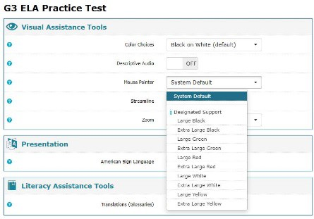

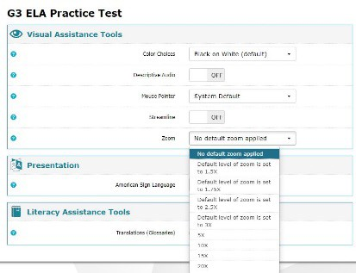

Resources for WVGSA

Please use the link below to access information and resources that will assist teachers and schools.
  - WV Assessment Portal at https://wv.portal.cambiumast.com/
  - Interims at https://wv.portal.cambiumast.com/ and https://bit.ly/3Bh42x6 (WV PEAKS Teams page)

WVGSA Summary Crosswalk of Codes

(See Section III for further details, explanations, and limitations of each code.)

 | Universal Tools | Accommodations
Embedded | Breaks  Calculator  Digital notepad  English dictionary  English glossary  Expandable passages  Notes highlighter  Keyboard navigation  Mark for review (Math)  tools  Spell check  Strikethrough  Thesaurus  Writing tools  Zoom | P01 – Text-to-speech – without reading passages (do not pair with P13)  P13 – Text-to-speech – with reading passages (do not pair with P01)  P17 – Braille computer test – computer adaptive test format  P22 – Enlarge text on computer screen (beyond what the Universal Tool can provide)  P28 – Color contrast  P32 – Translations (Spanish only; math and science sections only)  P34 – American Sign Language  P35 – Braille - computer-based, fixed form, with paper booklet for tactile graphics  P36 – Closed captioning  P37 – Masking  P43 – Streamline  R21 – Permissive mode for secure browser  R31 – Embedded speech-to-text
Non-embedded | English dictionary  Breaks  Scratch paper (lined or unlined)  Graph paper  Thesaurus | P02 – Human read aloud, excluding ELA reading passages (do not pair with P14)  P03 – Braille (paper)  P06 – Have test presented through sign language; excluding ELA passages  P14 – Human read aloud, including ELA reading passages (do not pair with P02)  P18 – Simplified test directions  P23 – Magnification  P30 – Translated test directions (by trained bilingual human reader or translation app)  P38 – Color contrast  P39 – Color overlay  P40 – Print on demand  P42 – Noise buffers  P46 – Read aloud in language other than English or ASL  P50 – Test presented through sign language, locally provided; including ELA reading passages  R03 – Braille writer or tactile to respond  R04 – Scribe  R05 – Abacus  R11 – Assistive technology - alternate response options  R15 – Bilingual word-to-word glossary (utilize the glossary the student is accustomed to accessing for instruction for WVGSA)  R19 – Calculator – tactile/talking  R20 – Multiplication table  R21 – Permissive mode for secure browser  R23 – 100s Number table  R32 – Personal Health Management Monitoring Devices  R34 – Printed Test Book  T03 – Extra Breaks  T07 – Flexible scheduling (late start)  T09 – Separate setting (small group) (do not pair with T10)  T10 – Separate setting (one-to-one) (do not pair with T09)  T11 – Testing environment modifications  T12 – Preferential seating  T13 – Outside of traditional school setting (change in location)  T14 – Flexible scheduling (limited time testing)  T15 – Extended breaks  T16 – Breaks as needed

Section VII.

SAT School Day
Grade 11

Section VII. SAT School Day

Overview
The SAT School Day is the College Board’s flagship college- and career-readiness assessment. This test is used to measure Grade 11 students’ levels of achievement on the West Virginia College- and Career- Readiness Standards (WVCCRS). The SAT School Day provides scores for Reading/Writing, Mathematics, and Science. The SAT School Day is a digital, stage-adaptive test used for accountability purposes. Students requiring accessibility accommodations (e.g., text-to- speech, braille, enlarge test on computer screen, high color contrast, alternate response formats, etc.) will receive these accommodations via the assessment platform.
The SAT School Day assessment is delivered in two sessions with two modules each. A short break is scheduled between sessions. The first session assesses reading and writing while the second session assesses math. The assessment includes multiple-choice and student-produced responses.
The assessment results provide information about a student’s academic strengths, as well as areas that need improvement. The parent/guardian will receive a student report that indicates levels of performance in each of the content areas. Results of the tests will be used by educators to improve student learning and performance.
Students enrolled in Grade 11 shall participate in the WVGSA SAT School Day unless they have been found eligible for the WVASA (See Section IV).
Universal tools are available to all students based on student preference and selection. See Table 1. Universal Tools for the SAT School Day.

Accommodations are changes in procedures or materials that increase equitable access during the assessments by generating valid assessment results for students who need them and allowing these students the opportunity to show what they know and can do. See Table 2. Accommodations for SAT School Day.

For the SAT School Day administration in West Virginia, all embedded assessment accommodations are electronically transferred daily from WVEIS to the Bluebook testing platform – this typically begins in late-January and runs through the close of the state testing window. These accommodations must be finalized in students’ IEPs. For students with assessment accommodations from a 504 or EL plan, those settings must be entered manually into WVEIS and will then be part of the daily upload to Bluebook.

West Virginia public schools are required to use the IEP module within WVEIS to document accommodations for students with disabilities, and to manually input accommodations for students with 504 or EL plans. For further guidance on these procedures, please contact your LEA’s Special Education office.

Who Makes Decisions About Accommodations for Students with an IEP or a

Section 504 Plan?

IEP teams and educators for Section 504 plans make decisions about accommodations. These decision makers provide evidence of the need for accommodations and ensure they are noted on the IEP or Section 504 plan.

Review Assessment Accommodations Summary for directions on accessing in WVEIS a student’s accommodation list and how to verify and troubleshoot if necessary.
Embedded Universal Tools for the SAT School Day

Table 1. Universal Tools for the SAT School Day
Available to All Students | Description
Zoom | Use the device’s native controls (Control +/- on a PC; Command +/- on a Mac; pinch and zoom on an iPad) to zoom in and out for all items. The default font size is 12 points.
Color contrast | The device’s color settings are available for students to select their required displays. Students can also use colored plastic overlays on the device’s screen.  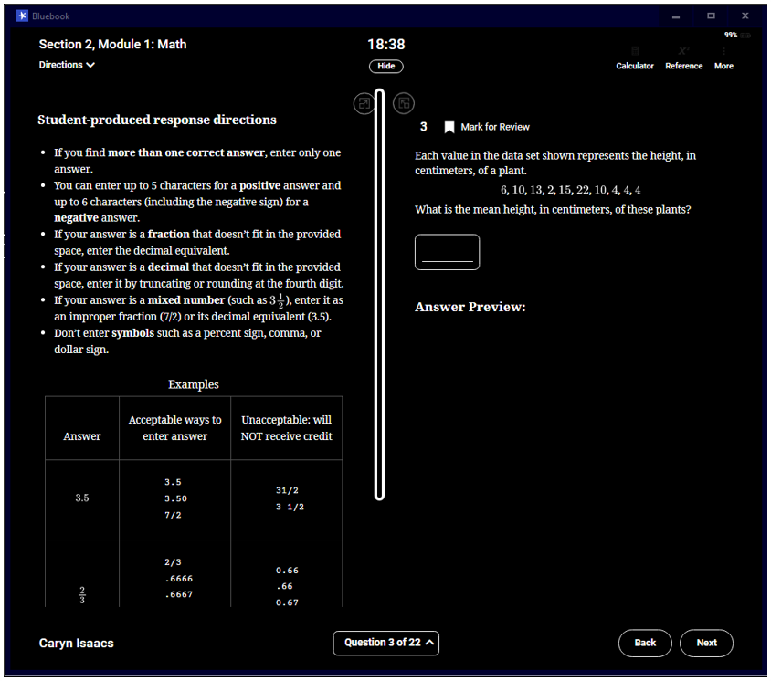
Calculator | A calculator is built into the platform and is available to all students. Bluebook uses the Desmos calculator. There isn’t a “math with no calculator” section of the assessment.  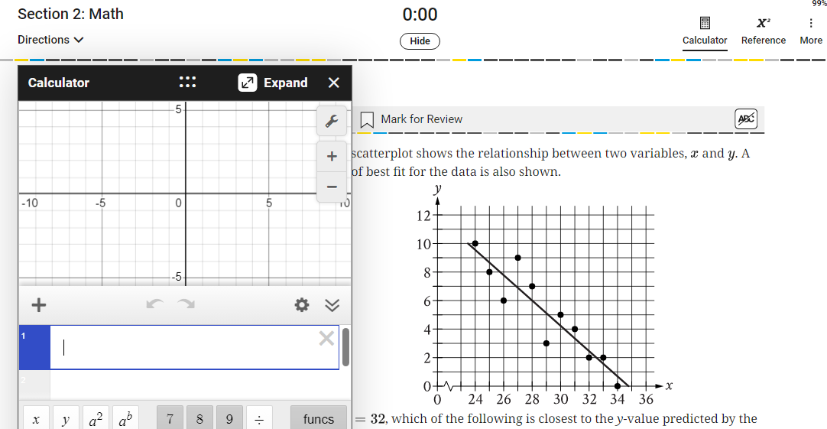
Math reference sheet | A reference sheet displaying common math formulas is displayed for each math question.  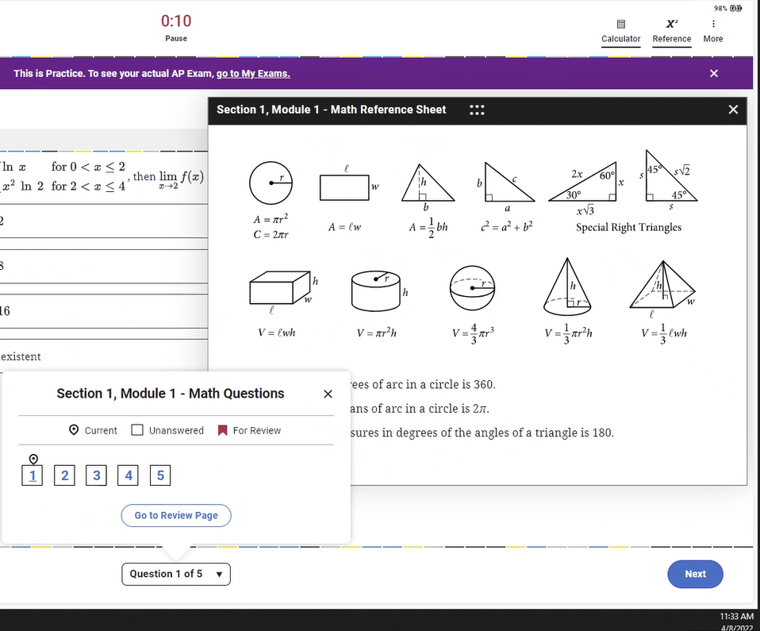
Annotator | After clicking and dragging the cursor over a section of text, click the “Annotate” icon for a notepad pop up.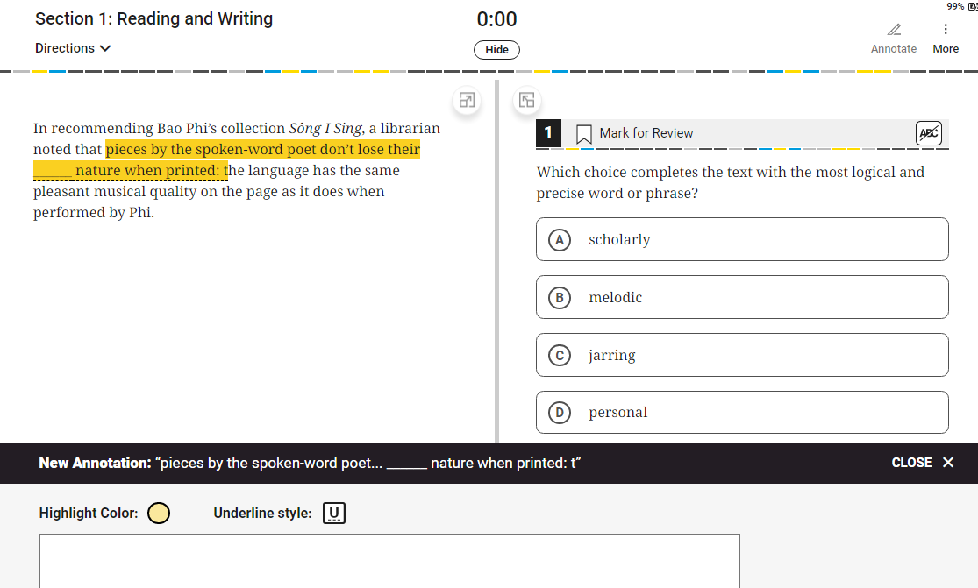
Mark for review | Questions can be flagged by clicking the icon in the upper right corner for later review.  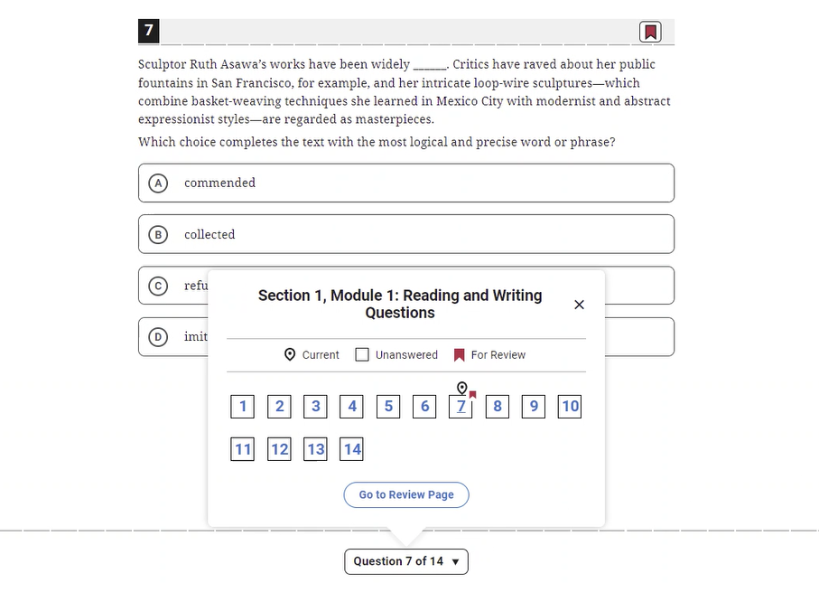
Answer eliminator | Answer options can be eliminated as a test taking strategy. Eliminated responses can be toggled to being available for selection again.  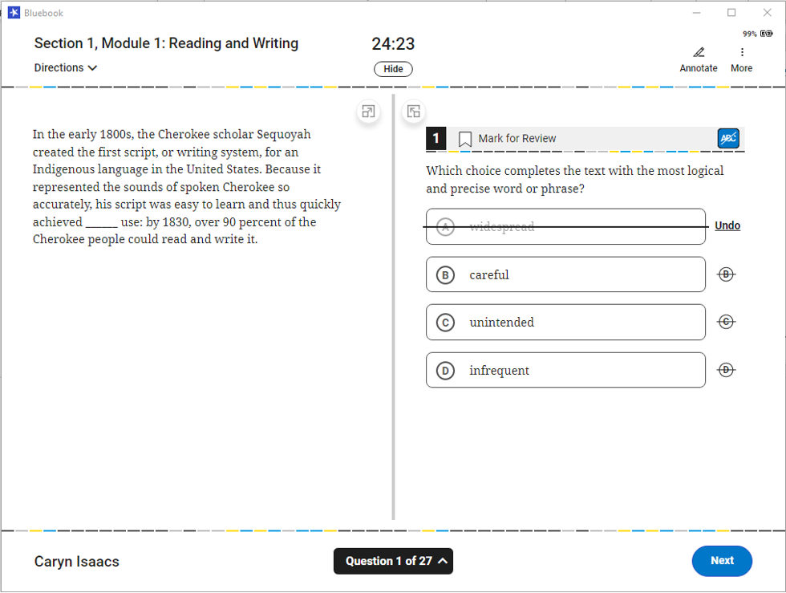
Question navigator | Specific questions can be quickly reviewed and navigated to.
Expand passage or item | Depending on the screen size and resolution settings, the test taker may have the option to expand the right and left sides of a passage or item for improved readability.  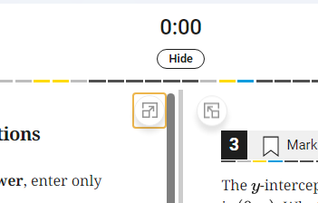
Clock display | A countdown of remaining time left for each section and gives a 5-minute warning is provided at the top of the screen. This clock display can be toggled on/off. If toggled off, when the timer reaches 5 minutes left in the test sessions – it will reappear and not be able to be hidden.  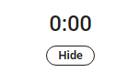

Accessibility Settings for SAT School Day

Students are strongly encouraged to take a practice test with the device they will be participating in the SAT School Day with to gain familiarity with these tools.

Screen Readers & Text-to-Speech

https://Bluebook.collegeboard.org/students/accommodations-and-assistive-technology/screen-readers-and-text-to-speech

This link provides instructions for accessing different screen readers and text-to-speech supports across the different operating system platforms.

Speech-to-Text

https://Bluebook.collegeboard.org/students/accommodations-and-assistive-technology/speech-to-text

This link provides instructions for accessing voice recognition or speech-to-text which transcribes a student’s spoken response into the digital test platform. College Board supports Dragon NaturallySpeaking, Apple Voice Control, Chromebook Dictation, and Windows Voice Recognition/Dictation.

Visual Assistive Technology

https://Bluebook.collegeboard.org/students/accommodations-and-assistive-technology/visual-assistive-technology

The following magnification options are available through College Board’s testing platform, Bluebook.

ZoomText

Fusion

Windows Zoom and Magnifier

Apple (OS and iOS) Zoom

Chromebook Display and Magnification

Accessing Bluebook Features and Content

https://Bluebook.collegeboard.org/accessing-Bluebook-features-content

Many of the embedded supports and features have keyboard shortcuts. This link provides instructions for the different operating systems to access those shortcuts. No additional configuration is needed to use the shortcuts. Additionally, information is available for recommended verbosity and punctuation settings for any read aloud supports.

MathJax

https://Bluebook.collegeboard.org/students/accommodations-and-assistive-techology/mathjax

Bluebook utilizes MathJax AssistiveMML technology to support students using a variety of screen readers. The exam will function without additional settings activated. Bluebook does not prohibit students from using personalized settings.

Refreshable Braille

https://satsuite.collegeboard.org/digital/accommodations-digital-testing/using-accommodations-digital-tests

Students approved for a braille accommodation will test digitally using their own refreshable braille display or screen reader. If a student is unable to test using the digital test, they should update their IEP to indicate a paper braille/embossed assessment. Raised line drawings are available through the student’s IEP accommodation section.

Chromebooks

https://Bluebook.collegeboard.org/help-center/how-do-i-enable-accessibility-features-chromebooks

For schools using Chromebooks for student devices, the link above provides instructions for accessing the floating accessibility menu. The floating accessibility menu provides student access to the built-in screen reader and other accessibility features.

Table 2: Accommodation Codes

Table 2: Accommodations for SAT School Day
WVEIS Code | Accommodation Name  SAT School Day | Notes | College Board Code*
P03 | Braille Test booklet (paper) | Do not pair this accommodation with P17. | 027 + 200
P13 | Text-to-speech, including ELA reading passages | Required minimum 50% extra time for SAT School Day for entire test (T17); 100% extra time can be indicated if appropriate for this assessment (T20) | 209
P14 | Human read aloud,  including ELA reading passages | Required minimum 50% extra time for SAT School Day for entire test (T17); 100% extra time can be indicated if appropriate for this assessment (T20) | 204
P16 | Directions presented  through sign language, locally provided | Directions can be ASL or SEE | 44
P17A-E | Braille computer test | P17A – Braillant 40 cell  P17B – Qbraille XL  P17C – Active Braille  P17D - Braille note touch 32 cell  P17E – Other _____ | 201
P17A-E | Braille computer test |  | 201
P17A-E | Braille computer test |  | 201
P17A-E | Braille computer test |  | 35
P17A-E | Braille computer test |  | 201
P19 | Large print paper test | P19A – 14-point font  P19B – 20-point font  P19C –22-point font (WVGSA Grades 3-8 only)  P19D -- 24-point font (SAT School Day only) | 022 + 200
P19 | Large print paper test |  | 023 + 200
P19 | Large print paper test |  | 021 + 200
P21 | Screen-reading software used with computer |  | 201
P22 | Enlarge text on computer screen |  | Universal Tool
P23 | Magnifying device to enlarge assessment material | P23A – Other ______ | 29
P27 | Approved bilingual word to word dictionary for directions only, on all sections |  | n/a
P28 | High contrast for computer-based assessments |  | Universal Tool
P30 | Translated test directions |  | n/a
P35 | Braille computer-based fixed form with paper booklet for tactile graphics | Do not pair this accommodation with P03. Select P35 only if the student needs paper testing support for math. This accommodation must be paired with P17. | 030
P37 | Masking |  | n/a
P39 | Color overlays |  | 145
P42 | Noise buffers |  | 083
P50 | Test presented through sign language, locally provided, including ELA passages | Signed Exact English only | n/a
P51 | Text-to-speech; math only |  | 157
R03A-D | Braille writer or tactile to respond | R03A – Perkins Embosser  R03B – ViewPlus Embosser  R03C – PixBlaster Embosser  R04D – Other ______ (indicate name/brand of device) | 035
R03A-D | Braille writer or tactile to respond |  | 035
R03A-D | Braille writer or tactile to respond |  | 035
R03A-D | Braille writer or tactile to respond |  | 035
R04 | Scribe |  | 205 (digital)  34  (non-digital)
R05 | Abacus |  | 105
R11A | Assistive technology – alternate response options | R11A - Other _________ (indicate name/brand of electronic device(s) used for alternate response input) | 50
R15 | Bilingual word-to- word glossary |  | n/a
R19 | Calculator – tactile/talking  calculator | R19A – Orion TI-84 Plus Talking Graphing Calculator  R19B – Other ______ | 083
R19 | Calculator – tactile/talking  calculator |  | 045
R20 | Multiplication table |  | 045
R21A-B | Permissive mode for secure browser | R21A – Dragon NaturallySpeaking series for speech-to-text  R21B - Other ___________ (indicate name/brand of program(s) needing permissive mode for Bluebook) | 50
R23 | 100s number table |  | 045
R32A-D | Personal health devices | R32A – Blood glucose monitoring device  R32B – Seizure monitoring and alert device  R32C – Migraine monitoring device  R32D – other ______________(indicate name/brand of device) | 045
R32A-D | Personal health devices |  | 045
R32A-D | Personal health devices |  | 045
R32A-D | Personal health devices |  | 045
R34 | Printed test book | Before this accommodation is added to an IEP/504 plan, please contact your county test coordinator. | 200
T03 | Extra breaks (no studying) |  | 16
T07 | Flexible scheduling (late start) |  | n/a
T09 | Separate setting (small group) | Do not pair with T10 | 39
T10 | Separate Setting (one-to-one) | Do not pair with T09 | 41
T11 | Testing environment modifications |  | n/a
T12 | Preferential seating |  | 38
T13A-B | Outside of traditional school setting (change in location - homebound/ hospital or alternate school setting) | T13A – Home or hospital setting  T13B - ___________ (enter location) | 47
T13A-B |  |  | 49
T14 | Flexible scheduling (limited timed testing) | 2-day testing | 46
T15 | Extended breaks |  | 17
T16 | Breaks as needed |  | 18
T17 | Extended time up to +50% Reading/ELA |  | 1
T19 | Extended time up to +50% Math |  | 007
T20 | Extended time up to +100% Reading/ELA |  | 002
T22 | Extended time up to +100% Math |  | 008

* College Board codes display in SDMS/TDTK and are included in this guide for informational purposes
only.
* Additional College Board codes include:
149 EL support – up to 50% extra time
208 Nutrition break – cannot be waived; between section 1 and 2 (automatically added to
+100 extended time Reading (T22), Human reader (P14), Raised line drawings (R35))

Non-Standard Accommodation(s) Requests

IEP teams, Section 504 committees, and EL committees may request permission to use accommodations other than those included in this manual. Such requests should be received by the WVDE Office of Assessment no later than four (4) weeks prior to the testing window.
The request must come from the county test coordinator, county special education director, or Title III coordinator. The following information must be included in the request:

- Student’s name, West Virginia Education Information System (WVEIS) number, school, and county,
- Specific requested accommodation(s) – please include as much information as possible including descriptions of any devices (make and model numbers, names and version of apps required, etc.),
- Rationale for the request provided by the IEP team, Section 504 committee, or EL committee,
- Verification the student receives the accommodation(s) on a regular basis during classroom instruction and classroom assessment, and is familiar with the accommodation(s), and
- Impact on student’s assessment results if the student is not permitted to use the requested accommodation(s),

These requests must be submitted to your county test coordinator.

Upon completion of the review of the request, the county test coordinator and/or the county Title III coordinator (EL students only) will be notified of the review committee’s decision.

Please see Appendix Q: Non-Standard Accommodation(s) Requests for the appropriate form and signatures to submit.

Section VIII.

NAEP Accommodation Guidelines

Section VIII. Accommodations Guidelines for the National Assessment of Educational Progress (NAEP)

National Assessment of Educational Progress (NAEP) accommodations should be included for all IEPs which will be in effect for students aged 9, 13, or 17 or in 4th, 8th, or 12th grade. Grade-based NAEP has completed the transition from paper assessments to digitally based assessments. NAEP contractors are working on protocols to streamline processes. One proposed protocol is to upload accommodations from West Virginia Education Information System (WVEIS) to the NAEP Assessment Management System (AMS). We need to be prepared for this change.

The NAEP Long-Term Trend (LTT) assessment is a national representative sample of age 9, age 13 and age 17 students conducted by the National Center for Education Statistics (NCES). The purpose of NAEP LTT is to measure students’ knowledge in mathematics and reading. LTT has not been converted to digital. NAEP LTT is reported at the national level only. No state, county, or school results are reported.

Main NAEP is a national assessment of a representative sampling of America's students in Grades 4, 8, and 12 conducted by the National Center for Education Statistics (NCES). NAEP measures what America's students know and can do in various subject areas. Assessments are conducted periodically in various subjects, such as reading, mathematics, science, and U.S. history.

NAEP participation is required by policy and law. As defined in the Elementary and Secondary Education Act, NAEP reading and mathematics assessments are required to be administered to fourth and eighth graders. As defined by West Virginia Code §18-2wE-2, NAEP shall be administered in academic areas at various grades designated by NAEP officials. As indicated in West Virginia Board of Education (WVBE) Policy 2340, NAEP is part of the West Virginia Measures of Academic Progress (WV-MAP). Students’ participation on NAEP is required by Policy 2340. Only students who take the WVASA or who have assessment accommodations for the statewide WVGSA or SAT School Day that are not allowed on NAEP, may be considered for exclusion on NAEP.

NAEP assessments are administered uniformly across the nation. Their results serve as a common metric for all states and selected urban counties. The assessments stay essentially the same from year to year, with only carefully documented changes. This consistency permits NAEP to provide a clear picture of the academic progress of the nation’s students over time. Some NAEP assessments also produce state-level results.

The allowed accommodations and requirements for administration of NAEP are determined by NCES and the National Assessment Governing Board (NAGB), and information about them is provided to the schools through the Assessment Management System (AMS) secure website for NAEP sampled schools (Kopriva et al., 2007). NAEP accommodations for each assessment year are typically finalized in late fall prior to the assessment year. Sampled schools should check the AMS site when indicated by State NAEP Coordinator for the current accommodations. The accommodations listed in this document were used for NAEP in the most recent assessment at the time of publication.

On March 6, 2010, NABG adopted a new Policy Statement on NAEP Testing and Reporting on Students with Disabilities and English Language Learners (National Center on Educational Outcomes, 2016).

This policy statement provides the following guidance for inclusion of students with disabilities and English learners:
- The proportion of all students excluded from any NAEP sample should not exceed 5%. Samples exceeding this goal shall be prominently designated in reports as not attaining the desired inclusion rate of 95% of the total sample.
- Among students classified as being either English learners (i.e., having limited English proficiency) or students with disabilities, a goal of 85% inclusion shall be established. National, state, and county samples falling below this goal shall be identified in NAEP reporting. This inclusion rate is in the calculation of the Individuals with Disabilities Act (IDEA) Part B Results-Driven Accountability.

NAEP assesses a representative sample of all students across the state, including those with special needs. NAEP strives to obtain as complete a picture as possible of the educational progress of all students. Thus, the NAEP sample includes students who have been identified as having physical, emotional, or developmental disabilities, or who have had limited exposure to the English language. NAEP’s goal is to include as many students with disabilities and/or limited English proficiency as possible. Therefore, NAEP’s advice to schools is, when in doubt, include the student.

NAEP is administered by a federally contracted assessment team that receives extensive training to ensure consistent administration across the nation. School personnel may be asked to assist with some accommodations, such as signing questions for students.

Questions regarding accommodations on NAEP should be directed to your school’s NAEP coordinator. Determination of accommodations should be made by the school prior to the NAEP Assessment Planning Meeting conducted prior to the assessment administration and updated, as necessary.

WVBE Policy 2340 states:
All public-school students enrolled at Grades 4, 8 and 12 who are part of the NAEP state sample shall participate in the NAEP. Students participating in the WVASA and students with IEPs, Section 504 Plans, or EL Plans whose accommodations are not allowed by NAEP may be excluded from participation or assessed and not scored after having been randomly selected.

School personnel with the best knowledge of the student’s accommodation needs should use the guidance provided on the AMS site to decide if the student should be included in the NAEP assessment and the accommodations needed. In general, students should receive the same accommodations on NAEP that are provided for the WVGSA. Please review the student’s planned accommodations prior to the assessment. Each student’s participation or exclusion should be considered carefully, and every student who can participate should.

Procedures for Monitoring NAEP Exclusions and Accommodations
As with all state assessments, NAEP accommodations and exclusions must be monitored. NAEP exclusions are monitored by the NAEP state coordinator. Accommodations on NAEP are monitored by the assessment administration contractor and NAEP state coordinator. Since accommodations on NAEP and exclusions from NAEP are monitored using these two procedures, schools are not required to complete the MAE.4SA process.

In compliance with federal regulations, the NAEP state coordinator must monitor exclusions on NAEP.
For each student excluded from the NAEP assessment, the NAEP school coordinator or principal should email the following information to the NAEP state coordinator as instructed on the AMS site:

    - NAEP Session #
    - Line #
    - Subject Assigned to Student
    - Reason for Exclusion (Student takes the WVASA or specify the accommodation required for student but not available on NAEP)

Student names should not be emailed.

Remember students should take NAEP using the same accommodations used on the WVGSA. Any exclusion that appears to violate WVBE Policy 2340 may be reviewed further. If a student needs an accommodation not listed on the AMS, the school coordinator should contact the NAEP state coordinator at the West Virginia Department of Education prior to submitting the request in the AMS system.

Transition from NAEP-provided devices to school-provided devices

As NAEP transitions to school devices, students will be able to use the device used daily. This familiar device will have the familiar accessories, such as headphones, physical keyboard, mouse, etc. Additionally, the student will be using the familiar software, such as screen readers. The NAEP school coordinator needs to work with the NAEP representative to ensure these additions will work with the NAEP assessment. Please do not assume the features, such as screen readers, will work.

NAEP Accommodations for Students with IEPs and Section 504 Plans for Digitally Based Assessments
The accommodation information listed in this document reflects the most currently known set of accommodations. The accommodation information and administration practices for NAEP testing for any given assessment year are provided to schools through the AMS site and/or discussed with school personnel during the Assessment Planning Meeting.

Each accommodation is described below. Accommodations available for students with IEPs are indicated by the notation of SD in parentheses. Some accommodations are also available for English learners indicated by EL.

If a student needs an accommodation not listed, the NAEP school coordinator should discuss the specific accommodation with the NAEP state coordinator at the West Virginia Department of Education prior to entering the request in the AMS system.

Zooming (SD, EL)

Universal Design tool available to all students

Description: Zooming enlarges content onscreen up to two times the default text/image size while preserving clarity, contrast, and color. Students can change text sizes ranging from approximately 12- point font to approximately 24-point font.

The tutorial explains how to use the zooming tool and has full audio. The tutorial is generally available on the public NCES website prior to each administration.

NOTE: Zooming only enlarges the items and does not include the toolbar, item tabs, scrollbars, calculator, and equation editor. If students need content larger than 2 times the default text/image size or if they need all tools enlarged, select the magnification accommodation.

Individual Testing Experience (SD, EL)

Universal Design tool available to all students

Description: Read Aloud and other UDE and accommodations are provided through the device and will not distract other students in the room. All students are interacting on a one-on-one basis with the device and will have earbuds to reduce distractions. Refer to the accommodation Preferential Seating to minimize distractions for testing with other students. If this is not sufficient separation from the other students, the Separate Location accommodation should be added.

Directions Only Read Aloud/Text-to-Speech (English) (SD, EL)

Universal Design tool available to all students

Description: General directions are read aloud to all students. All directions within the assessment can be selected and read aloud by the system using text-to-speech.

Some students’ IEPs or 504 Plans stipulate they should receive this accommodation. For those students, this will be coded as an accommodation. Students who do not have this as an IEP or 504 requirement, but who need the general directions (the same for all students) and/or the subject-specific directions read aloud, repeated, or reworded in any way in English can request this by raising their hand during the session, and it will not be recorded as an accommodation.

Directions Explained/Clarified (SD, EL)

Universal Design tool available for all students

Description: Students can raise their hand at any time to ask the test administrator to clarify or explain directions.

Note: This accommodation should be chosen if the student requires directions to be simplified.

Read Aloud/Text-to-Speech (English) – Occasional or Most or All (SD, EL – not available for Reading)

Text-to-Speech is a Universal Design tool available to all students, but it is not allowed on the NAEP Reading passages or items.

Description: Students select some or all text to be read aloud by the system using text-to-speech.

The tutorial explains how to use the text-to-speech tool and has full audio. The tutorial is generally available on the public NCES website prior to each administration.

Use a Computer/Tablet to Respond (SD, EL)

Universal Design tool available to all students

Description: All students respond on devices.

Color Theming (SD, EL)

Universal Design tool available to all students

Description: Students have a choice of three color-contrast options, including one high-contrast option. The default is black text on white background, and the two other options are white text on black background and black text on beige background.

The tutorial explains how to use the color theming tool and has full audio. The tutorial is generally available on the public NCES website prior to each administration.

NOTE: This tool is not available for the tutorial and some items. If students need all content in high contrast, please select the accommodation High Contrast for Visually Impaired Students.

Scratch work/Highlighter Capability (SD, EL)

Universal Design tool available to all students

Description: A scratch work/highlighter tool allows freehand drawing and highlighting on the screen for most content. If the student needs physical scratch paper, use the Scratch Paper accommodation.

The tutorial explains how to use the scratch work/highlighter tool and has full audio. The tutorial is generally available on the public NCES website prior to each administration.

Eliminating Capability (SD, EL)

Universal Design tool available to all students

Description: This accommodation allows students to gray out answer choices for multiple choice items.

The tutorial explains how to use the eliminating tool and has full audio. The tutorial is generally available on the public NCES website prior to each administration.

NOTE: This tool is not available for constructed response items.

Volume Adjustment (SD, EL)

Universal Design tool available to all students

Description: Students may raise or lower the voice-over volume using the device’s volume buttons. All voice-over narration is closed-captioned.

The tutorial explains how to use the volume adjustment tool and has full audio. The tutorial is generally available on the public NCES website prior to each administration.

Closed Captioning (SD, EL)

Universal Design tool available to all students

Description: All voice-over narration is closed-captioned.

Scratch (lined or unlined) Paper (SD, EL)

Universal Design tool for all students

Description: Administrators will inform students that scratch paper (lined or unlined) and pencil are available upon request. Students can raise their hands to request scratch (lined or unlined) paper and pencil.

Note: This accommodation only includes blank scratch paper (lined or unlined), not prepared graphic organizers.

Extended Time (SD, EL)

Description: This accommodation requires students to be given extra time to complete the assessment. The students will be given up to three times the allotted time to complete the assessment. Students with extended time should be included in the first testing session to ensure enough time is available.

NOTE: Most students are able to complete the NAEP cognitive sections in the time allowed.
Magnification Equipment (SD)

Description: This accommodation is for students requiring magnification of all assessment content, including all tools, toolbars, menus, calculator, and equation editor. Screen magnification software allows students to scroll over a portion of the screen to magnify the image on the screen greater than two times the default text or graphic size.

NOTE: See Zooming to determine if students need the additional magnification on assessments provided by this accommodation.

Low Mobility Version of the Test (SD)

Description: The low mobility version of the test provides a test form with items that are keyboard navigable or accessible with an alternate input device provided by the school and that do not require the use of the mouse or touch pad.

Calculator Version of the Test (SD - available for Mathematics only.)

Description: This accommodation provides a mathematics test form that permits the use of a calculator. The calculator is an onscreen calculator provided via the test delivery system. The online calculator can be viewed with the eNAEP feature in the online NAEP Questions Tool.

Hearing-Impaired Version of the Test

Description: The hearing-impaired version of the test provides a test form that has all auditory content closed-captioned.

High Contrast for Visually Impaired Students (SD)

Description: For visually impaired students that require high contrast of all content, a test form is provided with all content that is compatible with high contrast.

Breaks during Test (SD, EL)

Description: Breaks during testing require the student to be allowed to take breaks as requested or at predetermined intervals during the assessment. This could also mean the student can take the assessment in more than one sitting during a single day.

Note: Some students may need to have breaks in the assessment to deal with medical issues, such as diabetic needs.

Separate Location/Small Group (SD, EL)

Description: Refer to the UDE Individual Testing Experience and accommodation Preferential Seating to determine if a separate location/small group is needed. Students with this accommodation may be tested in the same room but in a specific location or in a different room. They may be tested individually or with a small group of students.

Familiar Person Present in Testing Room (SD, EL)

Description: The paraprofessional who regularly works with the student must be present in the testing room during the time of assessment. This individual should be focused on the student’s needs and not participating in the administration of the assessment. Only trained NAEP staff may conduct the assessment session.

Uses Template (SD, EL)

Description: A template is a cutout or overlay provided by the school that is used to focus a student’s attention on one part of the screen by obscuring other parts of the screen. This is also known as masking, line reader or place marker. Templates must be provided by the school.

For questions about allowed templates, the NAEP school coordinator should contact the NAEP State Coordinator in the WVDE Office of Assessment.

Special Equipment (SD, EL)

Description: Special equipment includes the following and must be provided by the school:
- FM system, amplification equipment, or an auditory amplification device
- Noise buffers, study carrel, blinders, special lighting, or adaptive furniture
- Stress ball or sensory fidget item

For questions about allowed special equipment, the NAEP school coordinator should contact the NAEP State Coordinator in the WVDE Office of Assessment.

Preferential Seating (SD, EL)

Description: Preferential seating requires a student to sit in a designated area for the assessment, such as away from other students to limit distractions, a location where there is access to special equipment, or close to the test administrator so the student can see or hear more easily.

Cueing to Stay on Task (SD, EL)

Description: Cueing to stay on task may include the following and must be provided by a school staff member.
- Monitor for understanding, monitor placement of responses
- Redirect to stay on task, reminders to stay on task, prompts to stay on task
- Provide verbal encouragement, reinforcement, refocus
- Track test items

A school staff member should discuss this accommodation with the NAEP assessment administrator prior to the start of the assessment. Cueing to stay on task MAY NOT include assistance with answering the questions.

Scribe (SD)

Description: This accommodation requires the student to be allowed to respond orally to a scribe provided by the school or to respond by pointing to their answers. The scribe then records the student’s responses in the device.

This accommodation requires a Separate Location accommodation.

Directions Only Presented in Sign Language (SD)

Description: A qualified sign language interpreter at the school signs the instructions general directions, directions within the assessment, tutorial, help, and student questionnaire screens. The interpreter should be someone who typically works with the student.

NOTE: The school determines who is a qualified sign language interpreter.

Presentation in Sign Language/Response in Sign Language (SD – not available for Reading)

Description: Presentation in Sign Language requires a qualified sign language interpreter provided by the school to sign the instructions included in the session script and some or all the test questions or answer choices for the student. The interpreter should be someone who typically works with the student.

Response in Sign Language (SD)

Description: Response in Sign Language requires hearing-impaired students to be allowed to sign their responses to a scribe provided by the school who records the responses in the device (select Scribe accommodation).

NOTE: The school determines who is a qualified sign language interpreter.

Students taking the assessment who require presentation or response in sign language should be tested in a separate location and be given extended time.

Braille Version of the Test (SD)

Description: The braille version of the test is a paper-based embossed Braille form of the test. NAEP uses contracted Unified English Braille (UEB) for all subjects. For the mathematics and science assessments, NAEP offers two versions: UEB plus Nemeth or UEB only. Students can use a scribe to record their answers (select Scribe accommodation). A scribe is provided by the school and records the student responses directly in the device. Students can also use a braille output device provided by the school.

NOTE: This accommodation requires a separate location.

NAEP Accommodations for English Learners for Digitally Based Assessments
The accommodation information listed in this document reflects the most currently known set of accommodations. The accommodation information and administration practices for NAEP testing for any given assessment year are provided to schools through the AMS site and/or discussed with school personnel during the Assessment Planning Meeting.

Each accommodation is described below. Accommodations available for students with IEPs are indicated by the notation of SD in parentheses. Some accommodations are also available for English learners indicated by EL.

If a student needs an accommodation not listed, the NAEP school coordinator should discuss the specific accommodation with the NAEP state coordinator at the West Virginia Department of Education prior to entering the request in the AMS system.

Zooming (SD, EL)

Universal Design tool available to all students

Description: Zooming enlarges content onscreen up to two times the default text/image size while preserving clarity, contrast, and color. Students can change text sizes ranging from approximately 12- point font to approximately 24-point font.

The tutorial explains how to use the zooming tool and has full audio. The tutorial is generally available on the public NCES website prior to each administration.

NOTE: Zooming only enlarges the items and does not include the toolbar, item tabs, scrollbars, calculator, and equation editor. If students need content larger than 2 times the default text/image size or if they need all tools enlarged, select the magnification accommodation.

Individual Testing Experience (SD, EL)

Universal Design tool available to all students

Description: Read Aloud and other UDE and accommodations are provided through the device and will not distract other students in the room. All students are interacting on a one-on-one basis with the device and will have earbuds to reduce distractions. Refer to the accommodation Preferential Seating to minimize distractions for testing with other students. If this is not sufficient separation from the other students, the Separate Location accommodation should be added.

Directions Only Read Aloud/Text-to-Speech (English) (SD, EL)

Universal Design tool available to all students

Description: General directions are read aloud to all students. All directions within the assessment can be selected and read aloud by the system using text-to-speech.

Some students’ IEPs or 504 Plans stipulate they should receive this accommodation. For those students, this will be coded as an accommodation. Students who do not have this as an IEP or 504 requirement, but who need the general directions (the same for all students) and/or the subject-specific directions read aloud, repeated, or reworded in any way in English can request this by raising their hand during the session, and it will not be recorded as an accommodation.

Directions Explained/Clarified (SD, EL)

Universal Design tool available for all students

Description: Students can raise their hand at any time to ask the test administrator to clarify or explain directions.

Note: This accommodation should be chosen if the student requires directions to be simplified.

Read Aloud/Text-to-Speech (English) – Occasional or Most or All (SD, EL – not available for Reading)

Text-to-Speech is a Universal Design tool available to all students, but it is not allowed on the NAEP Reading passages or items.

Description: Students select some or all text to be read aloud by the system using text-to-speech.

The tutorial explains how to use the text-to-speech tool and has full audio. The tutorial is generally available on the public NCES website prior to each administration.

Use a Computer/Tablet to Respond (SD, EL)

Universal Design tool available to all students

Description: All students respond on devices.

Color Theming (SD, EL)

Universal Design tool available to all students

Description: Students have a choice of three color-contrast options, including one high-contrast option. The default is black text on white background, and the two other options are white text on black background and black text on beige background.

The tutorial explains how to use the color theming tool and has full audio. The tutorial is generally available on the public NCES website prior to each administration.

NOTE: This tool is not available for the tutorial and some items. If students need all content in high contrast, please select the accommodation High Contrast for Visually Impaired Students.

Scratch work/Highlighter Capability (SD, EL)

Universal Design tool available to all students

Description: A scratch work/highlighter tool allows freehand drawing and highlighting on the screen for most content. If the student needs physical scratch paper, use the Scratch Paper accommodation.

The tutorial explains how to use the scratch work/highlighter tool and has full audio. The tutorial is generally available on the public NCES website prior to each administration.

Eliminating Capability (SD, EL)

Universal Design tool available to all students

Description: This accommodation allows students to gray out answer choices for multiple choice items.

The tutorial explains how to use the eliminating tool and has full audio. The tutorial is generally available on the public NCES website prior to each administration.

NOTE: This tool is not available for constructed response items.

Volume Adjustment (SD, EL)

Universal Design tool available to all students

Description: Students may raise or lower the voice-over volume using the device’s volume buttons. All voice-over narration is closed-captioned.

The tutorial explains how to use the volume adjustment tool and has full audio. The tutorial is generally available on the public NCES website prior to each administration.

Closed Captioning (SD, EL)

Universal Design tool available to all students

Description: All voice-over narration is closed-captioned.

Scratch (lined or unlined) Paper (SD, EL)

Universal Design tool for all students

Description: Administrators will inform students that scratch paper (lined or unlined) and pencil are available upon request. Students can raise their hands to request scratch (lined or unlined) paper and pencil.

Note: This accommodation only includes blank scratch paper (lined or unlined), not prepared graphic organizers.

Extended Time (SD, EL)

Description: This accommodation requires students to be given extra time to complete the assessment. The students will be given up to three times the allotted time to complete the assessment. Students with extended time should be included in the first testing session to ensure enough time is available.

NOTE: Most students are able to complete the NAEP cognitive sections in the time allowed.

Directions Only Translated to Spanish and Directions Read Aloud/Text-to-Speech (Spanish) (EL)

Description: All directions are provided in Spanish and English including the tutorial. A toggle button is available on the screens to go back and forth between Spanish and English. All Spanish translated content is text-to-speech enabled. The tutorial is also available in Spanish.

Spanish/English Version of the Test and Read Aloud/Text-to-Speech (Spanish) – Occasional or Most or All (EL – not available for Reading)

Description: All content is provided in Spanish and English. A toggle button is available on the screens to go back and forth between Spanish and English. All Spanish translated content is text-to-speech enabled.

Breaks during Test (SD, EL)

Description: Breaks during testing require the student to be allowed to take breaks as requested or at predetermined intervals during the assessment. This could also mean the student can take the assessment in more than one sitting during a single day.

Note: Some students may need to have breaks in the assessment to deal with medical issues, such as diabetic needs.

Separate Location/Small Group (SD, EL)

Description: Refer to the UDE Individual Testing Experience and accommodation Preferential Seating to determine if a separate location/small group is needed. Students with this accommodation may be tested in the same room but in a specific location or in a different room. They may be tested individually or with a small group of students.

Familiar Person Present in Testing Room (SD, EL)

Description: The paraprofessional who regularly works with the student must be present in the testing room during the time of assessment. This individual should be focused on the student’s needs and not participating in the administration of the assessment. Only trained NAEP staff may conduct the assessment session.

Uses Template (SD, EL)

Description: A template is a cutout or overlay provided by the school that is used to focus a student’s attention on one part of the screen by obscuring other parts of the screen. This is also known as masking, line reader or place marker. Templates must be provided by the school.

For questions about allowed templates, the NAEP school coordinator should contact the NAEP State Coordinator in the WVDE Office of Assessment.

Special Equipment (SD, EL)

Description: Special equipment includes the following and must be provided by the school:
- FM system, amplification equipment, or an auditory amplification device
- Noise buffers, study carrel, blinders, special lighting, or adaptive furniture
- Stress ball or sensory fidget item

For questions about allowed special equipment, the NAEP school coordinator should contact the NAEP State Coordinator in the WVDE Office of Assessment.

Preferential Seating (SD, EL)

Description: Preferential seating requires a student to sit in a designated area for the assessment, such as away from other students to limit distractions, a location where there is access to special equipment, or close to the test administrator so the student can see or hear more easily.

Cueing to Stay on Task (SD, EL)

Description: Cueing to stay on task may include the following and must be provided by a school staff member.
- Monitor for understanding, monitor placement of responses
- Redirect to stay on task, reminders to stay on task, prompts to stay on task
- Provide verbal encouragement, reinforcement, refocus
- Track test items

A school staff member should discuss this accommodation with the NAEP assessment administrator prior to the start of the assessment. Cueing to stay on task MAY NOT include assistance with answering the questions.

Bilingual Dictionary (in Any Language) (EL – not available for Reading)

Description: Some English language learners may require a bilingual dictionary, which must be either a handheld electronic or hardcopy bilingual dictionary provided by the school in any language that contains English translations of words but does not contain definitions.

This is also known as a word-for-word dictionary, word-to-word translation dictionary, or a bilingual word list. NAEP does not provide bilingual dictionaries, so students should bring their school-provided dictionaries to the assessment.

NOTE: Students who require a bilingual dictionary should be given extended time.

NAEP Accommodations for Students with IEPs and Section 504 Plan On Paper-Based Assessments
The accommodation information listed in this document reflects the most currently known set of accommodations. The accommodation information and administration practices for NAEP testing for any given assessment year are provided to schools through the AMS site and/or discussed with school personnel during the Assessment Planning Meeting.

Each accommodation is described below. Accommodations available for students with IEPs are indicated by the notation of SD in parentheses. Some accommodations are also available for English learners indicated by EL.

If a student needs an accommodation not listed, the NAEP school coordinator should discuss the specific accommodation with the NAEP state coordinator at the West Virginia Department of Education prior to entering the request in the AMS system.

Marks/Writes Directly in Test Booklet (SD/EL)

Universal Design tool available to all students

Description: All students write directly in the test book. NAEP does not have Scantron or bubble sheets.

Directions Explained/Clarified (SD/EL)

Universal Design tool available to all students

Description: Students can raise their hand at any time and ask the test administrator to clarify or explain directions.

Scratch Paper (SD/EL)

Universal Design tool available to all students

Description: Administrators inform students that they can use the white space in the test booklet as scratch paper.

Extended Time (SD/EL)

Description: Students are given up to three times the allotted time to complete the assessment.
- If state test is untimed, students may or may not require extended time on NAEP.
- Most students are able to complete the NAEP cognitive sections in the time allowed.

Small Group (SD/EL)

Description: Group includes no more than five students. A student can be assigned to a small group because:
- Student requires this accommodation.
- One or more of the student’s accommodations must be administered in a separate location to minimize distractions to other students in the general session.

One-on-One (SD/EL)

Description: Student is assessed individually in an area free of distractions.

Read Aloud in English—Directions Only (SD/EL)

Description: General directions (the same for all students) and/or subject-specific directions are read aloud, repeated, or reworded in any way in English so that the student understands what to do.
- Some students’ IEPs or 504 Plans stipulate this as an accommodation. This will be coded as an accommodation for these students.
- Students who do not have this as an IEP or 504 requirement but who need the general directions (the same for all students) and/or the subject-specific directions read aloud, repeated, or reworded in any way in English can request this by raising their hand during the session, and it will not be recorded as an accommodation.

Read Aloud in English—Occasional (SD/EL – available for Mathematics only)

Description: Students may request to have words, phrases, or sentences read aloud in English.

Read Aloud in English—Most or All (SD/EL – available for Mathematics only)

Description: Students may request to have most or all of the assessment read aloud in English.

Breaks During Test (SD/EL)

Description: Student is allowed to take breaks as requested or at predetermined intervals during the assessment. This could also mean that the students can take the assessment in more than one sitting during a single day.

Use Computer/Tablet to Respond (SD/EL)

Description: Student records answers using a computer or tablet provided by the school.

Familiar Person Present or Administer the Test (SD/EL)

Description: School staff member familiar to the student must be present during the assessment or administer the test.

Scribe (SD)
Description: Scribe provided by the school. Student responds orally or by pointing to their answers to a scribe who records the student’s responses in the booklet.

Large Print Version of the Test (SD)

Description: NAEP provides large-print booklets to visually impaired students.
- Assessment booklets are enlarged by 129 percent.

Magnification Equipment (SD)

Description: Lens or system, provided by the school, that enhances visual function. Magnification devices include:
- Eyeglass-mounted magnifiers, freestanding or handheld magnifiers, enlarged computer monitors, or computers with screen-enlargement programs.
- Closed-circuit television to enlarge print and display printed material with various image enhancements on a screen.

Uses Template (SD/EL)

Description: Provided by the school. This may include cutout, masking, color overlays, line reader, or place marker.

Special Equipment (SD/EL)

Description: Provided by the school.
- FM system, amplification equipment, auditory amplification device.
- Noise buffers, study carrel, blinder, special lighting, adaptive furniture.
- Stress ball or sensory fidget item.

Preferential Seating (SD/EL)

Description: Provided by the school.
- Location with minimal distractions, reduced distractions, quiet location or setting.
- Front of the class, close to the test administrator.

Cueing to Stay on Task (SD/EL)

Description: Provided by a school staff member.
- Monitor for understanding, monitor placement of responses.
- Redirect to stay on task, reminders to stay on task, prompts to stay on task.
- Provide verbal encouragement, reinforcement, refocus.
- Track test items.

Braille Version of the Test (SD)

Description: A paper-based embossed Braille form. NAEP uses contracted Unified English Braille (UEB) for all subjects. For the mathematics assessment, NAEP uses UEB plus Nemeth.
- Students can use a scribe to record their answers (select Scribe accommodation).
- Student can use a Braille output device provided by the school.

Directions Only Presented in Sign Language (SD)

Description: A qualified sign language interpreter, provided by the school, signs the instructions included in the session script. The school determines who is a qualified sign language interpreter.

Presentation in Sign Language (SD – available for Mathematics only)

Description: A qualified sign language interpreter, provided by the school, signs the instructions included in the session script and some or all of the test questions or answer choices for the student.

Response in Sign Language (SD)

Description: Student signs their responses to a scribe, provided by the school, who records the responses in the booklet (select Scribe accommodation).

Other (specify) (SD/EL)

Any accommodation not listed above. Please check with your NAEP State Coordinator to see if other accommodations are allowed on the NAEP.

NAEP Accommodations for English Learners On Paper-Based Assessments
The accommodation information listed in this document reflects the most currently known set of accommodations. The accommodation information and administration practices for NAEP testing for any given assessment year are provided to schools through the AMS site and/or discussed with school personnel during the Assessment Planning Meeting.

Each accommodation is described below. Accommodations available for students with IEPs are indicated by the notation of SD in parentheses. Some accommodations are also available for English learners indicated by EL.

If a student needs an accommodation not listed, the NAEP school coordinator should discuss the specific accommodation with the NAEP state coordinator at the West Virginia Department of Education prior to entering the request in the AMS system.

Marks/Writes Directly in Test Booklet (SD/EL)

Universal Design tool available to all students

Description: All students write directly in the test book. NAEP does not have Scantron or bubble sheets.

Directions Explained/Clarified (SD/EL)

Universal Design tool available to all students

Description: Students can raise their hand at any time and ask the test administrator to clarify or explain directions.

Scratch Paper (SD/EL)

Universal Design tool available to all students

Description: Administrators inform students that they can use the white space in the test booklet as scratch paper.

Extended Time (SD/EL)

Description: Students are given up to three times (3X) the allotted time to complete the assessment.
- If state test is untimed, students may or may not require extended time on the NAEP.
- Most students are able to complete the NAEP cognitive sections in the time allowed.
Small Group (SD/EL)

Description: Group includes no more than five students. A student can be assigned to a small group session because:
- Student requires taking the assessment in a small group.
- One or more of the student’s accommodations must be administered in a separate location to minimize distractions to other students in the regular session.

One-on-One (SD/EL)

Description: Student is assessed individually in an area free of distractions.

Read Aloud in English—Direction Only (SD/EL)

Description: General directions (the same for all students) and/or subject-specific directions are read aloud, repeated, or reworded in any way in English so that the student understands what to do.
- Some students’ IEPs or 504 Plans stipulate this as an accommodation. This will be coded as an accommodation for these students.
- Students who do not have this as an IEP or 504 requirement but who need the general directions (the same for all students) and/or the subject-specific directions read aloud, repeated, or reworded in any way in English can request this by raising their hand during the session, and it will not be recorded as an accommodation.

Read Aloud in English—Occasional (SD/EL – available for Mathematics only)

Description: Students may request to have words, phrases, or sentences read aloud in English.

Read Aloud in English—Most or All (SD/EL – available for Mathematics only)

Description: Students may request to have most or all of the assessment read aloud in English.

Breaks During Test (SD/EL)

Description: Students are allowed to take breaks as requested or at predetermined intervals during the assessment. This could also mean that the students can take the assessment in more than one sitting during a single day.

Use Computer/Tablet to Respond (SD/EL)

Description: Students record answers using a computer or tablet provided by the school.

Familiar Person Present or Administer the Test (SD/EL)

Description: School staff member familiar to the student must be present during the assessment or administer the test.

Uses Template (SD/EL)

Description: Provided by the school.
Cutout, masking, color overlays, line reader, or place marker.

Special Equipment (SD/EL)

Description: Provided by the school.
- FM system, amplification equipment, auditory amplification device.
- Noise buffers, study carrel, blinder, special lighting, adaptive furniture.
- Stress ball or sensory fidget item.

Preferential Seating (SD/EL)

Description: Provided by the school.
  - Location with minimal distractions, reduced distractions, quiet location or setting.
  - Front of the class, close to the test administrator.

Cueing to Stay on Task (SD/EL)

Description: Provided by a school staff member.
- Monitor for understanding, monitor placement of responses.
- Redirect to stay on task, reminders to stay on task, prompts to stay on task.
- Provide verbal encouragement, reinforcement, refocus.
- Track test items.

Bilingual Dictionary (in any language) (EL – available for Mathematics only)

Description: A handheld electronic or hardcopy bilingual dictionary provided by the school in any language that contains English translations of words but does not contain definitions.
Also known as a word-for-word dictionary, word-to-word translation dictionary, or a bilingual word list.

General Directions Only Read Aloud in Spanish (EL)

Description: The general session script instructions are read aloud in Spanish. Session script is the same for all students.

Spanish/English Version of the Test (EL – available for Mathematics only)

Description: Spanish/English version of the booklet.
- One page has the directions and questions in Spanish, and the facing page has the same directions and questions in English.
- Students may mark their answers on either page and in either language.

Test Items Read Aloud in Spanish (EL – available for Mathematics only)
Description: Students may request to have words, phrases, or sentences read aloud in Spanish.
This requires the students to use a bilingual Spanish/English assessment booklet (select Spanish/English Version of the Test).

Other (specify) (SD/EL)

Any accommodation not listed above. Please check with your NAEP State Coordinator to see if other accommodations are allowed on the NAEP.

Section IX.

References and Additional Readings

Section IX. References and Additional Readings
Accessible Teaching, Learning, and Assessment Systems. (2019). Dynamic Learning Maps. http://dynamiclearningmaps.org/

Acosta, B., Rivera, C., & Willner, L. S. (2008). Best practices in the accommodation of English language learners: A Delphi study. Prepared for the ELL Partnership, U.S. Department of Education.
George Washington University.

American Educational Research Association, American Psychological Association, National Council on Measurement in Education. (2014). Standards for educational and psychological testing. AERA. http://www.apa.org/science/programs/testing/standards.aspx

Bernthan, J. E., Bankson, N. W., & Flipsen, P. (2017). Articulation and phonological disorders: Speech sound disorders in children, 8th edition. Pearson.

Bielinski, J., & Sheinker, A. (2001). Varied opinions on how to report accommodated test scores: Findings based on CTB/McGraw-Hill’s framework for classifying accommodations. Paper presented at the Council of Chief State School Officers Large-scale Assessment Conference, Houston, TX.

Christensen, L., Thurlow, M., and Wang, T. (2009). Improving accommodations outcomes: Monitoring instructional and assessment accommodations for students with disabilities. University of Minnesota, National Center on Educational Outcomes.

Christensen, L., Carver, W., VanDeZande, J., & Lazarus, S. (2011). Accommodations manual: How to select, administer, and evaluate the use of accommodations for instruction and assessment of students with disabilities (3rd ed.). Assessing Special Education Students State Collaborative on Assessment and Student Standards, Council of Chief State School Officers.

Christensen, L., Shyyan, V., Schuster, T., Mahaley, P., & Saez, S. (2012). Accommodations manual: How to select, administer, and evaluate use of accommodations for instruction and assessment of English language learners. University of Minnesota, National Center on Educational Outcomes.

Christensen, L. L., Gholson, M. L., & Shyyan, V. V. (2018). Establishing a definition of
English learners with significant cognitive disabilities (ALTELLA Brief No. 1). Retrieved
from University of Wisconsin–Madison, Wisconsin Center for Education Research,
Alternate English Language Learning Assessment project:
http://altella.wceruw.org/resources.html

DIAMOND Project. (2018) https://nceo.info/About/projects/nceoprojects/diamond

EDGAR 34 C.F.R. 76.770 Education Department General Administrative Regulations. December (2008). http://www2.ed.gov/about/offices/list/osdfs/edgar2008.pdf

Elliott, J. L., Thurlow, M. L., & Ysseldyke, J. E. (1996). Assessment guidelines that maximize the participation of students with disabilities in large-scale assessment: Characteristics and considerations (Synthesis Report 25). University of Minnesota, National Center on Educational Outcomes.

ELPA21. (2018). Accessibility and accommodations manual. Washington, DC: Author. Accessibility and accommodations manual
ELPA21. (2019) English Language Proficiency Assessment for the 21st Century. http://www.elpa21.org/
Francis, D., Rivera, M., Lesaux, N., Kieffer, M., & Rivera, H. (2006). Research-based recommendations
for the use of accommodations in large-scale assessments. Book 3 in Center on Instruction (Ed.)
Practical guidelines for the education of English language learner series. RMC Research
Corporation, Center on Instruction. http://www.centeroninstruction.org/files/ELL3- Assessments.pdf

Gordon-Brannan, M., & Hodson, B. (2000). Intelligibility/severity measurements of prekindergarten children's speech. American Journal of Speech-Language Pathology, 9, 141-150. https://doi.org/10.1044/1058-0360.0902.141

Heumann, J. E., & Cantu, N. V. (1997). Dear colleague letter: Including students with disabilities in all educational reform activities (September 29, 1997). United States Department of Education. http://www2.ed.gov/about/offices/list/ocr/docs/asses902.html

Hixson, N., & Hammer, P. C. (2011). Examining accommodations in West Virginia: A descriptive analysis of accommodations specified for students in Individualized Education Programs, 504 plans, and limited English proficient plans in 2009-2010. West Virginia Department of Education, Division of Curriculum and Instructional Services, WVDE Office of Research, Accountability and Data Governance.

Kopriva, R. J., Emick, J. E., Hipolito-Delgado, C., & Cameron, C. A. (2007). Do proper accommodation assignments make a difference? Examining the impact of improved decision making on scores for English language learners. Educational Measurement: Issues & Practice, 26(3), 11-20.

National Center on Educational Outcomes. (2016). Accommodations bibliography.
University of Minnesota, National Center on Educational Outcomes. https://apps.cehd.umn.edu/nceo/accommodations/

National Council on Measurement in Education. (2012). Testing and data integrity in the administration of statewide student assessment programs.

National Assessment Governing Board (2010). NAEP testing and reporting on students with disabilities and English language learners. Policy statement. March 6, 2010. Author. http://www.nagb.org/content/nagb/ assets/documents/policies/naep_testandreport_studentswithdisabilities.pdf

Rivera, C., Collum, E., Willner, L. S., & Sia, J. K. (2006). Study 1: An analysis of state assessment policies regarding the accommodation of English language learners. In E. Collum & C. Rivera (Eds.), State assessment policy and practice for English language learners: A national perspective (pp. 1-174). Lawrence Erlbaum Associates.

Shyyan, V., Christensen, L., Touchette, B., Lightborne, L., Gholson, M., & Burton, K. (2013).
Accommodations manual: How to select, administer, and evaluate use of accommodations for instruction and assessment of English language learners with disabilities. University of Minnesota, National Center on Educational Outcomes.

Shyyan, V., Thurlow, M., Christensen, L., Lazarus, S., Paul, J., and Touchette, B. (2016). CCSSO Accessibility Manual: How to select, administer, and evaluate use of accessibility supports for instruction and assessment of all students. CCSSO. https://ccsso.org/sites/default/files/2017- 10/CCSSO%20Accessibility%20Manual.docx

Thompson, S. J., Johnstone, C. J., & Thurlow, M. L. (2002). Universal design applied to large scale assessments (Synthesis Report 44). University of Minnesota, National Center on Educational Outcomes. http://education.umn.edu/NCEO/OnlinePubs/Synthesis44.html

Thompson, S. J., Morse, A. B., Sharpe, M., & Hall, S. (2005). Accommodations manual: How to select, administer, and evaluate use of accommodations for instruction and assessment of students with disabilities. Second edition. Council of Chief State School Officers. http://www.ccsso.org/Documents/ Accommodations_Manual_How_2005.pdf

Thompson, S., Thurlow, M., & Walz, L. (2000). Student perspectives on the use of accommodations on large-scale assessments (Minnesota Report No. 35). University of Minnesota, National Center on Educational Outcomes. http://education.umn.edu/NCEO/OnlinePubs/MnReport35.html

Thurlow, M. & Bolt, S. (2001). Empirical support for accommodations most often allowed in state policy. (Synthesis Report 41). University of Minnesota, National Center on Educational Outcomes. http://www.cehd.umn.edu/nceo/onlinepubs/Synthesis41.html

Thurlow, M. L., Christensen, L. L., & Shyyan, V. V. (2016). White paper on English language learners with significant cognitive disabilities. University of Minnesota, National Center on Educational Outcomes, English Language Proficiency Assessment for the 21st Century.

Thurlow, M., Lazarus, S. S., Albus, D., & Hodgson, J. (2010). Computer-based testing: Practices and considerations (Synthesis Report 78). University of Minnesota, National Center on Educational Outcomes. http://www.cehd.umn.edu/NCEO/onlinepubs/Synthesis78/Synthesis78.pdf

Thurlow, M. L., Quenemoen, R. F., & Lazarus, S. S. (2011). Meeting the needs of special education students: Recommendations for the Race-to-the-Top consortia and states. University of Minnesota, National Center on Educational Outcomes. http://www.cehd.umn.edu/NCEO/onlinepubs/Martha_ Thurlow- Meeting_the_Needs_of_Special_Education_Students.pdf

Thurlow, M., Quenemoen, R., Thompson, S., & Lehr, C. (2001). Principles and characteristics of inclusive assessment and accountability systems (Synthesis Report 40). University of Minnesota, National Center on Educational Outcomes. http://education.umn.edu/NCEO/OnlinePubs/ Synthesis40.html

U.S. Education Department (nd). Federal Programs Consolidated Monitoring Requirements. Education Department General Administrative Regulations (EDGAR) Title 34, Code of Federal Regulations (CFR) 76.770. Author.

U. S. Education Department (2007). Assessment and accountability for recently arrived and former limited English proficient (ELL) students. Non-Regulatory Guidance. May 2007. Author. Office of Elementary and Secondary Education. http://www.ed.gov/policy/elsec/guid/ELLguidance.doc

U.S. Education Department (2009). Standards and Assessments Peer Review Guidance: Information and Examples for Meeting Requirements of the No Child Left Behind Act of 2001. Author. Office of Elementary and Secondary Education. http://www2.ed.gov/policy/elsec/guid/saaprguidance.pdf

West Virginia Board of Education. (2022). Policy 2417: Regulations and English Language Proficiency Standards for English Learners. Author. http://wvde.state.wv.us/policies/

West Virginia Board of Education. (2023). Policy 2419: Regulations for the Education of Students with Exceptionalities. Author. http://wvde.state.wv.us/policies/

West Virginia Board of Education. (2022). Policy 2340: West Virginia measures of academic progress.
Author. http://wvde.state.wv.us/policies/

West Virginia Board of Education. (2022). Policy 2510: Assuring the quality of education: regulations for education programs. Author. http://wvde.state.wv.us/policies/

West Virginia Board of Education. (2018). Policy 2520.16: Alternate academic achievement standards for West Virginia schools. Author. http://wvde.state.wv.us/policies/

White, L., Hixson, N., D’Brot, J., & Perdue, J. (2009). Examining accommodation recommendations in West Virginia (2008-2009). West Virginia Department of Education, Office of Assessment and Accountability.

Section X.

Appendices

Section X. Appendix

Appendix A. Assessment Accommodations Summary – ACC.OMS application
Assessment Accommodations Summary
Superintendents, County Test Coordinators, and other designees are required to login to WVEIS 2.0 to verify assessment accommodations for students with IEPs, students with 504 plans, and for EL students.
Instructions for Viewing Accommodations Summary
To verify the assessment accommodations for students, log into WVEIS 2.0.
Then,

  - Select the Special Education menu button. (If you are assigned WVEIS access to multiple schools, before proceeding to the next step, select the school you wish to review from the drop down at the top of the screen.)
  - Select the Accommodations Summary menu button.
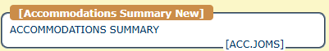

  - Select ACC.JOMS.

  - After selecting ACC.JOMS, you will find instructions on the main page that direct you to the menu on the left.
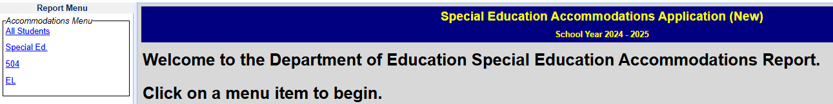

Select any of the categories to see the roster of students and their accommodations.

In the screenshot below, you can see the user has selected “All Students” on the left. By selecting the “All Students” tab, students within each of the three categories (i.e., Special Ed, 504, and EL) will be displayed.

The “Category” column indicates the accommodations category that is applicable to the student.
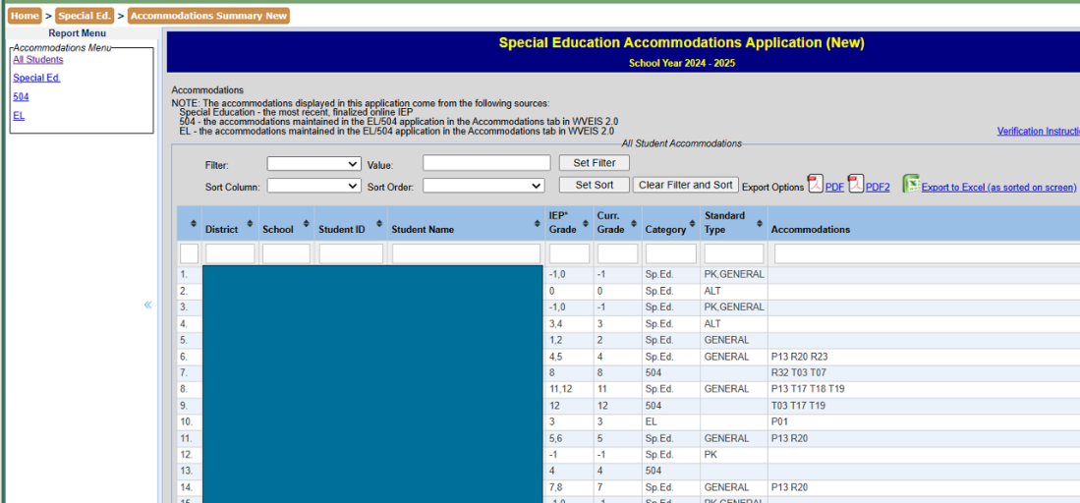

For students with assessment accommodations, the specific accommodations will be displayed in the Accommodations column.
If no accommodations are displayed for a student and the area is blank, it means no accommodations have been designated for the student in their plan.

Note: For details about the accommodation(s) listed, hover over the accommodation with the mouse cursor to have the detail displayed in a popup.

To download a pdf of the report, click either View PDF or View PDF2.

View PDF is a printable version of what is shown on the screen.

View PDF2 is a printable version but with one student per page.

Export to Excel will export the screen to excel.

How to Filter
There are times when it is necessary (or faster) to see only a select group of students that meet certain criteria or answer a specific question. For example, you may want to see students whose Last Name begins with the letter R.

- Click on the group of students on the left that is applicable. In this example, the “All Students” category has been selected.

- Go to the Filter box near the top of the page and click on the arrow to select “Last Name”.

- Next, type in the letter R in the “Value” box that is to the right of the Filter box.

- Finally, click on “Set Filter” to have only students whose last name begins with R displayed.
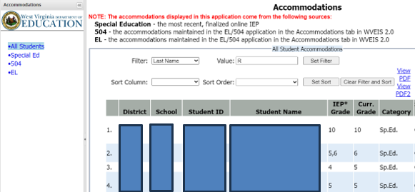
- To filter for a specific grade, you will need to select “Curr. Grade” in the filter box and then type in the appropriate value in the “Value” box.
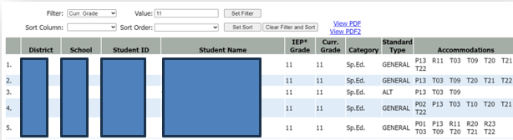

How to Sort
The sort feature is helpful when you’d like to see the information displayed in a different manner than the default display, which is ordered by last name from A to Z. You may wish to see the information sorted by current grade level.

For this example, the filter is set to display only school 301.

To sort by current grade:
- Click on the group of students on the left that is applicable. In this example, the “All Students” category has been selected.

- Go to the Sort dropdown box near the top of the page and click on the arrow to select “Curr.Grade”.

- Next, select Ascending in the “Sort Order” box to have the student information returned from smallest to largest number.

- Finally, click on “Set Sort” to have the information sorted by current grade level.

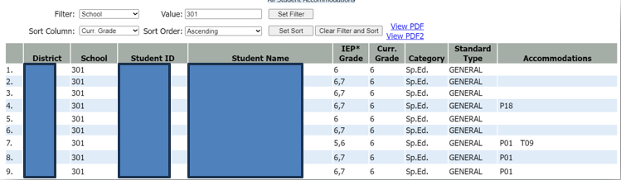

Filtering and Sorting for Alternate Assessment Students
The filter and sort feature can also allow you to easily identify students needing the alternate assessment test.

To filter for alternate assessment students:

- Click on the group of students on the left that is applicable. In this example, the “All Students” category has been selected.
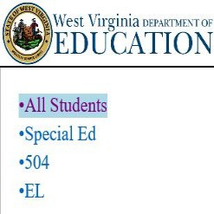
- Go to the Filter box near the top of the page and click on the arrow to select “Standard Type”.
- Next, type “ALT” in the Value box. The ALT represents alternate standards.
- Finally, click on “Set Filter” to have the information filtered for students receiving instruction through the alternate standards as per their IEP.

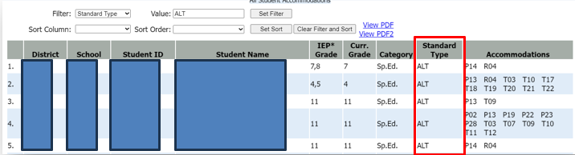

Additional notes
  - Larger counties’ data requires additional time to load.

Technical Assistance Communication Process
  - County Test Coordinators with questions or issues should contact the WVEIS County Contact. If the WVEIS County Contact cannot answer the question or solve the problem, they should contact the WVDE WVEIS Help Desk.

Column header filtering

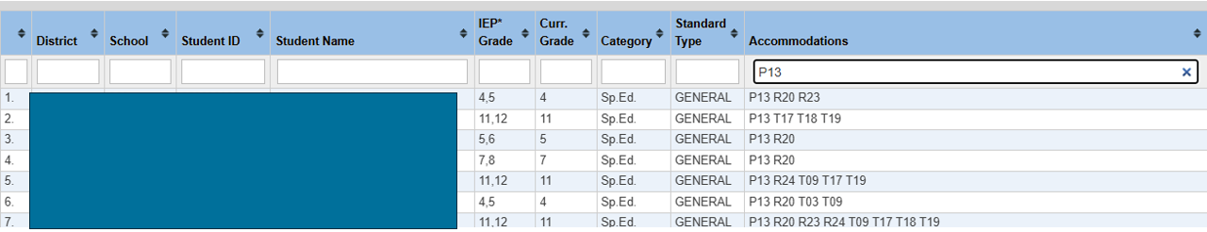
These fields can filter information.
In this example, P13 was entered under Accommodations so only those students with P13 will appear on the screen.

Appendix B. Accommodations Monitoring Process – MAE.4SA
Monitoring Accommodations Electronically.4 State Assessments (MAE.4SA)

This WVEIS-housed program is the monitoring system educators will use in documenting the provision of accommodations on state assessments – West Virginia General Summative Assessment (WVGSA), SAT School Day (SAT SD), English Language Proficiency Assessment – 21st century (ELPA21), Alternate-English Language Proficiency Assessment (Alt-ELPA), and West Virginia Alternate Summative Assessment (WVASA). This program is to be utilized following the administration of a state assessment. The information in this program should match the accommodation information found on the ACC.OMS report.

Test administrators, case manager(s), and building administrators should review the ACC.OMS report for accuracy prior to administering any state assessment. Review the section on Providing Accommodations for suggested timelines.

IEP/504/EL committees are strongly encouraged to have any accommodation changes completed prior to the opening of the state assessment window.

This ensures sufficient opportunity for the information to be provided to the testing platforms and the student to be allowed practice with the supports.

Accommodation information is drawn from the IEP 2.0 program and the 504/EL plan accommodations entered directly into WVEIS.

This guidance document assumes that the committee has determined the students’ accommodations (whether from an IEP/504/EL plan) to be appropriate and was provided during the administration of a state assessment. If, at any time, an error is found – the appropriate personnel are to be notified, and corrective actions engaged immediately.

Educators access MAE.4SA with their WVEIS log in and will have access to those students enrolled in the same school the educator is assigned to in WVEIS. Once logged in, educators will need the student’s WVEIS number to verify the accommodation provision. The records created are attached to that user’s WVEIS log in.

With the use of MAE.4SA, no paper forms are required to verify the provisions of accommodations. The WVEIS screen can be printed if the educator wishes to create a paper copy for their records. A printout of the ACC.OMS report could be used if a paper copy is needed.

Building administrators should utilize the “Reports” feature to monitor the completion of verification records.

The following screenshots and directions provide an overview of creating the records verifying the provision of student accommodations for state assessments.

- After administering a subject area or domain of a state assessment, log into WVEIS with your user account.
- Navigate to the MAE.4SA program.
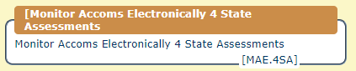

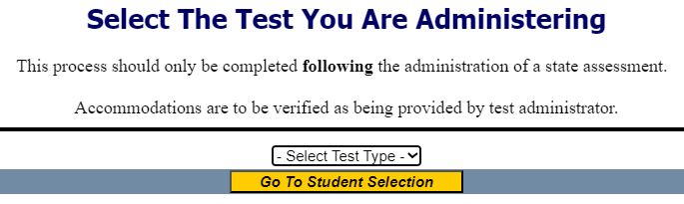
Click the drop-down menu and select the state assessment you have administered.

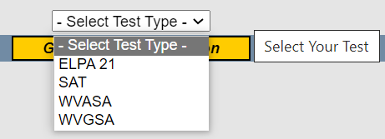
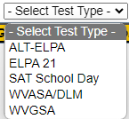

- Verify you have selected the correct assessment and enter the student’s WVEIS number.
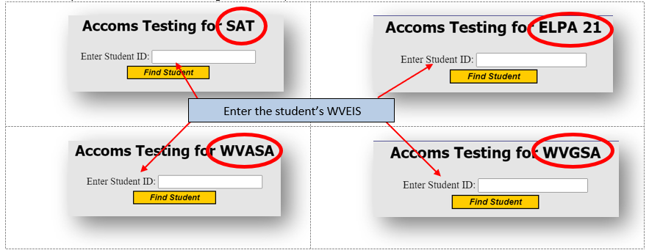
If you have selected the wrong assessment, click on the “Test Selection” link on the left side of the screen.

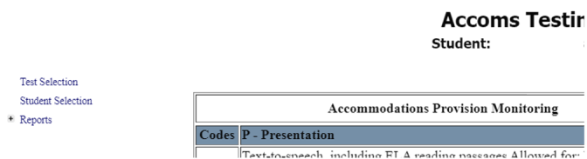
You can click here to go back to “Test Selection”.

- Verify the student’s name matches the WVEIS number entered.
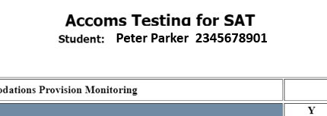

- Verify the accommodations listed match the student’s IEP/504/EL accommodations. If the accommodations listed here do not match, STOP. Contact the building administration to address the issue.

Once the error(s) have been resolved and the accommodations match the ones listed on the student’s educational plan, proceed with the verification process.
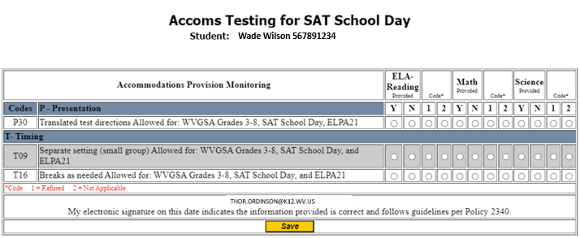

Only for the subject(s)/domain(s) assessed for the day:
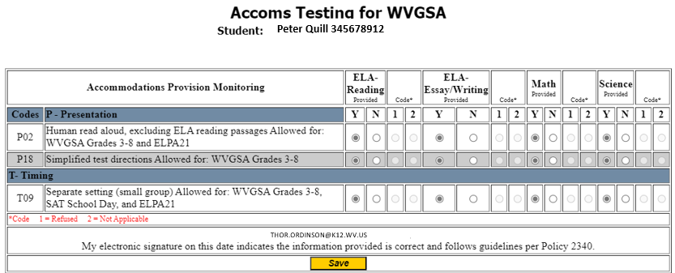
- To the right of each accommodation are columns to select (Y) for Yes, the accommodation was provided for the assessment or (N) for No, the accommodation was not provided for the assessment.

- If the accommodation was not provided, the test administrator must select either code (1) student refusal of the accommodation or (2) the accommodation was not applicable for this assessment.

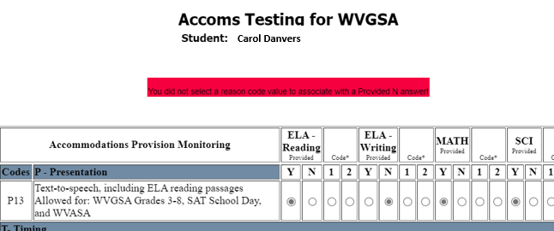
If (N) is selected but neither code of (1) or (2) is selected, upon clicking save, an error message will appear.
Carol Danvers 345678912

- Once all accommodation selections have been completed, click the yellow “Save” button at the bottom of the screen. This will lock your responses into WVEIS and attach your WVEIS log in to this record.

Verify your WVEIS log in matches the name displayed here. If your name is not displayed, STOP. Notify your building administrator and address the issue.

Reports Tool

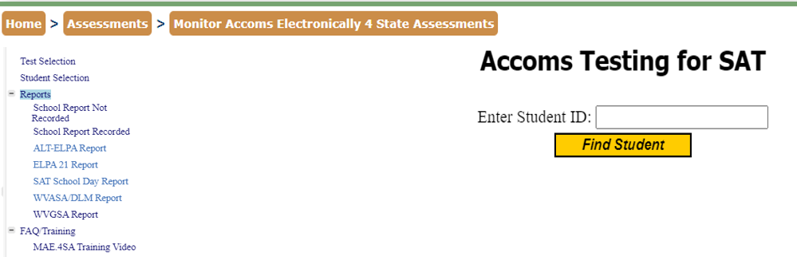
Building and County administrators have access to reports that indicate students who have records submitted verifying accommodations were provided, and a report with a list of students who do not have records submitted.

The screenshots on the following pages are mock-ups for the “School Report Recorded” report.

Reports for the “School Report Not Recorded” would look similar but without the completed information fields after the student’s name and school.

WVGSA Grades 3-8 & DLM MAE Report

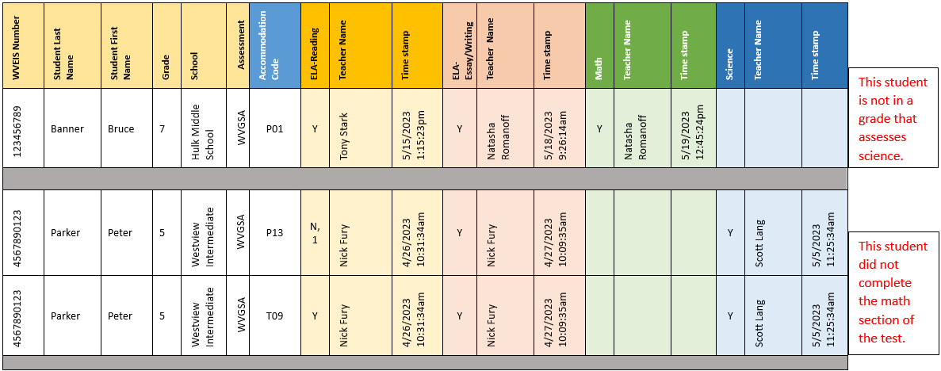
EXAMPLE

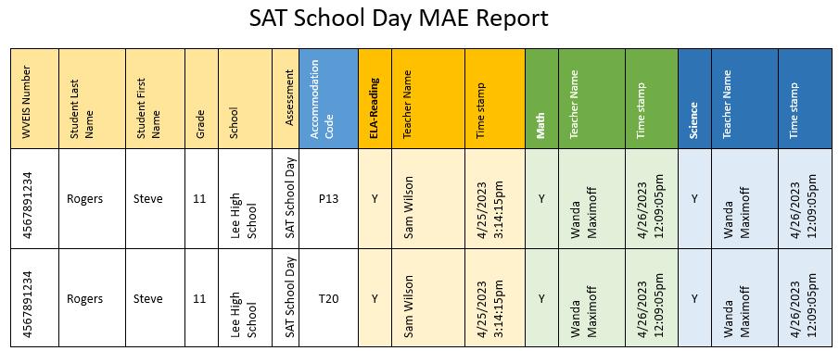

EXAMPLE

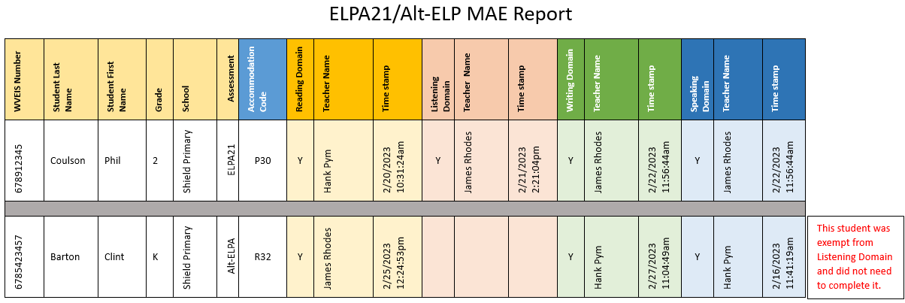
EXAMPLE

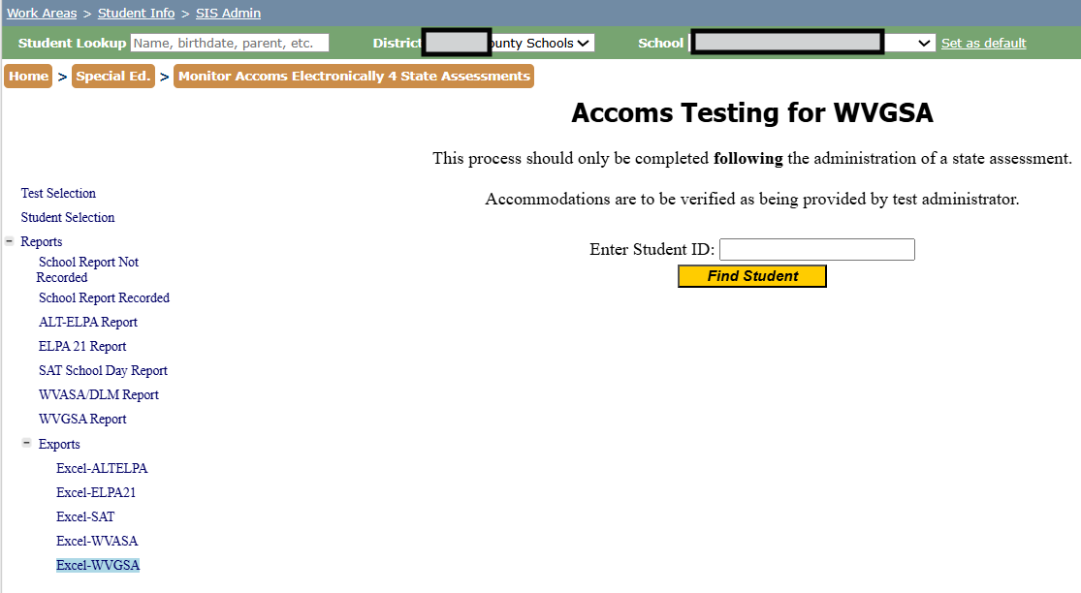
Reports Tool – Excel Export

Click “YES” if you get this pop up when opening the Excel file:

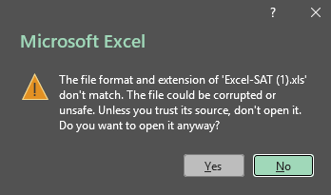
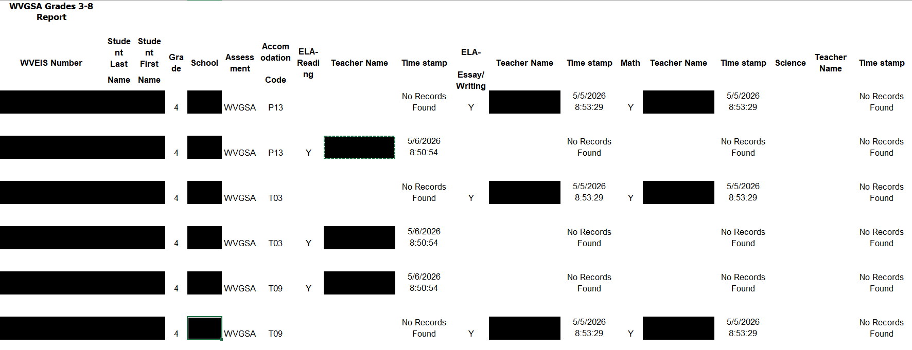
MAE.4SA Excel Exporting
There are no reports in the Science column because this student is not in a grade level that tests science.
If reviewing reports for multiple schools, remember to back up out of MAE before changing schools.

Completion Responsibilities for MAE.4SA
- The person administering the assessment for that day must be the person of record entering verification in MAE.4SA.
  - The only circumstance someone other than the test administrator who admitted the students into the testing platform should complete the MAE.4SA verification process is if that test administrator does not have WVEIS access (e.g., substitute teachers), then the building principal must be the individual to verify the accommodations have been provided.
    - In these circumstances, the school or county may require a hand-written and signed statement for their records from the substitute test administrator indicating that accommodations were provided as required by the student’s academic plan.
- Verification must be entered at the conclusion of each subject/domain area before the end of the day the test was administered.
  - Note: DLM administrators do not need to complete MAE.4SA after each testlet, only at the conclusion of the entire subject area.
- If more than one teacher is responsible for monitoring students during a test session, the teacher who admitted the students into the test platform is the person who must complete the MAE.4SA verification process.
- Homebound teachers who administer a state assessment are responsible for completing the MAE.4SA verification process for their student(s).

Common Sources of Accommodation Errors
- IEP not finalized.
- IEP service initiation date has not yet occurred.
- IEP not finalized for the correct initiation year.
- Demographic or enrollment information is incorrect in WVEIS.
- 504 or EL accommodations not entered in WVEIS.

Parent Refusal
If a parent refuses the accommodation on behalf of the student (either as part of “opting-out” of state assessments, initially taking the test or as part of an investigation re-test situation), treat this as a “Student Refusal” and indicate this with marking “N” and “1”.

Ensure the documentation about this refusal is stored with the student’s special education records and addressed at the next IEP meeting.
Out of State IEP Accommodations
If a student has accommodations from an out of state IEP, while the county is progressing through the West Virginia eligibility process as outlined in Policy 2419, the county is to utilize the Temporary Assessment Accommodations Entry System (TAAES.ACCM) process. This process provides a method to enter out-of-state assessment accommodations into the testing platforms and environment during the eligibility proceedings. The County Test Coordinator has information for this process.

Multiple Testing Administrators

If a student has multiple educators administering different subjects/domains of an assessment, the educator responsible for each subject/domain would enter the accommodation verification for their subject/domain only.

Example: Mr. Ramirez administers the math portion of the WVGSA while Ms. Perkins administers the ELA reading and writing portions. Mr. Ramirez would log into WVEIS and verify the provision of the accommodations for the math test that he administered, and Ms. Perkins would log in and verify the provision of accommodations only for the ELA reading and writing portions she administered.

Duplicate Accommodations Listed

If multiple entries appear for an accommodation, the student may have more than one educational support plan requiring accommodations. The ACC.OMS report will indicate if accommodations are being reported from a 504, IEP, or an EL plan.
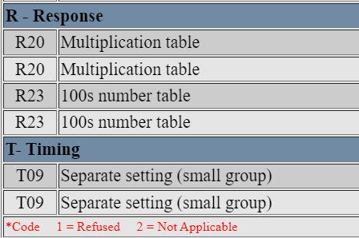

Selection Error

If an error is made in selecting a cell, exit from the page without saving the record by either clicking on “test selection” or “student record selection” links on the left side of the screen. This will permit you to reenter the accommodation verification page with a blank screen.

Verifying Across Different Testing Days

If you are only entering verifications for a specific subject/domain of the test – for example you administered the math portion of the test today - you can return to this screen following the administration of the rest of the assessment to enter the rest of the information. Entering and saving additional information will create a new record of the verification process attached to the appropriate WVEIS log in.

Changed Accommodations During Testing Window

If a student’s accommodations changed during the state test window, do not enter responses for new accommodations under subject areas that were tested prior to the IEP/504 plan changes. Leave them blank. Remind the building administration the reason for the blanks.

Different Accommodations in MAE Reports vs. ACC.OMS reports

If in the process of completing the MAE verification report, the test administrator determines a student was over/underaccommodated – report this immediately to the BLC and wait for further instructions.

Newly Eligible for Accommodations after Completing Some (or all) Tests

If a student becomes eligible for assessment accommodations but they have already completed some (or all) areas of the summative assessment, leave the reporting fields for those completed subjects in MAE blank. Remind the building administration the reason for the blanks.

Appendix C. Guidelines Read Aloud, Test Reader

Guidelines for Read Aloud, Test Reader

When a student cannot access text-to-speech, an embedded resource, the student may be eligible to work with a test reader. A test reader is an adult who provides an oral presentation of the assessment text to an eligible student. The student depends on the test reader to read the test questions accurately, pronounce words correctly, and speak in a clear voice throughout the test. The test reader must be trained and qualified and must follow the Guidelines for Read Aloud, Test Reader presented here. The guiding principle in reading aloud is to ensure the student has access to test content.

Qualifications for Test Readers
- The test reader should be an adult who is familiar with the student, and who is typically responsible for providing this accommodation during educational instruction and assessments.
- Test readers must be trained in the administration of the assessment in accordance with state policy, and familiar with the terminology and symbols specific to the test content and related conventions for standard oral communication.
- Test readers must be trained in accordance with state administration and security policies and procedures as articulated in state test administration manuals, guidelines, and related documentation.

Preparation
- Test readers should read and sign a test security/confidentiality agreement prior to test administration.
- Test readers are expected to familiarize themselves with the test environment and format in advance of the testing session. Having a working familiarity with the test environment and format will help facilitate reading of the test.
- Test readers should have a strong working knowledge of the embedded and non-embedded accessibility and accommodations options and tools available on assessments.
- Test readers should be familiar with the Individualized Education Program (IEP) or 504 plan if the student for whom they are reading has access to additional accommodations. This will ensure there are plans in place for providing all the necessary accommodations.
- In addition to a test reader, students may make use of any other approved specialized tools or equipment during the test as appropriate and in accordance with the 2026-2027 Participation Guidelines for West Virginia State Assessments document. Test readers should be familiar with any assistive technology or approved accommodations the student requires.
- Test readers should have extensive practice in providing the read aloud accommodation and must be familiar and comfortable with the process before working directly with a student.
- The reader should be knowledgeable of procedures for reading aloud text by content area (see Table 1 at the end of the Guidelines for Read Aloud, Test Reader).
- The test reader should meet with the student in advance and inform the student of the parameters of the accommodation. A suggested test reader script is included at the end of this appendix.
- Unless otherwise specified by a student’s IEP or 504 plan, the test reader does not have a role in manipulating the test or assisting with any other tools. Test readers should be ready with appropriate script that reinforces the parameters during the test session.

General Guidelines
- The test reader’s support should ideally be provided in a separate setting so as not to interfere with the instruction or assessment of other students.
- Read each question exactly as written as clearly as possible.
- Throughout the exam, strive to communicate in a neutral tone and maintain a neutral facial expression and posture.
- Avoid gesturing, head movements, or any verbal or non-verbal emphasis on words not otherwise emphasized in text.
- Avoid conversing with the student about test questions as this would be a violation of test security; respond to the student’s questions by repeating the item, words or instructions verbatim as needed.
- Do not paraphrase, interpret, define, or translate any items, words, or instructions as this would be a violation of test security.
- Spell any words requested by the student.
- Adjust your reading speed and volume if requested by the student.

Post Administration
- The test reader must collect scratch (lined or unlined paper) paper, rough drafts, and login information immediately at the end of the testing session and deliver it to the test administrator in accordance with state policies and procedures.
- The test reader must not discuss any portion of the test with others.
English Usage/Conventions Punctuation: Read all text as punctuated.
- Ellipses: When an ellipsis is used to signify missing text in a sentence, pause briefly, and read as ‘dot, dot, dot.’
- Quotations: Quotation marks should be verbalized as “quote” and “end quote” at the beginning and end of quoted material, respectively.
- Emphasis: When words are printed in boldface, italics, or capitals, tell the student the words are printed that way. In order not to provide an unfair advantage to students receiving this accommodation, test readers should be cautious not to emphasize words not already emphasized in print. Emphasis is appropriate when italics, underlining, or bold is used in the prompt, question, or answers.
- Misspellings: In some cases, a test item may present a word or phrase that is intentionally misspelled as part of the assessment. In these instances, the student is required to respond in a specific way. When presented with intentionally misspelled words test readers should not attempt to read the word(s) aloud as pronunciation is somewhat subjective.

Images/Graphics
- Before describing a picture or graphic, the test reader should determine whether the details of the picture are necessary to understand and respond to the item(s). In many cases, an image will be used to accompany a passage or reading excerpt as a piece of visual interest that is not essential in responding to the item.
- Describe the image/graphic as concisely as possible following a logical progression. Focus on providing necessary information and ignoring the superfluous. Use grade-appropriate language when describing the image/graphic.
- Read the title or caption, if available.

- Any text that appears in the body of an image may be read to a student. Read text in images in the order most suited for the students’ needs. Often the reader moves from top to bottom, left to right, or general to specific in accordance with teaching practices.

Passages
- Read the passage in its entirety as punctuated (e.g., pauses at periods; raised intonation for questions). Do not verbalize punctuation marks other than ellipses and quotation marks as noted above.
- If the student requires or asks for a specific section of the passage to be re-read with the punctuation indicated, the test reader should re-read those specific lines within the passage and indicate all punctuation found within those lines as many times as requested by the student.
- When test questions refer to lines of a passage, read the lines referenced as though they are part of the stem.

Graphic Organizers
- Before reading a graphic organizer, the test reader should discern the most appropriate and logical way to present the information. In general, information should be presented from broad to specific as indicated by the visual components of the document. The test reader should read the terms exactly as indicated in the graphic organizer. No other information about the graphic organizer should be given. For example, the test reader should not create sentences if information is bullet or appears in a title or label.
- Use common grade-appropriate language throughout the item and the test when referring to graphic organizers and their attributes (labels, blank cells, stems, etc.).

Mathematical Expressions
- Mathematical expressions must be read precisely and with care to avoid misrepresentation by a student who has no visual reference. For mathematics items involving algebraic expressions or other mathematical notation, it may be preferable for the reader to silently read the mathematical notations or the entire question before reading it aloud to the student.
- Test readers must read mathematical expressions with technical accuracy. Similar expressions should be treated consistently.
- In general, numbers and symbols can be read according to their common English usage for the student’s grade level.
- Numbers greater than 99, however, should be read as individual numbers.
- Additional examples may be found in this appendix.
- Abbreviations and acronyms should be read as full words. For example, 10 cm needs to be read as “ten centimeters.” Some abbreviations may be read differently by different readers. For example,
𝑐³ may be read as “cubic centimeters” or “centimeters cubed”.

Table 1. Test Reader Guidance for Mathematics

Numbers

Description | Example(s) | Read as:
Large whole numbers | 632, 407, 981  45,000,689,112 | “six three two comma four zero seven comma nine eight one”  “four five comma zero zero zero comma six eight nine comma one one two”
Decimal numbers | 0.056  4.37 | “zero point zero five six”  “four point three seven”
Fractions - common  Fractions - not common - read as “numerator over denominator” | $\frac{1}{2}$ $\frac{1}{4}$ $\frac{2}{3}$ $\frac{4}{5}$ | “one half, one fourth, two thirds, four fifths” Other common fractions include “sixths, eighths, tenths”
 | 14  25 | “fourteen over twenty-five”
 | 487  6972 | “four eight seven over six nine seven two”
Mixed numbers - read with “and” between whole number and fraction | 3 ½ | “three and one-half”
 | 57 ¾ | “fifty-seven and three fourths”
Percent | 62%  7.5%  0.23% | “sixty-two percent” “seven point five percent”  “zero point two three percent”
Money - if contains a decimal point, read as “dollars AND cents” | $4.98  $0.33  $5368.10 | “four dollars and ninety-eight cents” “thirty-three cents”  “five three six eight dollars and ten cents”
Negative numbers  - do NOT read negative sign as “minus” | -3 | “negative three”
Negative numbers  - do NOT read negative sign as “minus” | - $\frac{5}{8}$ | “negative five eighths”
Negative numbers  - do NOT read negative sign as “minus” | -7.56 | “negative seven point five six”
Dates (years) | 1987  2005 | “nineteen eighty-seven”  “two thousand five”
Roman Numerals | I  II III IV | “Roman Numeral one” “Roman Numeral two” “Roman Numeral three”  “Roman Numeral four”
Ratios | 𝑥𝑥:𝑦𝑦 | “x to y”

Equations

Description | Example(s) | Read as:
Addition | 13  + 27 13 + 27 =  13 + 27 =? | “thirteen plus twenty-seven equals”  “thirteen plus twenty-seven equals question mark”
Subtraction | 487  – 159 487 – 159 =  487 - 159 =? | “four eight seven minus one five nine equals”  “four eight seven minus one five nine equals question mark”
Multiplication | 63  X 49 63 X 49 =  63 X 49 =? | “sixty-three times forty-nine equals”  “sixty-three times forty-nine equals question mark”
Division – Vertical or Horizontal | 120 ÷ 15 = 8  120  =8  15 | “one two zero divided by fifteen equals eight”
Operations with boxes | 3 + ☐= 8 | “three plus box equals fifteen”

Expressions

Description | Example(s) | Read as:
Expressions containing variables (any letter may be used as a variable) | 𝑁 + 4 | “‘N’ plus four”
 | 8x-3 | “eight ‘x’ minus three”
 | 4(y-2)+5=7 | “four open parentheses ‘y’ minus two close parentheses plus five equals seven”
 | 𝑉 = $\frac{4}{3}$ 𝜋𝑟³ | “‘V’ equals four-thirds pi ‘r’ cubed”
 | |t|-2  6 ≤ 15 | “the absolute value of ‘t’ (pause) minus two (pause) over six is less than or equal to fifteen”
 | x²y³ = -36 | “‘x’ squared ‘y’ cubed equals negative thirty- six” or “’x’ to the second power times ‘y’ to the third power equals negative thirty-six”
 | 156x ≥ 4 | “one hundred fifty-six ‘x’ is greater than or equal to four”

Coordinate pairs  Answer choices with no other text | the point (–1, 2) | “the point (pause) negative one comma two”
Coordinate pairs  Answer choices with no other text | the point A is at (6, 3). | “The point ‘A’ is at (pause) six comma three.”
Coordinate pairs  Answer choices with no other text | A. (–3, –4) | “‘A’ (pause) negative three comma negative four”
Parallels | $\overline{AB}∥\overline{CD}$ | “line AB is parallel to line CD”
Perpendiculars | $$\overline{AB}⊥\overline{CD}$$ | “line AB is perpendicular to line CD”

Suggested Test Reader Script
(to be used with student in advance of the day of testing)

Hi ,
I'm the person who will be reading your test to you when you take your assessment next week in [mathematics/ELA]. I wanted to let you know how we'll work together. When I'm reading a test to you, it's very different from when I'm reading to you during class time. I must follow certain rules.
  - I cannot help you with any answers.
  - I cannot click on anything in the screen.
  - I will not be using different character voices or changes in my tone when I read. I will be using a very direct voice that does not change very much, no matter how exciting the story or test item gets.
  - If there is a picture that has words in it, I will read those words. If you ask, I will re- read the words as well.
  - I can still help you with your [**list any assistive technology the student may require that would need adult support -- if that support is provided by you].
  - You can ask me to re-read parts of the test if you didn't hear me or need more time to think.
  - You can ask me to pause my reading if you need to take a break.
  - You can ask me to slow down or speed up my reading or read louder or softer if you are having trouble understanding what I read.
  - I will only read certain types of punctuation, but if you need me to re-read a sentence and tell you how it was punctuated, I can do that.
  - If you ask me a question about the test all I will say is: "Do your best work. I cannot help you with that."
  - Do you have any questions for me about how we’ll work together during the test?

A reader may click on something on the screen only if this is an identified need in the student’s IEP or 504 plan and the reader has received appropriate training on when and how to do so.

Appendix D. Guidelines for Read Aloud in Spanish - Test Reader

When a student cannot access text-to-speech, the student may be eligible to work with a test reader. A test reader is an adult who provides an oral presentation of the assessment text to an eligible student. The student depends on the test reader to read the test questions accurately, pronounce words correctly, and speak in a clear voice throughout the test. The test reader must be trained and qualified and must follow the Guidelines for Read Aloud, Test Reader presented here. The guiding principle in reading aloud is to ensure the student has access to test content. Test readers in Spanish are allowable across all grades as a language accommodation for mathematics.

Qualifications for Test Readers
- The test reader should be a biliterate adult who is familiar with the student, and who is typically responsible for providing a Read Aloud accommodation in Spanish during educational instruction and assessments.
- Test readers must be trained in the administration of the assessment in accordance with state policy, and familiar with the terminology and symbols specific to the test content and related conventions for standard oral communication.
- Test readers must be trained in accordance with state administration and security policies and procedures as articulated in state test administration manuals, guidelines, and related documentation.

Preparation
- Test readers should read and sign a test security/confidentiality agreement prior to test administration.
- Test readers are expected to familiarize themselves with the test environment and format in advance of the testing session. Having a working familiarity with the test environment and format will help facilitate reading of the test.
- Test readers should have a strong working knowledge of the embedded and non- embedded accessibility and accommodations options and tools available on assessments.
- Test readers should be familiar with the Individualized Education Program (IEP) or 504 plan if the student for whom they are reading has access to additional accommodations. This will ensure there are plans in place for providing all the necessary accommodations.
- In addition to a test reader, students may make use of any other approved specialized tools or equipment during the test as appropriate and in accordance with the 2026-2027 Participation Guidelines for West Virginia State Assessments document. Test readers should be familiar with any assistive technology or approved accommodations the student requires.
- Test readers in Spanish should have extensive practice in providing the read aloud accommodation in Spanish and must be familiar and comfortable with the process before working directly with a student.
- The reader should be knowledgeable of procedures for reading aloud text by content area (see Table 1 at the end of the Guidelines for Read Aloud, Test Reader).
- The test reader should meet with the student in advance and inform the student of the parameters of the accommodation. A suggested test reader script is included at the end of this appendix.

- Unless otherwise specified by a student’s IEP or 504 plan, the test reader does not have a role in manipulating the test or assisting with any other tools. Test readers should be ready with appropriate script that reinforces the parameters during the test session.

General Guidelines
- The test reader’s support should ideally be provided in a separate setting so as not to interfere with the instruction or assessment of other students.
- Read each question exactly as written as clearly as possible.
- Throughout the exam, strive to communicate in a neutral tone and maintain a neutral facial expression and posture.
- Avoid gesturing, head movements, or any verbal or non-verbal emphasis on words not otherwise emphasized in text.
- Avoid conversing with the student about test questions as this would be a violation of test security; respond to the student’s questions by repeating the item, words or instructions verbatim as needed.
- Do not paraphrase, interpret, or define any items, words, or instructions as this would be a violation of test security.
- Spell any words requested by the student.
- Adjust your reading speed and volume if requested by the student.

Post-Administration
- The test reader must collect scratch (lined or unlined paper) paper, rough drafts, and login information immediately at the end of the testing session and deliver it to the test administrator in accordance with state policies and procedures.
- The test reader must not discuss any portion of the test with others.

Spanish Usage/Conventions
- Punctuation: Read all text as punctuated.
- Ellipses: When an ellipsis is used to signify missing text in a sentence, pause briefly, and read as ‘punto, punto, punto.’
- Quotations: Quotation marks should be verbalized as “comillas” and “fin de comillas” at the beginning and end of quoted material, respectively.
- Emphasis: When words are printed in boldface, italics, or capitals, tell the student the words are printed that way. In order not to provide an unfair advantage to students receiving this accommodation, test readers should be cautious not to emphasize words not already emphasized in print. Emphasis is appropriate when italics, underlining, or bold is used in the prompt, question, or answers.
- Misspellings: In some cases, a test item may present a word or phrase that is intentionally misspelled as part of the assessment. In these instances, the student is required to respond in a specific way. When presented with intentionally misspelled words test readers should not attempt to read the word(s) aloud as pronunciation is somewhat subjective.

Images/Graphics
- Before describing a picture or graphic, the test reader should determine whether the details of the picture are necessary to understand and respond to the item(s). In many cases, an image will be used to accompany a passage or reading excerpt as a piece of visual interest that is not essential in responding to the item.

- Describe the image/graphic as concisely as possible following a logical progression. Focus on providing necessary information and ignoring the superfluous. Use grade- appropriate language when describing the image/graphic.
- Read the title or caption, if available.
- Any text that appears in the body of an image may be read to a student. Read text in images in the order most suited for the students’ needs. Often the reader moves from top to bottom, left to right, or general to specific in accordance with teaching practices.

Passages
- Read the passage in its entirety as punctuated (e.g., pauses at periods; raised intonation for questions). Do not verbalize punctuation marks other than ellipses and quotation marks as noted above.
- If the student requires or asks for a specific section of the passage to be re-read with the punctuation indicated, the test reader should re-read those specific lines within the passage and indicate all punctuation found within those lines as many times as requested by the student.
- When test questions refer to specific lines of a passage, read the lines referenced as though they are part of the stem.

Graphic Organizers
- Before reading a graphic organizer, the test reader should discern the most appropriate and logical way to present the information. In general, information should be presented from broad to specific as indicated by the visual components of the document. The test reader should read the terms exactly as indicated in the graphic organizer. No other information about the graphic organizer should be articulated. For example, the test reader should not create sentences if information is bullet or appears in a title or label.
- Use common grade-appropriate language throughout the item and the test when referring to graphic organizers and their attributes (labels, blank cells, stems, etc.).

Mathematical Expressions
- Mathematical expressions must be read precisely and with care to avoid misrepresentation by a student who has no visual reference. For mathematics items involving algebraic expressions or other mathematical notation, it may be preferable for the reader to silently read the mathematical notations or the entire question before reading it aloud to the student.
- Test readers read mathematical expressions with technical accuracy. Similar expressions should be treated consistently.
- In general, numbers and symbols can be read according to their common Spanish usage for the student’s grade level.
- Numbers greater than 99, however, should be read as individual numbers.
- Additional examples may be found in this appendix.

Abbreviations and acronyms should be read as full words. For example, 10 cm needs to be read as “diez centímetros.” Some abbreviations may be read differently by different readers. For example, 𝑐𝑐𝑐𝑐3 may be read as “centímetros cúbicos” or “centímetros al cubo”.

Table 1 Test Reader Guidance for Mathematics
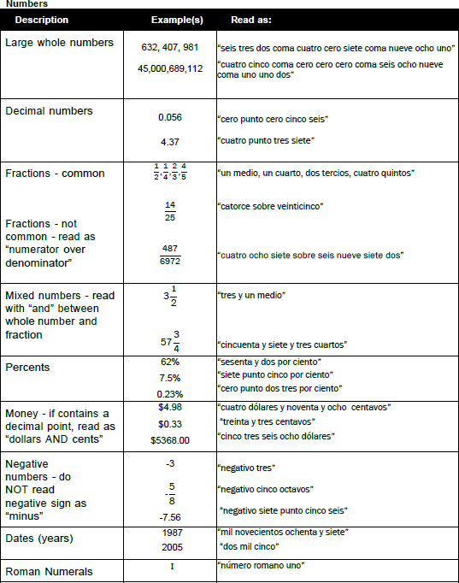

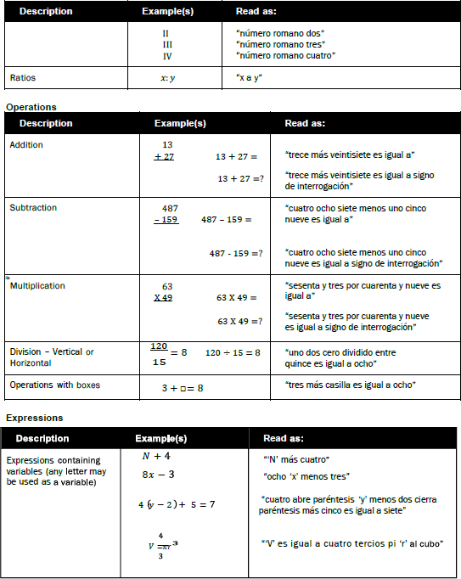

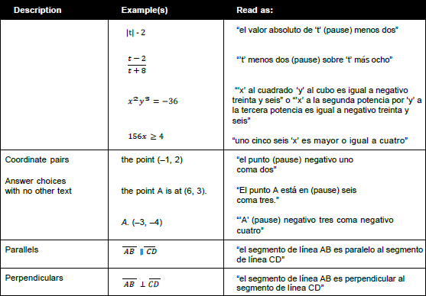

Suggested Test Reader Script
(to be used with student in advance of the day of testing)

Hola ,

Soy la persona asignada para leerte el examen que tomarás la próxima semana durante la Evaluación de de matemáticas. Me gustaría informarte cómo estaremos trabajando juntos. Cuando te esté leyendo la prueba, será de manera muy distinta a cuando te estoy leyendo durante la clase. Necesito seguir ciertas reglas.

- No te puedo ayudar con ninguna respuesta.
1
- No puedo hacer clic sobre nada en la pantalla.
- No estaré usando diferentes voces de personajes o cambiando mi tono de voz cuando lea. Estaré usando una voz muy directa que no cambie mucho, no importa qué tan emocionante sea la historia o ítem de la prueba.
- Si hay una imagen con palabras, leeré esas palabras. Si lo pides, leeré nuevamente las palabras.
- Algunas veces puede haber algo sobre una palabra o frase que te puede dar una clave si lo leo en voz alta. En esos casos, no leeré esa la palabra, la señalaré en la pantalla [o en el cuadernillo de o impreso al momento] y continuaré leyendo.
- Todavía puedo ayudarte con tus [***list any assistive technology the student may require that would need adult support -- if that support is provided by you].
- Me puedes pedir que lea nuevamente partes de la prueba si no me escuchaste o necesitas más tiempo para pensar.
- Me puedes pedir que haga una pausa en la lectura si necesitas tomar un descanso.
- Me puedes pedir que lea más despacio o más rápido, o leer más alto o más bajo si tienes problema entendiendo lo que leo.
- Leeré ciertos signos de puntuación, pero si necesitas que lea nuevamente una oración y que te diga la puntuación, puedo hacerlo.
- Si me haces una pregunta sobre la prueba lo único que te voy a decir es: "Haz tu mejor trabajo. No te puedo ayudar en eso.
- ¿Tienes alguna pregunta sobre cómo vamos a trabajar juntos durante la prueba?

1
A reader may click on something on the screen only if this is an identified need in the student’s IEP or 504 plan and the reader has received appropriate training on when and how to do so.

Appendix E. Guidelines for Scribing and Transcribing Student Responses

Definition and basic duties of scribes
A scribe is an adult who writes down what a student dictates via speech, American Sign Language, or an assistive communication device. The guiding principle in scribing is to ensure the student has access to and is able to respond to test content.

Qualifications for Scribes

- The scribe should be an adult who is familiar with the student, such as the teacher or teaching assistant who is typically responsible for scribing during educational instruction and assessments.
- Scribes must have demonstrated knowledge and experience in the subject for which scribing will be provided.
- Scribes should have extensive practice and training in accordance with state administration and security policies and procedures as articulated state test administration manuals, guidelines, and related documentation.
- Scribes must be a currently employed educator and/or approved employee of the state or county, or a currently employed educator of a nonpublic school.
- Scribes must hold a valid West Virginia teaching license or certification granted by the Office of Certification.
- Scribes must have been trained and must have on file a signed Examiner’s/Scribe’s Secure Materials and Test Procedures Agreement (See Policy 2340) for the purpose of administering or assisting with the administration of an assessment included in the WV-MAP.

Preparation

- Scribes must read and sign a test security/confidentiality agreement prior to test administration.
- Scribes are expected to familiarize themselves with the test format in advance of the scribing session. Having a working familiarity with the test environment will help facilitate the scribe’s ability to record the student’s answers.
- Scribes should be familiar with the Individualized Education Program (IEP) or 504 Plan if the student for whom they are scribing has a disability, so there are plans in place for providing all needed accommodations.
- Scribes should also have a strong working knowledge of the embedded and non-embedded accessibility and accommodations options and tools available on assessments.
- Scribes should review the Scribing Protocol for Assessments with the student at least one to two days prior to the test event.
- Even if the scribe is familiar with the student, the scribe should practice the process with the student at least once prior to the scribing test session.

General Guidelines

- Scribing must be administered so the interaction between a scribe and a student does not interrupt other test-takers or inadvertently reveal the correct answers.
- If not in a separate setting, the scribe should be situated near enough to the student to prevent their conversations from reaching other students in the room.
- For computer-based administrations, scribes must enter student responses directly into the test interface, making use of the available embedded and non-embedded tools available for a given item and student.
- Scribes are expected to comply with student requests regarding use of all available tools within the test environment.
- Scribes may respond to procedural questions asked by the student (e.g., test directions, navigation within the test environment, etc.).
- Scribes may not respond to student questions about test items if their responses compromise validity of the test. The student must not be prompted, reminded, or otherwise assisted in formulating their response during or after the dictation to the scribe.
- Scribes may ask the student to restate words or parts as needed. Such requests must not be communicated in a manner suggesting the student should make a change or correction.
- Scribes may not question or correct student choices, alert students to errors or mistakes, prompt or influence students in any way that might compromise the integrity of student responses. A scribe may not edit or alter student work in any way and must record exactly what the student has dictated.
- Students must be allowed to review and edit what the scribe has written. If necessary, the student can request the scribe to read aloud the completed text before final approval.
- Demonstrate proficiency in signing (ASL and/or signed English) if serving as both the interpreter and scribe.
- Remain silent while students are dictating or signing.
- Record the interpreter’s response.
- Produce legible text so the written portion of the test can be scored.
- When transcribing from a handwritten or word-processed response, record punctuation, capitalization, and spelling as provided by the student.
- Request clarification from the student about the use of capitalization, punctuation, and the spelling of key words.
- Refrain from editing student work or completing a student’s incomplete essay.
- Refrain from discussing the student’s essay with the student or any other person.

After the Assessment
- WVGSA/SAT School Day/DLM/ELPA21-Alt-ELPA - Enter the student’s responses into the appropriate testing platform, unless responses were directly entered into the test session through the student’s username.
- Fill out the Scribe Verification Form (Appendix L: West Virginia Assessment Scribe/Interpreter/Translator Verification Form in this book) at the end of the transcription.
  - List the names and enrollment grades of the students whose responses were transcribed and send the form to the principal/building level coordinator upon completion.

The use of a scribe can be either an accommodation or a modification, depending on how the scribing is provided. Modifications on WV-MAP are not allowed and result in invalidation of results. Any variation in the assessment environment or process that fundamentally alters what the test measures or affects the comparability of scores is considered a modification.
Notes: An examiner may be a substitute teacher or an aide serving as an examiner for special needs students when instructionally assigned. All aides and nonpublic school educators must be approved by the WVDE.
Student teachers may not serve as examiners or scribes. Much skill is involved in being a scribe, a skill that requires extensive practice. Individuals who serve as scribes need to be carefully prepared to ensure they know the vocabulary involved and understand the boundaries of the assistance to be provided.

English Language Arts Content - Specific Guidelines
Selected Response Items (Single and Multiple Answer)

- The student must point to or otherwise indicate their selection(s) from the options provided.
- Scribes are expected to comply with student directions regarding screen and test navigation and use of test platform tools available for a given item.
- The student will confirm the selected answer and indicate to the scribe when they are ready to move to the next item.

Constructed Response Items (Short-Text)

- The scribe will write verbatim student responses on paper or on screen in an area secluded from another students’ view.
- The scribe will correctly spell all words as dictated.
- The scribe will not capitalize words or punctuate text.
- The scribe will orally confirm spelling of homonyms and commonly confused homophones, e.g., than and then; to, two, and too; there, their, and they're.
- The student will proofread to add punctuation, capitalization, spacing, and make other edits.
- The scribe will make student requested changes, even if incorrect.
- The student will confirm the fidelity of the response.
- The student will indicate to the scribe when they are ready to move to the next item.

Long Essay (Full-Write)

- The scribe will write verbatim student responses on paper or on screen in an area secluded from another students’ view.
- The scribe will spell all words as dictated.
- The scribe will not capitalize words or punctuate text.
- The scribe will orally confirm spelling of homonyms and commonly confused homophones, e.g., than and then; to, two, and too; there, their, and they're.
- The student will proofread to add punctuation, capitalization, spacing, and other edits.
- The scribe will make student requested changes, even if incorrect.
- The student will confirm the fidelity of the response.
- The student will indicate to the scribe when they are ready to move to the next item.
- Scribes should request clarification from the student about the use of capitalization, punctuation, and the spelling of words, and must allow the student to review and edit what the scribe has written.

Mathematics Content - Specific Guidelines
Selected Response Items (Single and Multiple Answer)

- The student must point to or otherwise indicate their selection from the options provided.
- The scribe will comply with student directions, including requests regarding screen and test navigation and use of test platform tools available for the question.
- The student will confirm their selections and indicate to the scribe when they are ready to move to the next item.
- Scribes should request clarification from the student about the use of capitalization, punctuation, and the spelling of words, and must allow the student to review and edits what the scribe has written.

Constructed/Equation Response Items

- The student must point or otherwise direct the scribe in developing their response.
- The scribe will input student work directly onscreen and in view of the student.
- For responses requiring equations, the student must specify where to place figures and operands.
- For responses requiring text, the scribe will correctly spell all words as dictated and conform to standard writing conventions.
- For responses requiring text, the student will proofread to add punctuation, capitalization, spacing, and other edits.
- The scribe will make student requested changes, even if incorrect.
- The student will confirm the fidelity of the response.
- The student will indicate to the scribe when they are ready to move to the next item.

Post - Administration

- The scribe will submit online or paper-based student responses and collect scratch (lined or unlined paper) paper, rough drafts, and login information immediately at the end of the testing session and deliver it to the test administrator in accordance with state policies and procedures.

Appendix F. Guidelines for Simplified Test Directions
Simplified test directions is an accommodation allowable on WVGSA – all grades. Students with difficulties in auditory processing, short-term memory, attention, or decoding may benefit from having test directions simplified for them. This accommodation will require testing in a separate setting to avoid distracting other test takers.

A test administrator who provides the simplified test directions accommodation is an adult who simplifies the script within the SAY boxes in the Online Summative Test Administration Manual (TAM). Test administrators should not deviate from the test directions found in the TAM in ways that impact the content being measured. The student depends on the test administrator to read the script in the TAM accurately, pronounce words correctly, and speak in a clear voice. When a student needs additional support understanding the test directions found in the TAM, the test administrator may simplify or paraphrase the language in the script and verify the student’s understanding.

Simplifying test directions should be consistent with classroom instruction and includes repeating or rephrasing. This may include breaking TAM directions into parts or segments or using similar words or phrases, but it should exclude defining words or concepts. The test administrator must be trained in administering the assessment and must follow the Simplified Test Directions presented here. The test administrator must ensure the student understands the directions in the TAM. Only the script in the TAM may be simplified. Test content, including test items, words from items, or instructions for individual items may NOT be simplified or paraphrased.

Qualifications for Test Administrators Who Simplify Test Directions
- The test administrator who simplifies test directions should be an adult who is familiar with the student, and who is typically responsible for providing this accommodation during educational instruction and assessments.
- Test administrators must be trained on the administration of the assessment in accordance with member policy and be familiar with the terminology and symbols specific to the directions and related conventions for standard oral communication.
- Test administrators must be trained in accordance with state policies and procedures.
- Test administrators must be familiar with the vocabulary used in the TAM directions and be able to speak clearly and at a normal pace with clear pronunciation.
- Test administrators must be willing to be patient and repeat test directions.

Prior to Test Administration
In addition to the guidelines noted in the TAM, test administrators who simplify test directions should:
- Be trained in administering the assessment per the requirements noted in test specific Test Administrator Manuals.
- Familiarize themselves with the testing environment and format in advance of the testing session.
- Have a strong working knowledge of the embedded and non-embedded universal tools and accommodations available on assessments.
- Have extensive practice in simplifying test directions and must be familiar and comfortable with the process before working directly with the student.
- Be familiar with the students’ needs, including the Individualized Education Program (IEP) or 504 plan if the student for whom they are reading has access to additional accommodations. This will ensure there are plans in place for providing all the necessary accommodations.
- Be familiar with any assistive technology or approved accommodations the student requires. In addition to the simplified test directions accommodation, students may make use of any other approved accessibility resource during the test as appropriate and in accordance with the 2026-2027 Participation Guidelines for West Virginia State Assessments document.
- It is recommended that the same test administrator be assigned to students for each day of testing.
Day of Test Administration
In addition to the guidelines noted in the Test Administrators Manual, test administrators who simplify test directions should:
- Be prepared to restate the language in the script.
- Read the directions aloud in paraphrased, clarified, or simplified form, rather than reading the script verbatim.
- Follow the TAM guidelines for assisting the student with taking the test.
- Not prompting the student in any way that would result in a different response to a test item.
- Not influence the student’s response in any way.
- Spell any words in the script if requested by the student.
- Adjust their reading speed and volume if requested by the student.
- Not paraphrase, interpret, define, or translate any aspect beyond the script provided in the TAM. They should NOT read aloud any parts of the test content, including items, words, or instructions as this would be a violation of test security.
- If the student is also registered for the read aloud accommodation in conjunction with the simplified test directions accommodation, the test reader should follow the Guidelines for Read Aloud.

Following Test Administration
Test administrators who simplify test directions should follow any guidelines for “Following Test Administration”, in the test specific TAM.

Example of Simplified Test Directions

Full Log-in Directions | Simplified Log-in Directions
Now we are ready to log in. Once you have logged in, you will have to wait for me to approve the test before you start. I’ll be checking you have correctly entered the test session ID and other information.  Enter your legal first name, not your nickname, followed by your SSID number. Then enter the test session ID. Raise your hand if you need help typing this information on your keyboard. | Now we are ready to log in. Enter your legal first name, not your nickname, followed by your SSID number. Then enter the test session ID.
Now click “Sign In.” Once you have successfully logged in, you will see a screen with your first name and other information about you. If all the information on your screen is correct, select YES to continue. If any of the information is incorrect, please raise your hand and show me what is incorrect. | Now click “Sign In.” Make sure your personal information on the next screen is correct and click YES to continue. If it is not correct, raise your hand.
On the next screen, select the [INSERT NAME OF TEST]. After you have selected your test, you will see a screen with a moving bar and a message saying you are waiting for Test Administrator approval.  Please wait quietly while I verify each of your tests. | On the next screen, select the [INSERT NAME OF TEST]. Then wait.
After I approve you to begin testing, you will see a screen asking you to check your test content area and settings. If all the information is correct, you may select YES, START MY TEST. If any of it is incorrect, please raise your hand.  Before your test appears, you will see a tutorial page listing the test tools and buttons you may use during the test or that will appear on the test. Please read this carefully. You can also find this information during your test by clicking the HELP button in the top right corner. | After I approve you to begin testing, make sure you have the right test and settings. If any of the test information is incorrect, please raise your hand. If the information is correct, click YES, START MY TEST.
When you are ready to begin your test, click BEGIN TEST NOW at the bottom of the page. | When you are ready to begin your test, click BEGIN TEST NOW at the bottom of the page.

Appendix G. Use of Human Translators Agreement

State of West Virginia West Virginia Board of Education
County of West Virginia Measures of Academic Progress

An allowance has been provided for the administration of the mathematics general assessment to include a non- embedded language accommodation for the translation glossaries. The provision provides the opportunity for a student with an EL plan to receive the language accommodation of a human translator when the test does not provide translation glossaries in the native language of a student.

It should be noted the non-embedded language accommodation of human translation is only allowed under the following conditions:
- The student must have an active EL plan, and at least one of the following:
  - P24: Translator (Human) be assigned to the student for WVASA, or
  - P30: Translated Test Directions be assigned to the student for WVGSA and
SAT School Day, or
  - P32: Embedded Spanish translations for computer-based assessments be assigned to the student for WVGSA or
  - P41: Provide translation glossary (paper/pencil tests) be assigned to the student for SAT School Day

A protocol has been established to ensure human translators meet a quality of assurances and comply with existing state requirements. Counties electing to utilize human translators must ensure the following:
- A certified examiner, meeting the criteria established in WVBE Policy 2340, West Virginia Measures of Academic Progress, must be present during the entire testing session.
- The human translator must meet the following expectations:
  - The human translator must be proficient in both English and the native language for which the student is requesting human translation accommodation.
  - The human translator complies with all the examiner criteria establish in Policy 2340, West Virginia Measures of Academic Progress.
  - The human translator provides services only in a school in which they do not currently have a child enrolled.
Human translators are required to sign the agreement below and WVBE Policy 2340, West Virginia Measures of Academic Progress, Examiner's/Scribe's Secure Materials and Test Procedures Agreement.
Please print your name, sign, and return the Use of Human Translators Agreement to the appropriate school coordinator five instructional days prior to administering any assessment.

Signature:
Print Name: _ Position:
School: __________________Date:_______________ _____

If this form is not on file, it will be considered a breach of security by the county and state boards of education.
This agreement is valid for the academic year of signatory date.

Appendix H. Accessibility Tools

Accessibility Supports in the Classroom

Use this chart to track different aspects of how a student uses accessibility supports (universal tools and accommodations) in your classroom. This will help inform decision making on accessibility supports.

Student: ____________ WVEIS:____________ Grade: Date:
Languages: ______________ Accessibility Support(s): _____________________________________________

What accessibility supports does the student use in the classroom? List them in the chart. Then follow the questions in the chart.

ACCESSIBILITY SUPPORT
Team Members (e.g., teacher, parent, specialist, interventionist, paraprofessional)

      - Is the support noted in the students’ IEP, 504, EL, or SAT plan?

      - For what types of task(s) is it used?

      - Does the student use it for that task every time? If not, how often?

      - Does the student use it alone or with assistance? (e.g., aide, peers)

      - If the accessibility support is presented differently on the test (e.g., an online calculator, embedded speech-to-text), how can you give the student opportunities to practice using it?

      - Does the student’s plan need to be updated?

After-test Accessibility Questions

Use this form after a test to interview a student about the accessibility supports (universal tools and accommodations) provided, used, whether they were useful, and whether they should be used again. Also note any adjustments or difficulties experienced by the student in either how the accessibility support was administered or in using the accessibility support during the assessment. Students in higher grades may do this independently or filling out this form could be facilitated through a discussion between a teacher and a student.

Student: ____________ WVEIS:____________ Grade: Date:
Accessibility support(s) used: ____________________________________________

Supports Available (List)
1. |  | 2. |  | 3. |  | 4.
Was the accessibility support used? (Circle Yes or No and record optional comments.)
Yes | No | Yes | No | Yes | No | Yes | No
Was the accessibility support useful? (Circle Yes or No and record optional comments.)
Yes | No | Yes | No | Yes | No | Yes | No
Were there any difficulties with the accessibility support? (Are adjustments needed?)
(Circle Yes or No and record optional comments.)
Yes | No | Yes | No | Yes | No | Yes | No
Should the accessibility support be used again? (Circle Yes or No and record optional comments.)
Yes | No | Yes | No | Yes | No | Yes | No

Accessibility Selection Questions for Teams

Teams can use the following questions to guide the initial selection of appropriate accessibility supports and to revisit supports students are currently using:

Student: ____________ WVEIS:____________ Grade: Date:

 | Questions | Comments
 | What are the students’ language learning strengths and areas of further improvement (applicable to all students, not just Els)?
 | How do the student’s learning needs affect the achievement of grade-level standards?
 | What specialist instruction (e.g., learning strategies, organizational skills, reading skills) does the student need to achieve grade-level standards?
 | What accessibility supports will increase the student’s access to instruction and assessment by addressing the student’s learning needs?
 | What accessibility supports are regularly used by the student during instruction, assessments, and at home?
 | How does the student’s performance on assignments and assessments compare when accessibility supports are used, versus when they are not used?
 | Which support does the student use at home to complete homework?
 | What difficulties does the student experience when using accessibility supports?
 | What are the perceptions of the student, parents or guardians, teachers, and other specialists regarding how well the accessibility support “worked”?
 | Should the student continue to use an accessibility support, are changes needed, or should the use of the accessibility support be discontinued?
When matching accessibility supports with students’ characteristics, have educators ensured:
- The student’s willingness to learn to use the accessibility support;
- Opportunities for the student to learn to use the accessibility support in classroom settings; and
- Conditions for use of support(s) on state assessments?
 | What are the characteristics of the test? Consider grade-level content standards, cognitive complexity (i.e., read through test blueprint), proficiency level, performance-level descriptors, etc.
 | Are tasks on the test like classroom assessment tasks? Do classroom tasks expose the student to the same cognitive complexities, level of mastery (based on achievement or performance-level descriptions), and range of difficulty for each content standard as the test?
 | Is there ample opportunity for the student to practice similar tasks prior to testing?
 | Does the student use an accessibility support for a classroom task, and is it allowed on the district or state tests?
 | Does the student use an accessibility support in the classroom that could compromise the construct being assessed?
 | Are there other barriers which could be removed by using an accessibility support that is different from what is already offered or in use (e.g., scheduling accommodation or universal feature)?

Adapted with permission from: Lazarus, S., Goldstone, L., Wheeler, T., Paul, J., Prestridge, S., Sharp, T., Hochstetter, A.,
and Warren, S. (2021). CCSSO Accessibility Manual: How to Select, Administer, and Evaluate Use of Accessibility
Supports for Instruction and Assessment of All Students. The Council of Chief State School Officers (CCSSO).

Appendix I. Request to Utilize Other Personnel for WV MAPS

West Virginia Assessment Administration, 2026-2027
You must circle the assessment this request is for, if you do not circle one it will NOT be processed.
WVGSA WVASA(DLM) SAT School Day ELPA21 Alt-ELP Assessment Benchmark

Name of School (no initials): _______________________ County: _____________________________Principal: _________________________

Please complete the following for all long-term aides and teachers on permit for whom you are requesting permission. If necessary, you may attach additional documentation. All approved personnel will need to be trained and sign the appropriate security agreements prior to testing. All information must be completed for each employee for whom you are requesting approval.

Employee’s | Employee’s Job Title | Student WVEIS number  (Must list each student  individually.) | Does employee | Requesting Permission to: | Justification of Request
Name |  |  | currently work with |  | (Give a specific reason why it is necessary to
(Last, First) |  |  | this student and for |  | use this employee to administer a West
 |  |  | how long? |  | Virginia Summative Assessment.)
 | - Long-term Aide |  | - Yes | - Scribe  - Administer WVGSA or SAT School Day w/out supervision  - Other (specify)
 | - Other (specify): |  | - No
 |  |  | - < 1 yr.
 |  |  | - > 1 yr.
 | - Long-term Aide |  | - Yes | - Scribe  - Administer WVGSA or SAT School Day w/out supervision  - Other (specify)
 | - Other (specify): |  | - No
 |  |  | - < 1 yr.
 |  |  | - > 1 yr.
 | - Long-term Aide |  | - Yes | - Scribe  - Administer WVGSA or SAT School Day w/out supervision  - Other (specify)
 | - Other (specify): |  | - No
 |  |  | - < 1 yr.
 |  |  | - > 1 yr.

Signature of Principal Date

Signature of County Test Coordinator Date

If WVDE approval is not received prior to administering the assessment with these requested personnel, student scores may be invalidated without the opportunity to retest.
County Test Coordinator:
WVDE Office use only: _________(date received)

Approved: (yes) (no) (Initials) Follow up needed?
Instructions will be provided on how to submit this request electronically.

Appendix J. Request for Exclusion from Participation Rate due to Catastrophic Medical Emergency

Student Name (last, first) |  | WVEIS |  | Grade
School (no initials) |  | School WVEIS Code
Date of Birth | County |  | County WVEIS Code

Assessment Requesting Waiver from Participation Rate Accountability | - WVGSA  - SAT School Day (Grade 11)  - WVASA | - ELPA21  - Alt-ELP Assessment
Content Area  (check all that apply) | - Math  - ELA  - Science (Only Grades 5, 8, and 11)
Dates of Condition | Start Date: | End Date:
Academic plan(s) student receives services through  (check all that apply) | - IEP  - 504 Plan | - EL Plan  - Health Care Plan
Is the student receiving homebound services during the state test window?  Is the school aware the homebound teacher can be trained to administer most state summative assessments? | - Yes  - No
 | If yes, please list date homebound services began _____________ and date of the last review of eligibility for homebound services _____________.
What accommodations or accessibility supports have been used to support this student’s needs? Are these supports successful in the classroom/during instruction? Why would they not suffice during the state summative assessment(s)?

____________________County ____________________ Student WVEIS number
Overview of Request (Brief description – include how the diagnosis prevents the student from successfully participating in the state summative assessment at any point in the state test window.)
Attached Documentation  Failure to provide the necessary information may result in the request be denied. | - Attendance  - Signed statement from the student’s treating physician/Health care provider which should contain:  - Description of the nature of the condition or treatment.  - Assertion that the condition or treatment has prevented the student from accessing educational services.  - A beginning and an end date or future anticipated end date.  - Any other relevant information to help in the review process.  5. Any other documentation that is relevant to the request. Describe below:

My signature below certifies the above information is true to the best of my knowledge and I will retain the appropriate signatures and other documentation in storage for a period of at least three years from the date of submission.

I understand during this time the documentation may be subject to an audit led by the Office of Research, Accountability and Data Governance.

County Required Signatures:

Principal: Date:

*Special Education Director/504 Coordinator or Title III Director: (*for students with disabilities or English language learners)
Date:

County Test Coordinator: Date:
County Test Coordinator – Instructions will be provided on how to
submit this request electronically.

Appendix K. Request for Accommodations for Temporary Medical Conditions

Process for Requesting Accommodations for Temporary Medical Conditions¹

- Acute situation
- Student treated for acute situation
- Student reports acute situation to school
- Classroom accommodations in place
- Principal completes and signs Temporary Medical Condition Form requesting accommodations (see next page)
- Principal sends form to county test coordinator
- County test coordinator reviews form and signs if appropriate
- County test coordinator forwards form to the WVDE Office of Assessment
- WVDE Office of Assessment reviews request; approves or denies and signs form
- WVDE Office of Assessment sends copy of form with decision to county test coordinator
- County test coordinator informs school of decision regarding testing accommodation

¹Temporary Medical Condition – an acute medical occurrence limiting student’s ability to access the assessment (i.e., a broken arm).

Accommodations Request for Student with Temporary Medical Condition

Student Name (last, first) | WVEIS | Grade
School (no initials) | County
Date of Birth | AI code (SAT School Day test only)

Please indicate the test the student will take:

_____ WVGSA _____ WVASA _____ SAT School Day _____ ELPA21 ____ Alt-ELPA

Describe accommodation requested (retain any documentation received):
_____________________________________________________________________________________________
__________________________________________________________________________________________________
_____________________________________________________________________________________________
_____________________________________________________________________________________________
_____________________________________________________________________________________________

Describe the injury or medical condition, include the date of onset:
__________________________________________________________________________________________________
_____________________________________________________________________________________________
_____________________________________________________________________________________________
_____________________________________________________________________________________________

Principal Name:

Principal Signature: Date:

County Test Coordinator Name:

County Test Coordinator Signature: Date: _ _ _

* Temporary Medical Condition – an acute medical occurrence limiting student’s ability to access the assessment (i.e., a broken arm).

If this request includes the use of a scribe/translator/interpreter, please note Appendix L: West Virginia Assessment Scribe/Interpreter/Translator Verification Form must be completed following the assessment.

County Test Coordinator – Instructions will be provided on how to
submit this request electronically.

WVDE Office use only: _________(date received)

Approved: (yes) (no) (Initials) Follow up needed?

Appendix L. West Virginia Assessment Scribe/Interpreter/Translator Verification Form

This form is to be completed following the assessment.

Student Name (last, first) |  | WVEIS | Grade
School (no initials) |  | County
Date of Birth | AI code (SAT School Day test only)

Please indicate the test the student required the use of a scribe:
_____ WVGSA _____ WVASA _____ SAT School Day _____ ELPA21 ____ Alt-ELPA

This is to verify the student’s responses have been:
- accurately transcribed from Test Book Number into the testing platform.
- directly entered to the testing platform (Kite Student Portal, TDS, Bluebook, etc.).

In case of “unintelligible student responses,” please list the content area and test item number(s) that are considered unintelligible.

Please check one of the following reasons for transcribing the student answers to the booklet/computer:

  - IEP/504 – Scribe (including sign interpreter)
  - EL – Scribe (including language translator)
  - Short Term Medical Condition

The following signatures are needed:

Examiner: Date:

Scribe: Date:

Principal: Date:

Keep a copy for the school file and submit a copy to the County Test Coordinator.

County Test Coordinator: Date:

* Students participating in the WVASA are not required to have this form completed as their test platform requires the test administrator to frequently enter responses for the student. The only exception would be if the student is typically able to enter their own responses but is unable to do so due to injury (i.e., broken wrist, etc.).

Appendix M. WVASA Testlet Name Form

State Operational Test Window: ____________________

Student: __________________________ School: ____________________________ Grade: ___________

Testlet | Date | Start Time | Ending Time | Complete Testlet Name
Example | April 23, 2027 | 8:30 am | 8:47 am | SP ELA 4.1.B DP 1234
1
2
3
4
5
6
7
8
9

______________________________________________ _________________________________________
Teacher/Examiner Signature Principal/BLC Signature

***Examiners must attach and return all printed tickets and TIPS to the Principal/BLC.
***Principal/BLC will:
- Shred all test tickets and TIPS
- Keep a copy of the security checklists at the school.
- Submit the original security checklists to the County Test Coordinator no later than 5 days after the closing of the test window.

Appendix N. EL Plan Participation Forms

EL: ELPA21 Assessment Participation Form
Date: |  |  | County:
School: |  |  | Student’s Name:
Grade: | WVEIS: |  | EL Teacher:
Universal Tools
These tools are available by default to all students.
Embedded Universal Tools |  |  | Non-embedded Universal Tools
Amplification Answer choice eliminator  Audio support/text-to-speech  Digital notepad  Expandable passages Flag for review Highlighter Keyboard navigation  Unlimited replays Unlimited re-recordings  Writing Tools Zoom (item-level) |  |  | Scratch (lined or unlined paper) paper  Technological assistance with test navigation
Accommodations for students with EL Plans
These tools are identified in advance by an informed educator. These tools are not available unless selected in WVEIS. Check all that apply.
Embedded Accommodations |  |  | Non-embedded Accommodations
- P22- Enlarge text on screen test-level (beyond what the Universal Tool can provide)  - P28-High color contrast  - P37-Masking  - P44- Line tracker |  |  | - P02-Human read aloud, excluding ELA reading passages  - P23-Magnification device  - P30- Translated test directions  - P39-Color overlay  - P42-Noise buffer  - T03-Extra breaks (no studying)  - T07-Flexible scheduling (delayed start; no studying)  - T09-Separate setting (small group) (do not pair with T10)  - T10-Separate setting (1:1 – student can read aloud to self) (do not pair with T09)  - T12-Preferential seating  - T13- Outside of traditional school setting  - T14-Flexible scheduling-limited timed testing  - T15-Extended breaks  - T16-Breaks as needed
Accommodations from IEP or 504 Plan
Please list any accommodation(s) the student has identified on either an IEP or 504 plan.
ONLY students found eligible for either an IEP or 504 will have anything listed in the box(es) below.
Accommodations from IEP: |  |  | Accommodations from 504:
(Optional) Domains being requested for exemption (student cannot be exempted from all 4 domains): |  | Reading Domain Writing Domain Listening Domain Speaking Domain  Domain exemptions can only be applied for by the county’s Title III director.  See Appendix O: ELPA21 & Alt-ELPA Domain Exemption Guidance for additional information.
EL Committee Members’ Signatures:

EL: WVGSA Participation Form
Date: |  | County:
School: |  | Student’s Name:
Grade: | WVEIS: | EL Teacher:
Universal Tools
These tools are available by default to all students.
Embedded Universal Tools |  | Non-Embedded Universal Tools
Breaks Calculator (only Grades 6-8)  Digital Notepad English Dictionary  Expandable Passages Global Notes  Highlighter Keyboard Navigation  Mark for review Math tools (embedded ruler/protractor)  Spell check Strikethrough  Writing tools Zoom (1.5 X to 3.0X) |  | Breaks  English Dictionary  Scratch (lined or unlined paper)  Paper Thesaurus
Accommodations for Students with EL Plans
These tools are identified in advance by an informed educator. These tools are not available unless selected in WVEIS.
Check all that apply.
Embedded Accommodations |  | Non- Embedded Accommodations
- P01- Text-to-speech (excluding ELA passages)  - P22- Enlarge text on computer screen (beyond what the Universal Tool can provide)  - P28- Color contrast  - P32-Translations for computer-based assessment (Spanish only; math & science areas only)  - P37- Masking  - P44-Line tracker |  | - P02-Human read aloud, excluding ELA reading passages  - P18-Simplified test directions  - P23-Magnification  - P27-Bilingual dictionary  - P30-Translated Test Directions  □ P38-Color contrast  - P39-Color overlays  - P42-Noise buffers  - P46-Read aloud in language other than English or ASL (math and science only)  - R15-Bilingual word-to-word glossary (utilize the glossary the student is accustomed to accessing for instruction)  - T03-Extra breaks (no studying)  - T07-Flexible scheduling (delayed start; no studying)  - T09-Separate setting (small group) (do not pair with T10)  - T10-Separate setting (one-to-one) (do not pair with T09)  - T12-Preferential seating  - T13-Non-traditional setting (change in location; home/hospital)  - T14-Flexible scheduling-limited timed testing  - T15-Extended breaks  - T16-Breaks as needed
Accommodations from IEP or 504 Plan
Please list any accommodation(s) the student has identified on either an IEP or 504 plan.
ONLY students found eligible for either an IEP or 504 will have anything listed in the box(es) below.
Accommodations from IEP: |  | Accommodations from 504:
EL Committee Members’ Signatures

EL: SAT School Day Participation Form
Date: |  | County:
School: |  | Student’s Name:
Grade: | WVEIS: | EL Teacher:
Universal Tools
These tools are available by default to all students.
Embedded Universal Tools |  | Non-Embedded Universal Tools
- Annotator  - Answer eliminator  - Color Contrast  - Calculator  - Clock display  - Expand passage or item  - Mark for review  - Math reference sheet  - Question navigator  - Zoom |  | - Breaks  - Scratch (lined or unlined paper) Paper
Accommodations for Students with EL Plans
These tools are identified in advance by an informed educator. These tools are not available unless selected in WVEIS. Check all that apply.
Embedded Accommodations |  | Non- Embedded Accommodations
- P38-Color contrast (available as Universal Tool)  - P51-Math only, text-to-speech  - T03-Extra breaks (no studying)  - T15-Extended breaks  - T16-Breaks as needed  - T17-“time and one-half” 50% extra time – Reading*  - T19-“time and one-half” 50% extra time - Math |  | - P23-Magnification  - P23A – Other ____ (device name)  - P30-Translated test directions***  - P39-Color overlays  - P41-Provide translation glossary (only approved glossaries)**  - P42-Noise buffers  - R15-Bilingual word-to-word glossary (only approved glossaries)**  - T07-Flexible scheduling (delayed start; no studying)  - T09-Separate setting (small group) (do not pair with T10)  - T10-Separate setting (one-to-one) (do not pair with T09)  - T12-Preferential seating  - T13-Non-traditional setting (change in location; home/hospital)  - T14-Flexible scheduling-limited timed testing
Accommodations from IEP or 504 Plan
Please list any accommodation(s) the student has identified on either an IEP or 504 plan.
ONLY students found eligible for either an IEP or 504 will have anything listed in the box(es) below.
Accommodations from IEP: |  | Accommodations from 504:
EL Committee Members’ Signatures

*If 50% extra time for the reading section is selected, the extra time will automatically apply to all section(s) on the SAT School Day assessment.
** https://collegereadiness.collegeboard.org/pdf/sat-sd-college-board-approved-glossaries.pdf
*** https://collegereadiness.collegeboard.org/sat/k12-educators/sat-school-day/downloads
Only students who have been identified by their Special Education team as being eligible for the Alt-ELPA assessment should be administered this assessment.
EL: Alt-ELPA Participation Form
Date: |  |  | County:
School: |  |  | Student’s Name:
Grade: | WVEIS: |  | EL Teacher:
Universal Tools
These tools are available by default to all students participating in the Alt-ELPA.
Embedded Universal Tools |  |  | Non-Embedded Universal Tools
- Zoom (1.5 X to 3.0X)  - Expandable Passages  - Notepad  - Highlighter  - Keyboard Navigation  - Mark for review  - Strikethrough  - Volume Control |  |  | - Breaks  - Scratch (lined or unlined paper) Paper  - Focusing prompts  - Hearing Asst. Tech  - Directions adjusted  - Medical devices  - Navigational assistance  - Verbal description of graphics  - Human read aloud (grades K-3 – this is a universal tool for these grades only) | - Object representation  - Setting  - Student use of preferred communication mode  - Student reads aloud to self  - Tactile graphics or symbols  - Text navigation assistance  - Verbal encouragement that does not assist the student to produce or correct responses
Accommodations Available for Students with IEPs for Alt-ELPA Assessment
These tools are identified in advance by an informed educator-based team.
These tools are not available unless selected in the student’s IEP. Check all that apply.
Embedded Accommodations |  |  | Non- Embedded Accommodations
- P28- High contrast  - P37- Masking  - P38-Color contrast/choices  - P40-Print on demand  - P43-Streamline mode  - P44-Line reader  - R11 – Assistive Technology (alternate response options)  - R21-Permissive mode  Note: Alt-ELPA does not support P01 Text-to-speech nor R31 Embedded speech-to-text. |  |  | - P02-Human read aloud, excluding ELA reading passages (grades 4 and above for Alt-ELPA)  - P23-Magnification (beyond print size/zoom)  - P30-Translated test directions  □ P39-Color overlays  - P42-Noise buffers  - P50-Sign language  - R04-Scribe  - T03-Extra breaks (no studying)  - T07-Flexible scheduling (delayed start; no studying)  - T09-Separate setting (small group) (do not pair with T10)  - T10-Separate setting (one-to-one) (do not pair with T09)  - T12-Preferential seating  - T13-Non-traditional setting (change in location; home/hospital)  - T14-Flexible scheduling-limited timed testing  - T15-Extended breaks  - T16-Breaks as needed
(Optional) Domains being requested for exemption (student cannot be exempted from all 4 domains): |  | Reading Domain Writing Domain Listening Domain Speaking Domain  Domain exemptions can only be applied for by the county’s Title III director.  See Appendix O: ELPA21 & Alt-ELPA Domain Exemption Guidance for additional information.
EL Committee Members’ Signatures

Appendix O. ELPA21 & Alt-ELPA Domain Exemption Guidance
Domain exemptions are available for the English Language Proficiency Assessment for 21st Century (ELPA21), ELPA21 Dynamic Screener, and the Alternate English Language Proficiency Assessment (Alt-ELPA) for students with the most significant cognitive disabilities. Counties can reach out to the West Virginia Department of Education (WVDE) Office of Federal Programs if the student’s disability prohibits the student from participating in the stated domain.

In determining which student situation might be applicable for a domain exemption, administrators and teachers must determine that:

- The student has a documented disability or impairment (IEP or 504) applicable to the domain;
- Even with available accommodations, the student cannot engage with (access) the domain (not just anticipated low scores); and
- The 504 plan or IEP team, in consultation with the educator(s) supporting student’s English language development, have established a need for a domain exemption. It is essential for the determination process, that IEP team include participants who have the requisite knowledge of the child’s English language development needs.

If all three criteria above are affirmed, the County Test Coordinator or County Title III Director will contact the WVDE Office of Federal Programs with the domain exemption request form. WVDE Office of Federal Programs Title III Coordinator will register participating students in Test Information Distribution Engine (TIDE) in advance of the testing window and will indicate exemptions under test settings and tools.

The county’s Title III director has additional information for consideration if a team suspects a student may be eligible for a domain exemption.

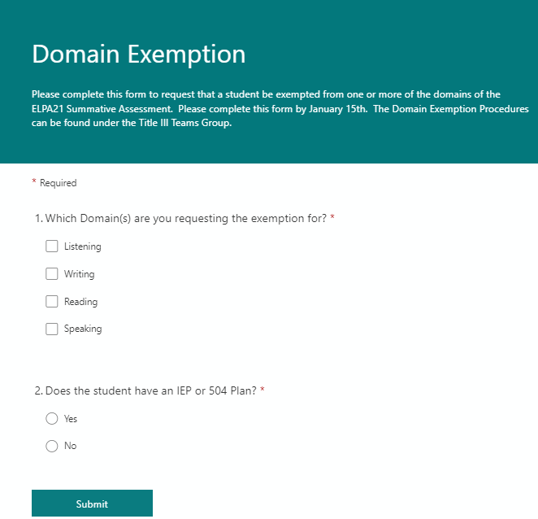

Appendix P. Guidelines for NOCTI Career Technical Education Assessments
NOCTI provides Career Technical Education (CTE) state-approved programs of study with a credible means of verifying the knowledge and skills expected by industry. In addition, NOCTI provides schools, counties, and state entities with the ability to accurately assess student and program needs, gaps, growth, and/or strengths, thus creating a high-quality CTE ecosystem across the state.

NOCTI and the West Virginia Education Information System (WVEIS) developed and implemented a communication tool to assist schools in easily transferring student data and assessment results between platforms, alleviating time management challenges, and duplication of information for school personnel.

NOCTI Roles and Access
Administrators
Individuals who are responsible for supervising the NOCTI assessment process. Various reports can be used to evaluate performance data to identify individual and program strengths and gaps.
Site Coordinators
Individuals (the administrators or the administrator’s designee) who manage the NOCTI technical assessments for the institution. The site coordinators are responsible for setting up the NOCTI system and ordering pre-tests, post-tests, and digital study guides. The site coordinators also arrange:
- scheduling pre-test and post-test dates,
- assigning student user codes,
- make-up dates
- coordinate late arrivals/early dismissals, and
- accommodations for students.
Instructors
Individuals can view reports, practice questions, and other resources via their NOCTI account. The pre-test and post-test will provide the instructor with data to support program improvement goals and track student growth throughout the program.
Proctors
Individuals administering the NOCTI technical assessment that is not the instructor of the classroom or an instructor in a related field. The assessments are implemented online, but paper/pencil tests can be ordered if needed. Accommodations are available for students, and some are automatically assigned in WVEIS. Proctors will:
- distribute assessments and user access codes,
- read instructions, including instructions for finishing early
- monitor assessments and maintain security
- collect materials, and
- complete forms.

Students
Individuals with access to view data reports highlighting their technical progress in comparison to the workforce entry levels, technical standards, and state and national averages.

Resources
Blueprints
Blueprints provide an overview of the specific skills measured on the NOCTI post-test that align with a state-approved program of study. Each Blueprint details the standards and competencies covered in the assessment. Additionally, each Blueprint outlines the percentage of the test covered by each standard.
Digital Study Guides
Study Guides are available for each of the NOCTI-developed post-tests. Each NOCTI Digital Study Guide contains 30 practice questions and is accompanied by the Teacher Companion Guide. Please note that other partner organization tests may not have study guides.

Micro-Credentials
Micro-credentials allow students to confirm familiarity with targeted set of knowledge and skills within a career pathway. The credentials focus on nationally validated, industry-based standards and competencies. Micro-credentials are a resource that may be used by the county/school. The cost is $5.00 per micro-credential per student. The WVDE does not pay for this resource.

Remote Proctoring
A resource that can be utilized if the student cannot make it to the school to take the test. NOCTI’s remote proctoring costs are $25 per student per assessment and can be ordered through Shop NOCTI at the county’s/school’s expense.

Student Certificates
Printable certificates (West Virginia Workforce Entry Certificate, Workforce Competency Credential, and College Credit) are available for students meeting target scores on the NOCTI assessments.

Assessments
Accommodations
Accommodations are available for students through the West Virginia Education Information System (WVEIS) and can be assigned by site coordinators or instructors. For CTE technical assessments, the WVDE recognizes the following accommodations from a student’s current IEP/504 Plan’s state assessment accommodations.
- P13 – Text to Speech
- P14 – Human Read Aloud
- P18 – Simplified Test Directions
- P24 – Translator (Human)
- T09 – Separate setting – small group
- T10 – Separate setting one-to-one
- T14 – Flexible scheduling
- T17 and T19 – 50% Extended Time
- T20 and T22 – 100% Extended Time

However, only P13, T17, T19, T20, and T22 can be sent to NOCTI via WVEIS. If testing accommodations change after students have been sent to NOCTI, they must be manually updated.

Pre-Tests
Pre-tests are optional online assessments that provide a baseline measurement of student proficiency. Pre-tests are only available during the same school year as the student will complete the post-test. The WVDE covers the costs of the pre-tests.

The testing window for all pre-tests is September 1 to November 30.

Pre-tests cannot be administered by the classroom instructor or an instructor of a related field. Pre-tests must be administered by an instructor in an unrelated field or other school staff members, such as counselors or school administrators.

Pre-tests can be divided into one, two, or three sessions. The length of each session is determined by calculating the total assessment time and dividing it by the number of sessions set to be administered. Sessions can be started at the student’s convenience but must be completed once the session has started. Tests must be administered at the school or use NOCTI’s remote proctoring for students who are not physically in the school building.

Post-Test
Post-tests are online technical assessments used to measure technical skills obtained during the state-approved program of study. Post-tests should be administered 60 to 90 days after the pre-test. Post-tests may be administered when the school determines the students are ready to test.
Post-tests are paid for by the WVDE and are the only assessments required by the WVDE for a student to be considered a state-approved CTE completer. The WVDE will pay for one post-test per program of study unless the post-tests are identical, then the students’ scores will count toward both programs of study.
The testing window for post-tests is September 1 to June 30 each year.
Post-tests cannot be administered by the classroom instructor or an instructor of a related field. Post-tests must be administered by an instructor in an unrelated field or other school staff members such as counselors or school administrators.
Post-tests can be divided into one, two, or three sessions. The length of each session is determined by calculating the total assessment time and dividing it by the number of sessions set to be administered. Sessions can be started at the student’s convenience but must be completed once the session has started. Tests must be administered at the school or use NOCTI’s remote proctoring for students who are not physically in the school building.
Performance Tests
Performance tests are hands-on, onsite assessments that allow students to showcase their skills in a technical field. Business and industry representatives from the community conduct the Performance tests and evaluate students as they rotate through a series of hands-on skills tests.

The WVDE does not require performance tests, but they are optional for schools to purchase via NOCTI. To receive the discounted pricing, the performance tests must be ordered at the same time as the post-tests. Schools are responsible for all costs of administering the performance tests, including materials.
Retakes
Students are eligible to retake a NOCTI post-test once before completing their state-approved program of study. There is a waiting period of five days from the test administration date before a retake can be ordered. The WVDE does not pay for retakes.

Reporting
CTE Annual Impact Review
The CTE Annual Impact Review (AIR) Report provides an overview of your school/county that includes data such as the number of completers; the number of students meeting/exceeding the workforce entry score; the average attendance rate, the number of B&I Reviews completed, etc.

Site/Instructor Summary Reports
Summary Reports are WVDE-customized reports highlighting key areas of interest in an easy-to-read format. The report is divided into two halves, with the top half serving as an overview of the average student performance on the pre-test and post-test compared to the workforce entry-level, state average, and national average. The lower half of the report looks at student(s) performance on individual standards compared to the state average and national average.

Standard/Competency Reports
Standard/Competency Reports offer a detailed look at the individual student and classroom data to showcase student proficiency in the standards and competencies within an assessment.

Scores
Workforce Entry Score
The Workforce Entry Score, Criterion-Referenced Cut Score, represents an individual sufficiently competent for a beginning position in a chosen field. The cut score is set by NOCTI’s subject matter experts, a mix of educators and practicing industry members.

Governor’s Workforce Credential (GWC) Score
The GWC score is defined by the top 10 percent of students (past and present) who have taken a specific NOCTI post-test. This GWC score will change yearly to include the new tests.

For more information about the NOCTI ecosystem, please see CTE Connect: A Guide for Administrators.

Appendix Q. Non-Standard Accommodation(s) Requests
Schools may request permission to use accommodations other than those included in this document.
Please indicate the test(s) this request is for:
- West Virginia General Summative Assessment _________
- SAT School Day (11th graders only) _________
- West Virginia Alternate Summative Assessment (DLM) ________
- ELPA21 ________
- Alt-ELPA ________
Student Name: |  |  | WVEIS Number:
County: | Gender: (SAT School Day test only) |  | School:
Grade: | AI code: (SAT School Day test only) |  | Date of Birth:
Indicate which plan(s) supports the student’s needs:
 |  | Health Care Plan | IEP | 504 plan | EL plan
Describe the specific accommodation(s) needed – please include as much information as possible including descriptions of any devices (make and model numbers, names and version of apps required, etc.):

Rationale for the requested accommodation(s) (e.g., Why can the need not be met within existing accommodation(s) as described in the Participation Guidelines?)
What impact might the student’s assessment results reflect if the requested accommodation(s) are not provided?

The signatures below verify the student receives the accommodation(s) on a regular basis during classroom instruction and classroom assessments and is familiar with the accommodation(s).

Principal Signature Date County Test Coordinator Date

County Special Education Director (only if 504/IEP student) Date

County Title III. Director (only if EL student) Date

WVDE Office use only: _________(date received)

Approved: (yes) (no) (Initials) Follow up needed?

County Test Coordinator – Instructions will be provided for how to submit this request.

Appendix R. Braille Accommodations Selections and WVGSA

Available Braille Accommodations for WVGSA
P03 - Braille test book This must be ordered in TIDE by the county test coordinator.
P17 - Braille computer test – computer adaptive test format
P35 - Braille computer-based, fixed form, with paper booklet for tactile graphics (available for math only) This must be ordered in TIDE by the county test coordinator.

Scenario 1: Student will take the WVGSA using only paper braille test books
  - Select only “P03 – Braille test book” in WVEIS IEP program.
  - Do not select P17 and/or P35.
  - P03 must be used for all subject areas, and a paper braille book for each subject will be shipped to the county for each student who has the P03 accommodation.
    - This student cannot mix-and-match paper braille books with computer-administered portions for different subjects with this accommodation.
  - TIDE Notes:
    - The P03 accommodation translates to the “Braille” value for the Paper Tester field in TIDE.
    - Students must have “Braille” for the Paper Tester field in TIDE for a test administrator to transcribe responses from braille test books into the Response Entry System.

What to select for IEP accommodations in the WVEIS IEP Program for Scenario 1:
Accommodation Code | Yes | No
P03 | X
P17 |  | X
P35 |  | X

Scenario 2: Student will take the WVGSA —computer adaptive forms for all subject areas
For computer adaptive test content to be delivered in a format compatible with refreshable braille devices and embossers across all subject areas, the student must have “P17 - Braille computer test – computer adaptive test format”, selected for ELA (reading and writing), math, and science in the WVEIS IEP program and in TIDE.
  - Do not select P03 for any student who will be taking WVGSA assessment on via computer for any subjects.
  - For science, ELA-Reading, ELA-Writing, and math subjects to be administered via a refreshable braille device, only select in the WVEIS IEP Program “P17 - Braille computer test – computer adaptive test format”.
  - TIDE Notes:
    - The Paper Tester field shows the value of “Select” or “No.”
    - The P17 accommodation translates to the P17-Language Choice field in TIDE. Students that have a value of “Braille” in this field will take the computer-adaptive test for a given subject.
    - The P17-Language Choice field shows the value of “Braille” (indicating the student has P17) selected for all subject areas.
    - P35 Braille value is “OFF” in the Mathematics column.

What to select for IEP accommodations in the WVEIS IEP Program for Scenario 2:
Accommodation Code | Yes | No
P03 |  | X
P17 | X
P35 |  | X

Scenario 3: Student will take the WVGSA —computer adaptive forms for ELA- Reading, ELA-Writing, and Science with mathematics completed using a fixed-form administration and tactile graphics booklet.
For test content to be delivered in a format compatible with refreshable braille devices and embossers for ELA-Reading, ELA-Writing, and science, the student must have “P17 - Braille computer test – computer adaptive test format”, selected for ELA (reading and writing), and science in TIDE.
If the student will require the support of an embossed tactile graphics booklet for math, additionally select the accommodation “P35 - Braille computer-based, fixed form, with paper booklet for tactile graphics” in the WVEIS IEP program. The booklet will be sent from the test vendor.
    - Do not select P03 for any student who will be taking the WVGSA assessment via a computer for any subjects.
  - TIDE Notes:
    - The Paper Tester field shows the value of “Select” or “No.”

    - The P17-Language Choice field shows the value of “Braille” (indicating student has P17) selected only for ELA Reading, ELA Writing, and science.
    - P17-Language Choice field with the value of “English” for Mathematics
    - P35 Braille value is “ON” (indicating student will take the fixed form mathematics test online using the supplementary tactile graphics booklet) in the mathematics column.

What to select for IEP accommodations in the WVEIS IEP Program for Scenario 3:
Accommodation Code | Yes | No
P03 |  | X
P17 | X
P35 | X (for math)

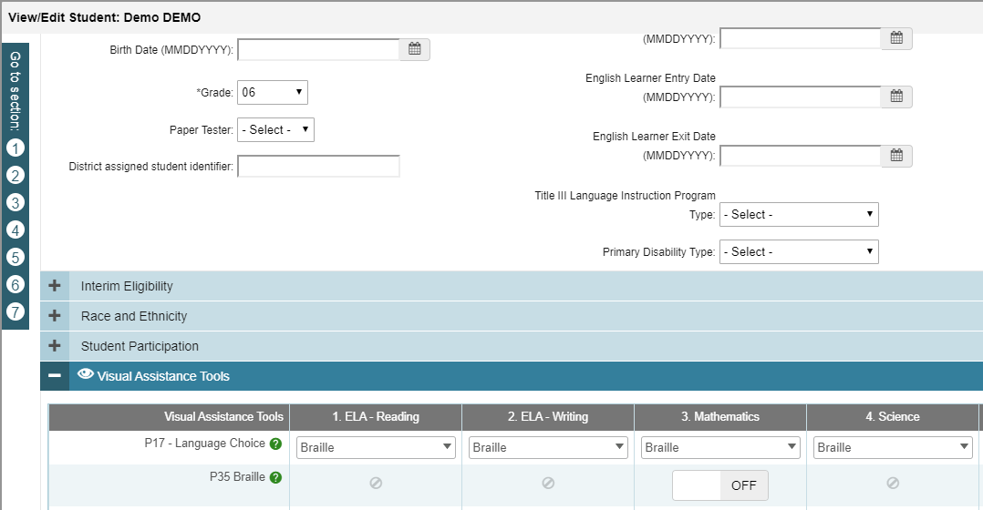

TIDE fields

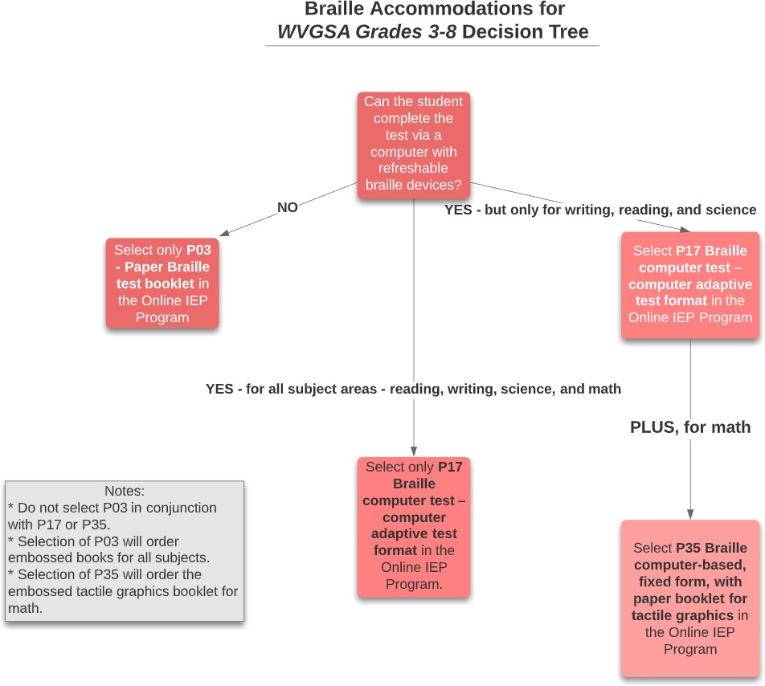

Appendix S. P13/P14 Eligibility Matrix
The full guidance document can be found at:
https://tinyurl.com/P13P14Matrix
Note: This assessment accommodation is appropriate for a very small number of students who have a severe documented reading or print disability. Text-to-speech (including ELA reading passages) is available as an embedded accommodation for students whose need is documented in an IEP or 504 plan. A student’s eligibility for P13/P14 support should be reviewed by the IEP/504 team at the annual review meeting. This documentation should be kept with the student’s folder and available upon request.

Student Name (last, first) | WVEIS | Grade
School (no initials) | Case Manager
Does the student have an IEP or 504 plan? IEP 504 Neither

(Note: if the student does not have an IEP or 504 plan, STOP. They do not qualify for P13/P14 support.)
‘YES’ responses in the following fields may indicate a need for the text-to-speech (P13) or read-aloud (P14) accommodation of ELA Reading Passages.
» A preponderance of evidence should exist rather than one or two marks in the YES column for the accommodation to be provided to students for use on the state summative assessments (WVGSA Grades 3-8 and SAT School Day).
» A documented reading/print disability is a prerequisite for grades 3-11. Review the student’s IEP and special education eligibility information. A student’s exceptionality category should not be the sole determining factor for an accommodation or accessibility support eligibility.

Eligibility consideration: Lexile scores should be less than the 10th percentile (or equivalent data if the administered assessment does not provide a Lexile score) for the student’s grade level and at the time of year the test was administered.

A student with a 504 plan may qualify for P13/P14 support if their need and interventions are equally documented.

Diagnostic Information
Date(s) Assessment Administered
Assessment Name (e.g., iReady, Lexile, DIBELS, Star, AIMSweb, Cambium, other assessments your LEA uses, can also include psychoeducational academic assessments)
Student Score/Results (e.g. Lexile scores)

Questions for Teachers | Yes | No | Comments
1. Is this student blind, or does this student have a significant visual impairment?
— If so, is the student learning to read braille?
2. Does the student have a reading-based disability?
3. Does the disability affect the student's decoding?
— Does the disability affect the student's fluency?
— Is the student an English language learner (EL)?
4. Does the student have other needs that might be accommodated by providing text-to-speech or read-aloud accommodation?

Intervention Documentation
(If the answer to the next four questions is “no”, this student is not eligible for P13/P14 accommodation.)
Intervention Documentation | Yes | No | Comments
1. Have interventions been used to improve the student’s decoding or fluency? If so, what approaches have been used to strengthen the student’s decoding or fluency?
2. Does the student use text-to-speech or receive a read-aloud accommodation during instruction on a daily basis?
3. Does the student on a regular basis use text-to-speech or receive a read-aloud accommodation during benchmark, formative, or classroom assessments?
4. Does someone (e.g., teacher, paraprofessional, another student, parent) read aloud on a daily basis to the student in school?

Questions for Students | Student Response | Comments
1. Do you read to yourself when you are at home?
— If not, is it because you have trouble reading?
2. Is it harder or easier for you to understand a book if you read it yourself?
— Is it harder or easier for you to understand a book that is read to you through text-to-speech or by another person?

3. If you could choose, would you like to have tests read to you, or would you prefer to read them yourself?
Student Response:

General Question | Yes | No | Comments
Are there additional considerations for recommending TTS/RA test accommodation for this student, specific to their unique disability-related needs? If so, explain.

Eligibility Decision | Yes | No
Does the diagnostic information and question responses provide a preponderance of evidence (see page 8 for explanation of “preponderance of evidence”) of the student needing text-to-speech/read aloud (P13/P14) on the ELA/reading passages of the WVGSA Grades 3-8 or the SAT School Day assessment?

Committee Member Signatures:
THE LEA IS RESPONSIBLE FOR MAINTAINING THIS DOCUMENT AND SHARING THE MATRIX TO THE NEW LEA IF THE STUDENT TRANSFERS. THE LEA IS RESPONSIBLE FOR THE ANNUAL REVIEW OF A STUDENT’S ELIGIBILITY TO RECEIVE P13/P14 SUPPORT FOR THE STATE SUMMATIVE ASSESSMENT.
_______________________________________
Name Position
_______________________________________
Name Position
_______________________________________
Name Position
_______________________________________
Name Position

P13/P14 Eligibility Matrix FAQs
1. What are Text-to-Speech (P13) and Read-Aloud (P14)?
P13: Text-to-Speech
A digital accommodation in which embedded software reads directions, questions, answer choices, and ELA reading passages aloud to the student.
P14: Read-Aloud
An accommodation in which a trained human reader reads all test content aloud in accordance with West Virginia test administration guidelines.
Both accommodations provide auditory access to printed text. Neither alters test content, rigor, or scoring.
2. Who is eligible for P13 or P14 on state assessments?
Only students who meet all of the following conditions may receive P13 or P14:
- The student has an active IEP or Section 504 Plan.
- The student has a documented reading or print disability or is blind and not proficient in braille.
- A preponderance of evidence demonstrates a disability-based need for auditory access to text.
Students without an IEP or 504 Plan are not eligible.
3. Why is eligibility for ELA reading passages restricted?
ELA reading passages are designed to measure independent reading skills, including decoding and comprehension.
Providing Text-to-Speech or Read-Aloud to a student who can decode independently changes what the assessment measures. In such cases, the assessment reflects listening comprehension rather than reading ability. This change limits the validity and interpretability of the resulting score.
4. What does “preponderance of evidence” mean in practice?
A preponderance of evidence refers to the weight, consistency, and alignment of multiple data sources collected over time.
Evidence typically includes:
- Reading assessment data at or below the 10th percentile
- Documentation of a reading or print disability
- Sustained, targeted decoding and fluency instruction
- Limited response to intervention
- Consistent instructional and assessment use of Text-to-Speech or Read-Aloud
- Data showing improved access with auditory support, not preference alone
No single score, observation, or student preference is sufficient.
5. Does a low Lexile score automatically qualify a student?
No. A Lexile score represents one data point.
Eligibility decisions must be based on a comprehensive review of disability documentation, intervention history, instructional impact, and accommodation use. A low Lexile score without corroborating evidence does not qualify a student for P13 or P14.
6. Does slow reading qualify a student for P13 or P14?
No. Slow reading rate alone does not indicate a reading or print disability.
Text-to-Speech and Read-Aloud are not intended to increase reading speed, reduce effort, or manage attention. Reading rate concerns should be addressed through instruction and intervention rather than assessment accommodations.
7. What are hidden barriers, and why must they be considered?
Hidden barriers are factors that may resemble reading difficulties but are not caused by a reading disability.
Examples include:
- Attention or executive functioning challenges
- Anxiety or emotional distress
- Inconsistent or insufficient instruction
- Environmental distractions
- English language acquisition needs
When hidden barriers are identified, instructional, environmental, or behavioral supports are appropriate. P13 and P14 are not appropriate in these circumstances.
8. Can English Learners receive P13 or P14?
English Learner status alone does not qualify a student for P13 or P14.
An English Learner may receive the accommodation only when a documented reading or print disability or blindness is also present and all eligibility criteria are met.
- 9. May Text-to-Speech or Read-Aloud be introduced only for testing?
- No. Assessment accommodations must reflect routine instructional practice.
If a student does not regularly use Text-to-Speech or Read-Aloud during instruction and classroom or benchmark assessments, the accommodation should not be introduced for a state assessment.

10. What documentation responsibilities do teachers have?
Teachers contribute essential evidence by documenting:
- The type, frequency, and duration of reading interventions
- Progress monitoring results and response to instruction
- Student performance with and without auditory supports
- Consistency of accommodation use during instruction and assessments
- Classroom observations related to access and independence
Accurate documentation supports valid eligibility decisions.
11. Does eligibility for P13 or P14 replace reading instruction?
No. Remediation and accommodation serve different purposes.
- Remediation addresses skill development in decoding and fluency.
- Accommodation provides access to text despite a disability.
When appropriate, both should occur simultaneously to support access while continuing skill instruction.
12. What is the purpose of the Reading to Text-to-Speech balance?
The Reading to Text-to-Speech balance is a framework used by teams to consider how students divide time between reading instruction and technology-supported access to grade-level content.
As students’ progress through grade levels and reading demands increase, instructional emphasis may shift to ensure continued access to curriculum while still supporting skill development as appropriate.
13. Can a student lose eligibility for P13 or P14?
Yes. Eligibility is reviewed annually and should be reconsidered when evidence shows:
- Improved decoding and fluency
- On-grade-level comprehension
- Reduced dependence on auditory supports
- Consistent independent access to print
Removal of the accommodation reflects student progress and successful intervention.

14. What is the role of the general education teacher?
General education teachers:
- Observe daily reading behaviors
- Implement accommodations as written
- Normalize the use of accessibility tools
- Support student independence and self-advocacy
- Provide critical instructional evidence to IEP and 504 teams
Teacher input is essential to informed decision-making.
15. What is the central principle teachers should remember?
Text-to-Speech and Read-Aloud are access accommodations, not performance tools.
When used appropriately, they preserve assessment validity, support students with documented reading or print disabilities, and ensure equitable access without replacing instruction.

Index for Accommodation Codes

P01, 41, 44, 49, 59, 115, 130, 228
P02, 42, 45, 120, 130, 227, 228
P03, 42, 47, 86, 88, 108, 116, 130, 237, 238, 239
P06, 43, 52, 86, 120, 130
P13, 41, 44, 49, 59, 85, 88, 116, 130
P14, 42, 45, 87, 88, 120, 130
P15, 46, 120
P17, 43, 47, 116, 130, 237, 238, 239
P18, 47, 121, 130, 228
P19, 48, 109, 121
P21, 44, 45, 49, 121
P22, 49, 85, 88, 104, 116, 130, 227
P23, 50, 85, 86, 88, 106, 121, 130, 227, 228, 229, 230
P24, 50, 87, 88, 215
P27, 51, 122, 228
P28, 51, 85, 88, 104, 117, 130, 227, 228, 230
P30, 52, 106, 122, 130, 215, 227, 228, 229, 230
P32, 52, 117, 130, 215, 228
P34, 53, 117, 130
P35, 43, 47, 53, 116, 130, 237, 238, 239
P36, 54, 118, 130
P37, 54, 105, 118, 130, 227, 228, 230
P38, 55, 122, 130, 228, 229
P39, 55, 106, 122, 130, 227, 228, 229, 230
P40, 55, 56, 123, 130
P41, 51, 56, 215, 229
P42, 56, 107, 123, 130, 227, 228, 229, 230
P43, 57, 118, 130
P44, 57, 105, 227, 228
P46, 57, 123, 130, 228
P47, 58, 86, 88
P49, 58
P50, 52, 58, 88, 123, 130
P51, 59, 140
P52, 59
R03, 61, 124, 130
R04, 62, 87, 88, 109, 124, 130
R05, 63, 86, 88, 124, 130
R11, 63, 86, 87, 88, 108, 125, 130
R15, 51, 65, 125, 130, 228, 229
R19, 65, 125, 130
R20, 66, 118, 130
R21, 64, 66, 119, 130
R23, 67, 119, 130
R24, 67, 87, 88
R25, 67
R26, 68
R27, 68
R28, 68
R29, 69
R30, 69
R31, 66, 70, 119, 130
R32, 71
R34, 72
T03, 63, 73, 126, 130, 227, 228, 229, 230
T07, 73, 126, 130, 227, 228, 229, 230
T09, 74, 126, 130, 227, 228, 229, 230
T10, 42, 43, 45, 63, 74, 107, 127, 130, 227, 228, 229, 230
T11, 75, 127, 130
T12, 75, 127, 130, 227, 228, 229, 230
T13, 76, 88, 127, 130, 227, 228, 229, 230
T14, 76, 127, 130, 227, 228, 229, 230
T15, 76, 127, 130, 227, 228, 229, 230
T16, 77, 128, 130, 227, 228, 229, 230
T17, 43, 44, 45, 67, 77, 78, 229
T19, 78, 229
T20, 63, 67, 78, 79
T22, 43, 44, 45, 79






Michele L. Blatt
West Virginia Superintendent of Schools
wvde.us

