


Annual Compliance Report 2021-2022
Office of Federal Programs & Support

West Virginia Board of Education
2022-2023

L. Paul Hardesty, President
Nancy J. White, Vice President
F. Scott Rotruck, Financial Officer

Robert W. Dunlevy, Member Victor L. Gabriel, Member Daniel D. Snavely, M.D., Member
Christopher A. Stansbury, O.D., Member
Debra K. Sullivan, Member
James S. Wilson, D.D.S., Member

Sarah Armstrong Tucker, Ph.D., Ex Officio
Chancellor West Virginia Higher Education Policy Commission
West Virginia Council for Community and Technical College Education

Michele L. Blatt, Ex Officio State Superintendent of Schools
West Virginia Department of Education

Introduction
During the 2021-2022 school year, the West Virginia Department of Education (WVDE), Office of Federal Programs & Support (OFPS) and Office of Special Education (OSE), shared the responsibility for ensuring that educational services were provided to all eligible students with exceptionalities. The Individuals with Disabilities Education Improvement Act 2004 (IDEA) and Policy 2419: Regulations for the Education of Students with Exceptionalities mandate that all students with exceptionalities have available a free appropriate public education (FAPE).

This annual compliance report includes data on monitoring activities, dispute resolution, and other general supervision activities completed during the state fiscal year (FY22) and documents the WVDE’s efforts to meet the requirements under IDEA and Policy 2419 pertaining to:

» administering the monitoring system and dispute resolution system, and;
» identifying findings and making decisions based on the on-site monitoring, the annual desk audit (ADA), annual Local Education Agency (LEA) determinations, written complaints, facilitated Individualized Educational Programs (FIEPs), mediations, and due process hearings, in addition to making data from these processes available to the public.

Monitoring System
The OFPS is responsible for ensuring West Virginia’s compliance with the IDEA and its implementing regulations and West Virginia Code §18-20 (Education of Exceptional Children) that require the West Virginia Department of Education to adopt and use procedures to assure public agencies are providing a free appropriate public education to students with exceptionalities. Furthermore, IDEA guarantees the free appropriate public education of children with disabilities in the least restrictive environment.

To meet the state’s responsibilities to students with disabilities through enforcement of the requirements of the IDEA, the OFPS has developed a continuous improvement monitoring process which focuses on both compliance requirements and the performance of students with
exceptionalities. The Compliance Monitoring System includes various ongoing monitoring activities. Acknowledging that the ultimate purpose of compliance monitoring is increased results for students with disabilities, the OFPS requires each LEA to present its Results Driven Accountability Plan (RDP) at the opening of the onsite monitoring review. In addition, all LEAs are required to complete annually
a LEA Self-Assessment for self-review and improvement planning. Four types of formal monitoring processes are conducted by the West Virginia Department of Education.

» Compliance Desk Audit & On-Site Monitoring
» Annual Desk Audit
» LEA Determinations
» Focused Monitoring
» Dispute Resolution Process

Compliance Monitoring
Compliance Monitoring is a comprehensive monitoring activity occurring for each of West Virginia’s 57 school local education agency (LEA) on a four-year cycle, as required by West Virginia Code §18- 20-1 (Education of Exceptional Children). More frequent monitoring reviews may be scheduled as warranted. Each LEA receives on-site monitoring no less than every four years. This activity is done through a remote file review process focusing on various compliance indicators, followed by school visits and on-site document reviews in selected LEAs. A corrective improvement process, including
additional onsite visits as necessary, follows the onsite reviews. The monitoring team during the 2021- 2022 school year consisted of OFPS staff and other educators as determined by the lead monitor.

The following table provides the four-year onsite monitoring cycle.

Compliance On-Site Monitoring 2018-2019 |  | Compliance On-Site Monitoring 2019-2020 |  | Compliance On-Site Monitoring 2020-2021 |  | Compliance On-Site Monitoring 2021-2022
» | Brooke | » | Barbour | » | Berkeley | » | Boone
» | Doddridge | » | Braxton | » | Cabell | » | Hardy
» | Grant | » | Calhoun | » | Fayette | » | Harrison
» | Hampshire | » | Clay | » | Gilmer | » | Lincoln
» | Jackson | » | Lewis | » | Greenbrier | » | Logan
» | Jefferson | » | Marshall | » | Hancock | » | Marion
» | Nicholas | » | Mercer | » | Kanawha | » | Mason
» | ODTP | » | Mineral | » | McDowell | » | Monongalia
» | Pleasants | » | Mingo | » | Morgan | » | Putnam
» | Pocahontas | » | Monroe | » | Ohio | » | Raleigh
» | Taylor | » | Pendleton | » | Preston | » | Ritchie
» | Wayne | » | Roane | » | Randolph | » | Summers
» | Webster | » | Tucker | » | Wirt | » | Tyler
» | Wetzel | » | Wood | » | Wyoming | » | Upshur
» | WVSDB |  |  |  |  | » | WVSDB

Annual Desk Audit (ADA)
The ADA is submitted annually by each West Virginia school LEA and is a review of both compliance and results State Performance Plan (SPP) Indicators. The ADA is designed to identify strengths
and weaknesses of the LEAs and address findings of noncompliance and areas requiring program improvement. LEAs that do not meet the targets on indicators receive written notice of noncompliance. An improvement plan is required to identify steps that will be taken to improve results for students with disabilities. Once the improvement plan is found acceptable by the OFPS, the LEA receives ongoing support to meet its identified goals.

Focused Monitoring
Focused Monitoring is a monitoring process conducted by the OFPS whereby an LEA may receive a visit based on an identified need. Focused Monitoring drills down within the LEA’s data and/or practices
to identify root causes and solutions to an on-going compliance and/or performance concern. Each focused monitoring conducted is individualized to the LEA and the situation.

Dispute Resolution Process
Policy 2419: Education of Students with Exceptionalities and/or the IDEA require that all parents of students with exceptionalities or adult students with exceptionalities have available a process to file written state complaints, due process complaints, request mediation and request facilitated individualized education programs (FIEPs). This important procedural safeguard provides assurance
that the rights of students with exceptionalities are being protected. Effective dispute resolution data can enable the state to track identified issues to determine whether patterns or trends exist and the effectiveness of the resolution process.

Office of Special Education Programs OSEP 09-02 Memorandum
The United States Department of Education, Office of Special Education Programs (OSEP) issued a memorandum (OSEP 09-02 Memorandum of Correction) to states on October 17, 2008 clarifying expectations for correction of noncompliance by the LEA and the verification of that correction by the state. The principles in this memorandum are the standards by which the WVDE reports noncompliance and correction for the State Performance Plan/Annual Performance Report (SPP/ APR) and determines whether each LEA has made the appropriate corrections. The memorandum
requires two levels, or prongs, of verification showing correction (individual student-level and systemic corrections) for all findings identified in writing to an LEA, excluding State Complaints and Due Process Hearing Decisions.

2021-2022 Findings of Noncompliance
The data included in this document provides the total number of findings of non-compliance for the 2021-2022 school year. The findings of noncompliance are provided to each LEA for review and correction. If the state finds noncompliance in an LEA, the State must notify the LEA in writing of the noncompliance and the requirement that the noncompliance be corrected as soon as possible, but in no case more than one year from identification. The one-year correction requirement begins the date the State provides written notification to the LEA. The written notification from the State will detail specific steps the LEA must take to correct the noncompliance. To assure the LEA is correctly implementing the specific regulatory requirement(s) that were found to be noncompliant, a random sample of current IEPs will be reviewed in approximately six months following the initial finding of noncompliance. This practice is known as Prong 2. Correction is completed on the date the State determines both prongs comply.

2021-2022 Compliance Monitoring Findings
Fifteen (15) LEAs received an on-site compliance monitoring visit during the 2021-2022 school year and follow: Boone, Hardy, Harrison, Lincoln, Logan, Marion, Mason, Monongalia, Putnam, Raleigh, Ritchie, Summers, Tyler, Upshur and WVSDB. The following information provides the number of LEAs monitored that were noncompliant for the specific area indicated.

Administrative Review

Administrative Findings | Noncompliant Districts
AF1: Finance: Budget and Expenditures (Requisition, PO, Invoice, Check) | 3 LEAs
AF2: Finance: Time/Effort | 8 LEAs
AF4: Instructional Groupings | 2 LEAs
AF5: Certification/Caseloads | 12 LEAs
AF6: Full Instructional Day | 12 LEAs
AF 7: Other/Private School Consultation Documentation | 3 LEAs
AF8: Other/Not Providing a Continuum of Services | 2 LEAs
AF8: Other/Orientation and Mobility and Occupational Therapy services not being provided | 2 LEAs
AF8: Other/Special Education rooms identified | 1 LEA
AF8: Other/Discipline procedures not followed for SWD suspended for more than 10 days | 1 LEA
AF8: Other/No Consultation Logs for Indirect Services | 2 LEAs
AF8: Other/Teacher/student ratio for co-teaching class over the 50% allowance | 1 LEA
AF8: Other/Teacher/student ratio per period for resource class over the policy limit of 12 students | 1 LEA
AF8: Other/ Special Education teachers teaching | 1 LEA
multiple subjects at the same time | 1 LEA
AF8: Other/No Crisis Team that is restraint trained in the school | 1 LEA
AF8: Other/Indirect Service Logs were not completed | 2 LEAs
AF8: Other/Square footage for a special education class did not meet requirements for the number of students in a class | 1 LEA
AF8: Other/Course codes for Alternate standards students were not listed on student schedules to show achievement and credits | 1 LEA
AF8: Other/IEPs were not finalized | 1 LEA

AF8: Other/IEPs were corrected without an amendment or a targeted review | 1 LEA
AF8: Other/Access to IEPs and accommodation logs were not provided to general education teachers | 1 LEA
AF8: Other/Special Education teachers teaching two subjects at the same time, Math/ELA | 1 LEA
AF8: Other/Students were not receiving the appropriate amount of time for lunch | 1 LEA
AF8: Other/No transportation for Extended School Year | 1 LEA

Student File Review

File Review Summary of Percentage of Noncompliance | LEAs Below 75%
General Supervision
Amendments to the IEP | 11 LEAs
Transition | 14 LEAs
ESY Services | 6 LEAs
Service Verification | 13 LEAs
Transfer of Rights | 6 LEAs
Related Services | 2 LEAs
Supplemental Services | 3 LEAs
Special Education Services | 1 LEA
Meeting Notice | 1 LEA
Predetermining | 13 LEAs
LRE Statement | 1 LEA
Performance Gap | 2 LEAs
Personalized Education Plans | 12 LEAs
Evaluations | 3 LEAs
Assessments | 2 LEAs
Initial Consent | 2 LEAs
Discipline | 3 LEAs
Prior Written Notice | 1 LEA
Impact Statement | 1 LEA
Initiation date for services | 1 LEA
Efforts to affect continuous improvement for Indicator #13 (Secondary Transition) include technical assistance to LEAs delivered prior to the collection and reporting of transition age IEPs reviewed during the on-site monitoring process. In addition, the OFPS continues to mandate the annual self-assessment process for Indicator 13 for those LEAs not receiving an on-site monitoring review. The table below provides the compliance data prior to the correction period for those LEAs who received an on-site monitoring review and does not include the self-reporting during the ADA. Technical assistance for Indicator 13 will continue until compliance targets are met by each LEA on a systemic basis.

Secondary Transition On-Site Monitoring File Review

County LEA | File Sample Size | Compliance Percentage
LEA 1 | 10 | 72%
LEA 2 | 10 | 65%
LEA 3 | 10 | 96%
LEA 4 | 10 | 60%
LEA 5 | 10 | 66%
LEA 6 | 10 | 64%
LEA 7 | 10 | 72%
LEA 8 | 10 | 40%
LEA 9 | 10 | 66%
LEA 10 | 10 | 62%
LEA 11 | 10 | 67%
LEA 12 | 10 | 62%
LEA 13 | 10 | 71%
LEA 14 | 10 | 91%
LEA 15 | 10 | 66%

Surveys
Surveys were disseminated to special education directors in all LEAs monitored during the 2021-2022 school year to collect feedback on the on-site monitoring process. Results of the surveys returned are reported in the matrix on the following pages:

West Virginia Department of Education Office of Federal Programs
On-site Monitoring Activities Evaluation

County: Special Education Director: Guest Monitor:  The Office of Federal Programs (OFP) Monitoring Team’s purpose it to provide guidance to the district staff regarding compliance issues related to the education of students with disabilities. So that we may continually work to improve our monitoring procedures, we would appreciate your input. Please rate your level of satisfaction with the on-site monitoring activities. | Not at all satisfied | Somewhat satisfied | Satisfied | Very Satisfied | Extremely Satisfied
1. In general, how satisfied were you with the monitoring visit? |  |  |  | 1 | 7
2. Did the Compliance Coordinator attempt to gain your trust and confidence prior to the visit? |  |  |  | 1 | 7
3. At the entrance conference, did the Compliance Coordinator clearly outline the procedures and team activities for the visit? |  |  |  | 1 | 7
4. Were staff interviews and focus group sessions conducted in a professional manner? |  |  |  | 1 | 7
5. At the exit conference, did the Compliance Coordinator and other members of the monitoring team present themselves as fair and impartial? At the exit conference, did the Compliance Coordinator address preliminary compliance findings? |  |  |  | 1 | 7
6. Did district staff have ample time to ask questions? |  |  |  | 1 | 7
7. Did the team clearly describe the follow up monitoring activities? |  |  |  | 1 | 7
8. Do you feel comfortable contacting the Compliance Coordinator with any follow up questions? |  |  |  | 1 | 7
- What are some ways that we can improve the monitoring process?
  - I find it very transparent and objective.
  - There were a couple of items I was unclear on, what you were needing, such as bus schedules. Maybe clarify a bit on documents.
  - The process has really improved over the years with Lesa and Jeremy.
  - No suggestions at this time.
  - No concerns.
  - The entire process is user friendly.
  - I have no recommendations to improve the monitoring process. When anyone hears the term “monitoring or evaluation” they immediately become concerned. The monitoring team made us know they are here to assist and support us. Their intents are to teach us, not to “gig” us.
  - None at this time.

- Do you believe that you have the capacity to correct all findings?
  - Yes
  - Yes
  - Yes
  - Yes
  - Yes – some may not be able to be corrected immediately, but all can be corrected.
  - Yes – Staffing issues are our only concern.
  - Yes
  - I do feel the capacity to correct or improve through recommendations is possible. I primarily feel this way because of the support we are provided.
- What additional support would you like from the WVDE office of Federal Programs?
  - At some point and IEP training session. Scheduling is a problem.
  - Recruiting staff activities.
  - None, unless you can send me some certified teachers.
  - Additional IEP training for teachers.
  - None at this time.
  - Further training on discipline and training (already scheduled).
  - NA
  - Our monitors Jeremy and Lesa are already coming to our county to provide specific training for teachers and principals to address recommendations. We were able to schedule our training within a month of monitoring.
- Did the Compliance Coordinator clearly communicate information about scheduled monitoring activities prior to the monitoring visit? Was there any additional information that you would like to have?
  - Yes, we were well prepared for the monitoring.
  - It was perfect!
  - No additional information needed.
  - Yes
  - Yes – all activities were thoroughly explained. There was no additional information I would have liked to have.
  - Felt very comfortable in the process.
  - Yes and NA
  - Our monitors were very explicit in what we could expect and gave us documents to follow the schedule or listed specific expectations, for example, the number of parents for the interview and how it is best to interview students and parents of those students.

- What do you believe are the greatest obstacles for your district in regards to improving student achievement? What additional support could the WVDE provide to assist you in overcoming those barriers?
  - Attendance issues with middle/high school students.
  - Staff shortages
  - Lack of certified staff.
  - Core instruction needs to improve for all students.
  - There is still confusion on what specially designed instruction is and might look like at the different programmatic levels.
  - Staffing issues with service, professionals, and bus drivers has been the biggest hurdle as well as behavior concerns.
  - Increase in student needs due to COVID. We have so many struggling children due to lack of face-to-face instruction.
  - There are so many programs/products available it is difficult to know what is available and what could be most effective. What additional support could the WVDE provide to assist you in overcoming those barriers? WVDE provides great support, they attempt to keep us informed in most recent updates, expectations & requirements.
- Do you have any additional comments?
  - None at this time.
  - This process is transparent, objective and aligned with policy.
  - It would have been nice to have had a bit more time between notification of selected schools and visit. Moreso, for the schools benefit than mine. They are so very busy. I know a couple that had to come in on Saturdays to get ready.
  - No
  - My schools would have liked for the teams to spend more time in their schools. They were very excited to show you what they do well.
  - I really appreciate Lesa and Jeremy always making time to answer my questions. It is great to feel support as a first year director.
  - Thank you Lesa and Jeremy for always being user friendly and professional. Tyler county welcomes them back anytime.
  - I very much appreciate the support we receive year round, regardless of where we are in the monitoring cycle. Jeremy and Lesa are very busy individuals attempting to accomplish their county cycle rotation but they always make time for questions and seek answers for us in a very timely manner.

Annual Desk Audit
Each West Virginia LEA submits the ADA electronically each year on or before April 30th to the Office of Federal Programs and Support, Special Education office. This deadline was extended to May 2, 2022, since April 30th fell on Saturday. This audit is a review of both compliance and results of the State Performance Plan (SPP) Indicators. LEAs not meeting targets on compliance indicators will receive written notice of noncompliance on or before May 31st. LEAs that did not meet at least one result indicator were required to develop a LEA Systemic Improvement Plan (DSIP) around one or more related indicators based on importance or need for a systemic change.

Twenty-two (22) LEAs received written notification of non-compliances identified in the ADA Report for the compliance SPP indicators. The data is reported below:

» Twenty (20) LEAs were identified as noncompliant for Indicator 11: Child Find.
» The percentage of children who were evaluated within 80 days of receiving parental consent for initial evaluation.
» Four (4) LEAs were identified as noncompliant for Indicator 12: Early Childhood Transition.
» Percent of children referred by West Virginia Birth to Three (IDEA Part C) prior to age three, who are found eligible for pre-school services (Part B) and who have an IEP developed and implemented by their third birthday.
» Six (6) LEAs were identified as noncompliant for Indicator 13: Secondary Transition.
Percent of youth with IEPs age 14 and above with an IEP that includes appropriate measurable postsecondary goals that are annually updated and based upon an age- appropriate transition assessment, transition services, including courses of study, that will reasonably enable the student to meet those postsecondary goals, and annual IEP goals related to the student’s transition needs. There also must be evidence that the student was invited to the IEP Team meeting where transition services are to be discussed and evidence that, if appropriate, a representative of any participating agency was invited to the IEP Team meeting with the prior consent of the parent or student who has reached the age of majority.

Local Educational Agency Determinations
IDEA section 616(e) and Part B Regulations §300.600(a) and 300.604 require states to annually determine if the LEA:

» Meets the requirements and purposes of IDEA, Part B;
» Needs assistance in implementing the requirements of Part B;
» Needs intervention in implementing the requirements of Part B; or
» Needs substantial intervention in implementing the requirements of Part B.

In making each LEA’s Annual Determination, the Office of Federal Programs and Support, Special Education used a Results/Compliance matrix. The four (4) factors considered were:

- LEA’s performance on selected SPP results and compliance indicators;
- Valid and reliable data;
- Dispute resolution; and
- Other data available to the State about the LEA’s compliance, including relevant audit findings.

For the April 2022 ADA submission, there were 33 total points available on both Results and Compliance indicators. Result indicators 1 (Graduation), 2 (Dropout), 3 (Assessment) and 6 Preschool LRE for home services, were not included in the determination process. The calculation of the indicators had either changed or reflected new data being reported based on the revised reporting requirements for Federal Fiscal Years 2020-2025. Also included were Timely and Accurate Data, Cyclical Monitoring, and Correction of Compliance. Graduation and Dropout were considered and could be used to earn up to one bonus point. The Results/Compliance matrix reflects a percentage score that was used to determine the LEA’s 2022 Annual Determination as follows:

- Meets Requirements: The LEA’s Annual Determination is Meets Requirements if the matrix percentage is at least 80%.
- Needs Assistance: The LEA’s Annual Determination is Needs Assistance if the matrix percentage is less than 80% for one to three consecutive years.
- Needs Intervention: The LEA’s Annual Determination is Needs Intervention if the total matrix percentage is less than 80%, for four to six consecutive years.
- Needs Substantial Intervention: The LEA’s Annual Determination is Needs Substantial Intervention if the total matrix percentage is less than 80%, for more than six consecutive years.

The following is a summary of LEA Determinations status:

- Meets Requirements: 51 LEAs
- Needs Assistance – One Year: 5 LEAs
- Needs Intervention – Three Years – 1 LEA

A tiered system of support from the OFPS, Special Education Office was implemented in School year 2022. All LEAs are provided ongoing technical assistance and monthly universal support through LEA director Teams Meetings. LEAs that do not meet requirements are required to participate in progress meetings on their DSIP. Quarterly progress meetings are required for LEAs in Needs Assistance and a monthly progress meeting is required for any LEA in Needs Intervention or Needs Substantial Intervention.

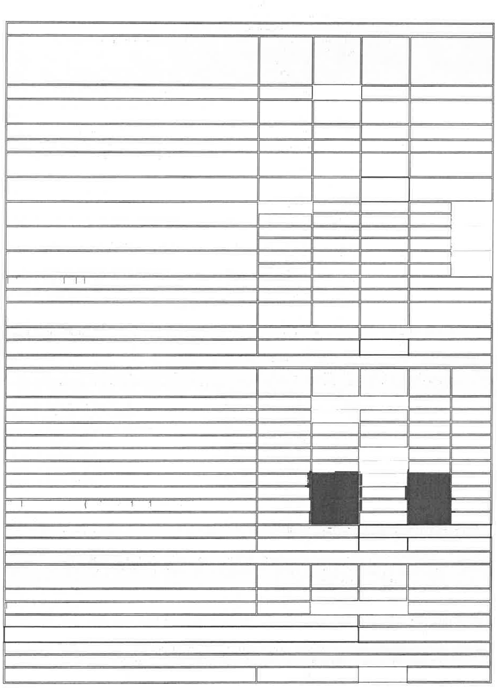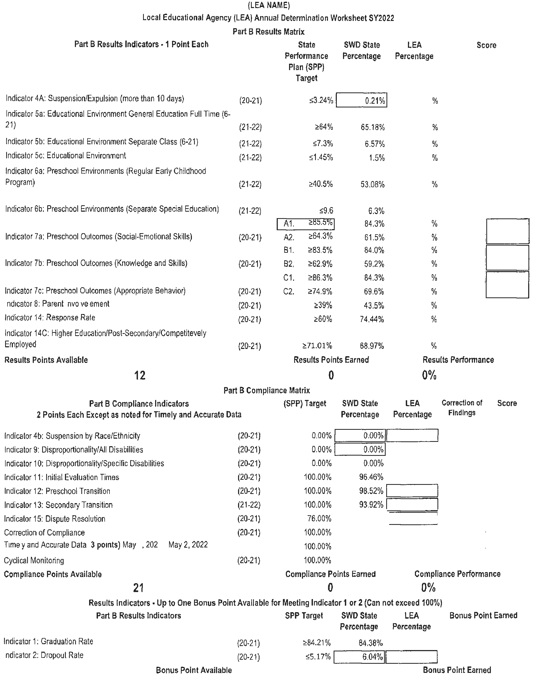

West Virginia Interagency Consolidated Monitoring of Out-of-State Residential Facilities

The West Virginia Legislature created The Commission to Study Residential Placement of Children to establish a mechanism to achieve systemic reform by which all the state’s child-serving agencies involved in the residential placement of at-risk youth jointly and continually study and improve upon this system. One of the topics of study outlined by the legislation when it formed the Commission was to develop ways to certify out-of-state providers to ensure that children who must be placed out-of-state receive high quality services consistent with West Virginia’s standards. As part of this charge, the West Virginia Department of Health and Human Resources (WVDHHR) and the WVDE joined efforts to develop and implement a collaborative monitoring system to review out-of-state facilities providing treatment and educational services to West Virginia youth.

For students with disabilities, each state has a responsibility, under federal statute and regulation, to have a system of general supervision that monitors the implementation of IDEA. The WVDE implemented the educational monitoring of out-of-state facilities in April 2002. In 2012 an interagency team comprised of WVDE and WVDHHR, developed the interagency consolidated monitoring process and a manual which describes the procedures to monitor out-of-state facilities servicing West Virginia students. These procedures aim to ensure appropriate treatment and educational services are being provided in a safe environment. The team representing WVDE and WVDHHR conducts on-site reviews of out-of-state facilities that provide services to students in West Virginia. A consolidated written report is issued to the facility administrator following the exit conference. Each report consists of recommendations for educational improvement, any child-specific and/or systemic findings of noncompliance under IDEA, WV state educational policies, WV state and federal codes, or WVDHHR rules, policies, and procedures. Corrective action plans are imposed when appropriate. In addition, at the conclusion of the on-site monitoring and in the event suspension of placements or removal of members/students is ordered, the entire review team must return for a second on-site monitoring visit to determine the facility’s correction of the deficiencies prior to a suspension being lifted.

The interagency team completed four (4) on-site reviews for the 2021-2022 school year. The facilities which received an on-site review were:
- Abraxas I – Marienville, PA
- Sandy Pines – Tequesta, FL
- Woods Services – Langhorne, PA
- Timber Ridge School – Winchester, VA

All facilities reviewed had educational findings of noncompliance and corrective action plans were required. Common educational findings of noncompliance in out of state facilities include lack of appropriate certification for school faculty; IEP services minutes unable to be verified by the school schedule; applicable students not consistently participating in their IEP Team meetings when transition services are addressed; notification of parents for IEP meetings and restraints; other findings are unique to individual facilities.

Dispute Prevention and Resolution System
When LEAs and parents have disagreements regarding students with exceptionalities, the WVDE encourages the parties to make every effort to resolve their differences informally through conferences and/or IEP Team meetings. For those cases when it is not possible to informally resolve a disagreement, the WVDE administers a system for dispute resolution, which includes options
for written state complaints, mediations and due process complaints regarding the identification, evaluation, placement and/or provision of a free appropriate public education. A state complaint is a charge that a special education law or regulation is not being followed by a county LEA or public agency and is investigated at the WVDE by OFPS staff. A complaint may also address a LEA’s failure to implement a due process hearing decision. A due process hearing provides a forum in which
an impartial hearing officer resolves the dispute between the parents and the county LEA unless it is settled by an agreement of both parties through a resolution session. Parents and LEAs are encouraged to use mediation, which is less formal than a complaint or a due process hearing, to
resolve disagreements. In addition, as a preventative measure, the WVDE has added the FIEP process whereby trained, impartial facilitators assist the parties to resolve the issues by collaboratively developing an IEP to meet the student’s needs.

Facilitated Individual Education Program (FIEP):
Total number of FIEPs requested 15
Total number of FIEPs completed 14
Total number of FIEP requests withdrawn 0
Total number of FIEP requests wherein parents refused to participate 1
Total number of FIEP requests not held due to resolution of issues 0
Total number of FIEP requests wherein LEA refused to participate 0
State Complaints:
Total number of state complaints requested 21
Total number of state complaints determined insufficient 4
Total number of state complaints where agreement was reached through early resolution 3
Total number of state complaints which were withdrawn 5
Total number of state complaints where agreement was reached through mediation 0
Total number of state complaints where issues were deferred pending due process 0
Total number of Letter of Findings issued 9
Mediations:
Total number of mediations requested 2
Total number of written agreements 0
Total number of mediations pending 1
Total number of mediations without agreements or withdrawn 1
Due Process Hearings:
Total number of due process hearings requested. 14
Total number of cases dismissed (resolution agreement, mediation agreement, withdrawal or other resolution without hearing)… 14
Total number of cases resulting in a decision by a hearing officer 0

Facilitated Individualized Education Program (FIEP)

An FIEP is a student focused IEP process designed to help the IEP Team overcome the pressures and challenges of a potentially contentious meeting. While the FIEP is not a required dispute resolution option under IDEA, West Virginia has joined many other states in making this option available. A Facilitated IEP Team meeting provides an opportunity for early conflict prevention and may be requested by LEAs, parents of children with disabilities, and adult students (18 years and older) with disabilities.

Upon receipt of a request for a FIEP meeting, the OFPS assigns a facilitator whose primary responsibility is to assist IEP Team members in the thoughtful and productive development of a quality IEP focused on the student’s specific needs. A trained, impartial professional facilitator or pair of facilitators will attend the IEP Team meeting to assist the members of the IEP Team in remaining focused on student issues and goals while addressing conflicts and disagreements that may arise during the meeting. The process may be used for any IEP Team meeting or eligibility meeting. IEP facilitation is free to all participants.

The IEP Facilitator’s role is to:
- Keep the meeting focused on the student.
- Ensure that all IEP team members have an opportunity to participate.
- Encourage active listening by all participants.
- Keep the group moving toward consensus without getting stalled on one part of the IEP.

To formally request a Facilitated IEP Team meeting, parents or school staff may contact their LEA’s special education director or complete a Request for a Facilitated IEP Team meeting form on the WVDE website at https://wvde.us/special-education/policies-and-compliance/monitoring-and-compliance. Impartial facilitators will be selected by the OFPS on a rotational basis. The entire IEP Team will participate in the Facilitated IEP Team meeting.

Both parties must agree to participate in the facilitated IEP process to schedule the meeting and subsequently, a mutually agreed upon date and time for the meeting shall be established. A request for a Facilitated IEP cannot delay the timeline for completion of the student’s annual IEP Team meeting.

State Complaints
The federal regulations for implementing Part B of the IDEA require each state to administer a system for investigating and resolving state complaints. A formal state complaint is a charge that special education laws or regulations are not being followed by a LEA or public agency.

An individual or organization may file a state complaint under the procedures described in Policy 2419,
Chapter 11. The WVDE has made available a form for filing a state complaint which can be accessed on the Department’s website. Although the use of this form is not required, the complaint must be in writing, contain the complainant’s signature and meet the criteria specified in Chapter 11, Section 2.A.

The WVDE has adopted written procedures for responding to and investigating state complaints and widely disseminates these procedures to parents and other interested individuals including parent training and information centers, protection and advocacy agencies, independent living centers and other appropriate entities in the state.

Within sixty days of receipt of a state complaint, the WVDE must carry out an independent investigation if the WVDE determines the state complaint is sufficient. Upon review of all relevant information, the WVDE must make an independent determination as to whether the public agency is violating state or federal special education laws or regulations. The WVDE issues a written decision to the LEA and the parent that addresses each allegation in the complaint and contains findings
of facts and conclusions, the reasons for the WVDE’s final decision, and procedures for effective implementation of the WVDE’s final decisions, if needed, including corrective actions to achieve compliance.

State Complaints and Due Process Complaints
If a written state complaint is received that is also the subject of a due process complaint or contains multiple issues of which one or more are part of the due process complaint, the WVDE shall set
aside any part of the state complaint that is being addressed in the due process complaint until the conclusion of the hearing. Any issue that is not a part of the due process action will be resolved following the established state complaint procedures and timelines. For issues that are addressed in the due process hearing, the hearing officer’s decision is binding and the WVDE must inform the complainant to that effect. Any remaining issues not addressed in the due process hearing decision will be investigated upon receipt of the hearing decision by the WVDE in accordance with the established state complaint procedures and timelines.

A state complaint alleging a LEA’s failure to implement a due process hearing decision must be investigated and resolved by the WVDE utilizing the state complaint procedures.

Early Resolution of State Complaints
Either the special education director or the parent/adult student may initiate an early resolution to a state complaint investigation by contacting the other party and participating in a local conference if both the LEA and parent voluntarily agree to utilize the early resolution option. If early resolution is reached on any or all allegations within fifteen days of being notified of the receipt of the state
complaint, the LEA need not submit its written response to the allegations to the WVDE, and the state complaint will be considered resolved. Allegations not resolved will be investigated using established procedures and timelines.

Mediation and State Complaints
Another option for resolving a state complaint is mediation. The parent and the LEA may agree to voluntarily engage in mediation consistent with the WVDE’s procedures to resolve the issues in the complaint. If both parties agree, the timeline for the investigation may be extended to accommodate the mediation session. If a mediation agreement is reached, the decisions are documented in a settlement agreement and the complaint is considered resolved. A settlement agreement is binding in any court of competent jurisdiction.

Of the twenty-one (21) state complaints submitted during the 2022 school year, nine (9) were fully investigated and resulted in the WVDE issuing a Letter of Findings (LOF). Four (4) state complaint requests were determined to be insufficient. The remaining 8 complaints were resolved and/or withdrawn.

Most Prevalent Violations Identified in 2022 State Complaints
- Failure to implement the IEP.
- Failure to provide documentation of the implementation of the IEP and the provision of services.
- Failure to adhere to timelines for evaluations and IEP Team meetings.

Mediation
Mediation is an informal process for assisting parents and LEAs to resolve disputes and reach agreements. Mediation is voluntary on the part of both parties and opens the lines of communication which should benefit the student, parents and school personnel throughout the student’s school career. Hopefully, when mediation is requested, parents and school personnel will have the opportunity to resolve their differences amicably, make decisions with the student’s best interest in mind; and therefore, reduce the need for further dispute resolution options. Parents and LEAs are encouraged to use mediation, which is a less formal process than a due process hearing, to resolve disagreements.

Mediation Requests 2022

Number of Mediations Requested | Number of Mediations Requested in Lieu of Resolution Meetings | Mediations Withdrawn or Dismissed | Mediation Agreements | Mediations Held Without an Agreement
2 | 0 | 0 | 0 | 1
*Note that M22-002 was pending at the end of FY22.

Mediation Issues Chart

Case | Issues | Outcome
M22-001 | Mediation requested after parent withdrew due process request. | No Agreement
M22-002 | Mediation requested by parents. | Pending

Mediation Costs
The West Virginia Department of Education assumes the total cost of the mediator assigned to the requested mediation. Mediators are selected by a solicitation process mandated by the State of West Virginia through the West Virginia Purchasing Division to conduct the mediation pursuant to the procedures specified in the IDEA and Policy 2419: Regulations for the Education of Students with
Exceptionalities. Mediators are compensated at the rate per hour specified on their individual contract for preparation, conducting the mediation and travel time. Total mediation costs for FY22 were
$3,581.50. The chart below provides a breakdown of mediation costs by case.

Case Number | Cost
M22-001 | $ 2,281.50
M22-002 | $1,300.00
Total Costs - $ 3,581.50

Due Process Hearing
Special education laws and regulations ensure that all students with exceptionalities have available a free appropriate public education. The WVDE, OFPS, is required to accept due process complaints regarding the identification, evaluation, educational placement and/or provision of FAPE for exceptional students. Due process complaints and hearings are important procedural safeguards for parents and are required by federal law. A parent, an adult student with an exceptionality, an LEA or
an attorney representing either party may request a hearing by filing a due process complaint with the LEA’s superintendent or the WVDE.

Due Process Complaint Resolution Meeting
In the IDEA, Congress recognized the need to provide additional opportunities for early dispute resolution. A 30-day resolution period was added when a parent files a due process complaint. The LEA is required to hold a resolution meeting within 15 days of receiving notice of the parents’ due process complaint to discuss the issues leading to their due process hearing request. This provides the LEA an opportunity to attempt to resolve the issues. The parents and LEA decide which IEP Team members will attend the resolution meeting; however, a LEA representative who has decision-making authority must participate in the resolution meeting. The resolution meeting must be held unless the parents and LEA agree in writing to waive the resolution meeting or agree to use mediation. If the LEA and parents resolve the issues relating to the due process hearing request during a resolution meeting, they must execute a legally binding agreement. If the LEA has not resolved the request for
the due process hearing to the satisfaction of the parents within 30 days of the receipt of the parents’ hearing request, the due process hearing may proceed, and all the applicable timelines begin.

Due Process Complaints & Hearing Requests
A total of fourteen (14) due process complaints were filed with the WVDE during the FY 2022 school year. All 14 were filed by parents or attorneys representing parents. A total of three (3) due process complaints were resolved through the resolution session process. One (1) complaint was resolved by a settlement agreement being reached beyond the 30-day resolution period. One (1) mediation was requested to resolve a due process complaint and resulted in a mediation agreement. One (1)
complaint was resolved through private mediation. One (1) complaint was withdrawn by a parent and one (1) was dismissed by a hearing officer. One (1) complaint resulted in a fully adjudicated hearing with a decision issued by a hearing officer.

Case Number | Alleged Violation | Action
D22-001 | Parents allege LEA failed to provide student with necessary specially designed instruction, in particular speech therapy services and assistive technology device, to enable student to make educational progress. | Withdrawn
D22-002 | Parents allege LEA failed to: adequately evaluate the student; design and implement appropriate IEPs; address behavioral issues in an appropriate manner; and provide the student an aide or otherwise provide safe transportation. | Early Resolution
D22-003 | Parents allege LEA has not recognized and provided appropriate supports for student’s ASD diagnosis, resulting in a denial of FAPE to the extent possible in the student’s LRE. | Early Resolution
D22-004 | Parent alleges LEA does not have a certified AU teacher in the student’s classroom. | Withdrawn
D22-005 | Parent alleges LEA took too long to initiate testing and that changes are necessary because the student has major deficits that are being ignored. | Withdrawn
D22-006 | Parent alleges LEA failed to identify the student as eligible for special education services, conduct a timely multidisciplinary evaluation or provide the accommodations and modifications necessary for the student to make appropriate progress, resulting in a denial of FAPE. | Early Resolution
D22-007 | Parent alleges LEA failed to identify the student as eligible for special education services. | Early Resolution
D22-008 | Parents allege LEA failed to identify the student as eligible for special education services. | Early Resolution
D22-009 | Parent alleges multiple violations related to eligibility, evaluations, timelines, FAPE, IEP development, predetermination, ESY and programming. | Withdrawn
D22-010 | Parent’s allegations include failure to evaluate and/or reevaluate and address behavior issues in a timely manner. | Early Resolution

IDEA Due Process Hearing Complaint Issues

Case Number | Alleged Violation | Action
D22-011 | Parent alleges LEA failed to identify the student as a child in need of an IEP and failed to timely conduct a multidisciplinary evaluation. | Withdrawn
D22-012 | Parent alleges LEA violated the student’s current IEP. | Early Resolution
D22-013 | Parent alleges LEA did not handle student’s suspension because of social media post in an appropriate manner. | Early Resolution
D22-014 | Parent alleges LEA denied parental participation; has low goals/ expectations on IEP; never worked multiplication and division and had safety issues that violated the Safe Schools Act. | Mediation

IDEA Due Process Hearing Costs

The WVDE has entered into a contractual agreement for due process hearing officer services following a solicitation process mandated by the State of West Virginia through the West Virginia Purchasing Division. Hearing officers are compensated at the rate specified in each individual contract for preparation, travel, conducting the hearing and preparing and submitting the written decision. The WVDE remits payment to the hearing officer for 2/3 of the approved cost of the hearing officer’s fee.
The LEA remits payment to the hearing officer for 1/3 of the approved cost of the hearing officer’s fee based on a memorandum of understanding between WVDE and the local education agencies. When a case is settled or dismissed prior to a hearing, the hearing officer is only paid for time accrued, which is considerably less than when a hearing occurs. The WVDE is responsible for 100% of the cost of a court reporter for the due process hearing. The LEA is responsible for the cost of the LEA’s attorney.

The total cost of due process complaints for FY 2022 was $9,905.00. The chart below breaks down the specific costs paid separately by the WVDE and the LEA, as well as the total cost for each due process complaint filed.

Case Number | Hearing Costs |  | Court Reporter Cost | Total Hearing Cost
Case Number | WVDE Cost | LEA Cost | Court Reporter Cost | Total Hearing Cost
D22-001 | $382.50 | $191.25 | $0.00 | $573.75
D22-002 | $532.00 | $266.00 | $0.00 | $798.00
D22-003 | $793.33 | $396.67 | $0.00 | $1,190.00
D22-004 | $1,300.00 | $650.00 | $0.00 | $1,950.00
D22-005 | $630.00 | $315.00 | $0.00 | $945.00
D22-006 | $0.00 | $0.00 | $0.00 | $0.00
D22-007 | $351.00 | $175.50 | $0.00 | $526.50
D22-008 | $386.67 | $193.33 | $0.00 | $580.00
D22-009 | $0.00 | $0.00 | $0.00 | $0.00
D22-010 | $0.00 | $0.00 | $0.00 | $0.00
D22-011 | $608.00 | $304.00 | $0.00 | $912.00
D22-012 | $611.00 | $304.50 | $0.00 | $916.50
D22-013 | $337.50 | $168.75 | $0.00 | $506.25
D22-014 | $671.33 | $335.67 | $0.00 | $1,007.00
Total Costs | $6,603.33 | $3,300.67 | $0.00 | $9,905.00

The West Virginia Department of Education, OFPS, Special Education, continually strives to support West Virginia’s LEAs in meeting the requirements of the Individuals with Disabilities Education Improvement Act and Policy 2419: Regulations for the Education of Students with Exceptionalities through the processes discussed in this report. Additionally, the OFPS provides resources and information on all dispute prevention and resolution processes to parents of children with disabilities, adult students with disabilities, and other interested parties. Questions regarding the information provided in this report should be directed to the West Virginia Department of Education, OFPS, at 304- 558-2696.



Michele L. Blatt West Virginia Superintendent of Schools

