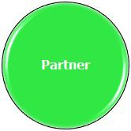


Components of a Routine
Effective routines have a beginning, middle and end.

- Initiate – How will the individual know it is time to begin?


- Prepare – What does the individual need to do to be ready?

- Perform Activity – How will the individual participate or partially participate?

- Terminate – How will the individual know when the activity is over?

