Updated March 2026
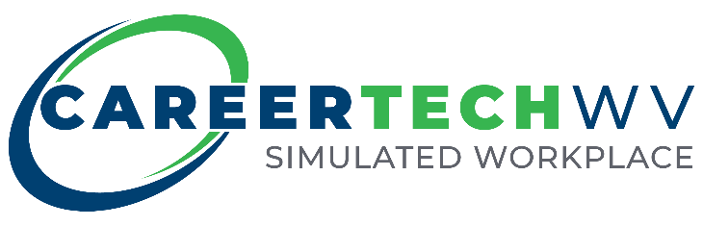

[Replace With Image]

SIMULATED WORKPLACE

Policies and

Procedures Manual
www.simulatedworkplace.com

Template Disclaimer
This manual is intended to serve as a template for Simulated Workplace implementation. Some sections contain guidance, while others are designed to be customized by individual programs. Sections labelled with a double asterix “**” are intended to be customized by the individual programs.

Simulated Workplace - Local Policy and Procedure Manual
(This document is a local operating addendum aligned to the Simulated Workplace Operations Manual. Schools and programs customize designated sections to reflect their company identity while maintaining required Simulated Workplace expectations.)

Section 1: Purpose and Company Overview

Purpose of This Manual
This Policy and Procedure Manual serves as the operating guide for the local Simulated Workplace company. It establishes how the company is structured, how work is organized, and how expectations are applied consistently throughout the year.

This manual is not a curriculum or a set of daily lesson plans. It is a classroom management and leadership development tool that allows students to operate a simulated company within the school environment. Through this structure, students gain hands-on experience with professional expectations, workplace responsibilities, teamwork, communication, and problem-solving.

The manual is designed to be introduced at the beginning of the course and is used continuously as the reference point for decision-making, accountability, and performance expectations.

Relationship to the Simulated Workplace Operations Manual
This local manual functions as an addendum to the Simulated Workplace Operations Manual. While the Operations Manual defines statewide protocols, philosophy, and non-negotiable expectations, this
document defines how those expectations are implemented locally through a student-created company.

All procedures, roles, and structures outlined in this manual are aligned to the Simulated Workplace protocols and reinforce student ownership, safety, professionalism, and continuous improvement.

**Company Overview

Company Name:

Program/Pathway:

School:

School Year:

(Insert Company Logo)

This Simulated Workplace company is created and operated by students enrolled in the program listed above. Students function as employees and leaders within the company and are responsible for carrying out daily operations in alignment with established procedures.

The company structure, roles, and procedures outlined in this manual provide consistency while allowing flexibility for program-specific needs.

Guiding Principles
The Simulated Workplace company operates using the following principles:
- Students learn professional and employability skills by actively performing workplace roles.
- Leadership responsibilities are held by students and supported through coaching.
- Clear procedures create consistency and fairness.
- Mistakes are treated as learning opportunities.
- Continuous improvement is expected and encouraged.

Teacher Role
The instructor serves as a coach, facilitator, and advisor. Rather than managing every task, the instructor supports student leadership, reinforces expectations, and intervenes when necessary to ensure safety, fairness, and alignment with Simulated Workplace protocols.

Student Role
Students are responsible for understanding and following the expectations outlined in this manual. As employees and leaders within the Simulated Workplace company, students are expected to:
- Perform assigned job responsibilities
- Follow established procedures
- Participate in decision-making when appropriate
- Uphold safety and professionalism standards
- Contribute to continuous improvement of company operations

Section 2: Company Structure and Hierarchy

Purpose
This section defines how the Simulated Workplace company is organized and how leadership and responsibility are distributed. A clear structure establishes accountability, supports student leadership, and ensures consistent decision-making.

The company structure is developed early in the course and is revisited as roles evolve, new positions are created, or operational needs change.

**Organizational Structure
Each Simulated Workplace company will establish an organizational structure appropriate to its program, size, and scope. The structure should reflect realistic workplace roles and provide opportunities for leadership, teamwork, and accountability.

Company Organization Framework (Sample)
(Local programs customize titles and structure while maintaining leadership tiers and accountability pathways.)
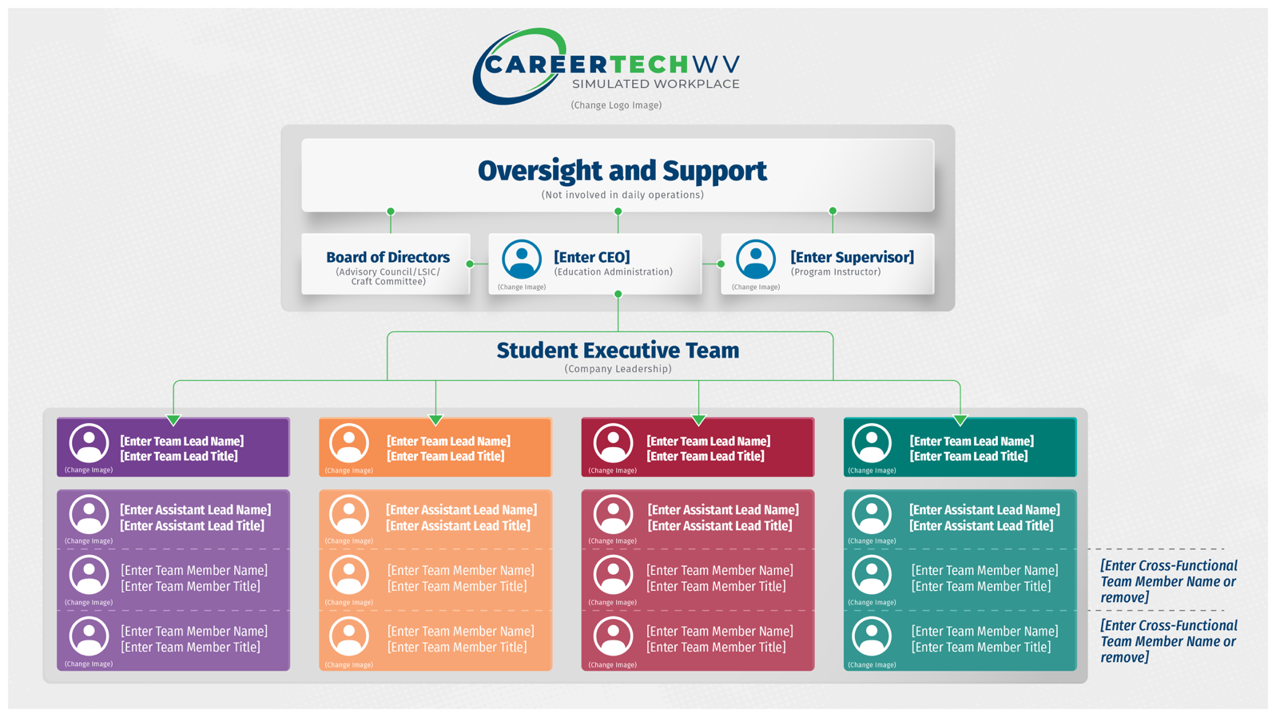

Leadership Roles
Leadership roles are held by students and carry real responsibility within the Simulated Workplace company. Leaders are expected to model professionalism, support team members, and assist with managing daily operations.

Leadership roles may include, but are not limited to:
- Company President / Manager
- Operations Lead
- Safety Manager
- Quality or Performance Lead
- Human Resources or Personnel Lead
(The specific titles and number of leadership positions may vary by program.)

**Employee Roles
Employee roles are defined based on the needs of the company and the instructional goals of the program. Each role should have a clear purpose and set of responsibilities.

Employee roles may include production, service, technical, administrative, or support positions aligned to the program of study.

Chain of Responsibility
The Simulated Workplace company follows a clear chain of responsibility:
- Employees address routine issues within their role or team.
- Team leaders or supervisors assist with problem-solving and decision-making.
- Company leadership addresses issues that impact operations, safety, or performance.
- The instructor intervenes when issues exceed student authority or involve safety, fairness, or compliance.

This structure reinforces leadership development while ensuring appropriate oversight.

Role Expectations
All roles within the company are expected to:
- Follow established procedures
- Communicate effectively
- Uphold safety and professionalism standards
- Support team and company goals
- Participate in continuous improvement

Section 3: Job Descriptions and Hiring Process

Purpose
This section establishes a consistent and authentic process for defining roles, posting positions, and hiring employees within the Simulated Workplace company. The hiring process mirrors real-world workplace practices and provides students with hands-on experience in applying, interviewing, and accepting job responsibilities.

**Job Descriptions
Each Simulated Workplace company will develop written job descriptions for all leadership and employee roles. Job descriptions should be created or reviewed by student leadership and approved by the instructor prior to posting.

Job descriptions should include:
- Job title
- Primary responsibilities
- Required skills or qualifications
- Reporting relationship (who the role reports to)
- Expectations for performance and professionalism

Job descriptions may be revised as company needs change.

Job Postings
Once job descriptions are finalized, positions are posted for applicants. Job postings should be visible to all potential applicants and include clear instructions for applying.
Job postings should:
- Clearly identify the position
- Reference the job description
- Include application deadlines
- Identify required materials (application, interview, references if applicable)

Application Process
Students seeking employment within the Simulated Workplace company must complete a job application using the approved application template. Applications are reviewed using the Simulated Workplace Job Application Rubric.

Applications are used as a practice tool to build professional writing, attention to detail, and intentional decision-making.

Interview Process
Interviews are conducted as a practice-based experience focused on building comfort and professionalism. Interviews may be conducted by:
- Student leadership
- Instructors
- Peers
- Advisory council members or industry partners

Interview questions and evaluation tools should align to Simulated Workplace expectations and emphasize growth rather than exclusion.

**Selection and Placement
Final placement decisions are made based on application materials, interview performance, program needs, and available positions. The selection process should be transparent and consistently applied. Students may be reassigned or rotated into different roles as part of the learning experience.

Posting the Company Hierarchy
Once positions are filled, the company organizational chart is updated and posted. This hierarchy serves as the official reference for reporting relationships and leadership responsibilities.

Hiring as a Learning Process
The hiring process is not intended to limit student participation. Instead, it provides structured opportunities to practice workplace skills, reflect on feedback, and grow over time.

Section 4: Company Procedures and High-Frequency Situations

Purpose
This section establishes consistent procedures for handling situations that occur frequently during daily operations. Clear procedures reduce confusion, promote fairness, and support student leadership by providing a shared reference for decision-making.

Procedures are developed collaboratively, reviewed regularly, and used as coaching tools rather than punitive measures.

Identifying High-Frequency Situations
High-frequency situations are issues or tasks that occur repeatedly throughout the year and require consistent handling. These situations should be identified early and revisited as the company evolves.

Common examples may include:
- Attendance and punctuality
- Absences and make-up work
- Daily start-up and shut-down procedures
- Safety concerns and violations
- Use and care of equipment and materials
- Work quality and productivity expectations
- Team communication and conflict

Developing Procedures
Procedures are created with input from student leadership and employees. Once developed, procedures are documented, reviewed with the company, and applied consistently.

Each procedure should clearly define:
- The expected behavior or action
- Steps to follow when the situation occurs
- Roles responsible for addressing the situation
- When an issue should be escalated to leadership or the instructor

Procedure Ownership
Primary responsibility for enforcing and supporting procedures lies with student leadership. Leaders are expected to address issues respectfully, document outcomes when appropriate, and seek guidance when situations exceed their authority.

This structure reinforces accountability while allowing the instructor to coach rather than manage day-to-day issues.

**Documentation and Consistency
The company will determine how procedures and outcomes are documented. Documentation may include logs, checklists, reports, or digital tools.

Documentation supports consistency, transparency, and continuous improvement.

Review and Revision of Procedures
Procedures are not static. Leadership should regularly review procedures to determine effectiveness and recommend updates as company needs change.

Revisions should be communicated clearly and applied consistently.

Instructor Role
The instructor supports procedure development, ensures alignment with safety and school expectations, and intervenes when necessary. The instructor’s role is to guide, coach, and ensure fairness rather than serve as the primary enforcer of procedures.

Section 5: Performance, Accountability, and Continuous Improvement

Purpose
This section establishes how performance is reviewed, feedback is provided, and improvement is supported within the Simulated Workplace company. The focus is on growth, accountability, and continuous improvement rather than punishment.

Performance processes are used to build professional habits, strengthen leadership skills, and reinforce expectations aligned to Simulated Workplace protocols.

Performance Expectations
All employees and leaders are expected to:
- Perform assigned job responsibilities
- Follow company procedures and safety expectations
- Communicate effectively
- Demonstrate professionalism and work ethic
- Contribute to team and company goals

Performance expectations apply consistently across all roles.

**Performance Reviews
The company will establish how and when performance reviews occur. Reviews may include:
- Informal check-ins
- Peer feedback
- Leadership feedback
- Self-reflection
- Use of tools such as 6S inspections, interview rubrics, or performance checklists

Performance reviews should be scheduled regularly and documented as appropriate.

Feedback and Coaching
Feedback is timely, specific, and focused on improvement. Coaching conversations are used to help employees understand expectations, recognize strengths, and identify next steps.

Leaders are encouraged to address performance concerns early and respectfully. Coaching precedes formal corrective action whenever possible.

Accountability and Corrective Action
When performance does not meet expectations, corrective action follows a progressive approach:
- Coaching and clarification of expectations
- Additional support or retraining
- Leadership intervention
- Instructor involvement when necessary

Corrective actions are documented when appropriate and used as learning opportunities.

Continuous Improvement
The company is expected to regularly review performance data, procedures, and outcomes to identify opportunities for improvement.

Continuous improvement may include:
- Updating procedures
- Adjusting roles or responsibilities
- Refining workflows
- Setting new performance goals

Improvement efforts should be visible and shared with the company.

**Recognition and Growth
The company may establish methods for recognizing growth, improvement, and leadership. Recognition may include verbal acknowledgment, certificates, role advancement, or additional responsibilities.

Recognition should reinforce desired behaviors and professional growth.

Instructor Role
The instructor supports performance systems, ensures fairness, and intervenes when necessary to maintain alignment with safety, school expectations, and Simulated Workplace protocols.

Notes

Note

Michele L. Blatt
West Virginia Superintendent of Schools

wvde.us

