Our discussion and analysis of the ____________ County Board of Education’s (RESA’s, MCVC’s) financial performance provides an overview of the Board’s financial activities for the fiscal year ended June 30, 2016. Please read this discussion and analysis in conjunction with the Board’s basic financial statements, which are presented immediately following this Management’s Discussion and Analysis.

Financial Highlights

- The Board’s assets plus deferred outflows of resources exceeded liabilities plus deferred inflows of resources by $_______ (net position) at the close of the most recent fiscal year. Of this amount, $_________ (unrestricted net position) may be used to meet the government’s ongoing obligations to citizens and creditors.

- The Board’s total net position increased by $_________. Approximately $________ of this increase is attributable to ____________________________________________

- As of the close of the current fiscal year, the Board’s governmental funds reported combined ending fund balances of $_________, an increase of $_________ in comparison with the prior year. Approximately $_________ of this total amount is available for spending at the board’s discretion (unreserved fund balance).

- At the end of the current fiscal year, unreserved fund balance for the general fund was $________, or ___ percent of total general fund expenditures.

If Applicable,

- The Board’s total debt increased by $________ during the current fiscal year. The key factor in this increase was the issuance of $________ in general obligation (revenue, etc.) bonds.

- On ( date ), the public voted to authorize the Board to issue $ _____ million of general obligation school building bonds for _______________, _______________, and _______________. This debt will be issued to cope with _________ (i.e. student growth) over the next ________ to _______ years.

Overview of the Financial Statements

The discussion and analysis is intended to serve as an introduction to the Board’s basic financial statements. The Board’s basic financial statements comprise three components: 1) district-wide financial statements, 2) fund financial statements, and 3) notes to the financial statements. This report also contains other supplementary information in addition to the basic financial statements themselves.

District-wide financial statements - The district-wide financial statements are designed to provide readers with a broad overview of the Board’s finances, in a manner similar to a private-sector business.

The statement of net position presents information on all of the Board’s assets, deferred outflows of resources, liabilities, and deferred inflow of resources. Net position is reported as assets plus deferred outflows of resources minus liabilities minus deferred inflows of resources. Over time, increases or decreases in net position may serve as a useful indicator of whether the financial position of the Board is improving or deteriorating.

The statement of activities presents information showing how the government’s net position changed during the most recent fiscal year. All changes in net position are reported as soon as the underlying event giving rise to the change occurs, regardless of the timing or related cash flows. Thus, revenues and expenses are reported in this statement for some items that will only result in cash flows in future fiscal periods (e.g., uncollected taxes and earned but unused vacation leave).

The district-wide financial statements can be found on pages __-__ of this report.

Fund financial statements - A fund is a grouping of related accounts that is used to maintain control over resources that have been segregated for specific activities or objectives. The Board, like other state and local governments, uses fund accounting to ensure and demonstrate compliance with finance-related legal requirements. All of the funds of the Board can be divided into two categories: governmental funds and fiduciary funds.

Governmental funds. Governmental funds are used to account for essentially the same functions reported as governmental activities in the district-wide financial statements. However, unlike the district-wide financial statements, governmental fund financial statements focus on near-term inflows and outflows of spendable resources, as well as on balances of spendable resources available at the end of the fiscal year. Such information may be useful in evaluating a government’s near-term financing requirements.

Because the focus of governmental funds is narrower than that of the district-wide financial statements, it is useful to compare the information presented for governmental funds with similar information presented for governmental activities in the district-wide financial statements. By doing so, readers may better understand the long-term impact of the government’s near-term financing decisions. Both the governmental fund balance sheet and the governmental fund statement of revenues, expenditures, and changes in fund balances provide a reconciliation to facilitate this comparison between governmental funds and governmental activities.

The Board maintains _____ individual governmental funds. Information is presented separately in the governmental fund balance sheet and in the governmental fund statement of revenues, expenditures, and changes in fund balances for the general fund, the special revenue fund, the debt service fund, (list all applicable funds), all of which are considered major funds.

Fiduciary funds. Fiduciary funds are used to account for resources held for the benefit of parties outside the governmental entity. Fiduciary funds are not reflected in the district-wide financial statement because the Board cannot use these funds to finance its operations.

The Board uses an agency fund to account for resources held for student activities and groups. The basic fiduciary fund financial statement can be found on page __ of this report.

Notes to the basic financial statements - The notes provide additional information that is essential for a full understanding of the data provided in the district-wide and fund financial statements. The notes to the financial statements can be found on pages __ to __ of this report.

District-wide Financial Analysis

As noted earlier, net position may serve over time as a useful indicator of a government’s financial position. In the case of the Board, assets plus deferred outflows of resources exceeded liabilities plus deferred inflows of resources by $________ at the close of the most recent fiscal year.

- The largest portion of the Board’s net position (insert %) reflects its investment in capital assets (e.g. land, buildings, furniture and equipment, vehicles), less any related debt used to acquire those assets that is still outstanding. The Board uses these capital assets to provide services to students; consequently, these assets are not available for future spending. Although the Board’s investment in capital assets is reported net of related debt, it should be noted that the resources needed to repay this debt must be provided from other sources, since the capital assets themselves cannot be used to liquidate these liabilities.

- An additional portion of the Board’s net position (insert %) represents resources that are subject to external restrictions on how they may be used. The majority of the restricted balance is for capital projects (insert applicable wording).

- The remaining balance of unrestricted net position (insert %) may be used to meet the Board’s obligations to students, employees, and creditors and to honor next year’s budget.

The following summarizes the statement of net position at June 30, 2016 in comparison with June 30, 2015:

(Note: The table below is linked directly to the financial statement Excel template)

 |  | 2016 |  | 2015
 |  | Governmental |  | Governmental
 |  | Activities |  | Activities |  | Variance
ASSETS AND DEFERRED OUTFLOWS OF
RESOURCES
Current and other assets |  | $ - |  | $ - |  | $ -
Capital assets |  | - |  | - |  | -
Deferred outflows of resources |  | - |  | - |  | -
Total assets and deferred outflows  of resources |  | - |  | - |  | -
LIABILITIES, DEFERRED INFLOWS OF
RESOURCES AND NET POSITION
Liabilities and deferred inflows of resources:
Current and other liabilities |  | $ - |  | $ - |  | $ -
Long-term liabilities outstanding |  | - |  | - |  | -
Deferred inflows of resources |  | - |  | - |  | -
Net pension liability - Proportionate share |  | - |  | - |  | -
Total liabilities and deferred  inflows of resources |  | - |  | - |  | -
Net position:
Net Investment in Capital Assets |  | - |  | - |  | -
Restricted |  | - |  | - |  | -
Unrestricted |  | - |  | - |  | -
Total net position |  | - |  | - |  | -
Total liabilities, deferred inflows of  resources, and net position |  | $ - |  | $ - |  | $ -

The key elements of the (increase/decrease) of the Board’s net position for the year ended June 30, 2016 are as follows:

- Current and other assets (increased/decreased) by approximately $________ which primarily represents (insert applicable wording to describe the reason for the variance).

- Capital assets (increased/decreased) by approximately $________ which represents (insert applicable wording to describe the reason for the variance).

- Current and other liabilities (increased/decreased) by approximately $________ which was primarily the result of (insert applicable wording to describe the reason for the variance).

- Long-term liabilities (increased/decreased) by approximately $________ which was primarily the result of (insert applicable wording to describe the reason for the variance).

- Deferred inflows of resources (increased/decreased) by approximately $________ which was primarily the result of (insert applicable wording to describe the reason for the variance).

- At the end of the current fiscal year, the Board is able to report positive balances in all three categories of net position. The same situation held true for the prior fiscal year. (insert applicable wording).

- Restricted net position (increased/decreased) by $_________ during the year ended June 30, 2016. This (increase/decrease) resulted primarily from ________________________________________________.

- The Board’s net position (increased/decreased) by $___________ during the current year. The following discussion and analysis on governmental activities focuses on this (increase/decrease):

The following summarizes the statement of activities for the year ended June 30, 2016 in comparison with the year ended June 30, 2015:

(Note: The table below is linked directly to the financial statement Excel template)

 |  | 2016 |  | 2015
 |  | Governmental |  | Governmental
 |  | Activities |  | Activities |  | Variance
Revenues:
Program revenues:
Charges for services |  | $ - |  | $ - |  | $ -
Operating grants and contributions |  | - |  | - |  | -
Capital grants and contributions |  | - |  | - |  | -
General revenues:
Property taxes |  | - |  | - |  | -
Unrestricted state aid |  | - |  | - |  | -
Unrestricted investment earnings |  | - |  | - |  | -
Unrestricted grants and contributions |  | - |  | - |  | -
Gain or (loss) on disposal of capital assets |  | - |  | - |  | -
Total revenues |  | - |  | - |  | -
Expenses:
Instruction |  | - |  | - |  | -
Supporting services:
Students |  | - |  | - |  | -
Instructional staff |  | - |  | - |  | -
General administration |  | - |  | - |  | -
School administration |  | - |  | - |  | -
Central services |  | - |  | - |  | -
Operation and maintenance of facilities |  | - |  | - |  | -
Student transportation |  | - |  | - |  | -
Other |  | - |  | - |  | -
Total supporting services |  | - |  | - |  | -
Food services |  | - |  | - |  | -
Community services |  | - |  | - |  | -
Interest on long-term debt |  | - |  | - |  | -
Total expenses |  | - |  | - |  | -
Change in net position before transfers |  | - |  | - |  | -
Transfers |  | - |  | - |  | -
Change in net position |  | - |  | - |  | -
Net position - Beginning |  | - |  | - |  | -
Restatement - GASB 68 |  | - |  | - |  | -
Net position - Ending |  | $ - |  | $ - |  | $ -

The key elements of the changes in the Board’s statement of activities for the year ended June 30, 2016 are as follows:

(Note: remove any category below that did not have a significant variance)

- Charges for services (increased/decreased) by approximately $_________ which was primarily the result of (insert applicable wording to describe the reason for the variance).
- Operating grants and contributions (increased/decreased) by approximately $_________ which was primarily the result of (insert applicable wording to describe the reason for the variance).
- Capital grants and contributions (increased/decreased) by approximately $_________ which was primarily the result of (insert applicable wording to describe the reason for the variance).
- General revenues from property taxes (increased/decreased) by approximately $_________ which was primarily the result of (insert applicable wording to describe the reason for the variance).
- General revenues from unrestricted state aid (increased/decreased) by approximately $_________ which was primarily the result of (insert applicable wording to describe the reason for the variance).
- General revenues from unrestricted grants and contributions (increased/decreased) by approximately $_________ which was primarily the result of (insert applicable wording to describe the reason for the variance).
- Overall expenses (increased/decreased) by approximately $_________ which was primarily the result of (insert applicable wording to describe the reason for the variance).

The following chart shows the Board’s revenues for fiscal year ended June 30, 2016 by source:
(Note: The chart below is linked directly to the financial statement Excel template)

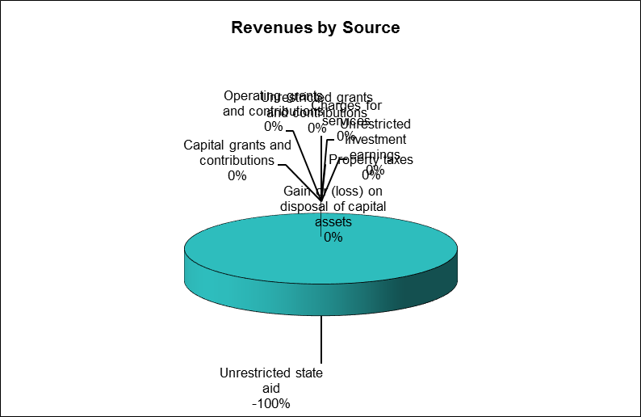

The following chart shows the Board’s expenditures for fiscal year ended June 30, 2016 by function:
(Note: The chart below is linked directly to the financial statement Excel template)

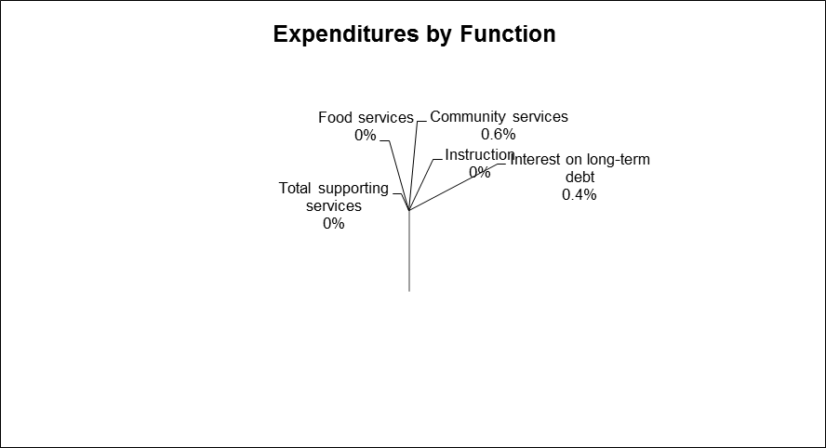
Financial Analysis of the Board’s Funds

As noted earlier, the School Board uses fund accounting to ensure and demonstrate compliance with finance-related legal requirements.

Governmental funds. The focus of the Board’s governmental funds is to provide information on near-term inflows, outflows, and balances of spendable resources. Such information is useful in assessing the Board’s financing requirements. In particular, unassigned fund balance may serve as a useful measure of a government’s net resources available for spending at the end of the fiscal year. As the Board completed the year, its governmental funds reported a combined fund balance of $ _______. Included in this year’s change in the combined fund balance is ______________________________________________.

Governmental funds report the differences between their assets, deferred outflows, liabilities, and deferred inflows as fund balance, which is divided into nonspendable, restricted, committed, assigned and unassigned portions. Nonspendable, restricted, committed, and assigned indicate the portion of the Board’s fund balances that are not available for appropriation. The unassigned fund balance is available financial resources in governmental funds. The $_____ fund balance of the general fund is primarily designated for the following purpose:

- (Explain primary balances of the general fund)

In addition, the following other changes in fund balances should be noted and whether restrictions, commitments, or other limitations significantly affect the availability of fund resources for future use:

- (Explain any other additional changes in fund balances)

The Board had ___ (insert number of funds maintained by the Board) major funds for the fiscal year ended June 30, 2016. Those funds are the General Current Expense Fund, Special Revenue Fund, (list remaining funds maintained by the Board.)

(Note: Remove any of the following fund descriptions that were not used by the Board during the current and prior year)

General Current Expense Fund

This is the principal operation fund which accounts for all financial resources of the Board except those required to be accounted for in another fund. The fund balance (increased/decreased) from $______ (prior year fund balance) to $_______ (current year fund balance) during the fiscal year ended June 30, 2016. As previously discussed, this (increase/decrease) of $_______ (insert actual amount of the change) was due primarily to (insert applicable wording to describe the reason for the variance).

Special Revenue Fund

This is an operating fund of the Board and accounts for all revenues and expenditures attributable to state and federal grants and other revenue sources that are legally restricted to expenditures for specific purposes. The fund balance (increased/decreased) from $______ (prior year fund balance) to $_______ (current year fund balance) during the fiscal year ended June 30, 2016. This (increase/decrease) of $_______ (insert actual amount of the change) was due primarily to (insert applicable wording to describe the reason for the variance).

Special Revenue ARRA Fund

This is a separate special revenue fund to account for all revenue and expenditures attributable to funds received as part of the American Recovery and Reinvestment Act (ARRA) of 2009 which are legally restricted to expenditures for specific purposes. The fund balance (increased/decreased) from $______ (prior year fund balance) to $_______ (current year fund balance) during the fiscal year ended June 30, 2016. This (increase/decrease) of $_______ (insert actual amount of the change) was due primarily to (insert applicable wording to describe the reason for the variance).

Debt Service Fund

This is a separate fund used to account for the accumulated resources, and the payment of, general long-term debt, principal, and interest. The fund balance (increased/decreased) from $______ (prior year fund balance) to $_______ (current year fund balance) during the fiscal year ended June 30, 2016. This (increase/decrease) of $_______ (insert actual amount of the change) was due primarily to (insert applicable wording to describe the reason for the variance).

Permanent Improvement Fund

This is a separate fund established under the authority of West Virginia Code §18-9B-14 to account for the proceeds of resources and subsequent expenditures for capital improvement activities. The proceeds of the fund must be used only for the support of building and capital improvements and cannot be transferred out of the fund. The fund balance (increased/decreased) from $______ (prior year fund balance) to $_______ (current year fund balance) during the fiscal year ended June 30, 2016. This (increase/decrease) of $_______ (insert actual amount of the change) was due primarily to (insert applicable wording to describe the reason for the variance).

Capital Projects Fund

This is a separate fund used to account for all financial resources used to acquire or construct specific major capital facilities other than by the sale of bonds or the reservation of monies in a permanent improvement fund. The fund balance (increased/decreased) from $______ (prior year fund balance) to $_______ (current year fund balance) during the fiscal year ended June 30, 2016. This (increase/decrease) of $_______ (insert actual amount of the change) was due primarily to (insert applicable wording to describe the reason for the variance).

Bond Construction Fund

This is a separate fund used to account for the financial resources used to acquire or construct major capital facilities financed as a result of issuing bonds. The fund balance (increased/decreased) from $______ (prior year fund balance) to $_______ (current year fund balance) during the fiscal year ended June 30, 2016. This (increase/decrease) of $_______ (insert actual amount of the change) was due primarily to (insert applicable wording to describe the reason for the variance).

General Fund Budgetary Highlights

During the year, the Board revised the budget. Budget amendments were to reflect changes in programs and related funding. The difference between the original budget and the final amended budget was an (increase/decrease) of $_____ or (insert %) in total general fund expenditures. The most significant differences, including the differences between the original and final budget figures, and significant variances between the actual amounts and final budget amounts may be summarized as follows:

- (Explain significant differences in budgetary items)

Capital Asset and Debt Administration

Capital assets - The Board’s investment in capital assets for its governmental activities as of June 30, 2016, amounts to $_________ (net of accumulated depreciation). This investment in capital assets includes land, buildings and improvements, furniture and equipment, and vehicles. The total increase in the Board’s investment in capital assets for the current fiscal year was ____ percent.

Major capital asset events during the current fiscal year included the following:

- (Explain major capital asset events)

 |  | 2016 |  | 2015
 |  | Governmental |  | Governmental
 |  | Activities |  | Activities |  | Variance
Land |  | $ - |  | $ - |  | $ -
Land improvements |  | - |  | - |  | -
Buildings and improvements |  | - |  | - |  | -
Furniture and equipment |  | - |  | - |  | -
Vehicles |  | - |  | - |  | -
Construction in process |  | - |  | - |  | -
Total capital assets |  | $ - |  | $ - |  | $ -

Additional information on the Board’s capital assets can be found in Note(s) __ to the basic financial statements.

Long-term debt. At the end of the current fiscal year, the Board had total bonded debt outstanding of $________ and capital lease obligations of $__________. Employees of the Board are eligible to receive special termination benefits in the form of convertible sick leave earned but not used prior to retirement. Upon retirement, an employee’s accumulated sick leave may be converted to a greater retirement benefit or to payment of the retired employee’s health insurance premiums. The cost of additional retirement benefits are the liability of the West Virginia Consolidated Public Retirement Board and therefore are not recorded in the Board’s financial statements. However, the cost of the health insurance premiums must be absorbed by the last agency employing the retiree. Historically, the West Virginia Legislature has appropriated funds for the Board for payment of these costs. However, because such appropriations are at the discretion of the Legislature and therefore not guaranteed, the liability for the cost of sick leave convertible to health insurance premiums is recorded in the Board’s financial statements. At June 30, 2016, the liability for such costs was $____________, which is included in the district-wide financial statement of net position. The obligation for compensated absences for vacations was $_________ at June 30, 2016.

 |  | 2016 |  | 2015
 |  | Governmental |  | Governmental
 |  | Activities |  | Activities |  | Variance
General obligation bonds |  | $ - |  | $ - |  | $ -
Capital Lease obligations |  | - |  | - |  | -
Compensated absences |  | - |  | - |  | -
Accrued sick leave |  | - |  | - |  | -
Total debt outstanding |  | $ - |  | $ - |  | $ -

Additional information on the Board’s long-term debt can be found in Note(s) ___ to the basic financial statements.

Factors Bearing on the Board’s Future

At the time these financial statements were prepared and audited, the Board was aware of circumstances that could significantly affect its financial health in the future:

- (Explain currently known facts affecting the Board’s future)

Contacting the Board’s Financial Management

This financial report is designed to provide our citizens and taxpayers with a general overview of the Board’s finances and to demonstrate the Board’s accountability for the money it receives. If you have questions about this report or need additional financial information, contact the Board Office, (insert the Board’s address).

