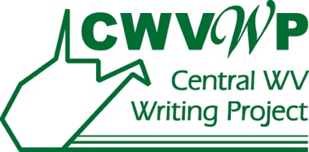

West Virginia Young Writers Contest Plagiarism Policy

Teachers: Please share this important information with students and parents.
The Young Writers Contest celebrates and expects original work from students at every grade level. Plagiarism is using part or all of someone else’s work and taking credit for it as your own. It is unethical behavior. The Young Writers Contest follows Marshall University’s policy against plagiarism. In accordance with this policy, all Young Writer entries will be submitted to the anti-plagiarism tool, SafeAssign. The penalty for plagiarism is notification of the sponsoring teacher and expulsion from the contest. If you wish more information about Marshall University’s academic honesty policy, visit: http://www.marshall.edu/academic-affairs/policies/

A basic rule for students is: Write your own thoughts in your own words. Do not cut and paste or copy anything written by another person or found online.

