West Virginia
1.0 Percent State-Level Participation Cap
Waiver Submission

Pursuant to 34 C.F.R. 200.6(c)(4), the West Virginia Department of Education (WVDE) will seek to extend the waiver for the 2018-2019 school year from the Secretary for the United States Department of Education (USDOE). The regulation in question, found at 34 C.F.R. 200.6(c)(2), requires State Education Agencies such as the WVDE to limit the total number of students assessed in a subject area using an alternate assessment. The limit on the percentage of students assessed by the alternate assessment is set by the federal regulation, stating the total number of students assessed with the alternate assessment per subject area shall not exceed 1.0 percent.
Specifically, 34 C.F.R. 200.6(c)(2) provides:
For each subject which assessments are administered, the total number of students assessed in that subject using an alternate assessment with alternate academic achievement standards may not exceed 1.0 percent of the total number of students in the State who are assessed in that subject.
The WVDE is requesting to extend a waiver previously granted by the USDOE because the most recent data (2017-2018) on the percentage of students taking West Virginia’s alternate assessments in all subject areas stands at over 1.0 percent.
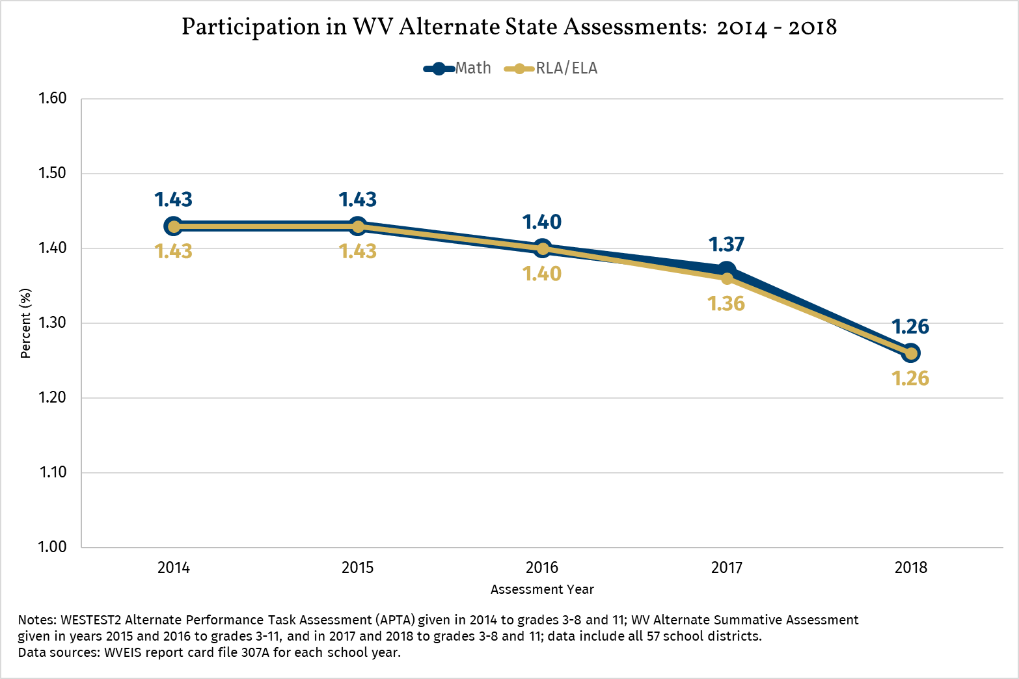
However, it is important to point out that West Virginia’s participation percentage for the number of students assessed on the alternate assessment has decreased from 2017 to 2018 from 1.37 to 1.26 for math, and 1.36 to 1.26 for RLA/ELA.
The waiver requirements are listed in bold lettering below.
If a State anticipates that it will exceed the 1.0 percent participation cap with respect to any subject for which assessments are administered in any school year, the State may request that the USDOE waive the cap for the relevant subject for one year. Such request must-
Be submitted at least 90 days prior to the start of the State’s testing window for the relevant subject;
The WVDE is requesting from the Secretary for the United States Department of Education an extension of the waiver of the 1.0 percent cap in ESEA section 1111(b)(2)(D)(i)(I) on the number of students who participate in alternate assessments aligned with alternate academic achievement standards (AA-AAAS).
West Virginia’s testing window for the 2018-2019 school year is April 9- May 24.
Provide State-level data from the current or previous school year, to show
- The number and percentage of students in each subgroup of students who took the alternate assessment aligned with alternate academic achievement standards; and content areas assessed
Table 1 shows participation rates by subject area for the 2017-2018 AA-AAAS. Based on the data, the state anticipates exceeding the 1.0 percent threshold set forth in the Every Student Succeeds Act (ESSA) for the 2018-2019 school year.
Table 1. Alternate State Assessment Participation by Content Area: 2017-2018
Content Area | Number (#) Participating in Statewide Assessment | Number (#) Participating in Alternate Assessment | Percent (%) Participating in Alternate Assessment
Reading  Grades 3-8 and 11 | 134,505 | 1,695 | 1.26
Mathematics  Grades 3-8 and 11 | 134,501 | 1,698 | 1.26
Science  Grades 5, 8 and 11 | 56,196 | 718 | 1.27
Data source: WVEIS RPTCRD18

- The State has measured the achievement of at least 95 percent of all students and 95 percent of students in the children with disabilities subgroup who are enrolled in grades for which the assessment is required.
West Virginia adheres to federal participation requirements for assessment and requires all students enrolled in public K-12 schools to be assessed with accommodations, without accommodations or with AA-AAAS. The only exception to participation for any student is a medical or extraordinary circumstances non-participation waiver. To date, West Virginia has met or exceeded the federal guidelines set at a participation rate of 95% of all students, including students with significant cognitive disabilities. For the 2017-2018 school year, West Virginia assessed 99% of all students and 98% of special education students in Grades 3-8 & 11 (see the WVDE public reporting dashboard, ZOOMWV at https://zoomwv.k12.wv.us/Dashboard/portalHome.jsp for more information).
Include assurances from the State that it has verified each LEA that the State anticipates will assess more than 1.0 percent of its assessed students in any subject for which assessments are administered in that school year using an alternate assessment aligned with alternate academic achievement standards-
- Followed each of the State’s guidelines: and
In the fall of 2017, the WVDE required each district that anticipated it would assess more than 1.0 percent of all students assessed using AA-AAAS to provide a letter of justification as to why the district anticipated exceeding 1.0 percent. Districts were also asked to provide action steps as to how the district was going to assure that appropriate decisions were being made at IEP meetings regarding the identification of students assessed on the West Virginia Alternate Assessment. Districts were asked to provide written assurances that they were utilizing the WV Alternate Assessment Participation Guidelines.
Review of current data (see Table 1) indicates that West Virginia anticipates exceeding the 1.0 percent participation cap for students assessed with AA-AAAS for the 2018-2019 school year. There were 32 (of 57) districts that exceeded the 1.0 percent threshold in ELA and math content areas during the 2017-2018 school year. By comparison, there were 41 districts over the threshold during the previous school year - a reduction of nine school districts. The same number of districts (37 of 57) experienced overages in the science content area during the two most recently completed school years. The WVDE is again requiring written assurances from districts that anticipate assessing more than 1.0 percent of their students using the AA-AAAS during the 2018-2019 school year. Districts must assure the WVDE that each IEP Team is following the WV Alternate Assessment Participation Guidelines, as well utilizing the WV Rubric for the Eligibility of Students Considered for the Alternate Assessment when making assessment participation decisions for students.

- Will address any disproportionality in the percentage of students in any subgroup taking the alternate assessment aligned with alternate academic achievement standards;
The WVDE is again requiring written assurances from districts that have assessed more than 1.0 percent of their students using AA-AAAS during the 2017-2018 school year. Districts must assure the WVDE that they will address any disproportionality in the percentage of students in any subgroup taking the alternate assessment. The WVDE used the same risk ratio methodology of determining disproportionality as last year. Any risk ratio above 1.0 indicates disproportionality; the higher the risk ratio, the greater the degree of disproportionality. The risk ratio method is the same analysis used by the WVDE in determining disproportionate representations for Indicators 9 and 10 in its State Performance Plan/Annual Performance Report.
Seen in Table 2 below, the risk ratio analysis identified disproportionality in five (5) subgroups; Black/African American, Asian, Low-SES, Homeless, and Male.

Table 2. Disproportionality by Sub-Groups of Students Participating in the WV Alternate Summative Assessment: SY 2018
Sub-group | ELA  (Grades 3-8 & 11) | Math  (Grades 3-8 & 11) | Science  (Grades 5, 8, and 11)
White | 0.87 | 0.87 | 0.78
Black/African American | 1.47 | 1.46 | 1.76
Hispanic | 0.93 | 0.92 | 0.72
Asian | 1.06 | 1.05 | 1.00
American Indian/Alaskan Native | 0.63 | 0.63 | 0.00
Pacific Islander | 0.00 | 0.00 | 0.00
Multiple races | 0.77 | 0.77 | 0.80
Low-SES | 1.77 | 1.77 | 1.91
English Language Learners | 0.62 | 0.62 | 0.40
Homeless | 1.52 | 1.52 | 1.44
Male | 1.77 | 1.77 | 1.78
Female | 0.55 | 0.55 | 0.51
Data source: WVEIS RPTCRD18

The WVDE will continue to address disproportionality in subgroups taking the AA-AAAS through the following activities:
- Calculation and analysis of subgroup participation rates in each content area at the state and individual school district levels.
- Identification of subgroup overrepresentation in the AA-AAAS participation.
- Technical assistance to include continued support and guidance for the use of the WV Alternate Assessment Participation Guidelines to districts and schools with identified disproportionality.
- Technical assistance to include support and guidance for the use of the WV Rubric for the Eligibility of Students Considered for the Alternate Assessment.
Include a plan and timeline by which-
- The State will improve the implementation of its guidelines, including reviewing if necessary revisiting its definition, so that the State meets the cap for which assessments are administered in future years;
The WVDE provided training and technical assistance to districts on the appropriate use of the WV Alternate Assessment Participation Guidelines and the WV Rubric for the Eligibility of Students Considered for the Alternate Assessment to:
- Promote a consistent standard for districts to use when determining a student’s individual assessment needs;
- Collect individual student data for monitoring appropriate documentation that a student has a significant cognitive disability; and
- Ensure students are being assessed using the appropriate method to demonstrate knowledge.

The WVDE developed or updated, disseminated, and provided training on the following:
- The WV Participation Guidelines for the Alternate Assessment to clarify participation criteria.
- A State Definition of Students with the Most Significant Cognitive Disability has been included in Policy 2419: Regulations for the Education of Students with Exceptionalities.
- The WV Rubric for the Eligibility of Students Considered for the Alternate Assessment is utilized at IEP meetings where teams are considering a student for the AA-AAAS.
- Understanding Alternate Diplomas Brochure: What Teachers, Parents and Students Need to Know about the Alternate Diploma Option
- All Things Alternate: Alternate Standards, Alternate Assessment, and Alternate Diploma
The WVDE provides state-wide and district training to both district Special Education Directors, and IEP team members to provide support in appropriately identifying students for the alternate assessment as well as providing information on WV’s updated Alternate Academic Achievement Standards and Support Documents. These documents aid teachers in identifying and providing appropriate support to students with significant cognitive disabilities.

- The State will take additional steps to support and provide appropriate oversight to each LEA that the State anticipates will assess more than 1.0 percent of its assessed students in a given subject in a school year using an alternate assessment aligned with alternate academic achievement standards to ensure that only students with the most significant cognitive disabilities take an alternate assessment. The state must describe how it will monitor and regularly evaluate each such LEA to ensure that all the LEA provide sufficient training such that school staff who participate as members of an IEP team or other placement team understand and implement the guidelines established by the State so that all students are appropriately assessed

2018-2019 Monitoring Training and Plan:
    - Identify districts with more than 1.0 percent of students taking the AA-AAAS;
    - Provide training, coaching, technical assistance, support and oversight to districts to ensure appropriate decisions for participation in the AA-AAAS are made by IEP Teams;
    - Address district and state needs regarding disproportionality among subgroups participating in the AA-AAAS; and
    - Monitor districts with more than 1.0 percent of their students participating in the AA-AAS to assure that IEP Teams have been trained and are receiving support in order to make appropriate participation decisions for the AA-AAAS.

- The State will address any disproportionality in the percentage of students taking an alternate assessment aligned with alternate academic achievement standards as identified through the data provided
The WVDE determined the statewide level of disproportionality of students participating in the alternate assessment by subgroup and content area for the 2017-2018 school year. Data were analyzed for disproportionality among multiple subgroup categories. Among each of the three content areas, the subgroups experiencing the highest disproportionality were Low-SES, males, and students who experienced homelessness at any time throughout the school year.

The WVDE believes the 1.0 percent state-level participation cap will act to continue to reduce the percentage of West Virginia students participating in the AA-AAAS.
- In 2017, 41 districts exceeded the 1.0 participation cap in Math and ELA. In 2018, 32 districts exceeded the 1.0 participation cap in Math and ELA.
- There were 158 fewer students assessed in ELA, and 157 fewer students assessed in Math on the Alternate Summative Assessment (ASA) in 2018 as compared to 2017.
- For the science content area, 126 fewer students were assessed in 2018 than on the ASA in 2017.
- The numbers of students assessed with the ASA are falling by grade level, particularly in the middle school grade span.
- Males, who are disproportionally represented on the ASA 2017, experienced a drop of approximatly100 students.
- The number of students assessed to reach the WV goal of 1.0% has decreased by approximately 100 students for math and ELA.
- When looking at the ASA by exceptionality:
  - Students with the primary exceptionality of Autism numbers have shifted very little; this is an area that the WVDE recommends that districts look closely at to ensure appropriate identification, content standards, and assessment are being provided.
  - Students with the primary exceptionality of mild intellectual disability taking the ASA reduced by over 100 students from the prior year; the WVDE will continue to stress the importance of appropriately identifying students for the ASA to only include students with the most significant cognitive disabilities.
  - Students with the primary exceptionality of moderate intellectual disability taking the ASA was reduced by approximately 20 students.

The WVDE believes that by emphasizing appropriate decision making, and the utilization of the WV Alternate Assessment Participation Guidelines and the WV Rubric for the Eligibility of Students Considered for the Alternate Assessment that districts will help the state to meet the federal requirement of the 1.0 percent state-level participation cap on the AA-AAAS.

Appendix A.
AA-AAAS Participation Heat Maps
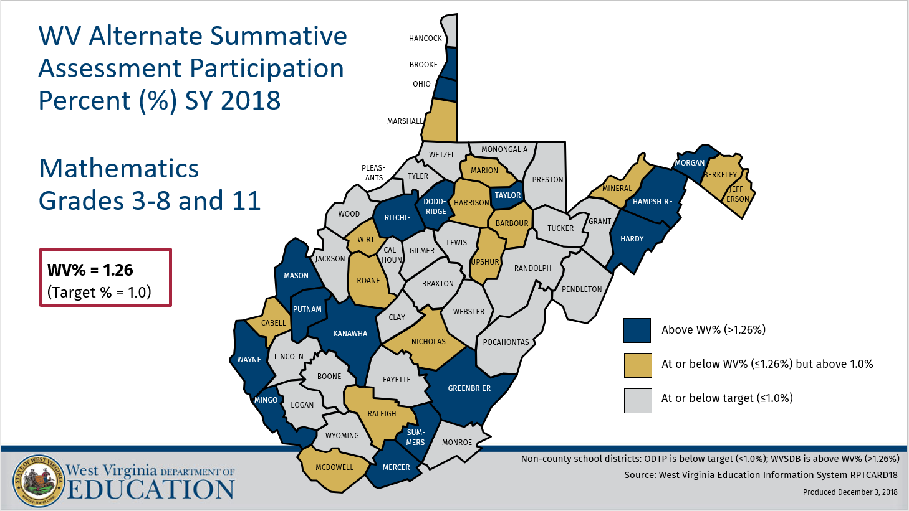
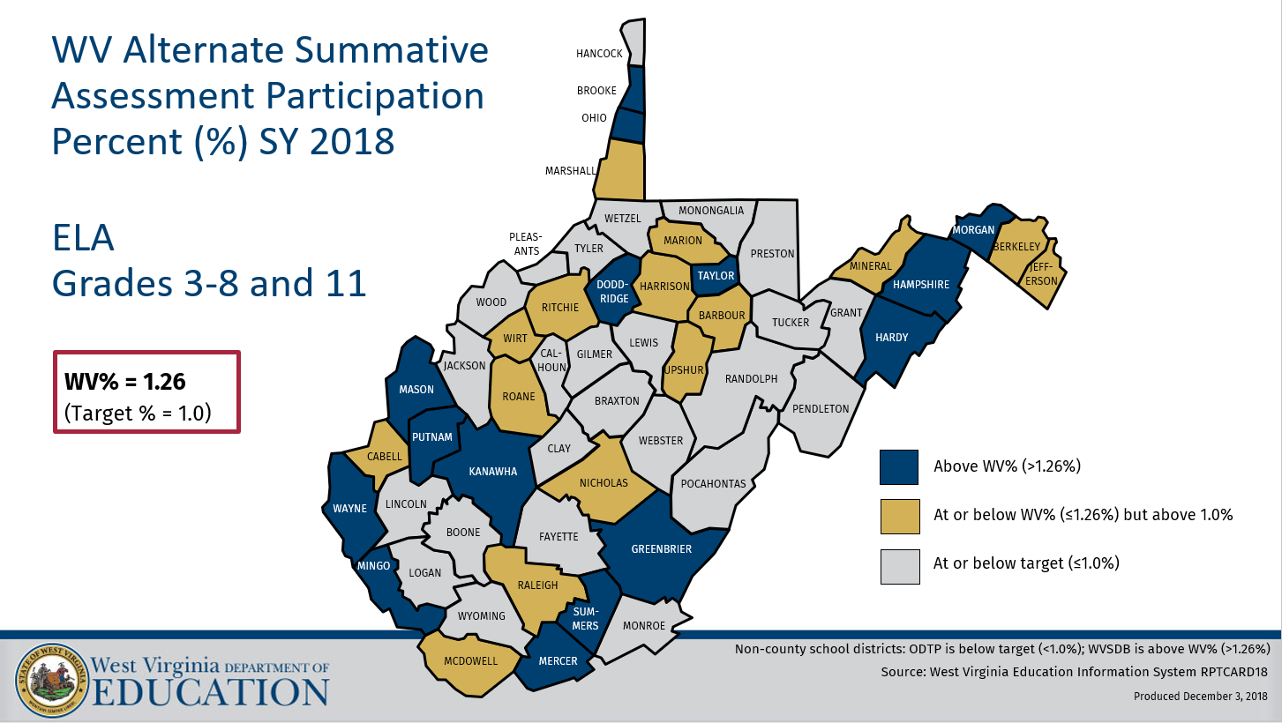
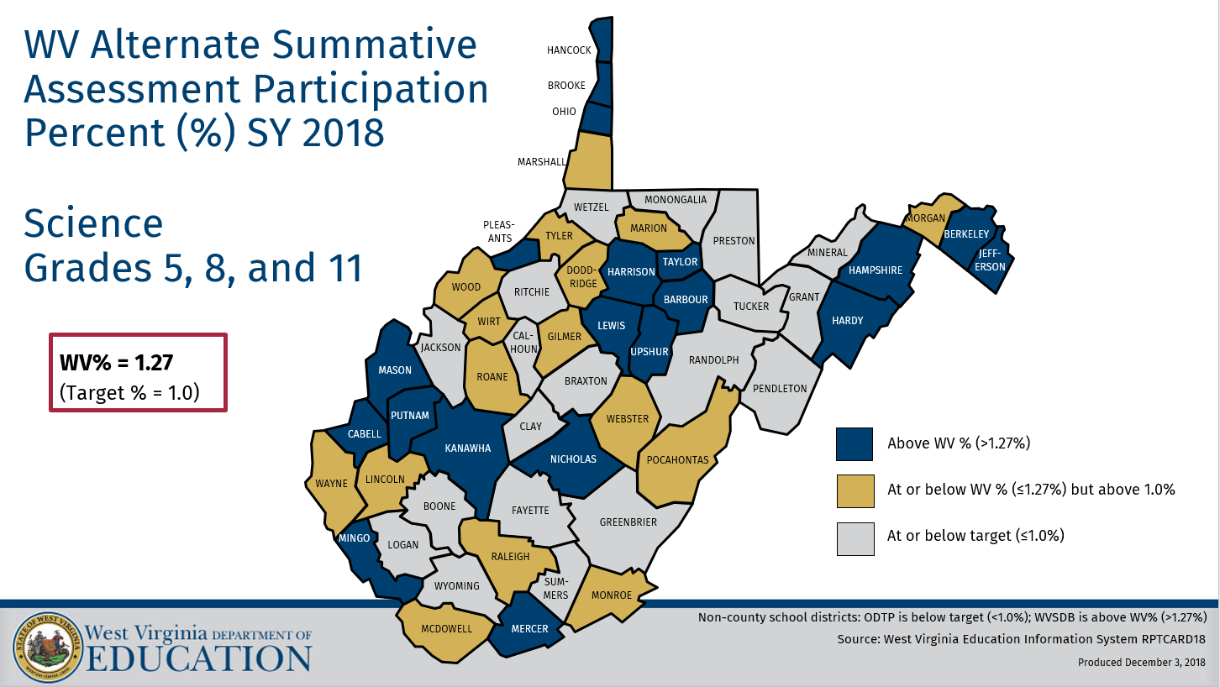
Appendix B.
AA-AAAS 2017 Participation Data (State example of District level data provided to each District)
WV 2018 ASA Participation Percent (%) by Content Area
Math | ELA | Science
1.26 | 1.26 | 1.27
Math and ELA content areas given to Grades 3-8 and 11. Science content area given to Grades 5, 8, and 11. Data source: WVEIS RPTCRD18

WV Alternate Assessment Participation Percent (%) by Year and Content Area
Year | Math % | ELA/RLA %
2014 | 1.43 | 1.43
2015 | 1.43 | 1.43
2016 | 1.40 | 1.40
2017 | 1.37 | 1.36
2018 | 1.26 | 1.26
2014 WESTEST2 Alternate Performance Task Assessment (APTA) tested grades 3-8 and 11, 2015 and 2016 WV Alternate Summative Assessment (ASA) tested grades 3-11, and 2017 and 2018 WV ASA tested grades 3-8 and 11. Data sources: WVEIS report card file 307A for each assessment year

WV 2018 ASA Participation Count (#) and Percent (%) by Grade and Content Area
Grade | Math # | Math % | ELA # | ELA % | Science # | Science %
3rd | 207 | 1.06 | 207 | 1.06 | - | -
4th | 239 | 1.20 | 237 | 1.19 | - | -
5th | 229 | 1.14 | 229 | 1.14 | 225 | 1.12
6th | 252 | 1.31 | 252 | 1.31 | - | -
7th | 239 | 1.23 | 239 | 1.23 | - | -
8th | 270 | 1.38 | 269 | 1.38 | 265 | 1.36
10th | - | - | - | - | - | -
11th | 255 | 1.51 | 255 | 1.51 | 225 | 1.51
Total | 1691 | 1.26 | 1688 | 1.26 | 715 | 1.27
Math and ELA content areas given to Grades 3-8 and 11. Science content area given to Grades 5, 8, and 11. Data source: WVEIS RPTCRD18

WV 2018 ASA Participation Count (#) and Percent (%) by Gender and Content Area
Gender | Math # | Math % | ELA # | ELA % | Science # | Science %
Female | 582 | 0.89 | 582 | 0.89 | 234 | 0.85
Male | 1109 | 1.60 | 1106 | 1.60 | 481 | 1.67
Total | 1691 | 1.26 | 1688 | 1.25 | 715 | 1.27
Math and ELA content areas given to Grades 3-8 and 11. Science content area given to Grades 5, 8, and 11. Data source: WVEIS RPTCRD18

WV 2018 ASA Participation Count (#) and Percent (%) by Low-SES and Content Area
 | Math # | Math % | ELA # | ELA % | Science # | Science %
Low-SES | 1086 | 1.61 | 1084 | 1.61 | 451 | 1.71
Total | 1691 | 1.26 | 1688 | 1.25 | 715 | 1.27
Math and ELA content areas given to Grades 3-8 and 11. Science content area given to Grades 5, 8, and 11. Data source: WVEIS RPTCRD18

WV 2018 ASA Participation Count (#) and Percent (%) by English Language Learner (ELL) Status and Content Area
 | Math # | Math % | ELA # | ELA % | Science # | Science %
ELL | 12 | 0.79 | 12 | 0.79 | <10 | 0.51
Total | 1691 | 1.26 | 1688 | 1.25 | 715 | 1.27
Math and ELA content areas given to Grades 3-8 and 11. Science content area given to Grades 5, 8, and 11. Data source: WVEIS RPTCRD18

WV 2018 ASA Participation Count (#) and Percent (%) by Homeless Status and Content Area
 | Math # | Math % | ELA # | ELA % | Science # | Science %
Homeless | 74 | 1.88 | 74 | 1.88 | 27 | 1.82
Total | 1691 | 1.26 | 1688 | 1.25 | 715 | 1.27
Math and ELA content areas given to Grades 3-8 and 11. Science content area given to Grades 5, 8, and 11. Homeless status = homeless anytime throughout 2016-2017 school year. Data source: WVEIS RPTCRD18

WV 2018 ASA Participation Count (#) and Percent (%) by Race/Ethnicity and Content Area
Race/ethnicity | Math # | Math % | ELA # | ELA % | Science # | Science %
Asian | 12 | 1.33 | 12 | 1.33 | <10 | 1.27
Black/African American | 104 | 1.81 | 104 | 1.81 | 53 | 2.17
Hispanic | 29 | 1.17 | 29 | 1.17 | <10 | 0.92
American Indian/Alaskan | <10 | 0.79 | <10 | 0.79 | 0 | 0.00
Multi-Racial | 41 | 0.97 | 41 | 0.97 | 16 | 1.03
Pacific Islander | 0 | 0.00 | 0 | 0.00 | 0 | 0.00
White | 1504 | 1.24 | 1501 | 1.24 | 632 | 1.24
Total | 1691 | 1.26 | 1688 | 1.25 | 715 | 1.27
Math and ELA content areas given to Grades 3-8 and 11. Science content area given to Grades 5, 8, and 11. Data source: WVEIS RPTCRD18

To reach 1.0% participation in the WV Alternate Summative Assessment:
Content Area | Current participation percent (%) | Current participation number (#) | Participation number (#) needed to reach 1.0%* | Change in participation number (+/-) to reach 1.0%*
Math | 1.26 | 1698 | 1345 | -353
ELA | 1.26 | 1695 | 1345 | -350
Science | 1.27 | 718 | 564 | -154
*Results for the participation number needed to reach 1.0% and the change in participation number to reach 1.0% are calculated with the assumption that the total number of students tested remain constant. Participation numbers are rounded to nearest whole number. Data source: WVEIS RPTCRD18

WV 2018 ASA Participation Count (#) and Percent (%) by Primary Exceptionality and Content Area
Exceptionality | Math # | Math % | ELA # | ELA % | Science # | Science %
AU – Autism | 409 | 30.14 | 409 | 30.12 | 160 | 31.19
BD – Behavioral Disorders | <10 | 0.47 | <10 | 0.47 | 0 | 0.00
CD – Speech Language | 0 | 0.00 | 0 | 0.00 | 0 | 0.00
DB – Deaf and Blind | <10 | 60.00 | <10 | 60.00 | <10 | 40.00
DF – Deafness | <10 | 7.50 | <10 | 7.50 | <10 | 15.00
HI – Hard of Hearing | <10 | 1.85 | <10 | 1.85 | 0 | 0.00
LD – Specific Learning Disorders | <10 | 0.01 | <10 | 0.01 | 0 | 0.00
MD – Moderate Intellectual | 554 | 87.66 | 553 | 87.64 | 249 | 89.89
MM – Mild Intellectual | 456 | 14.35 | 455 | 14.32 | 186 | 14.80
MS – Severe Intellectual | 108 | 99.08 | 108 | 99.08 | 51 | 100.00
OH – Other Health Impairment | 117 | 2.71 | 116 | 2.69 | 49 | 2.67
PH – Orthopedic | <10 | 17.07 | <10 | 17.07 | <10 | 15.38
TB – Traumatic brain injury | <10 | 18.60 | <10 | 18.60 | <10 | 23.08
VI – Blind / Low vision | 13 | 10.48 | 13 | 10.48 | <10 | 10.20
Percent = percentage of students with a given primary exceptionality code participating in the ASA. Math and ELA content areas given to Grades 3-8 and 11. Science content area given to Grades 5, 8, and 11. Data source: WVEIS RPTCRD18

