Experiencing Aboriginal Art

The oldest rock art from Aboriginal people dates back to 20,000 years ago. Ochres were used by the Aboriginal people to paint on the rock. Ochres are colors or pigments that come out of the ground. They are dug up and ground into a fine powder. The powder can be mixed in with egg yolk to bind it together like a paint, or it can be blown through a straw onto a surface. Ochres can be different colors. It can be almost as yellow as some leaves on the trees in the fall, it can be a rust-like brown, or it can be a dark red or purple. Look at the ground when it is stripped of vegetation. In our area we can see various colors in the earth. For example, there is an area of exposed earth on your right just after you cross the river on 219 leaving Ronceverte.

Digging pigments from the earth may be an option for some of us, but may prove difficult for others. There are, however, some other ways that we can create dyes from things that are readily available to all of us.

- Berries can be crushed and mixed with egg yolk and vinegar to get a range of blues, purples and dark reds.
- Dirt can be used for brown along with beetroot skin.
- Wood ash can be used to make gray.
- Yellow onion skins or dried turmeric can be boiled to turn the water yellow.
- Anything green, like grass, can be boiled to make a green dye.
- Burnt wood or toast can be scraped into a yolk as well.
- Pencils make gray.

Some colors may change in the process of adding heat or being diluted with the vinegar and egg yolk. Think of it as an experiment, and get your parents to help you make a collection of dyes.

Aboriginal art looks very different from the art of Western Culture. Animals are often depicted from a bird’s eye view. The legs of creatures are out from the body as if they have been squashed. The idea of deep space and perspective is not as much of a concern. Their bodies are not made to look realistic.

They are covered in patterns of dots, stripes and shapes, with even space between each dot, stripe or shape. The even space between shapes and lines help create “unity.” Unity is a principle of design. The shapes are also repeated. The repetition creates “rhythm”. Rhythm is also a principle of design. When these patterns work together to move your eye, following their direction, they create “movement”. Movement is another principle of design.

- Create your own work of art that is done in the style of the art of the Aborigine from Australia (see samples below).
- The subject of your artwork should be an animal.
- The animal must be involved with a storyline. Think of it as a picture to go along with a children’s book. (Possibly the cover.)
- The book should have a story that you will write.
- The story has to convey a message about learning right from wrong.
- Give your character a name.
- Describe how old your character is.
- Create a situation with your character where s/he has to make a choice between doing the right thing or the wrong thing. Have her/him choose the wrong thing.
- Tell how your character has to suffer the consequences for her/his actions.
- Tell how the character came to the realization that her/his actions were wrong.
- You may tell that someone comes to their rescue, or that they decide to behave differently from that point on.
- Try to use at least two colors. You can use colors you created (see directions above) or color in dots with a blue ink pen.

Some examples of Aborigine art.
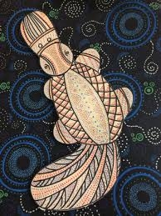

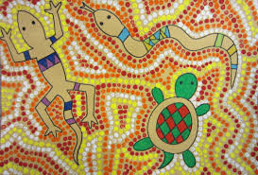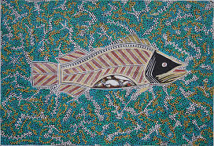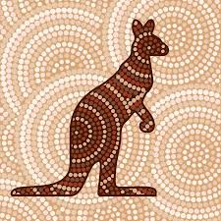

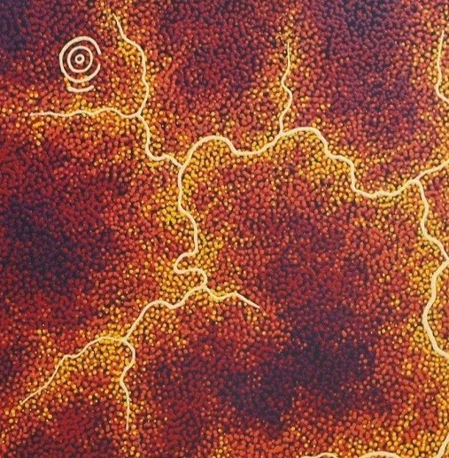
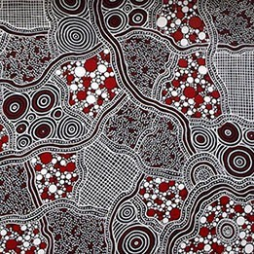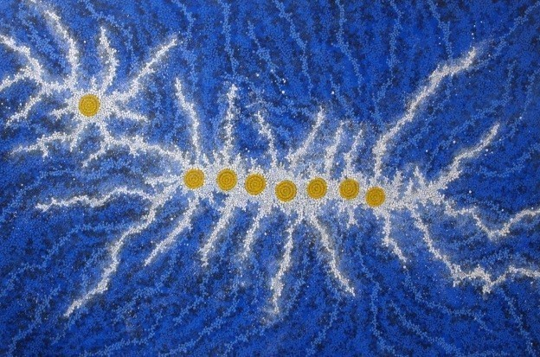

https://www.aboriginal-art-australia.com/gallery/aboriginal-paintings-500-to-1000/

