Harrington-MATH 6
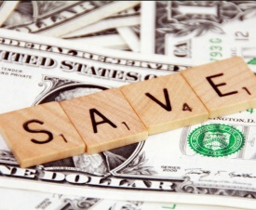 TAX, TIP, and DISCOUNTS 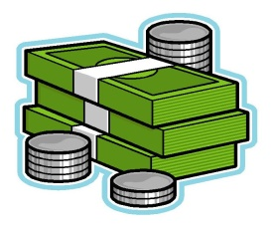
Directions: Watch each video and read the definitions for finding sales tax, tip, and discount. Complete the related problems on tax, tip, and discounts on WS #1, #2, & #3. Please show all work.

TERMS
Sales Tax-https://www.youtube.com/watch?v=wbjcuQB0onA
Taxes are collected from citizens by the government to pay for things citizens need like schools and roads. Taxes are collected in different ways and at various levels of the government. Sales Tax is added to the price of particular goods and services. Different states have different sales tax percentages. West Virginia’s is 6%. To calculate sales tax, multiply the original cost by the sales tax(in decimal format). This amount is the tax. To find the final cost of your item with tax included, add this amount to the cost of your item.

Tip-https://www.youtube.com/watch?v=4R6YxRV9n2U
A tip, sometimes referred to as gratuity, is a sum of money given as a “thank you” for a service rendered. Tipping can be varied amounts. In general, for a waiter or waitress, at 15 or 20% tip is acceptable. To calculate tip, you multiply the percent tip(in decimal format) by the cost of the goods or service. This amount is your tip. To find the total cost with tip included, add the price and the tip together.

Discount- https://www.youtube.com/watch?v=1pdnLsx6tkQ
discounts are taking an amount off a price; discounts are a percentage of the price that you do not have to pay. You calculate discount by multiplying the original cost by the percent discount (in decimal format). This amount is how much you can take off of the original price. To find the cost of the item after the discount, take the original price of the item and subtract the discount amount.
**Remember you must convert your percent to a decimal by moving it over two spaces to the left. Ex. 15% becomes .15 7% becomes .07

**On the worksheets that follow, you may use a calculator, but please show the steps followed to arrive at your answer. EX. 10% tip on $40 WORK
.10 X 40= $4.00
**ABOUT-means you can round. Ex. $25.80 would round to $26
Calculating Tax, Tip, and Discounts #1
- Amy wants to buy a necklace for 10% off the marked price. If the marked price is $25, how much will the necklace cost AFTER the discount?

Discount $______________ WORK

Cost-$_______________

- Jason ordered a pizza to be delivered. The total bill was $12, but he wants to leave the delivery person a 20% tip. How much would the TIP be?

Tip $____________ WORK

- A new softball bat sells for about $140. The sales tax rate is 8%. How much will the total cost of the bat be with sales tax included?

Tax-$ _______________ WORK

Total Cost-$___________________

- Nick has a coupon for 15% off the cost of a new Hollister shirt. The shirt he wants to buy is 25.99. ABOUT how much will his shirt cost AFTER the discount?(ABOUT means round)

Discount $_______________ WORK

Cost after discount- $_______________

- Alaira and Gavin’s lunch bill came to $11.25. They want to leave a 15% tip. How much will their lunch cost with the tip included?

Tip- $_____________ WORK

Cost with tip included-$________________

- Zeiva is buying a new DVD. The cost of the DVD is $22.50. The tax on the DVD is 8%. How much will the DVD cost in ALL?

Tax- $_________________ WORK
Total cost with tax included-$_________________

Calculating Tax, Tip, and Discount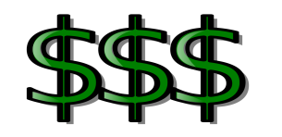 #2
- Andrew wants to buy a new glove for 10% off the marked price. If the marked price is $55, how much will the glove cost AFTER the discount?

Discount- $_________________ WORK

Final cost after discount-$_____________

- Billie and Allura went out for dinner. The total bill was $30. They want to leave the waitress a 20% tip. How much will their tip be?

Tip-$_________________ WORK

- Sasha has a coupon for 35% off the cost of a new pair of sneakers. The shoes cost $49.95. ABOUT how much will her shoes cost after the discount?
Discount-$___________ WORK

Final cost after discount-$_______________

- Teagan and Jayden’s bill came to $17.50. They want to leave a 15% tip. How much will their meal cost with the tip included?

Tip-$___________ WORK

Final Cost with tip included-$_______________

- Annie bought a few snacks to take to the game. The items she purchased came to $5.75. If there is a 6% sales tax, ABOUT how much would she have to pay in all?

Tax-$______________ WORK

Final cost with tax included-$________________

- Cameron wants to buy a car that costs $28,000. If the tax is 5%, how much will he pay JUST in taxes? Tax-$_____________

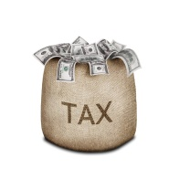Calculating Tax, Tip, and Discount #3
- Glenn bought some candy that costs $5. If he had to pay a 5% sales tax, how much did he pay for his candy in all?
Tax-$_____________ WORK
Total Cost-$___________________
- Jasmine wanted to buy a new pair of sandals for $30. When she went to the store, she found they were 10% off that price. How much does Jasmine pay for the shoes?

Discount-$______________ WORK

Final Cost-$________________

- A CD is on sale for $10. The sales tax rate is 6%. How much will the CD cost in all?

Tax-$__________________ WORK

Final Cost-$__________________

- Adam bought a pair of jeans for $35 and a shirt for $15. If the sales tax is 6%, what is the total cost of his purchase?

Tax-$_____________ WORK

Final Cost-$____________________

- Victor went to the barber to get a haircut. The haircut was $9 but he wants to leave a 25% tip. How much did Victor spend at the barber shop altogether?

Tip-$__________ WORK

Final Cost-$____________

