Leveraging Education To Show Gratitude of Occupations

WVU Nursery School Pre-K classroom and beyond…

#LETSGO Gratitude: Leveraging Education To Send Gratitude of Occupations
The Leveraging Education To Send Gratitude of Occupations, or LETSGO: Gratitude project is a collaborative effort between the Department of Pediatrics at the West Virginia University Health Sciences Center, the Department of Learning Sciences and Human Development in the College of Education and Human Services, and the West Virginia University Nursery School. The effort is focused on educating children (PreK-3rd Grade) about the occupations that are on the front lines of the COVID-19 pandemic. We are calling them the heroes of the fight against this epidemic.
Our focus is to educate children about these heroes, and to encourage young children and their families to display acts of gratitude toward these heroes. To accomplish this effort, we will provide the public with different learning resources about the heroes, as well as some ways to say “thank you!
Within #LETSGOgratitude, we created an interactive curriculum for early childhood students to learn about the variety of occupations working to fight the virus. Our collaborative goal is for children to gain knowledge and interest in a variety of occupations and send "Thank You" notes to these individuals. After studying each career we are requesting that students upload a thank you to that occupation. Those thank you items are delivered to persons who are serving their communities in that capacity during the fight against the virus.
This is the link to the Wufoo online submission form. https://wvucehs.wufoo.com/forms/gratitude-of-occupations-submission-form/
Children and parents can also mail in their cards to 507 Allen Hall PO Box 6122 Morgantown WV 26508.

Link to WBOY news clip https://www.wboy.com/only-on-wboy-com/lets-go-project-helps-parents-and-children-look-for-the-helpers-during-covid-19-pandemic/

The bottom of this document contains an example of a thank you that one of our children made (WVU Nursery School).

Link to the web site offering more content and information about the curriculum
https://lshd.wvu.edu/about/news-events/letsgo-gratitude

Link to the article from WVU Enews which has resource links at the bottom of the article.
https://wvutoday.wvu.edu/media-center-blog/2020/03/31/story-pitch-wvu-students-create-project-to-help-parents-look-for-the-helpers-during-covid-19-pandemic?utm_source=MOUNTAINEER+ENEWS&utm_campaign=9a96619c29-RSS_EMAIL_CAMPAIGN&utm_medium=email&utm_term=0_0

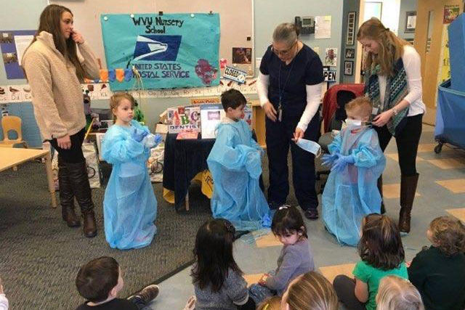 | STORY PITCH: WVU students create project to help parents ‘look for the helpers’ during COVID-19 pandemic | WVU Today | West Virginia University  A group of medical and education experts at West Virginia University is asking parents to take the advice of Mr. (Fred) Rogers and “look for the helpers” during the COVID-19 pandemic. Leveraging Education To Show Gratitude of Occupations (LETS GO), aims to educate youth about a number of careers essential to combatting the virus, from epidemiologists and health officers to food service ...  wvutoday.wvu.edu

Link to the web site with resources https://lshd.wvu.edu/about/news-events/educational-resources-for-parents
Educational Resources for Parents | Department of Learning Sciences and Human Development | West Virginia University
COVID-19 Parent Resources for 3/23/20. Switcheroo Zoo. www.switcheroozoo.com. Watch, listen and play games to learn about animals. Ten tips for keeping your family on track during the COVID-19 pandemic
lshd.wvu.edu

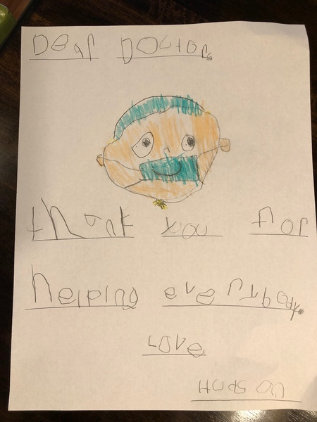

Community Helpers contracts to be
K-12 Next Generation Science Standards: https://www.nextgenscience.org/sites/default/files/AllDCI.pdf

WV Pre-K Content Standards:  https://wvde.us/wp-content/uploads/2019/05/PKStandardsBookletUPDATE-Final-May-2019.pdf | Role | Definition
 | 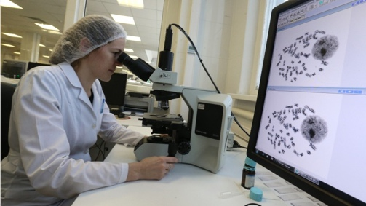  Epidemiologist | A person who studies infectious diseases. This person investigates how many people get the illness, signs and symptoms of the illness, how to treat the illness, where the illness came from and how to stop the illness.  https://youtu.be/l3B86BtpMgM  https://youtu.be/04g8fENG72E
 | Health Officer  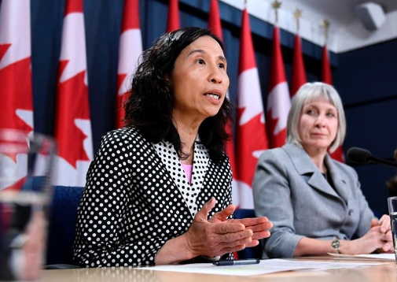 | A person who is in charge of making sure people follow laws and rules for health and sanitation (cleanliness).  https://youtu.be/eoBd2HULGIg  *Video of WV Health officer mentioning our project #LETSGOgratitude on FB  WVU Nursery School
 | 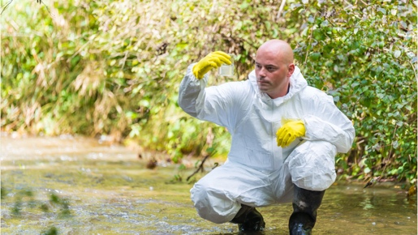  Environmental Scientist | A scientist that studies our environment (air, water, minerals, organisms).
 | Lab Technologists 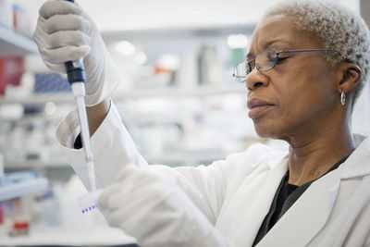 | A place where people experiment, investigate, observe and use special equipment to study many things.
 | Microbiologists 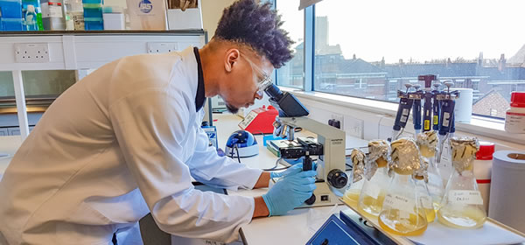 | People who study microscopic organisms. They study things that are so small they must use a microscope.  https://youtu.be/yzvADTExswk
 | Infection Control Specialist  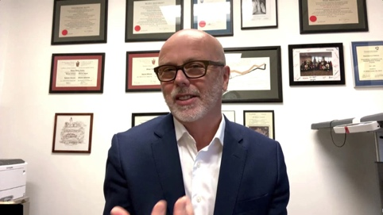 | A person who researches and learns about how to control and stop illnesses, viruses and other diseases.
 | Physicians also known as Doctors | A person who helps make people feel better when they are sick and can prescribe medicine to make them better.  https://youtu.be/-ijKZse7ey4
 | Nurses | A person who takes care of people who are sick or need help.  https://youtu.be/WWk7dF9-Xqs  https://youtu.be/qyvXVfURINM
 | 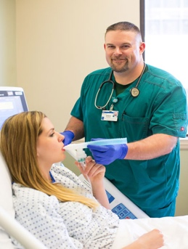  Respiratory Therapists | A person who helps people that cannot breathe well or have problems with their lungs.
 | Medical Assistants  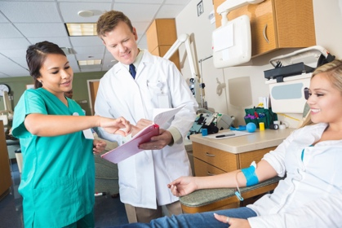 | People who help doctors, nurses and other health care providers.
 | Pharmacist  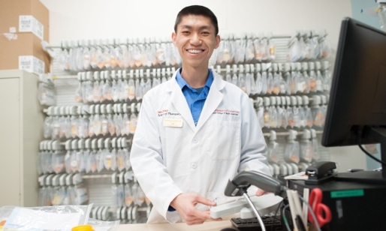 | A person who is specially trained to make and give out medicine.  https://youtu.be/qk4z7mKaU2U  https://youtu.be/XOwDyr5MEXc
 | 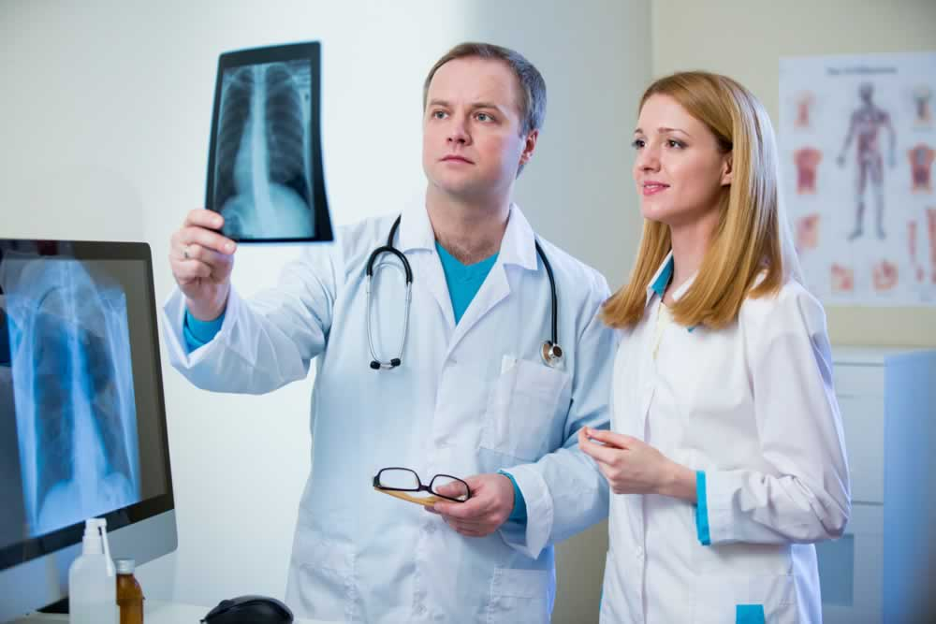  Radiology Technologists | A person specially trained to perform  X-rays or other medical tests.  https://youtu.be/XMMy-hcpvi4
 | Dietitian 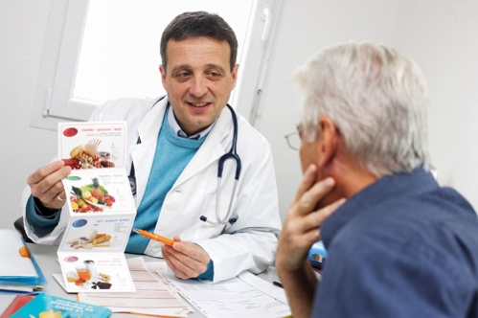 | A person who is specially trained in helping people learn to eat foods and choose foods that will make them healthier.  https://youtu.be/vP9B5muI0NM
 | 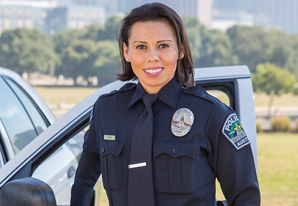  Police | People who help bring order, prevent and detect crime while supporting and protecting communities.  https://youtu.be/_hSiRCfqFqM
 | 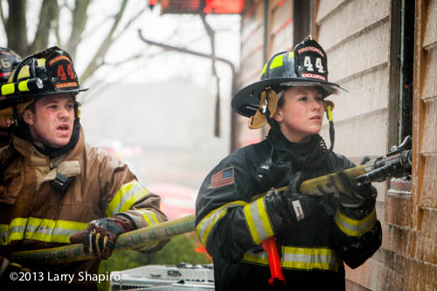  Fireman or Woman | A person who is specially trained to put out and stop fires.  https://youtu.be/jI7fJweAPRo
 | 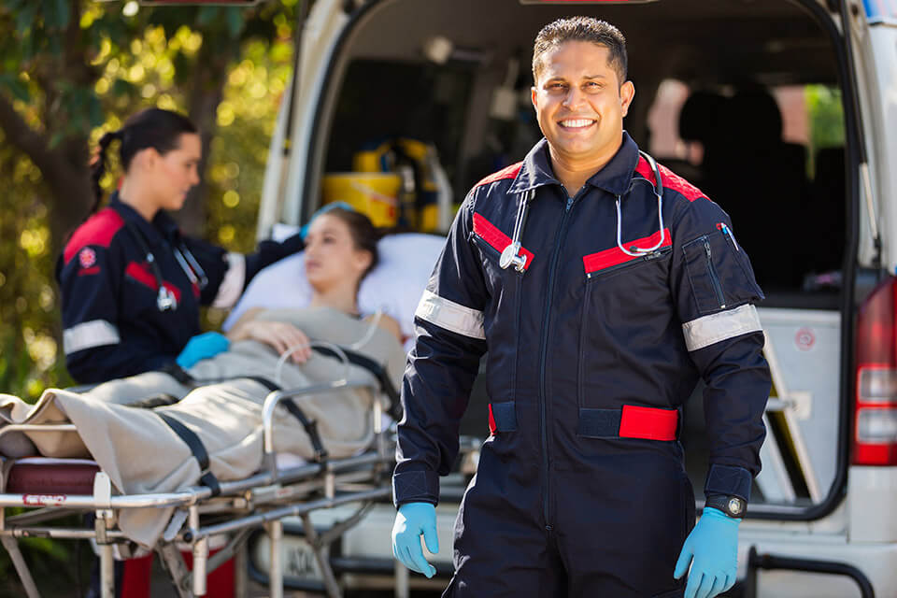  EMS- Emergency Medical Systems | Ambulance and emergency medical technicians who help people in emergency situations.  https://youtu.be/GBi1l0LDbpg
Children can click on the link to learn more about the community helper represented on the contract. Children can choose the career they wish to study and self-record that they studied that career and sent a thank you to those professionals. This curriculum is very child centered and crafted using WV Content Standards and NGSS Next Generation Science Standards. This is just one example of our contract because it is continually evolving and we are continually adding video clips to the contract. The WV State Health officer mentioned our #LETSGOgratitude project within the Governor’s address on April 2, 2020.

