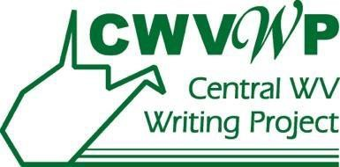
West Virginia Young Writers Contest

COVER SHEET FOR SCHOOL/COUNTY ENTRIES

DIRECTIONS FOR SCHOOLS:

Schools need to include a cover sheet for each entry submitted to the county for judging. All school entries are to be submitted to County Coordinators by February 13, 2023. Entries for state judging must be submitted electronically by the Young Writers County Coordinator through the Marshall University Blackboard system by February 27, 2023. Faxed or mailed entries will not be accepted.

Each entry must have a title. Do not write the student’s name or any other personally identifying information on the entry. Do not include graphics in the entries. Only prose entries will be accepted; entries of poetry will be disqualified.

Please enter the student’s and teacher’s name as each wishes it to appear on the WV Young Writers Day Program. Please type or print legibly. An MS Word version of this document can be downloaded from the website at the bottom of this page.

Title of entry:
Contest level (Circle one): 1-2 3-4 5-6 7-8 9-10 11-12

Student Name: Gender: M F

Student Grade Level School:

Teacher Name:

Teacher E-mail:

County: County Coordinator:

Contest forms and information: http://www.marshall.edu/cwvwp

Contest Contact: Dr. Barbara O’Byrne: bobyrne@marshall.edu

