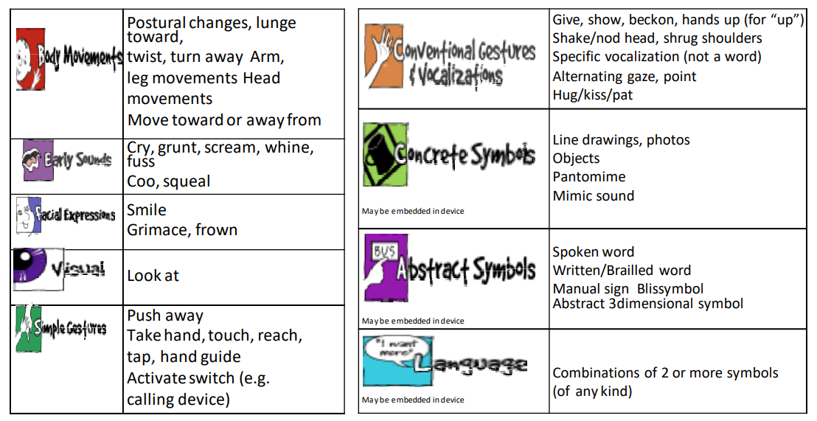
Examples of Specific Communicative Behaviors
This graphic was created by the Communication Matrix Foundation. www.communicationmatrix.org

