Abstract Symbols
Level VI

- In Level VI, behaviors are intentional, purposefully directed toward communication partner with an intended meaning, and the child communicates symbolically – using an object, picture, word, or speech generating device to express a message.
- Hierarchy of Visual Symbols from Concrete to Abstract
- Object used as part of the activity it represents
- Object identical to the one used as part of an activity
- Object similar but not identical to the object used as part of an activity
- Part of an object
- Full-sized color drawing of the object
- Full-sized black and white drawing of the object or a reduced-size color
- drawing of an object
- Reduced-size black and white drawing of an object
- Abstract or multiple meaning symbols
- Printed word
- Symbols are “Abstract” because they are NOT physically similar to what they represent.
- Abstract Symbols are typically developed at 12 – 24 months (in conjunction with gestures and words)
- Abstract symbols include: speech, manual signs, line drawn symbols, multiple meaning pictures, braille or printed words are used to communicate.
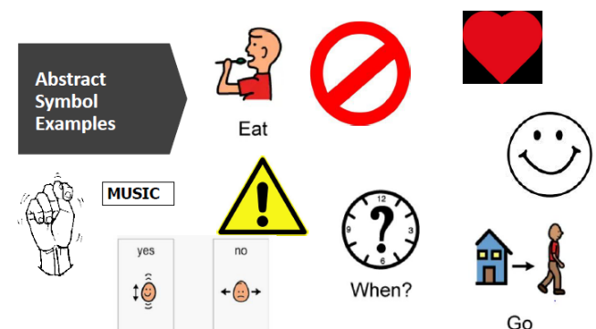
- In Level VI, children use one symbol at a time.
  - Spoken word (“no, “finished”)
  - manual sign (“no”, “stop”)
  - written word (“no”, “finished”)
  - brailled word (“no, “stop”)
  - abstract 3-D symbol (“no”, “stop”)
  - abstract 2-D symbol (“no”, “stop”)

