Building Syntactic and Morphological Skills (Grammar)

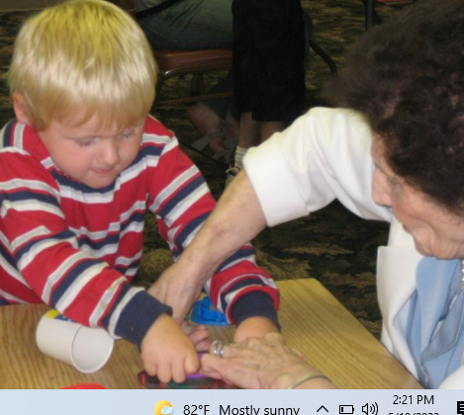

•Focused Stimulation-model grammatical utterances in meaningful activities (spoken or signed)

•Aided AAC Modeling-model using the individual’s mode and pair with words Intervention Strategies to Build Grammar Building Syntactic and Morphological Skills (Grammar)

Five principles to remember:

1. Consider the individual’s current language skills and select targets that would make the individual’s messages clearer and more easily understood.

2. Select targets (word order, tenses, pronouns, etc.) that the individual uses sometimes but not always. Building Syntactic and Morphological Skills (Grammar)

3. Arrange the environment for a real need for the language structures you are teaching.

4. Use recasts (language correction i.e. “Her go.” recasts to “She goes.”) to teach a more grammatically complete utterance.

5. Don’t use telegraphic language (content words only i.e.”Daddy go.”), model the complete form verbally even if the AAC mode only allows for telegraphic output.

