Combining Abstract Symbols Strategy
(Combine Known Symbols, Practice in Routines, Respond to Intent)
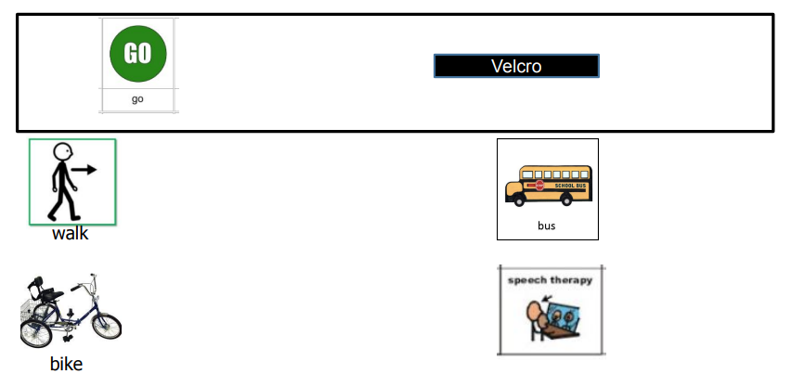

Introduction (Partner): combine known abstract symbol in existing routines and provide opportunities to use “new” two- and three- symbol utterances. For example: During lunch routine (with water and milk available), combine the individual’s symbol for “drink” and “milk” as partner says “Drink more milk”.

Targeted Behaviors (Response): demonstrates understanding of the combined use of known abstract symbols.

Partner’s Response: respond appropriately according to the individual's intent.

Outcome: Individual increases utterances across Level VI intents (greet, offer, direct attention, polite social forms, answer/ask questions).

