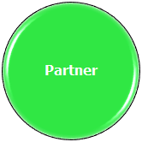
Embedding Goals into Routines

Routine | Goal | Communication Mode Examples
Arrival | Requests attention | - Squeal  - Bounce
Morning Circle | Make choices | - Slaps away object they don’t want  - Looks longer at a desired object
Center/Class | Requests new action | - Movement toward desired object or space
Snack/Recess | Refuses, rejects | - Push off table  - Throw  - Pull back  - Stiffen  - Laugh  - Rock  - Continue a Movement  - Move toward place where desired object is located
Specials (Art, PE, Music) | Requests new object | - Look at an object and vocalize
Note: At this level, it is often difficult to distinguish between conventional and unconventional behavior. It is critical to accept all behavior with communicative intent.

