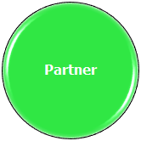
Establishing Intentional Behavior

General Strategy
- Create an atmosphere that is contingently responsive.
Remember
- The individual may not yet have control over his/her own movements. They may have some purposeful behavior, but it is so subtle or infrequent that intentionality is unclear.
Targeted Behavior
- These may include vocalizations, arm/leg movements, head movements, facial expressions, or a “call switch.”
Response
- A predictable response or attention from the partner occurs.
Outcome
- Individual develops or strengthens contingency awareness (physical or social).

