How are Concepts Developed?
- Learned incidentally through experiences and interactions with the environment.
- Develops effortlessly and freely with repetition and through a free flow of information.
- Concepts develop in a spiral as experiences expand.
- Understanding of one concept leads to the understanding of other concepts.

Concept vs. Skill

Concept Skill

A mental representation, The ability to do
Image, or idea of tangible something such as and concrete objects (chair, dog) tying a shoe or using
as well as intangible ideas and feelings vision to find an
(colors, emotions). object.

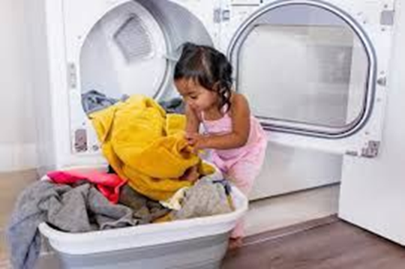
Example:

Clean clothes vs. doing laundry

Concepts
It is important to build concepts while providing vocabulary for individuals.
- Concepts are how we connect meaning to objects, events, and people.
- Concepts provide a foundation for communication and literacy.
- Concepts provide the framework for an individual to organize information.

Look at the vocabulary being taught and think about how to group the tangible symbols into conceptual categories. (core vs. personal vocabulary).

