Important Concepts to Consider
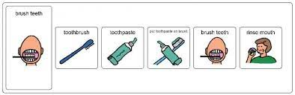
How Things are Sequenced
- Beginning/End
- Order of Activities
- Time Concepts

How the World Works
- Routines
- Cause and Effect
- Purpose and Use of Objects
- Where Things Come From
- The Natural World and its Cycles and Laws
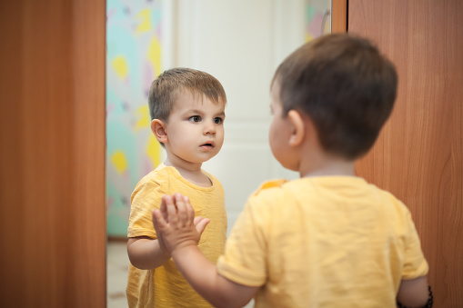
(Self-Concept (the mental perception one has of oneself)
- I exist and have feelings
- I can do things
- I affect people and objects around me

Social Concepts
- Greetings and Introductions
- How to Play
- Expectations in Social Situation

