Moving Toward Abstract Symbols Strategy
Pair known with Abstract, Practice in Routines, Respond
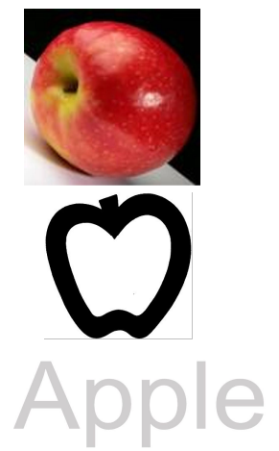

- Introduction (Partner): pair known symbol with a more abstract representation in the hierarchy of existing routines and provide opportunities to use “new’ symbol. For example: object to similar object; similar object to part of object; part of object to photograph; picture to line drawing; line drawing to word.

- Targeted Behaviors (Response): demonstrates understanding of new symbol, makes choice, participates in activity, touches or gazes at desired item.

- Partner’s Response: respond appropriately according to the individual's intent.

- Outcome: individual learns to communicate at more abstract levels across Level V intents (greet, offer, direct attention, polite social forms, answer/ask questions).

Why Move to Abstract Symbols?
Abstract symbols:
• Provide the means for creating language not just communication.
• Represent “core” vocabulary that can be the foundation for creating multi-word utterances.
• Provide the individual with frequently used vocabulary that are not easily picturable (e.g. that, want).
• Are available in predesigned sets, thereby decreasing the time needed to create symbols.
• Facilitate the use of electronic AAC devices.

