Nine Categories of Communicative Behavior
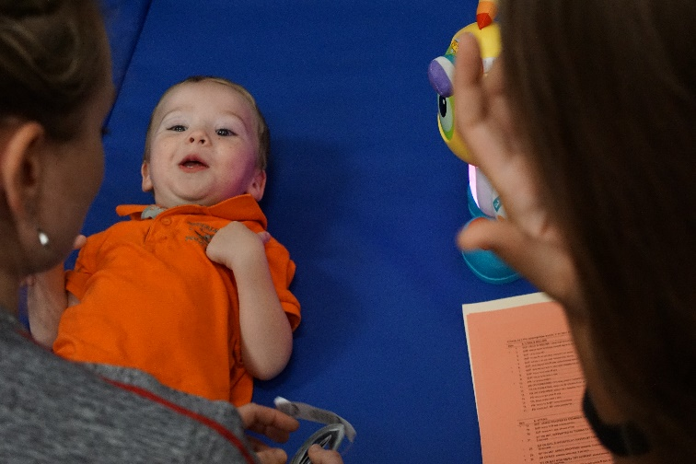
Body Movements
Early Sounds
Facial Expressions
Visual
Simple Gestures
Conventional Gestures and Vocalization
Concrete Symbols
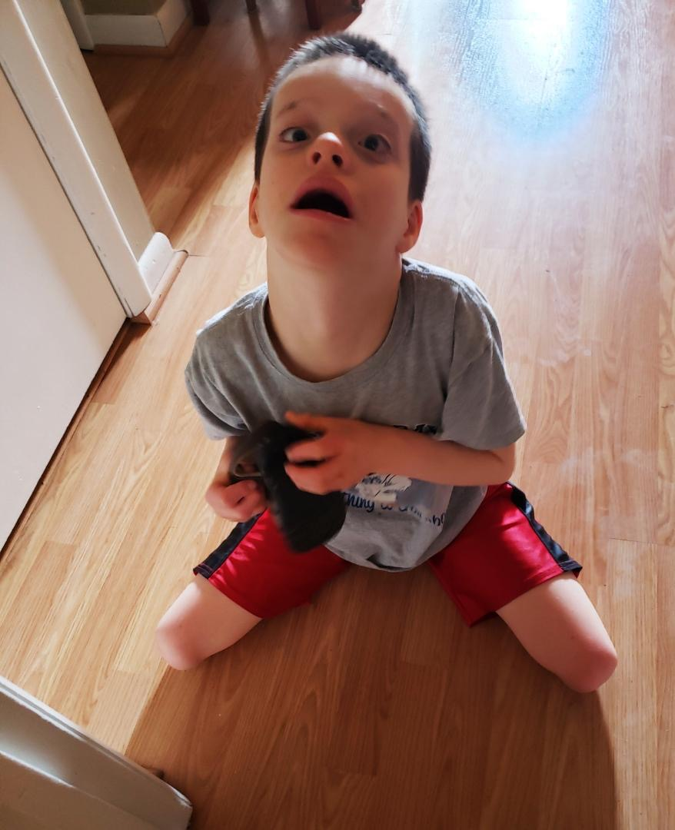
Abstract Symbols
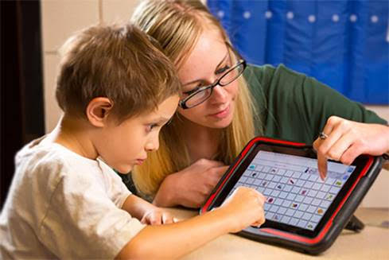
Language

