Steps to Building a Daily Calendar 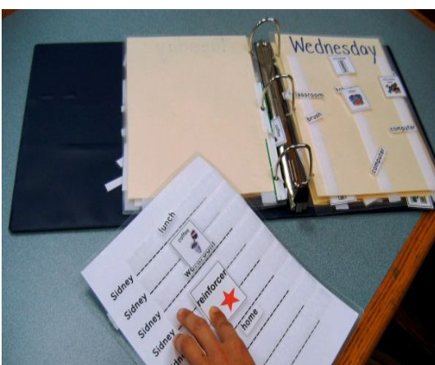

1. Identify the major routines in the individual’s day.

2. Identify the symbol known by the individual to represent this routine or used as part of the routine. a) Symbols must be accessible. b) Symbols must have meaning (1:1 correspondence) to the individual.

3. Gather and label the symbols.

4. Display each symbol (calendar event) in separate containers, in a velcro book, or timeline (sequence). Symbols must follow scheduled routines for the day and be displayed left to right and top to bottom.

5. Include a “finished” box, a “finished” page or a “finished” area in the timeline. This should be at the end of the calendar or cover for the container.

6. Calendar must be placed where the individual can easily access it throughout the day (Consider motor ability, height, scanning, eye gaze, and auditory support).

7. Orient the individual to their calendar. Bring the symbol to the routine.

8. At the end of each routine, assist the individual in moving the symbol to the “finished” box.

