FitnessGram
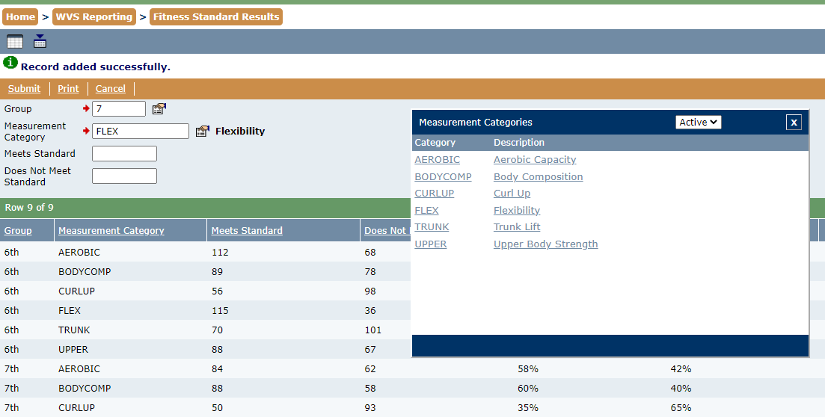
WV State Reporting – Fitness Standard Results (SFIT.200)
The Fitness Standard Results application (FitnessGram) can be found in the WV Reporting Menu in WVEIS and works very much like the original application.
Select the group (grade level) you plan to work with, and then the Measurement Category. Measurement categories can be selected from the pop-up, or typed in. The categories are listed below for reference –
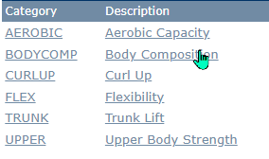
Add the total of students who met the standards and did not meet the standards for the grade level. Click Submit to save.
Grade levels are customized to the schools, and include a general High School group for high schools to accommodate mixed grades in the PE classes.

