How to Change a Query to a different county number or FY

I have a sequel library called SEQUELKIM with a variety of queries. SEQUELWEB are queries you can run at any time. It will either default your county number or prompt you for your county number. You also have a county sequel library called SEQUELXXF or XX (XX=county number).
Any query in your county sequel library will have your county number already in there. Any in mine would not. If you want to use a query in my sequel library, please copy it to your sequel library before making any changes. To do that, right click on the sequel and click Design. (If you don’t see Design as an option, you have an older version of sequel. I would suggest you download the latest version on the Sequel support page on the WVEIS.k12.wv.us website.)

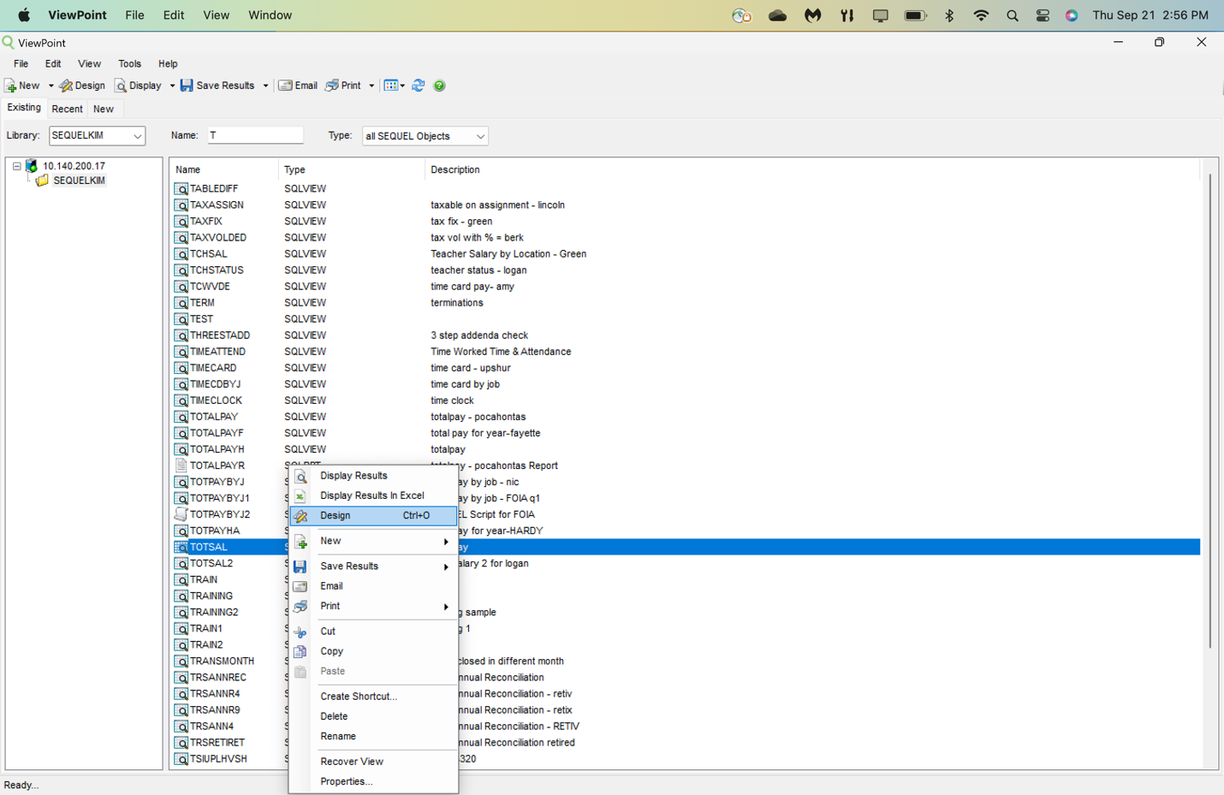

Once you pull up the query in Design mode, immediately hit File in the upper left and Save As and put your sequel library in the Save In Library field and hit enter. This will save the sequel in your library and you can make any changes you want without altering my version in my library.
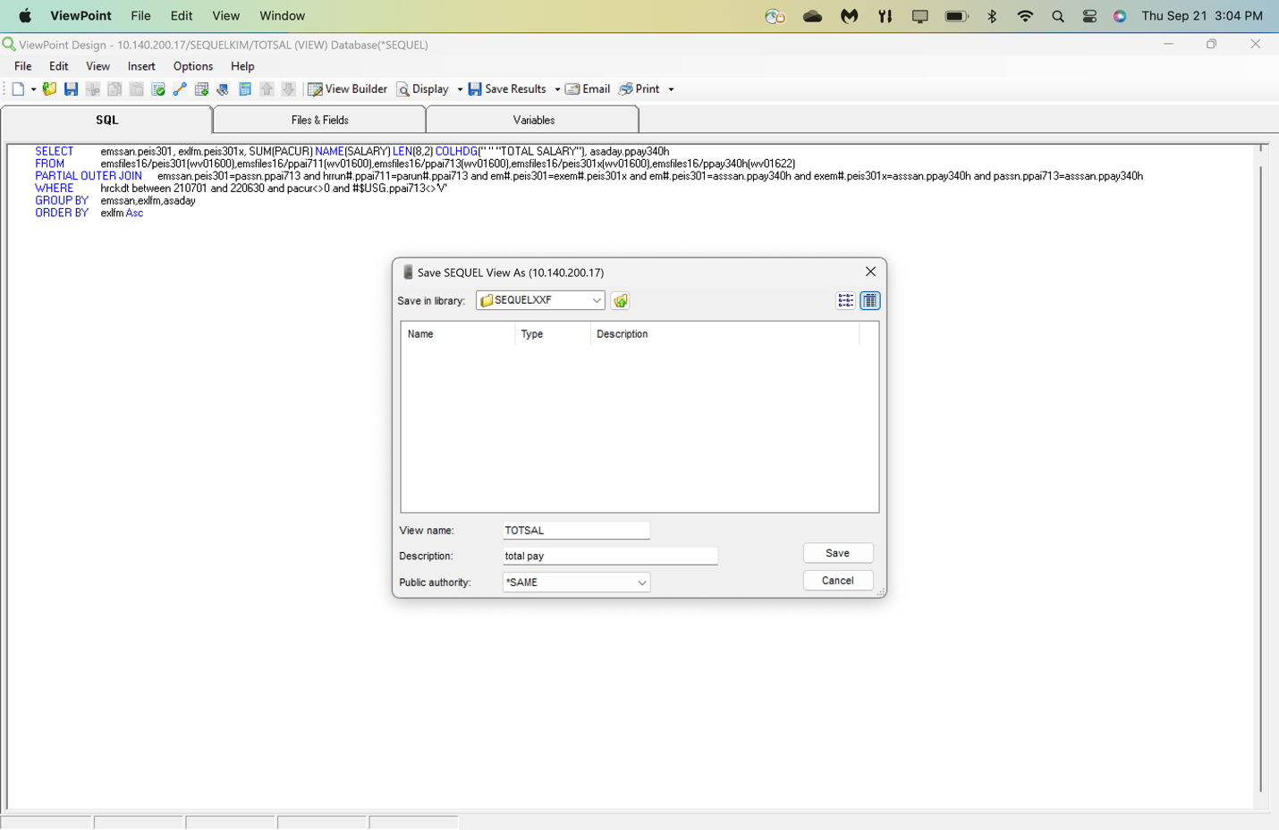

CHANGING THE COUNTY NUMBER

There are 2 ways of making mass changes to a query. One is the slower, safer way and one is the quicker, riskier way.
The safer way is to go into the files and fields tab and right click the shaded area at the top of each box which represents files selected in the query. Select Properties and change the library to your county number.
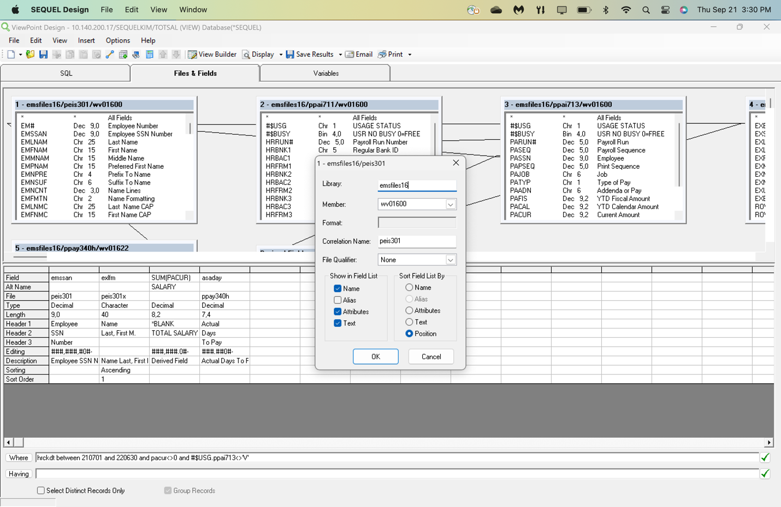

The faster, riskier way is to go to the SQL tab. Select Edit, Replace and enter the county number currently in the sequel in Find, Replace with your county number and hit Find Next. IF it positions to a library such as EMS or FMSFILESXX or the member WV0XX, then hit replace, else hit Next until it has gone through the entire sequel. Sometimes the original county number could be part of a file or field name, so you need to be careful to only replace when it is the library or member. If you mess up, you may want to start over again and copy the sequel from the SEQUELKIM library again.
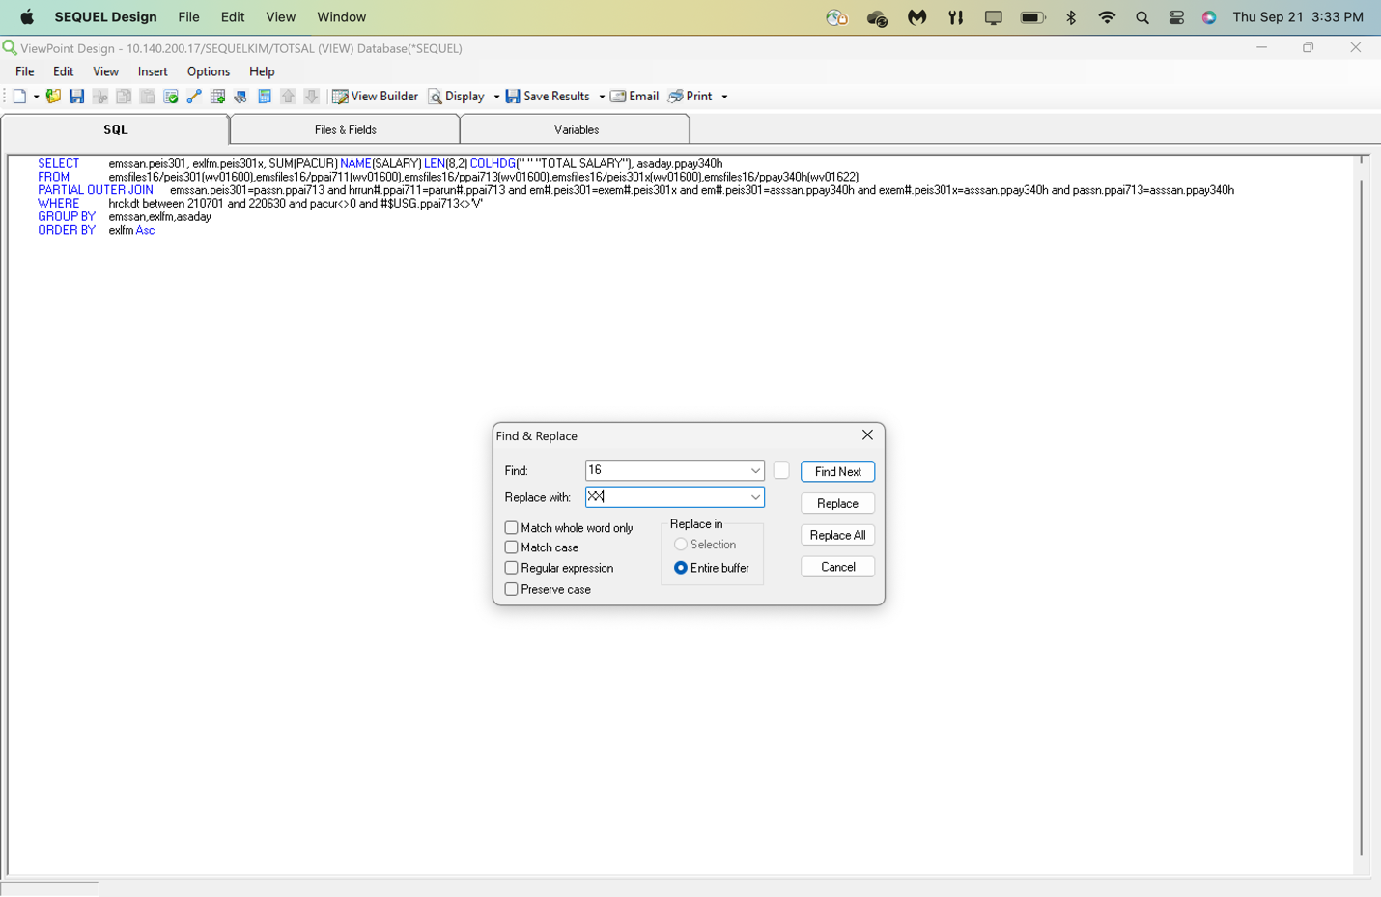

CHANGING THE FISCAL YEAR

You will go through the same steps to change the FY as you did the county number. The FY is in the member WV0XXYY. If the member is WV0XX00, then you don’t have to change that member. If it isn’t zero, then it is the FY and you will right click the shaded area at the top of the box, Properties and change the year on the member..

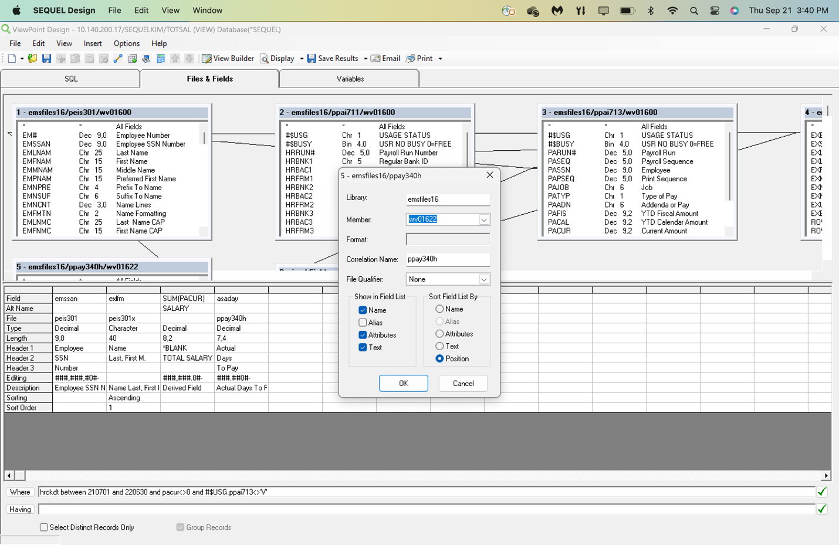

If you use the SQL tab, hit Edit, Replace and enter the FY in the sequel in Find and the desired FY in Replace. Hit Find Next. Again, watch to make sure you are only changing the member FY.

